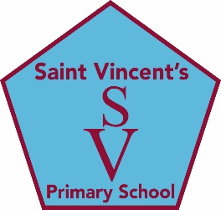

**education SERVICES**

**Executive Director: Tony McDaid**

**ST VINCENT'S PRIMARY SCHOOL**

Head teacher Eileen Tompkins

**Website Accessibility Statement:**

We want as many people as possible to be able to use this website. For example, that means you should be able to zoom in to text, navigate easily and listen to most of the website using a screen reader.

We’ve also made the website text as simple as possible to understand.

We know some parts of this website may not be fully accessible eg live videos may not have captions and some images may not have a text alternative.

Abilitynet.org.uk has advice on making your device easier to use if you have a disability.

If you need information on this website in a different format then please contact the school using the details on the home page.

We are always looking at ways to improve the accessibility of this website. If you have problems using the site or think we’re not meeting accessibility requirements then please contact the school using the details on the home page.

South Lanarkshire Council is committed to making all of its websites accessible, in line with the Public Sector Bodies (Websites and Mobile Applications (No 2) Accessibility Regulations 2018.

This statement was prepared September 2020