

**Education Resources**

**St Vincent’s Primary School**

**Handbook 2017**

**Contents**

**1: Introduction**

**2: About our school**

**3: Parental involvement**

**4: School ethos**

**5: The Curriculum**

**6: Assessment**

**7: Reporting**

**8: Transitions**

**9: Support for Pupils (Additional Support Needs)**

**10: School Improvement**

**11: School Policies and Practical Information**

**1)** Introduction by the head teacher

Dear Parent/Carer,

I am very pleased to welcome you to St Vincent's Primary school where we want your child to be very happy, safe and enjoy the many and varied learning opportunities that we offer to develop skills for learning, life and work. Our school aims to provide a happy and secure learning environment where every child is valued. We strive for excellence, reward effort and work to give every child the opportunity to develop their unique potential. We want our children to have happy memories of their time in school and become enthusiastic, independent, lifelong learners.

As a Catholic school we foster Christian values and promote respect and equality for all. Our school is located next to Saint Vincent’s Church and we are supported by our parish priest Fr Ivan Boyle who is a frequent visitor to our school. We also have very valued links with representatives from other churches in our area and beyond and we have a number of children from different faiths who contribute to the rich fabric of diversity in our school.

We want you to feel very welcome to the school and very involved in your child’s education as a parent of St. Vincent’s Primary School. There are many opportunities for you to have your views heard and to take an active part in the life of the school. Our Parent Council is firmly established and has regular meetings to which you are invited. In addition to taking an active interest in all that happens in the school, they also play an active role in supporting the school through regular fundraising and also social functions. Whatever skill or time you can offer will be invaluable in helping us.

I hope this handbook will answer many of the questions you have about our school. Should you have any other questions or concerns please feel welcome to contact us.

The staff of Saint Vincent’s Primary School look forward to working in partnership with you now and in the future.

Kind Regards

Eileen Tompkins





**South Lanarkshire Council is the fifth largest authority in Scotland. It covers the following main areas; Clydesdale in the south which features extensive rural areas, Cambuslang, Rutherglen, Blantyre and Uddingston to the north as well as the towns of East Kilbride and Hamilton.**

**The Council’s Plan Connect sets out the Council’s vision which is, “to improve the quality of life for all within South Lanarkshire”.**

**For Education Resources this means delivering services of the highest quality as well as striving to narrow the gap. It is about continually improving the services for everyone at the same time as giving priority to children, young people, families and communities in most need. The priorities for schools and services are set out in the Education Resources Plan which confirms the commitment to provide better learning opportunities and outcomes for children and young people.**

**School Prayer**



*Heavenly Father, bless the parents, children and staff of St. Vincent’s Primary School. Help us to live in love for You and one another as Jesus shows us in the Gospel.*

*We thank You for the different talents that You have given to each of us. Please guide us to work hard in developing our gifts. Help us to realise that we can also learn from our mistakes. Instead of looking back at any mistakes with regret, may we always look to the future with confidence, knowing that in all the ups and downs of life You are there with us.*

*Inspired by our patron Saint Vincent de Paul, may our faith and love be always strong and joyful so that all whose lives we touch will come to know and love You more deeply.*

*We ask this through Jesus Christ Our Lord.*

*Amen.*



2) About our school

Name St Vincent's Primary

Address Crosshouse Road

Greenhills

East Kilbride

G75 9DG

Phone Number 01355-241649

Fax Number 01355-241290

Email gw14stvincentsht@glow.sch.uk

Present Roll 315

Denominational Status Catholic

St Vincent's Primary is situated in the Greenhills area of the new town of East Kilbride, the sixth largest town in Scotland. Opened in August 1973, it initially served as an annexe to St Louise’s Primary before being fully established in 1974. St Vincent’s is a Catholic, co-educational primary, covering stages Primary 1-7, and has a valuable and happy working relationship with the parish community. The ethos of the school is built on the partnership of home, school and community. In 2014 we celebrated the 40th Anniversary of our school and in December 2016 we marked the tenth anniversary of the current school’s official opening when as part of South Lanarkshire Council’s investment in improving school buildings a brand new building opened in August 2006. The rooms are bright and colourful furniture and fittings are of a very high standard. Everyone takes a great pride in the school. We share our school building with Ballerup Nursery Centre. The school is well resourced and includes a large Infant Area, Computer Suite, General purpose room and a well-stocked library. Children have lunch in a bright area on the ground floor. We place considerable emphasis on giving children access to the outdoors and we have acquired the use of a woodland area adjacent to our school which can be used as an outdoor classroom. The safe playground, monitored by adults at all times, has a range of games that encourage the children to take part in energetic play and funding was received for the creation of a resourced area dedicated to Natural Play. An Out of School Care Group is also located in a purpose built building adjacent to the school grounds. (Phone No 01355 241511)

.

**STAFF**

**Head Teacher** Mrs E Tompkins

**Depute Head Teacher** Miss D Timmons

**Principal Teacher (Acting)** Mrs Yvonne Boyle and Mrs Lorena Ziolo

### Class Teachers and their responsibilities

**P1** Mrs E Blake

**P1** Mrs S Kelly

**P1/2** Mrs J Field

**P2** Mrs Y Boyle

**P2/3** Miss S Morrison

**P3/4** Mr M McKenna

**P4** Miss J McDade

**P5** Miss A Mulrain /Mrs A Tavendale

**P5/6** Mrs K Johnstone /Mrs L Ziolo

**P6** Miss S Toner /Miss L Mc Guigan

**P7** Mrs Cheryl Farrell

**P7** Miss L Gallacher

**Class Contact Reduction Teacher** Mrs A Tavendale

**Area Specialist Support Teacher** Mrs J Dykes

**Home/School Partnership Worker** Mrs L Highet

**Parish Priest**

Father Ivan Boyle

**Janitor**

Mr A McCrae

**Cleaning**

Mrs A Kenny - Cleaning Supervisor

**Catering**

Mrs M McCann – Catering Supervisor

**Support Staff**

Mrs L Daley – Team Leader

Mrs A McAneny Mrs D Morrison

Mrs H Young Ms J Barlas

Mrs L Boyle Ms E Watson

Mrs J Addison

Mrs J Aitken



[](http://www.southlanarkshire.gov.uk/)

**Have a Concern?**

If you have a concern regarding your child’s progress, behaviour or another school matter you should speak to their class teacher in the first instance. This can usually be done by speaking to the teacher at the end of the day or by making an appointment through the School Office.

For matters of a more urgent, confidential or sensitive nature, you should arrange to speak to the Head Teacher, through the School Office.

Formal parent/teacher evenings are arranged twice a year, normally in November and March. Throughout the session parents are most welcome to arrange an appointment to have their child's programme of work explained to them or have informal discussions regarding their progress. This can be organised by contacting the School Office.

Parental workshops on the curriculum and other matters take place throughout the year.

Regular Newsletters and Memos provide information for parents on a wide range of school matters.

**Child Unwell? Please Let Us Know**

Every day we carry out an Absence Check at 9.30 am. Please notify the School Office between 8.30 am and 9.30 am if your child is going to be absent from school and give a reason so that the Class Teacher can be informed. When a child has been identified as absent by the Class Teacher and no notification has been received from home the Office Staff will telephone parents or the Emergency Contact to find out where the child is. **Please phone before 9.30 am.**



**Complaints Procedure**

The quickest, easiest and often the most effective way to complain is to contact the School Office directly and speak to the Head Teacher or Depute Head Teacher, let them know what the problem is and what would put things right.

You can make a formal complaint:

In person: By making an appointment and calling into the school

By phone: Call and speak to a member of the management team detailing what you are unhappy about.

In writing: Write to the head teacher detailing the nature of you dissatisfaction

When making a complaint you should let us know:

* Your name.
* Your address.
* Your phone number.
* What you are complaining about.
* What we can do to put things right

**3) Parental involvement**

South Lanarkshire Council recognises the importance of parents as partners in the education of their child and has published a strategy entitled, ‘Making a difference – working together to support children’s learning’. This is available from the Council’s website: [www.southlanarkshire.gov.uk](http://www.southlanarkshire.gov.uk)

Parents, carers and family members are by far the most important influences on children’s lives. Children between the ages of 5 and 16 children spend only 15% of their time in school! Research shows that when parents are involved in their child’s learning, children do better at school and throughout life. Parental involvement can take different forms but we hope you share the same aims and agree that by working together we can be partners in supporting children’s learning.

As parents/carers we want you to be:

* Welcomed and given an opportunity to be involved in the life of the school;
* Fully informed about your child’s learning;
* Encouraged to make an active contribution to your child’s learning;
* Able to support learning at home;
* Encouraged to express your views and involved in forums and discussions on education related issues.

To find out more on how to be a parent helper, or a member of the Parent Council just contact the school or visit our website.

Some useful information contacts for parents to find out more on education are as follows:-

* Parentzone – [www.parentzonescotland.gov.uk](http://www.parentzonescotland.gov.uk)
* Engage Parent Forum – [www.engageforeducation.org](http://www.engageforeducation.org)
* National Parent Forum for Scotland – [www.educationscotland.gov.uk/parentzone](http://www.educationscotland.gov.uk/parentzone)
* South Lanarkshire Council – [www.southlanarkshire.gov.uk](http://www.southlanarkshire.gov.uk)



**Parent Council**

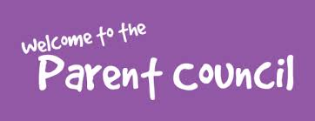

The school is fortunate to have a committed and enthusiastic Parent Council who work hard to support every pupil in the school by active involvement in matters pertaining to the school as well as organising events and fundraising to supplement school resources. The Parent Council meet regularly and new members are always welcome.

**Chairperson**: Mrs Paula Ferguson

Mr Gerry Gordon is appointed as Church representative and Mrs Grace Gordon is Parent Council Clerk.

The Head Teacher acts as Professional Adviser to the Parent Council but has no voting rights.

Local Councillors may also attend Parent Council Meetings but have no voting rights.

The school and the local authority are obliged to listen to what the Parent Council says and to respond to the issues raised. Parent Councils decide such things as:

• how their Parent Council will be set up

• what it should be called (Parent Council or other name)

• what size it should be – e.g. in a very small primary school, all parents could be involved

• who should be a member of the Parent Council

• how they should be appointed

• when the most convenient time is to hold meetings

• what will be discussed at meetings – these might be topics such as school uniform, parking near the school, the school’s anti-bullying policy, etc.

**Parents and Friends in School**

We work together to make parental involvement a particular strength of our school .We are fortunate to have a very loyal, hard working group of parents, grandparents and friends who help out each week in the school, e.g. assisting children in class and as required we also have Grandbuddies who support our gardening activities.

The Home School Partnership Worker, Liz Highet organises helper groups and our pupils benefit from a paired reading approach called “Scotland Reads” which operates with trained volunteers throughout the school year.

We value parental support and are always very pleased to welcome new helpers. Any parent wishing to become involved in helping in the school should contact the school office for information.

4) School ethos

Our strong, school ethos is focused on developing the whole child and is based on Christian values. In Saint Vincent’s Primary every lesson matters and every learner counts. Our children are encouraged to be confident, successful, responsible and effective contributors both in school and in the wider community. Through weekly assemblies the school’s vision and values are shared and achievements in learning are recognised and celebrated. Our assemblies also provide opportunities to engage with a range of visitors who bring colour, enjoyment and enrich the learning experience for our pupils.

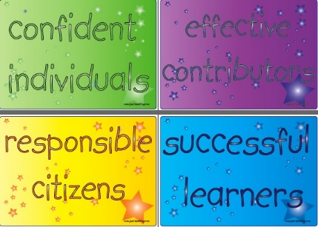

The staff of Saint Vincent’s Primary are highly motivated and fully committed to the continuous improvement of the school. There is a strong commitment to inclusion and working together and in partnership with outside agencies to achieve the best outcomes for our children. Staff work with specialist staff to plan for and meet the individual needs of pupils e.g. specialist support, behaviour support ,educational and clinical psychologist, staff from CAMHS, Integrated Childrens’ Services as well as speech and language and social work.

During the past session, special focus events such as “Our Fragile earth”, Rolls Royce Science prize related Space and astronomy events, Maths, Technology and Health Days have provided additional valuable learning experiences for our pupils, working in partnership with a number of outside agencies.

We have worked with other schools on projects such as Give a Kid a Goal, Maths Challenge Day, Young Engineers, No to Sectarianism to progress our anti-sectarian agenda. Our school enjoys a very positive and supportive relationship with our local parish and with the wider community. We are very fortunate to have the benefit of the skills and experience of highly experienced volunteers including a Chess master and a STEM Ambassador who enrich our pupils’ learning in school as well as leading very successful and popular afterschool clubs in engineering and technology.

During the past year our senior pupil council have met with senior pupil council representatives of neighbouring schools in what is now known as East Kilbride South Pupil Council. Agendas have included discussion on a range of issues relating to the local area. The attendance of local councillors has given the children the chance to use their voice to have their views heard at council level. They have also met with Tam Baillie Children’s’ Commissioner where following the visit he reported that he “was made to feel very welcome through the opportunity to meet with the school assembly, speak to the teachers and spend time discussing the school with pupils. He said “I really enjoyed the session with the East Kilbride South Pupil Council Group comprising of the 5 primary school councils – impressive – as were the Grandbuddies.”

 

Pupils have enjoyed sharing their learning with parents and the wider community through various newspaper articles, school website and special events such as the Christmas Concert, Assemblies, Parents’ Evenings and presentations at Coffee Mornings including very popular Café Noel, Choral evenings and Open Afternoons. During Catholic Education week, pupils from some classes showcased their learning and in September last year, four of our Primary 7 pupils were invited to do a presentation at the Scottish Learning Festival on Number Talks. Our Mother’s Day Assembly as well as our whole school Creativity showcase were particularly memorable school and community events. Such was the impact of the Creativity showcase that we have been invited by the South Lanarkshire Cultural coordinators to share our good practice at an upcoming South Lanarkshire Creativity Conference.

In December 2016 we marked the tenth anniversary of our current school building with a celebration of wider achievement where Andy Kerr (then MSP, now CEO of Sense Scotland) returned to speak and present certificates. At the end of the school year we held a Celebrating Success Awards’ ceremony where pupils’ achievements in Euro quiz, Football, Athletics, Netball Rotary Quiz, and Young engineers/technology club were recognised in front of a capacity crowd of families, delighted to celebrate their children’s success.



10th Anniversary Wider Achievement Celebration

This year Saint Vincent’s enjoyed national success when the school won second prize in the Rolls-Royce Science Prize 2016, a prestigious prize. Saint Vincent’s was the only Scottish school to be involved in the UK wide competition. Throughout the year, pupils in each class had the opportunity to take part in afterschool Space and Astronomy clubs and also in other related activities in science involving parents and the wider community.

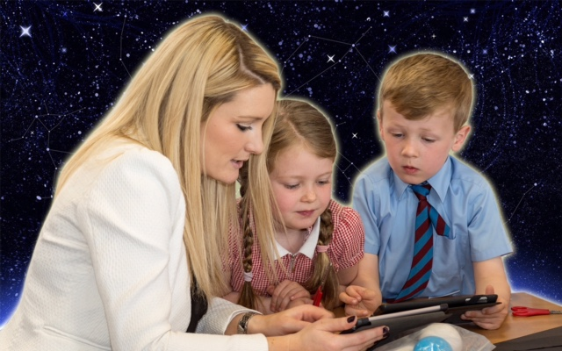



Saint Vincent’s had the honour this year of having our Depute Head Danielle Timmons recognised as Scottish Teacher of the year 2016, an occasion of reflected glory for the entire school community.

In recent years we also enjoyed success at local and national level in a number of events. In 2011 our Primary 7 Enterprise team were winners of the Micro Tyco pilot and arising from this involvement the children spent a day at the Hatchery in Ayrshire.

Following the visit Sir Tom wrote:

“Thanks so much for bringing your inspirational pupils to our Hatchery yesterday. I really enjoyed meeting them and was totally uplifted by their enthusiasm and obvious enjoyment about enterprise.”

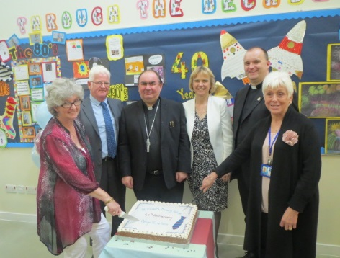

40th Anniversary Celebration

**We engage in regular consultation with parents, carers and our partners Examples of the feedback we have received following some of our events include:**

“This was a fantastic showcase of children’s work. The children presenting were engaged and knowledgeable. It was great to see evidenced all the learning and efforts that have been made.” (Parent visiting “Our Fragile earth showcase “)

“Such great work produced by the children. It was very interesting and a pleasure to see”

The presentation today by your staff and pupils was “truly out of this world “(Head teacher visitor to Our Fragile earth showcase)

“Fabulous!! Really well impressed with the efforts and detail gone into decorating and displaying all the good work that has been happening in the class Very well done “(Visitor to Our Fragile Earth showcase)

A fantastic amount of work undertaken with great enthusiasm from staff and pupils. I got great ideas to take back to my own school “Head teacher visitor to our school

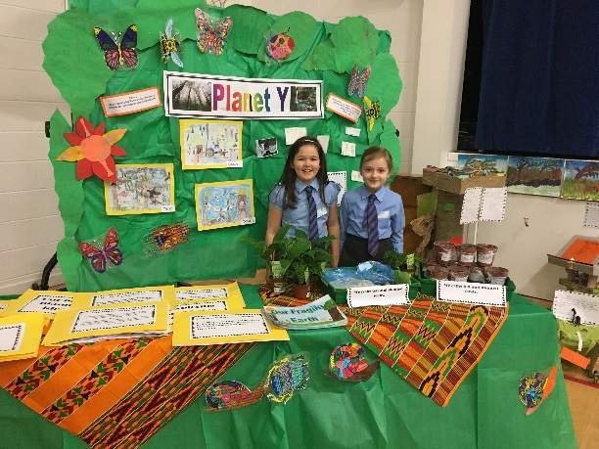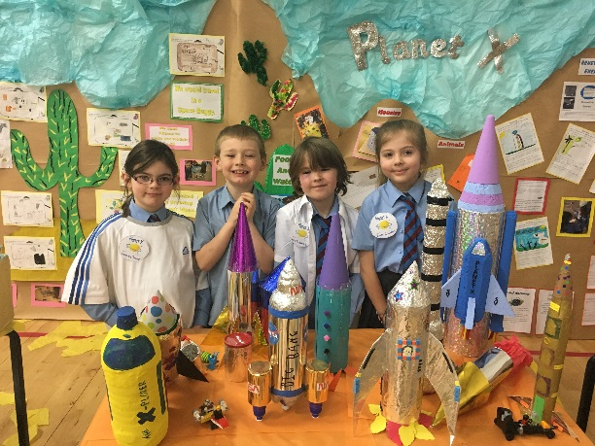

“Today’s Primary 1 blessing was a beautiful and thoughtful ceremony. It allows all parents and grandparents to see the progress of the little ones.” (Primary 1 Blessing)

“Very informative evening, everything was explained in great detail and at a level us parents could understand “(Parent Information Evening)

“Once again a pleasure to be in a classroom where learning is paramount and clearly a happy place” (Primary 1 Story sacks)

Thank you that was a great lesson with lots of ideas to do at home. Your classroom is so colourful! (Primary1 parent)

“Best school presentation ever! All schools should have a day like this” (Mother’s day Assembly)

“Loved the experience and Saint Vincent’s Primary never fail in providing us parents with lovely surprises of what our children are achieving” (Mother’s day Assembly)

“I found the Induction visit very informative, everything was covered. I liked the new buddy system and was impressed with the talented young pupils” (Primary 1 Induction visit).

“Very friendly and informative. We felt very welcome. Will be happy for our child to start at Saint Vincent’s” (Primary 1 Induction visit)

“Lots of information about practical issues. Covered all my questions about preparing my daughter for school. Also enjoyed seeing the pupil presentation.” (Primary 1 Induction visit)

“I am impressed by the positive professional ethos and practice in the school” (Visiting specialist)

“The school looked fantastic. I was so impressed with the interior and facilities available for your pupils. I wish I had resources like these available when I was going to primary school.” (Visitor for work experience)

“Fantastic time. The children were so interested and interesting.I loved it.”(World Book Day Visitor)

“Very informative, it is clear there is a robust plan of action to maintain and increase the already high standards that the school have strived to attain.” (Parent Information Evening)

“Everything was explained very well. Great tips on what to do at home” (Primary 1 Parent’s workshop)

“This has been an exciting week in Primary 1. The children have been enthusiastic and have learned more about their planet, the sun, the moon and the stars. The children enjoyed space missions within the classroom and loved eating astronauts’ food.” (Teacher)

“I think Space week was very successful. It gave the children an opportunity to utilise a variety of skills i.e., solving problems, designing, constructing and evaluating. They loved launching their rockets in the playground. The children have truly engaged in cross curricular learning this week and I have learned a few space facts myself!” (Teacher)

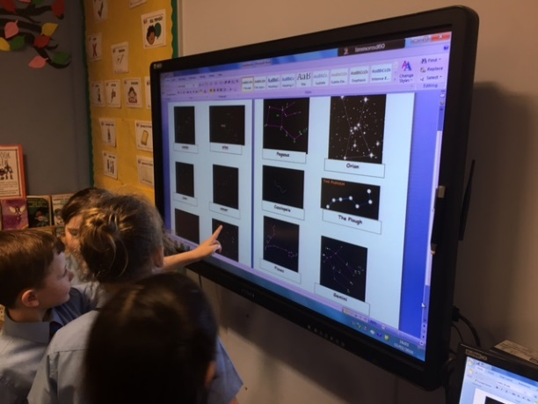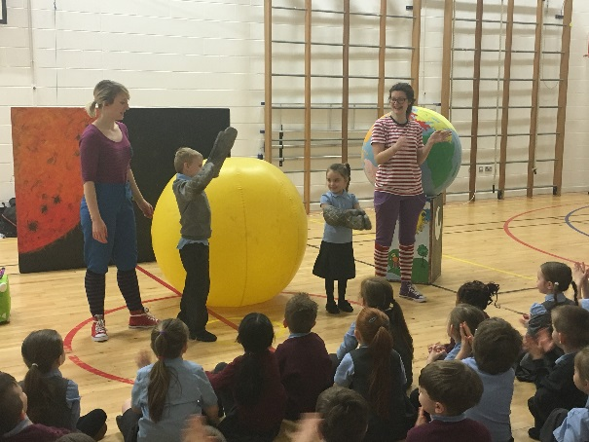

“Today was very good; I was really inspired by the people who came in to speak to us. I loved dressing up and reading about my character.” (World Book Day, P7 pupil)

“What makes Saint Vincent’s unique for me is that: The children are treated as individuals and made welcome and feel part of their great school by the kindest of staff” (Parent at Parent’s evening)

What makes Saint Vincent’s unique for me is that: “It has a caring environment, I feel the school really care about the progress of my children... Availability of after school clubs, great opportunity for learning with a fun aspect too. Loved the stargazing” (Parent at parent’s evening)

“It was a pleasure to do these seminars. The friendliness of staff and pupils alike was evident through the whole day, as was the warm, sunny climate. I was inspired and delighted to notice that many children already had experience of meditating, and this was clear in their manner and behaviour.” (Health Day, Martin Stepek who conducted Mindfulness workshop)

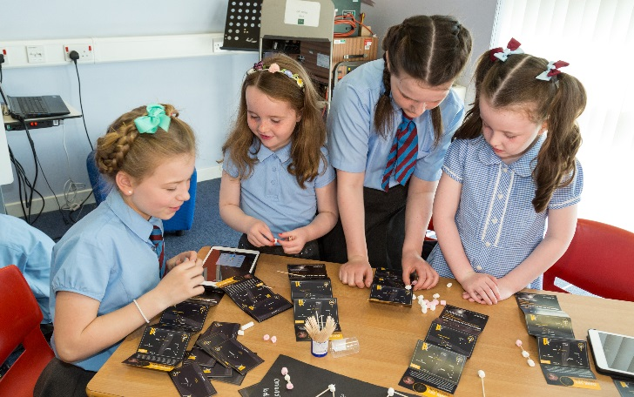

“Thank you for a very emotional and lovely day. So well organised and for such a worthwhile cause – re sponsorship in Delhi. Proud to be a granny in a school that focuses so much on the children.” (Mother’s Day Assembly, gran)

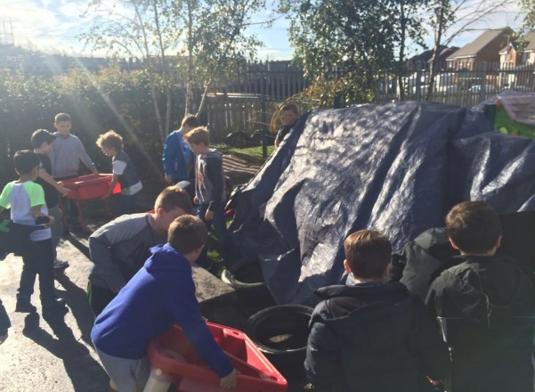

“It has been an absolute pleasure to be part of such a spiritual, caring and nurtured community. I cannot express how cherished the children have been made to feel throughout their time at the school.you have given them memories that will stay with them for life and for that we are most grateful.” (Former parent, a letter of thanks, June 2014)

“A very enjoyable morning listening to all the children singing and playing instruments. It was a very festive event and put everyone who attended into the festive spirit.” (Cafe Noel)

“I found the Christmas carols very moving. Appreciate the time and effort of all staff to make this event successful. The children were wonderful.’ (Carol Service)

We have loved working in partnership with the St Vincent’s school community over the course of 2016. It's reassuring when you find a school open to new ideas and able to play with possibilities. The staff are some of the most fun and dedicated we have ever worked with and seem to thrive with new challenges. We look forward to continuing the creative partnership in 2017.

Paul Gorman Creative Director Hidden Giants

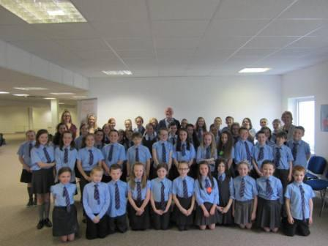

Saint Vincent’s school continues to show its responsibility towards others in its charity work with particular focus on a variety of creative fundraising activities during Lent each year to raise funds for our school charity Mothers Care India.

Each class has planned and implemented at least one charity/enterprise event of their choice with huge success. The Pupil Council works to ensure we are responding to pupils’ views in the choice and delivery of the fundraising and enterprise activities.

Classes have also taken part in many educational visits to enhance their learning during the past year which included visits to the Glasgow Science Centre, Scottish Parliament, Calderglen Park, Kelvingrove Art Gallery as well as working in school with representatives from BBC studios in Glasgow and also from Morgan Stanley.

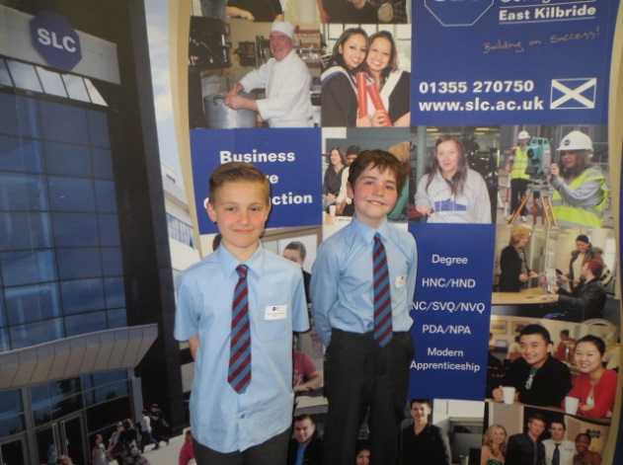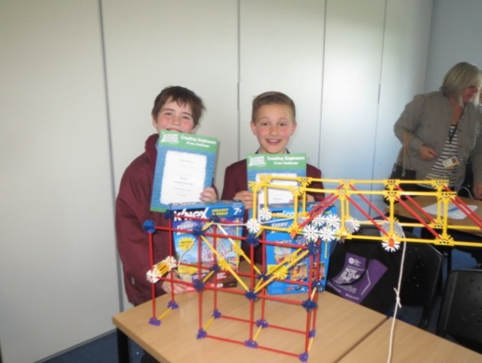

Young Engineers

All children have the opportunity to take part in a wide variety of lunchtime and after school clubs including Athletics, Music Tuition with pupils having the opportunity to play brass, woodwind and string, as well as traditional musical instruments including fiddle and tin whistle. We also provide clubs in Dance, Young Engineers, Chess and Choir as well as a parent led Spanish club. Following a very successful recent collaboration with representatives from Morgan Stanley who provided us with Coding taster sessions this term, we now plan to introduce Coding and Raspberry pie clubs as part of our efforts to promote Digital Literacy

Our school choir has performed at a number of events both in East Kilbride and beyond, including Hairmyres Hospital, Sunday service at Cathcart Old Parish Church in Glasgow and at South Lanarkshire Orchestral Society Christmas Concert following which The Lord Provost sent us this message

*“The children’s performance was faultless…they are a credit to their families, the choir and the school.”*

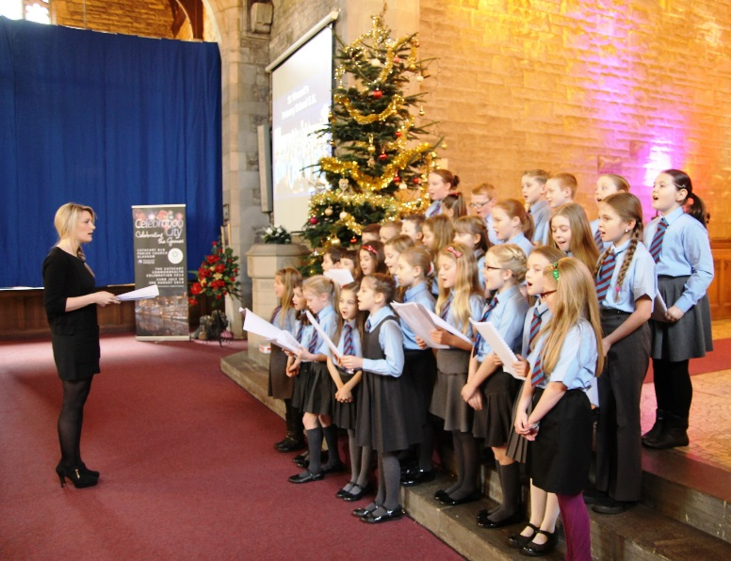

School Choir

**Early Years**

The school has an adjacent nursery (Ballerup Nursery) which provides a learning environment for young children. Parents from any area may apply to attend the nursery class. To find out more about the nursery please contact them directly on EK 236737. However, it should be noted that if you register your child for nursery it does not mean that they will automatically be enrolled at the school when they are ready to start primary school. (See next paragraph) – All children who move from early years to primary education must register separately for school in the month of January.

**Saint Andrew’s and Saint Bride’s Learning Community**



Saint Vincent’s Primary is part of Saint Andrew’s and Saint Bride’s Learning Community. A learning community is made up of schools and education establishments from the area including the secondary school, primary schools, early years establishments, early years partners and schools and bases which provide specialist additional learning services. It is about working together to plan better outcomes for children and young people. The learning community develops ways of working between establishments and with other agencies and organisations to ensure services are responsive, accessible and are delivered as effectively as possible.

**Integrated Children’s Services**

Education Resources is a key partner in developing an approach which promotes the delivery of better integrated services to children, young people and their families. Our vision for children and young people in South Lanarkshire is to ensure that they live in a community where they feel safe, included, nurtured and respected. They should be part of a society where they have the opportunity to maximise their full potential and have access to good quality health, education and leisure services and to have co-ordinated support for the most vulnerable.

Learning communities will strengthen the integration agenda at both strategic and local levels to enable a more collaborative approach in delivering services to all children. A support team for Integrating Children's Services works across four education areas, and within the Council, enabling all services to children and families to plan and work together, to achieve our vision.

**Religious Observance**

St Vincent’s is a denominational Catholic Primary School; our children are brought up to care for others, to be tolerant and understanding. St Vincent de Paul’s motto “Kindness is the key to hearts” is constantly reinforced as one of our core school values. We work in partnership with our parish community and children attend church services in Saint Vincent’s Church. As part of our religious instruction, they learn about other world faiths to give them a wider understanding of those around them. We have a number of children in our school who are not Catholics, this being entirely in order with Council Policy. The school’s Catholic status is discussed with parents before enrolment. Education Resources has produced guidelines on Religious Observance Policies and these are available in all establishments.

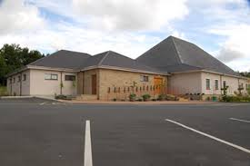

**St. Vincent’s Church**

**5) The Curriculum**

Curriculum for Excellence is the name given to the curriculum in Scotland for all children and young people aged 3-18. It is a forward; looking, coherent, more flexible and enriched curriculum that provides young people with the knowledge, skills and attributes them will need if they are to flourish in life, learning and work, now and in the future.

The curriculum includes all of the experiences that are planned for children and young people to support the development of their skills, wherever they are being educated, for example in the family and community, pre-school centre, nursery and school. This broad, general education will allow them to become successful learners, confident individuals, responsible citizens and effective contributors to life in the 21st century.

In taking this forward our school will work closely with South Lanarkshire Education Resources and other services to enable Curriculum for Excellence to be fully embedded, ensuring the best possible education for all children and young people. We wish you to feel confident that your child is encouraged and supported to develop their literacy, numeracy and other skills whilst they attend our school. The curriculum areas are as follows:

* Expressive arts
* Languages and literacy
* Health and wellbeing
* Mathematics and numeracy
* Religious and moral education
* Science
* Social studies
* Technologies

If you want to know more about Curriculum for Excellence, please visit website <http://www.educationscotland.gov.uk/thecurriculum/> or [www.parentzonescotland.gov.uk](http://www.parentzonescotland.gov.uk/).

Our learning and teaching activities are based on the outcomes and experiences in the guidelines that all schools have for Curriculum for Excellence.

**Level Stage**

Early The pre-school years and Primary 1 or later for some.

First To the end of Primary 4, but earlier or later for some.

Second To the end of Primary 7, but earlier or later for some.

The curriculum in Saint Vincent’s Primary is built around the four contexts for learning which are: the curricular areas named above, school ethos, interdisciplinary learning, (IDL) personal achievement and school ethos.

The curriculum addresses the following design principles: challenge, breadth, progression, depth, personalisation and choice, coherence and relevance.

Parents are regularly informed about their child’s learning and in addition to open evenings, parent’s nights, learning journeys, curriculum workshops, parents also receive regular updates on school improvement priorities at Parent Council meetings where the children give presentations on their learning.

Throughout the school children are given opportunities to use their skills of numeracy and literacy across the curriculum to apply their learning in real life situations and during events such as Enterprise and Financial Education Week. The promotion of reading for enjoyment is actively encouraged with regular access to the school library, book fair, World Book day and library visits.

**Literacy and English Language**

The Literacy and English Language Programme is based on Curriculum for Excellence outcomes and experiences which aim to enhance pupils’ knowledge and understanding of the English Language and encourage the development of literacy skills across learning. Using materials and resources which are appropriate to the child’s age and ability, we aim to provide a range of different reading experiences to help all our children to read fluently, accurately and with understanding and to transfer this skill to include reading in all other areas of the curriculum .

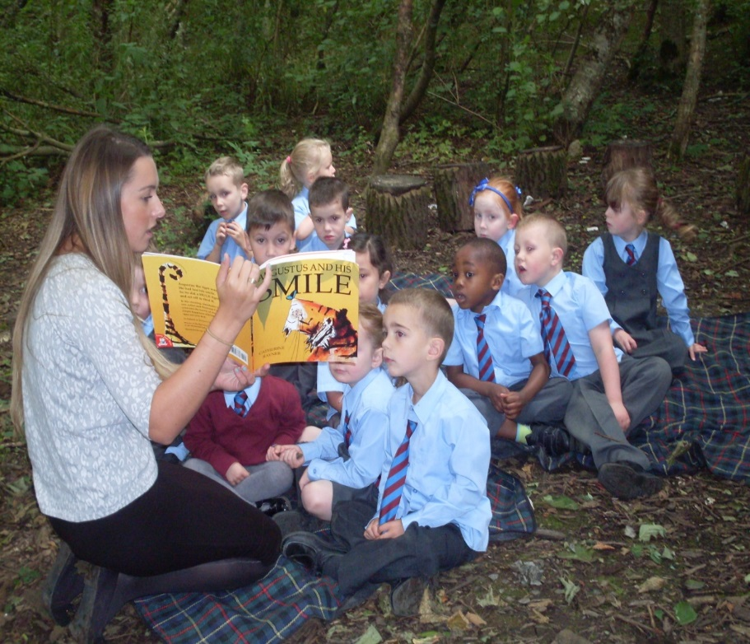

### Reading



In Saint Vincent’s Primary School we aim to foster a love of reading in all our pupils, developing progressive language using the following key resources: Oxford Reading Tree, Jolly Phonics, Jolly Grammar and Spelling, and Big Writing (VCOP) and a wide selection of novels.

The reading programme is further supported by the use of: “Big Books”, Literacy Circles, Reading Strategies, Literacy Boxes and a wide range of reference materials which link to cross curricular topics and build on the children’s interests.

The teaching of reading is planned using motivating and stimulating resources to meet the needs of individual learners and groups with differing abilities and aptitudes, ensuring that all children receive appropriate support and challenge. In addition to using core resources, teachers also use a cross curricular approach linking lessons to real life contexts. Children are encouraged to develop the skills of reading to learn as well as learning to read and to develop skills in critical literacy.

Class library corners stock a range of suitable reading materials and are supplemented by an extensive selection of books which are available for lending from the school library. Parent volunteers support reading development through the ‘Scotland Reads Project’ and the Infant Story Sacks Initiative.

**Writing**



The Writing Programme builds upon the children’s reading and literacy experiences by continuing to develop opportunities for enjoyment and choice in writing. It aims to equip children with the necessary tools for writing and creating texts in a wide variety of contexts and encourages pupils to organise and use information for specific purposes. The programme provides learning experiences which aim to develop skills in: personal writing, imaginative writing, functional writing and writer’s craft. Personal writing includes personal: stories, accounts, reports, letters, and poems. Imaginative writing covers imaginative: stories, accounts, letters, poems and responses to text. Functional writing focuses on functional: letters, news articles, instructions, leaflets, posters and reports. Writer’s craft requires the children to continue and extend texts using the writer’s style and language. The stimulus for many writing experiences is often provided by class topic work or current global issues. Staged approaches to the teaching of writing include: children expressing their ideas and thoughts through drawing, teacher scribe (teacher role model), emerging writing “have a go” strategy and independent writing.

The school uses the VCOP Method for promoting improving standards in writing from Primary 2 to 7. This method encourages the use of: wow **v**ocabulary, interesting **c**onnectives, powerful **o**peners and accurate **p**unctuation. The programme is enhanced by the use of: Moving Image Education, Games Based Technology and ICT resources.

In addition to the development of writing composition skills, pupils work progressively through: spelling, grammar and handwriting programmes which aim to develop secretarial skills. These programmes are supported by: St. Andrew’s and St. Bride’s Associated Schools Group Active Grammar planners, Nelson resources and Jolly Phonics materials.

**Listening and Talking**

[](http://www.google.co.uk/imgres?q=listening+and+talking&start=114&safe=active&sa=X&hl=en&biw=1024&bih=571&tbm=isch&tbnid=stxdIgEZebaWUM:&imgrefurl=http://www.brainboxx.co.uk/a3_aspects/pages/thinkingtalk.htm&docid=-PbY8rRmYoz37M&imgurl=http://www.brainboxx.co.uk/a3_aspects/images2/TALKpartners2.gif&w=556&h=556&ei=G2SwUsPUGtPX7AaI-IFw&zoom=1&iact=hc&vpx=94&vpy=210&dur=219&hovh=225&hovw=225&tx=140&ty=192&page=7&tbnh=142&tbnw=147&ndsp=20&ved=1t:429,r:20,s:100,i:64)

Listening and talking activities are central to learning across the curriculum and are closely linked to the school Reading and Writing Programmes. Using a variety of strategies children gain confidence and develop the ability to take turns and listen, with respect, to the opinions of others and to use their listening and talking skills to successfully fulfil personal roles and responsibilities within the school. For example, younger children will have the opportunity to develop skills by sharing experiences and taking messages and older pupils will discuss different extracts of written work, share opinions with others and take part in interviews and debates. school assemblies, pupil Council meetings and presentations. Responsive activities provide forums to assist pupils with learning to listen in order to: extract information, respond to information and appreciate the opinions, feelings and arguments of others.

**Modern Languages in the Primary School**

[](http://www.google.co.uk/imgres?q=i+speak+french&safe=active&hl=en&biw=1024&bih=571&tbm=isch&tbnid=AnHw29baCK4t3M:&imgrefurl=http://www.verbekefrench.com/category/french-lessons-2/&docid=B2L43KaOFHRMRM&imgurl=http://www.verbekefrench.com/wp-content/uploads/2012/11/bonjour.gif&w=840&h=751&ei=eGSwUuWwEYrDhAe5lIDABA&zoom=1&iact=hc&vpx=541&vpy=94&dur=1735&hovh=212&hovw=237&tx=116&ty=112&page=2&tbnh=158&tbnw=177&start=18&ndsp=25&ved=1t:429,r:34,s:0,i:192)

Pupils from P1-P7 study French as part of the Modern Language Programme with Spanish now being introduced throughout the school. The children enjoy many speaking activities based on everyday situations, singing French songs and use vocabulary daily in class. This is an excellent foundation for the curriculum they will meet in St Andrew’s and St Bride’s High School.

**Numeracy and Mathematics**

**[](http://www.google.co.uk/imgres?q=numeracy+and+maths&start=183&safe=active&hl=en&biw=1024&bih=571&tbm=isch&tbnid=eW9HMAMsLlUSJM:&imgrefurl=http://www.pontybreninprimary.com/Pages/NumeracyZone.aspx&docid=YgOsjxYEHvbHfM&imgurl=http://www.pontybreninprimary.com/siteimages/maths.jpg&w=640&h=537&ei=xWSwUs_CCtOUhQeu0YGYCg&zoom=1&iact=rc&dur=438&page=11&tbnh=148&tbnw=176&ndsp=22&ved=1t:429,r:99,s:100,i:301&tx=85&ty=52)**

The Numeracy and Mathematics Programme is based on Curriculum for Excellence experiences and outcomes. The programme is supported by Tee Jay, Number Connections, Scottish Heinemann, Big Maths and St. Andrew’s and St Bride’s Associated Schools Group Active Mathematics resources. The programme promotes the creation of key links with Information Communication Technology resources including, for example: RM Graph, Microsoft Excel, and My World 3 and internet games facilities. School enterprise activities provide meaningful opportunities for pupils to demonstrate their growing mathematical skills and abilities. Primary 7 pupils are given the opportunity to participate in a University Mathematics Challenge Competition. All pupils are encouraged to improve their mental agility through challenging daily activities.

**Numeracy**

Numeracy development focuses on encouraging the growth of pupil confidence in working efficiently with numbers and number processes. Essential Skills in mathematics are practised and basic facts mastered.

The programme aims to enable pupils to: solve mathematical problems, interpret data accurately, make informed decisions and recognise the impact of numbers in everyday life.

Pupils are provided with opportunities to develop their knowledge and skills in: estimating and round numbers; recognising and manipulating numbers and number processes; calculating fractions, decimal fractions and percentages; using money, time and measurement in life contexts; interpreting and analysing data and communicating ideas relating to probability.

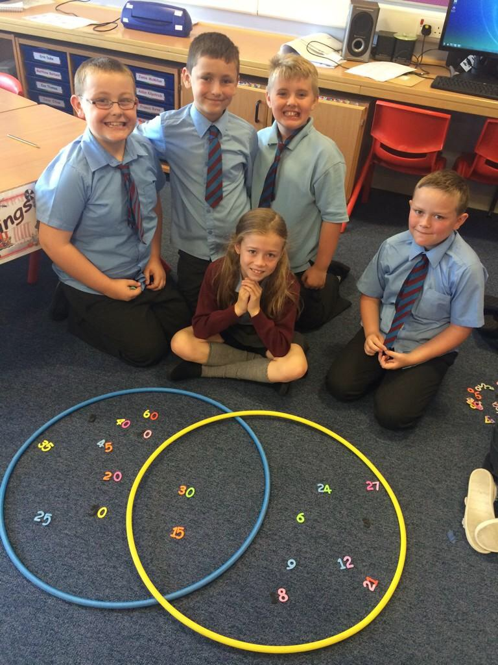

**Mathematics**

Mathematics progression highlights the importance of pupils using mathematical knowledge to enhance their understanding of the world and their environment. T he Mathematics division of the programme bases learning on: number, money and measure; shape, position and movement and information handling. Sub topics include: estimating and rounding; number and number process; multiples, factors, and prime numbers; powers and roots; fractions, decimal fractions and percentages; money, time, measurement; understanding the impact of Mathematics on the world, past, present and future; patterns and relationships, expressions and equations; properties of 2D shapes and 3D objects; angle, symmetry and transformation; data analysis; ideas of chance and uncertainty and problem solving.

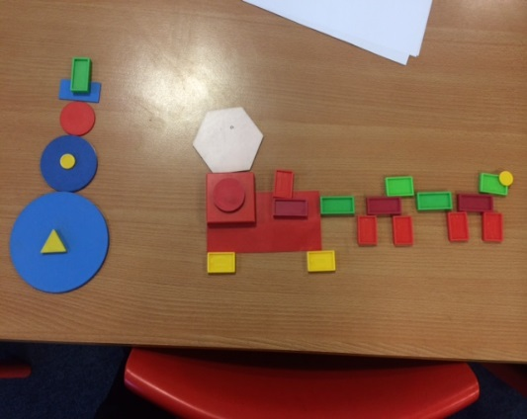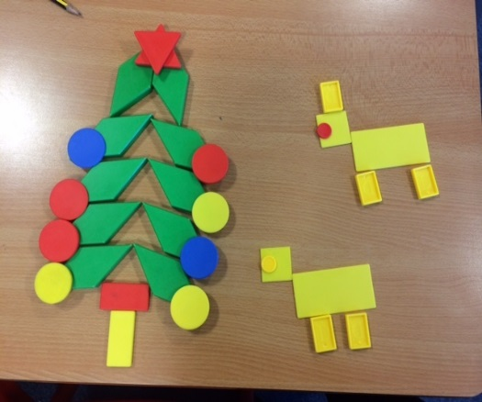

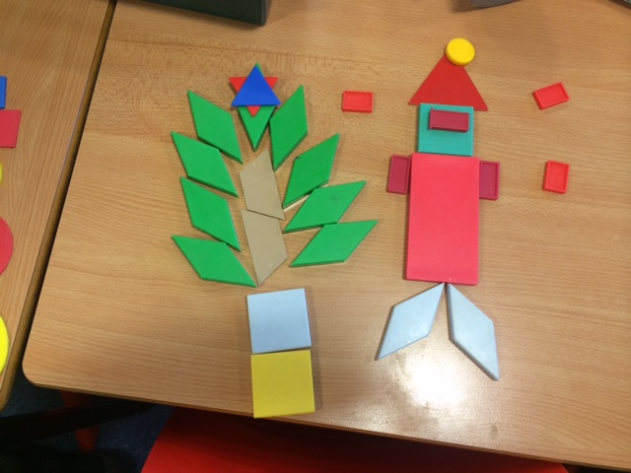

**Health and Wellbeing**

In Saint Vincent’s Primary School through our Health and Wellbeing Curriculum we aim to promote confidence, independent thinking and positive attitudes to health. It is the responsibility of every teacher to contribute to learning and development in this area. Using a whole school approach we work in partnership with other agencies and promote health and well being as an integral part of the school curriculum, supported by Health days and regular opportunities for our pupils to have their say through the Health Committee.

Our staff plan the Health Curriculum encompassing the Experiences and Outcomes of Curriculum for Excellence, taking account of the strands for Health & Wellbeing:-

1. Mental, Emotional, Social and Physical Wellbeing

2. Planning for choices and changes

3. Physical Education

4. Food and health

5. Substance misuse

6. Relationships, sexual health and parenthood

The **Relationships, sexual health and parenthood** strand of Health Education is taught through the **Education for Love Programme** in which we help our pupils to develop an understanding of how to maintain positive relationships with a variety of people and be aware of how thoughts, feelings, attitudes, values and beliefs can influence decisions about relationships, and sexual health. They develop their understanding of the complex roles and responsibilities of being a parent or carer

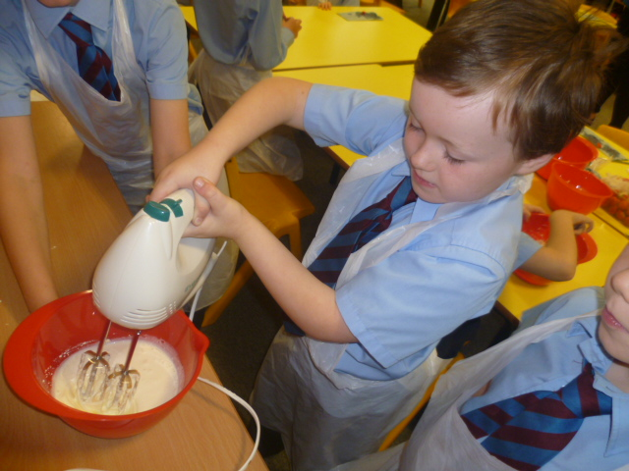

Scottish Food Day – Making Cranachan

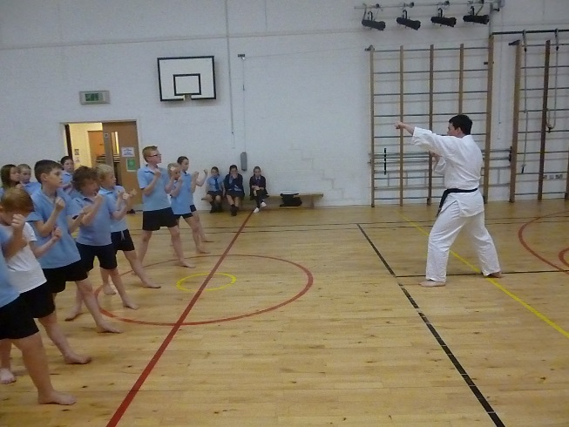

Specialist Ju-Jitsu classes

**Physical Education**

Children enjoy 2 hours of PE each week, learning ball skills, games skills, body awareness and dance. The programme is further enhanced by the opportunity to take part in team sports such as football, rugby, netball and athletics. At Christmas time the children enjoy social dancing for their class parties.

**Our Social studies programme** is organised in three categories: and staff use a range of cross curricular and interdisciplinary approaches to help the pupils engage with the learning in a meaningful and stimulating manner. The three stands of the social studies curriculum are as follows:

**People, past events and societies**

An area we might previously have thought of as History. It will use an inter- disciplinary approach to investigate events or cultures from the past, how we can learn from them and how they have influenced our modern world.

**People, place and environment**

Similarly, previously this would have come under the ‘Geography’ umbrella. Again, using an interdisciplinary approach, we will investigate the events that have shaped our landscape, how trade has helped our island community interact with the wider world and how events shape how and where we live.

**People in society, economy and business**

This area addresses social issues and how we can live successfully as a society learning from different models and developing an understanding for a shared responsibility towards those in our society.

Throughout the Social Subjects programmes there is an emphasis on developing a set of skills which will allow pupils to make choices based on investigating, evaluating, comparing and contrasting evidence from different sources and using it to develop a personal view while being open to the views of others. It may also offer opportunities to go on educational visits to look at first hand evidence of events, people in the past or society in action.

**Sciences**



Through our topics, the children will investigate the key features or ‘strands”‘, which are:

Planet Earth

Forces, Electricity and Waves.

Biological systems

Materials

Topical science

In investigating these areas which may be delivered as a stand alone series of lessons or as part of a topic, pupils will develop Inquiry and Investigative skills and Scientific Analytical Thinking skills.

In Saint Vincent’s Primary we aim to ensure that all our pupils’ experience enjoyable, challenging and meaningful learning and their experience of learning Science is enhanced by visits to the Science Centre, Stargazing evenings Science/Space weeks which include visits from Generation Science and other agencies.

As finalists and now prize-winners in the Rolls Royce Science prize, our pupils are benefitting from exceptional opportunities to engage with astronomy and develop their interest in space.

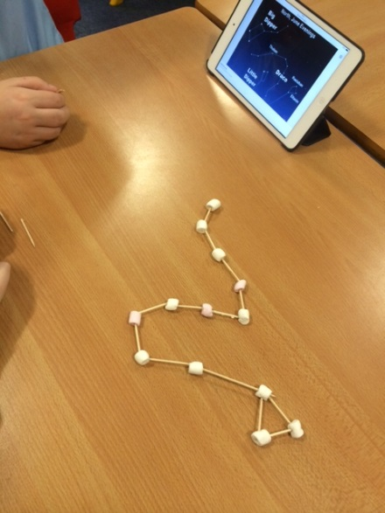

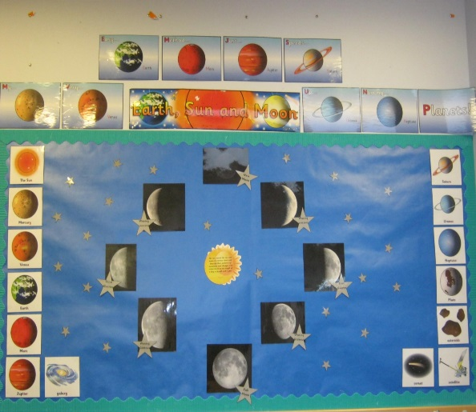

Researching and making star constellations

In a wide variety of science experiences we present our pupils with opportunities to:

• develop curiosity and understanding of the environment and their place in the living, material and physical world

• demonstrate a secure knowledge and understanding of the big ideas and concepts of the sciences

• develop skills for learning, life and work

• develop the skills of scientific inquiry and investigation using practical techniques

• develop skills in the accurate use of scientific language, formulae and equations

• apply safety measures and take necessary action to control risk and hazards

• recognise the impact the sciences make on their life, the lives of others, the environment and on society

• recognise the role of creativity and inventiveness in the development of the sciences

• develop an understanding of the Earth’s resources and the need for responsible use of them

• express opinions and make decisions on social, moral, ethical, economic and environmental issues based upon sound understanding

• develop as a scientifically-literate citizen with a lifelong interest in the sciences

• establish the foundation for more advanced learning and future careers in the sciences and the technologies.

**Technologies**

Through the Technologies Curriculum pupils have opportunities to develop skills in ICT, Problem Solving, Creativity and Innovation and also are encouraged to use their ICT skills in all areas of learning. Saint Vincent’s Primary benefits from a computer suite and almost all of our classrooms have interactive Touch Screen technology and the school has also invested in iPad to facilitate children’s learning.

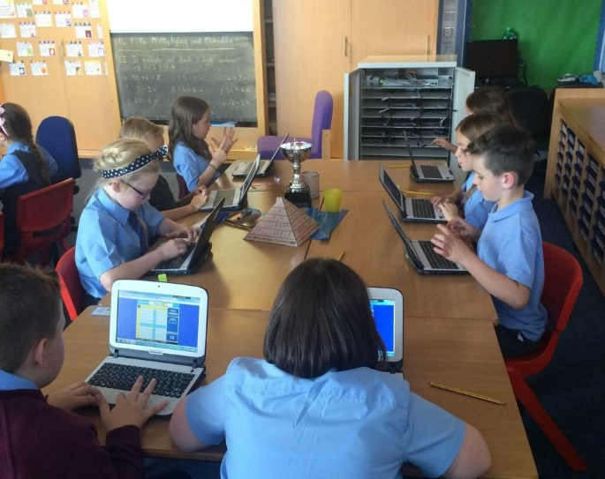

### Expressive Arts



In Saint Vincent’s Primary School Expressive Arts plays an important role in the education of all pupils. Through the Expressive Arts programmes we aim to foster imagination and creativity, develop practical and perceptual skills and promote intellectual and aesthetic development. Expressive Arts promote distinctive ways of understanding self, developing individual abilities and finding personal satisfaction and enjoyment.

All aspects of learning in Expressive Arts include opportunities to present and perform, for example through preparation of artwork for display, presentation of a short improvised drama to members of the class or performance of dance or music to parents or in the community. Our pupils experience a wide variety of activities which help build their confidence in performance and participation as well as developing particular skills. We are looking forward to staging our first P6/7 Cantata and also working with Pop UK as part of our link with Westwood hill church during Lent 2017.

### Art and Design

The children are involved in a progressive programme, investigating different materials, techniques and media. Some work may also come from the topic or using a variety of materials during Christmas activities.

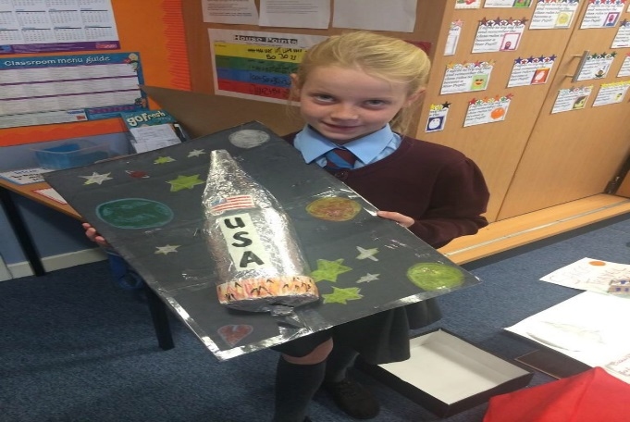

### Music

### This year we introduced a new programme to stimulate interest and active participation in music. A number of children have the opportunity to learn to play a musical instrument and also to take part in our school choir. Children enjoy rhythm, identify beat and musical patterns, sing songs old and new, and accompany themselves using an assortment of musical instruments and lots more! The programme is very much a “hands on” approach, the children building up their musical skills in a progressive way. South Lanarkshire Council’s music initiatives have benefited the school in that we have a visiting music specialist for a term in Primary 5.

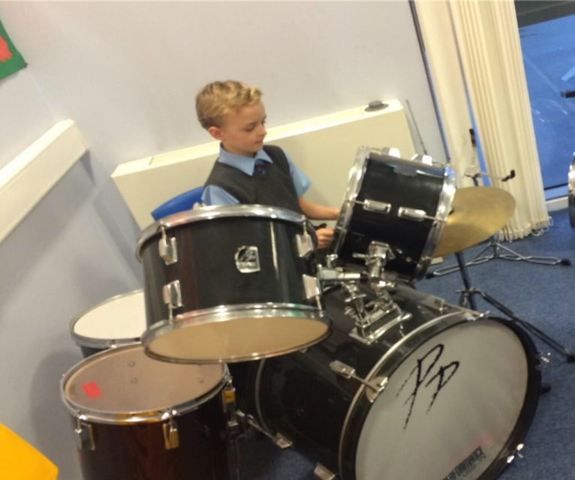

**Dance**

The children will follow a programme of dance both traditional and interpretative as part of their curricular activities or as part of a topic.

### Drama

Guidelines again develop skills progressively. There are also many opportunities for drama during infant Active Learning situations and topic work, for example, going to the hospital during a health topic, courtroom scenes in Bruce’s Scotland, or showing how we help others during RE activities. Children can further consolidate language skills too, especially talking and listening.

There are many opportunities for children to ‘perform’ whether through assemblies, our Nativity/Carol Concert or School Shows.

**Religious Education**



The religious education in our school is based on “This is Our Faith”, a document which has been designed to provide guidance on the experiences and outcomes of Catholic Religious Education and guide teachers in shaping the learning of young people in Religious Education. The document offers a programme based on scripture and tradition. This is Our Faith encourages the awareness, knowledge of and progression in sacramental development at all stages of the primary school. This is Our Faith encourages teachers to divide the school year into the pastoral calendar year and as such offers a range of learning opportunities which coincide with events in the church. With a greater emphasis placed on scripture, we can also explore the different religious views at Jesus’ time and relate this to Other World Religions. As mentioned previously we have children in the school who are not Catholic and so it remains of utmost importance to address other religions in conjunction with the Catholic faith.

As a Roman Catholic school, Religious and Moral Education and Religious Observance play an essential part in the education of our children. Our work in this area is carried out in close partnership with Saint Vincent’s Parish Priest, Father Ivan Boyle, who visits the school regularly and provides a monthly school mass in which the children are totally involved. They participate in Readings, Prayers, Offertory Procession and Singing.

The staff also work closely with the Parish Priest in the preparation of our children for the Sacraments and other religious events. The school is very involved in the life of Saint Vincent’s Parish.

The Religious Education programme consists of the following:

* + Roman Catholic Religious Education experiences and outcomes in Curriculum for Excellence.
  + Regular church celebrations throughout the school year. Each class takes
  + Responsibility for preparing the masses throughout the year.
  + Class Mass celebrations for every class in the school over the course of the year.
  + Observance of the Sacrament of Reconciliation throughout the year.
  + Preparations of the Sacraments of Reconciliation, First Holy Communion and
  + Confirmation.
  + Regular hymn singing with carols at Christmas.

In responding to that aspect of our programme which addresses Moral Education, we deliver the Diocese’s programme of ‘God’s Loving Plan’ which progressively develops children’s awareness of moral issues and responsibilities. Parents are encouraged to be involved in the programme.

In addition to a number of class initiatives to help others, we support a charity called Mothers’ Care as a whole school and each class has once again demonstrated impressive enterprising skills by sponsoring a child in India using money they have generated in class activities. The school won a prestigious Social Enterprise Award in recognition of outstanding work in this area.

**Personal and Social Development**

**[](http://www.google.co.uk/imgres?q=personal+and+social+development&safe=active&hl=en&biw=1024&bih=571&tbm=isch&tbnid=s78ew6BD_47zsM:&imgrefurl=http://3diassociates.wordpress.com/2012/11/26/holistic-personal-and-social-development/&docid=ItZMejREmivBwM&imgurl=http://3diassociates.files.wordpress.com/2012/11/ecm.gif?w%3D640&w=618&h=258&ei=WWawUvrxK4fwhQe17oHoAw&zoom=1&iact=hc&vpx=94&vpy=284&dur=406&hovh=145&hovw=348&tx=191&ty=97&page=1&tbnh=105&tbnw=252&start=0&ndsp=15&ved=1t:429,r:11,s:0,i:116)**

A comprehensive programme to help develop citizenship skills through ‘Circle Time’, Drugs Education, Education and the Law, Anti-sectarianism, Anti- racism as well as issues such as personal safety, internet safety and anti bullying approaches are planned for and developed throughout the school.

**Homework**



Our Homework Policy is based on consultation with parents and is reviewed regularly and is currently under review. A copy of the revised policy will be available from the school office. Children have a homework diary in which they are encouraged to record homework activities. The diary can also be used as a means of communication between parents and the school. To reinforce work being done in school many homework tasks actively encourage children to apply their learning in a practical situation. eg. children are encouraged in the early stages to sort the cutlery at home, to lay the table, to fetch 4 apples etc. – these being early maths activities. Parents are asked to read at home with their child and most importantly, to join the local library. Reading ambassadors are appointed in each class and together we foster a love of books and develop a positive attitude towards them by giving reading a high priority both at home and in school. Homework may also be in the form of completing work started at school or revising something already taught; children may be also involved in carrying out “research”, or engaging their parents and friends in questions for RE or topic tasks. Homework can be based in any curricular area and there should be a balance of activities throughout the week. Pupils are encouraged to be responsible for managing their own homework and teachers allow flexibility within the week so that homework may be managed to suit a family schedule. The school encourages the use of homework bags or folders.

Homework will be given 3-4 times per week and should last from 5 to 30 minutes per day depending on the age of the child. However, topic work, for example a visit to the library, collecting information at the local shops etc may involve time at the weekend. Parents are encouraged to contact school if problems arise or if they wish to discuss any area of their child’s homework.

Spiritual, social, moral and cultural values (religious observance)

**Rights of Parents / Carers**

Scottish Government Ministers consider that religious observance complements religious education and is an important contribution to pupils’ development. It should also have a role in promoting the ethos of a school by bringing pupils together and creating a sense of community.

There is a statutory provision for parents to withdraw children from participation in religious observance. This right of parents’ wishes will be respected.

Where a child is withdrawn from religious observance, schools will make suitable arrangements for the child to participate in a worthwhile alternative activity.

**Equalities**

Integral to this guidance is the principle of mutual respect. The diversity of belief and tradition provides an ideal context in which pupils can learn about, and so learn from, what is important in the lives of themselves and others. South Lanarkshire’s guidance recognises and welcomes diversity and promotes respectful understanding.

**Parents may request that their children be permitted to be absent in order to celebrate recognised religious events. Advance notice should be provided to the school when children will be absent. Appropriate requests will be granted and the pupil noted as an authorised absentee in the register.**

MC900048042[1]

**Equal Opportunities and Social Justice**



South Lanarkshire has an Equal Opportunities Policy which is operated fully within St Vincent’s. All our pupils, irrespective of gender, race or religious belief, are encouraged to participate in the wide range of activities offered both during and after school. All staff actively promote equal opportunities. Parents are invited to raise any issues of interest or concern with Mrs Tompkins.

# Reporting of Racist Incidents

1. Schools take seriously any reported racist incidents. Within the school’s approach to promoting positive discipline a record of all racist incidents is maintained and each incident fully investigated.

Schools are required to notify the local authority of any racist incident.

Equality and Diversity Impact Assessment

(ii)  Schools and education establishments have a legislative duty to undertake an assessment of equality and diversity. This is the process of systematically assessing and consulting on the effects that a policy, process or strategy is likely to have on different groups in the community who might experience disadvantage/barriers in accessing services. The process includes monitoring the actual effects of the policy once it is put into practice. Policies do not affect everyone in the same way. By assessing in the early stages, any adverse impact can be identified and minimised.

**6) Assessment**



Assessment is an integral part of learning and teaching. It helps to provide a picture of a child’s progress and achievements and to identify next steps in learning. In Saint Vincent’s we aim to challenge each pupil as an individual, developing strengths and supporting any area of need. Teachers discuss, clarify and share learning intentions and success criteria with pupils and plan appropriate learning experiences to achieve these. In this planning cycle we focus on what, when and how we will assess. There is continuous assessment of children’s work carried out in a variety of ways through teacher observation, thoughtful questioning, careful listening, correction/ evaluation of individual pieces of work, reflective responses and effective feedback. Evidence of assessment can be found in what a pupil writes, says, makes or does. These different types of assessment provide evidence upon which a teacher will base professional judgements. The teacher will assess the level at which a child is performing and an appropriate programme of work can then be decided upon. Children are encouraged to evaluate their own and their classmates work against set criteria through a self and peer assessment approach. As they develop skills in self and peer assessment, learners will build confidence and take more ownership for managing their own learning.

**7) Reporting**



Reporting will be ongoing and comprise of a range of activities which can include children presenting their learning, newsletters, and ongoing oral discussions.

We will provide parents with reports so that you can see what your child is doing and how they are progressing. In addition, there will be parents’ meetings which offer you the opportunity to discuss how your child’s progressing and how you can contact the school if you wish further information. The school will offer you an appointment time so that you can visit in person to discuss your child’s education.

Our ‘pupil reports’ will help you to get to know more about the curriculum which each child follows and will describe their strengths, achievements and areas for development so you know what encouragement and support you can give.

We welcome any comments or additional information from parents to help us provide the best possible education for your child.

St Vincent’s Primary school recognises that good teamwork among parents, children and schools is the key to a successful education for your child. Reporting will be ongoing and comprise of a range of activities which can include children presenting their learning, newsletters, and ongoing oral discussions. We will provide parents with reports so that you can see what your child is doing and how they are progressing. In addition, there will be parents’ meetings which offer you the opportunity to discuss how your child is doing in school and you can contact the school at anytime with any matter that you wish to raise. Our style of ‘pupil reports’ will help you to get to know more about the curriculum which each child follows and will describe strengths, achievements and areas for development and let you know how you can help.

We welcome any comments or additional information from parents to help us provide the best possible education for your child.



**8) Transitions**

Pupils normally transfer from primary to secondary school between the ages of 11½ and 12½, so that they will have the opportunity to complete at least 4 years of secondary education. Arrangements are made by the school to transfer children to the associated secondary school as determined by their home address. Parents of P7 children will be informed of the transfer arrangements made for their child to attend secondary school.

We will also provide you with information at this time and on events designed to let P7 children visit the secondary school, meet up with other P7 children from other schools so that the transition period is as smooth as possible.

Normally children attend the school in their catchment area. However, there are times when parents may wish their children to go to other schools. If you wish your child to go to another school then you may make what is known as a ‘placing request’. If you live in South Lanarkshire and decide to submit a ‘placing request’, we are unable to reserve a place in your local school until the Council have made a decision on the ‘placing request’. Please note if your ‘placing request’ application is unsuccessful and all places at your catchment school are filled you will be offered a place at the next nearest appropriate South Lanarkshire School.

Please note that if an application for a ‘placing request’ is successful then school transport is not provided.

If you move outwith your catchment primary school a ‘request to remain form’ must be completed. If you move outwith your catchment primary, this may affect your right to transfer to the associated Secondary School. Please note the secondary school is determined by the pupil’s permanent home address and chosen denomination. If you require further information, please contact Education Support Services on 0303 123 1023.

We belong to St Andrew’s and St Bride’s learning community. A programme is agreed upon to decide when visits may take place. There is an “Open evening” early in the year and our children also visit the high school in the summer term.

**If you require further information, please contact Education Support Services on**

0303 123 1023.

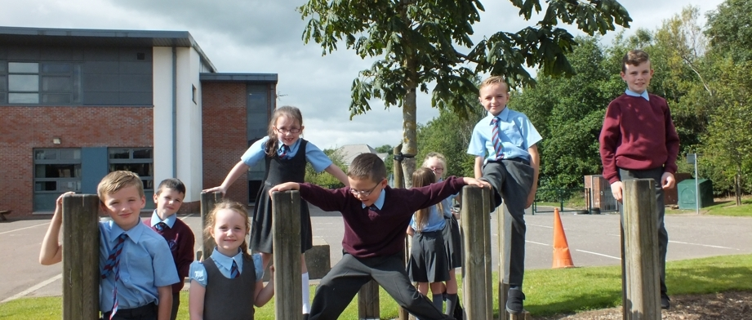**9) Support for Pupils**

[](http://www.girfecinlanarkshire.co.uk/)

**Getting it right for Every Child**

**Agreed script to describe the role of the named person in schools**

Getting it Right for Every Child (GIRFEC) was promoted and endorsed by the Scottish Government at the Children’s Summit in 2010. There is a commitment to ensure that your child has the best possible start in life and to improve outcomes for children and families based on a shared understanding of their wellbeing.

Most children make their journey from birth to the world of work supported by family and the universal services of Health and Education. The Named Person in education helps to make sure that the child’s wellbeing is developing. The school will let you know the named person for your child. This is likely to be the head teacher in a primary school and the pupil support teacher in a secondary. If you have any concerns you should speak to the Named Person who will work with you to address any issues and to ensure that your child gets any help needed at the right time.

**More information can be found on:**

[**www.girfecinlanarkshire.co.uk**](http://www.girfecinlanarkshire.co.uk) **and** [**www.scotland.gov.uk/gettingitright**](http://www.scotland.gov.uk/gettingitright)

In Saint Vincent’s Primary we place considerable emphasis on the pastoral care of all our pupils and our work with vulnerable families, and pupils who experience challenging behaviour is a particular strength of our school.

The GIRFEC agenda is encompassed within our school vision and the ethos and values of our school which promote friendship, fairness, kindness, resilience and respect. Our school prides itself on our welcoming, open door policy and through regular and prompt communication we aim to address any issues that arise which may impact on a child’s learning or wellbeing.

Enquire is funded by the Scottish Government to provide information on the framework for supporting children who require additional support for learning and to encourage positive partnerships between families, schools and local authorities to ensure children get the right support.

Enquire – the Scottish advice service for additional support for learning

Enquire offers independent, confidential advice and information on additional support for learning through:

Phone Helpline: 0345 123 2303

Address : Enquire

Children in Scotland

Rosebery House

9 Haymarket Terrace

Edinburgh

EH12 5EZ

Email Enquiry service: [info@enquire.org.uk](mailto:info@enquire.org.uk)

Advice and information is also available at [www.enquire.org.uk](http://www.enquire.org.uk)

Enquire provides a range of clear and easy-to-read guides and fact sheets including The parents’ guide to additional support for learning.

If you would like to order our leaflets, postcards or guides to share with parents and carers of pupils in your school, please contact us on [info@enquire.org.uk](mailto:info@enquire.org.uk)

**10) Support for All (Additional Support Needs)**

We in St Vincent's Primary are very aware of the fact that all children have needs but by “special educational needs” we mean any area in the child’s learning where extra support is needed. This is in line with the authority’s policy “Inclusion and Support for Learning;” it could mean extension work for children to challenge them or support for a child or group requiring to consolidate their skills or who need that little bit of extra support. A child may require support for a short time in a particular area, or an extended period throughout their school career. Support may be given on an individual, group or whole class basis.

Our school policy is familiar to, and given a very high priority by, all members of staff. The Head Teacher and Depute consult regularly with Class and Specialist Support teachers. We work closely with our designated Educational Psychologist, the extended Learning Community Team, Speech and Language Therapists and Behaviour Support Staff as required.

Support is also provided when necessary to children with English as an additional language. Children with support needs are identified at an early stage in line with our Early Intervention policy and support is offered where necessary. This support will obviously depend on the need of the child, and may be on an individual basis or within a group situation, but will always include:

* consultation between class teacher and Head Teacher/Depute to determine “targets”

• consultation with parents at the outset of the programme

• regular meetings involving teachers, DHT, HT and Specialist Support teacher

• report on progress to parents

• monitoring, observing and assessing – even when the child has achieved the set targets

• parents are consulted at all times, and invited to discuss their child’s progress regularly

• the Head Teacher is closely involved at all stages.

South Lanarkshire Education Resources have published a series of leaflets available which cover information for parents and carers about the Additional Support for Learning Acts. These are available through the school or on the South Lanarkshire Council website [www.southlanarkshire.gov.uk](http://www.southlanarkshire.gov.uk/).

The leaflets available are:

The Additional Support for Learning Act

Requesting an Assessment

Planning for Learning – ASP

Planning for Learning – CSP

Transitions

Future Planning

Information for Parents and Carers about moving on from school

Inclusive Education

ICT Assessment

Visual Impairment Support

Early Years Specialist Support

Independent Adjudication

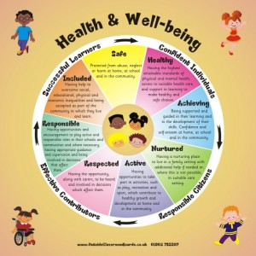

[](http://www.google.co.uk/imgres?q=school+improvement&safe=active&hl=en&biw=1024&bih=571&tbm=isch&tbnid=KpjRnxKvOrXSHM:&imgrefurl=http://lsc.k12.in.schoolfusion.us/modules/cms/pages.phtml?pageid%3D240697%26SID&docid=rq6vJ-oMahuAnM&imgurl=http://lsc.k12.in.schoolfusion.us/modules/groups/homepagefiles/cms/2273452/Image/school%20improvement%20plan.jpg&w=264&h=192&ei=XHSwUomYMc-ThQfew4HwCA&zoom=1&iact=hc&vpx=161&vpy=169&dur=63&hovh=153&hovw=211&tx=86&ty=88&page=2&tbnh=120&tbnw=160&start=16&ndsp=23&ved=1t:429,r:17,s:0,i:134)11) School Improvement

As a school community we are committed to continuous improvement. Our school improvement plan is designed to make definite improvements in teaching and learning. We have raised attainment with an emphasis on pace and challenge, improved motivation and enjoyment for our learners and continue to foster a sense of collegiality.

In recent years significant progress has been made in Literacy, Science, Mathematics, Health and Wellbeing and Outdoor Learning through planning new learning experiences with new resources and revised planning formats. Learning activities are matched to the needs of learners and groups with different abilities by adapting and differentiating resources, tasks and activities to provide support and challenge. There has been attention to widening range of experiential learning opportunities to motivate and stimulate learning- including interdisciplinary learning, enterprise, maths days, active/health days and outdoor learning opportunities.

Staff are involved in taking forward the priorities in the School Improvement Plan as members of working parties and also as subject co-ordinators. Progress is monitored and continues to be evaluated. Evidence of distributed leadership is seen in the number of class teachers who co-ordinate different events to support improvement and take forward initiatives such as Literacy , Enterprise, Outdoor Learning, Science, Eco, Health and Well Being .

A quality assurance programme of class visits, discussions with pupils, parent/pupil surveys, monitoring of forward plans all combine to provide evidence of challenge and progress in all classes. All children are encouraged to learn in a variety of ways with opportunities provided for pupils to work independently, in pairs and in groups. Pupils are actively involved in their learning and act on feedback from their teachers and peers to make improvements in their learning.

The introduction of active reading strategies and higher order questioning skills throughout the school has increased pupil’s involvement in managing their learning especially in reading. All classes have worked to increase personalisation and choice especially in inter-disciplinary learning. Many new projects using a multi-disciplinary and responsive planning format have been hugely popular with pupils and have resulted in excellent work in a variety of curricular areas. ‘Big Writing’ is used by all classes and there is evidence of a positive and sustained impact on pupils’ writing. During last session all classes engaged in developing our interdisciplinary learning and our Literacy programme. This school year our focus is on incorporating moving image education into our Literacy programmes and further developing creativity through interdisciplinary learning. We are also aiming to further develop our curriculum and assessment procedures and continue to build our school community as a community of faith working in partnership with our local parish and the wider community.

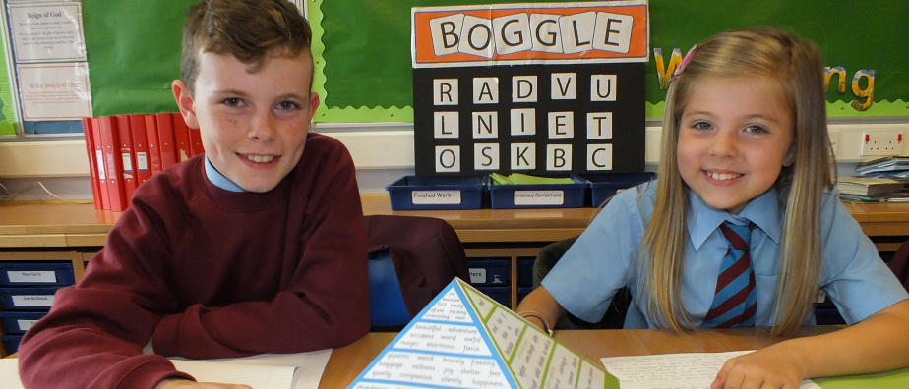**12) School policies and practical information**

**Free school meals**

Children of parents who receive the following benefits are entitled to a free lunchtime meal for their child

* Income Support, Income-based Job Seeker’s Allowance, Employment and Support Allowance (income related), Working Tax Credit and Child Tax Credit(where your income does not exceed £6,420 gross per annum as assessed by the HM Revenues and Customs) , Child Tax Credit only (where your income does not exceed £16,105 gross per annum as assessed by the HM Revenues and Customs)or receive support under PartV1 of the Immigration and Asylum Act 1999.

We would encourage parents of children who are in receipt of any of the above benefits to take up this opportunity of having a meal provided for their child when they are at school. Arrangements are in place so that children who receive free meals are not singled out and we encourage all children to remain in school at lunch time.

Healthy eating is something that the school supports and a range of meals are available at lunchtimes that meet the Schools (Health Promotion and Nutrition)(Scotland) Act 2007 and the Nutrient Requirements for Food and Drink in Schools (Scotland) Regulations2008

Pupils in Primary 1-3 are provided with a school lunch free of charge though they are asked to pay 20p for a carton of milk.

The current cost of a school meal for Primary 4-7 is £1.60

We would wish to draw to your attention to the fact that milk is available for pupils as part of the meal provision. Children who wish to have milk with their lunch can do so at a cost of 20p.

Milk is available free of charge to all nursery age children and is provided by the establishment.

South Lanarkshire Council provides fruit to P1 and P2 children 3 days per week a selection of schools within the South Lanarkshire area

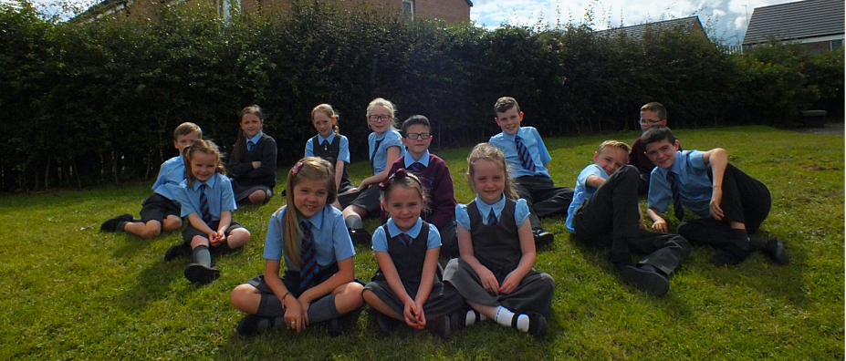

**School uniform**

Parents are to be congratulated on the way in which they turn out their children in school uniform and we thank them sincerely for their efforts.

We ask all children to wear soft shoes for comfort and safety during the day.

The picture below consists of the uniform worn by St. Vincent’s Primary pupils.

Blue shirt

Grey or maroon jumper/cardigan

Grey trousers/skirt

School tie, blazer and/or fleece are available to order from the school office.

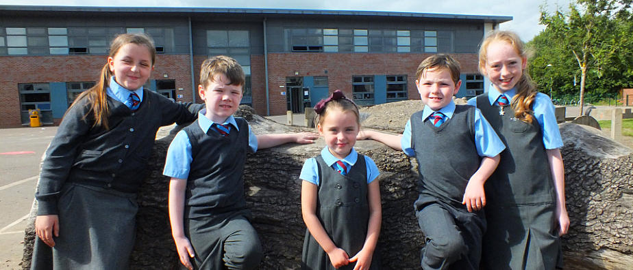

We ask all parents/carers to support the school by encouraging your child (ren) to adhere to the agreed dress code and the wearing of our school uniform. The wearing of a school uniform helps promote the identity of the school in the local community and helps create an ethos of sharing and pride in the school.

In addition, the wearing of a uniform helps towards increasing the protection of all pupils. The wearing of a uniform helps staff and the pupils to distinguish between who belongs to the school and those who may be visitors. This enables staff to approach and identify visitors more readily and helps in trying to offer a safer environment for pupils and teachers alike.

Equality of opportunity is an important aspect of the life of the school. Any proposals on the dress code and on what constitutes the school uniform will be the subject of discussion with the Parent Council and where appropriate consultation with parents, pupils and staff.

There are forms of dress which are unacceptable in all schools such as:

* the wearing of football colours
* clothing with slogans that may cause offence (anti-religious, symbolism or political slogans)

1. clothing which advertises alcohol, tobacco or drugs
2. clothing which can be deemed unsuitable in terms of health and safety grounds such as shell suits, combat style clothing, dangling earrings, loose fitting clothes particularly in practical classes
3. articles of clothing that could be deemed to inflict damage on other pupils or be used by others to do so
4. Footwear that may damage flooring.

**Support for parent/carers**

Clothing grant

In certain circumstances the Council provides support to parents/carers for the purchase of school wear.

Application forms for clothing grant are available from the Council’s website: [www.southlanarkshire.gov.uk](http://www.southlanarkshire.gov.uk) or from QandA Offices, Audit and Development 01698 453504/ 453505/453213, the school or Education Resources, Almada Street, Hamilton, phone 0303 123 1023.



**School hours/holiday dates**

Open from 9.00am – 3:00pm

MC900019961[1]Interval 10:30am – 10:45am

Lunchtime 12:15pm – 1:00pm

*See attached list showing school holiday dates.*

Enrolment – how to register your child for school



If your child is starting school for the first time you must enrol your child at their catchment school in January. If parents want their child to go to another school, they must enrol in the first instance with their catchment school and ask for an information leaflet that provides details on how to make a placing request. Forms are available from the SLC website – [www.southlanarkshire.gov.uk](http://www.southlanarkshire.gov.uk), schools, Q and A offices or by contacting Education Resources, Almada Street, Hamilton, phone 0303 123 1023. Completed forms should be returned as soon as possible to Education Resources, Almada Street, Hamilton ML3 0AE.

**Enrolment date for 2017 is week commencing 16th January 2017. Please telephone the school for specific dates and times available during this week to enrol your child.**

Parents wishing to enrol their child in St Vincent's are asked to contact Mrs Tompkins to arrange a visit at a mutually convenient time. If you are enrolling for the first time, please bring your child along to school with birth and baptismal certificates (if your child has been baptised) and 2 proofs of address. Children who are starting in August 2017 will be invited to school with their parents in June to meet their teachers, join in some activities and find out lots about the year ahead. Parents will be invited to take part in our Transition programme early in the new session and to discuss methods and materials used in school. Please note that **Primary 1 children should attend for a full day from Thursday August 17th 2017.**

**School transport**

South Lanarkshire Council has a policy of providing school transport to primary pupils who live more than one mile by the recognised shortest walking route from their catchment school. This policy is more generous than the law requires. This means that the provision of transport could be reviewed at any time. Parents who consider they are eligible should obtain an application form from the school or Education Resources, Hamilton, phone 0303 123 1023 or web [www.southlanarkshire.gov.uk](http://www.southlanarkshire.gov.uk). These forms should be completed and returned before the end of March for those pupils starting the school in August to enable the appropriate arrangements to be made. Applications may be submitted at any time throughout the year and will be considered by Education Resources.

A paid privilege transport scheme is operated for mainstream school contracts where a pupil is not entitled to free school transport. Privilege transport will only be granted providing there is spare capacity on an existing school contract and will be from and to designated pick up and drop off points. Privilege transport will not be provided where a service bus is used on the school run. Any spare capacity will be allocated using agreed priorities. For more information on school transport contact Education Resources phone 0303 123 1023.

**(ii) Pick-up points**

Where school transport is provided it may be necessary for pupils to walk a certain distance to the vehicle pick-up point. Walking distance in total, including the distance from home to the pick-up point and from the drop-off point to the school in any one direction, will not exceed the authority’s distance limit for school transport.

It should be noted that it is the parent’s responsibility to ensure their child behaves in a safe and acceptable manner while travelling in and alighting from the vehicle. Misbehaviour can result in your child losing the right to school transport.

Parents are asked to note that South Lanarkshire Council does not provide transport for those pupils who attend school via a placing request. Where there is a request to place a child under school age in a school within the local catchment area they may receive transport in line with the Council’s transport policy.

Any information on transport appropriate to the school should be mentioned.

Insurance for schools – pupils’ personal effects

South Lanarkshire Council is concerned at the level of claims being received for loss or damage to pupils’ clothing or personal effects. Parents are asked to note the Council’s position in terms of insurance for pupils’ personal effects:

Theft/loss of personal effects

The Council is not liable for the loss or theft of pupils’ clothing or personal effects and any items are therefore brought into the school at the pupil/parents’ own risk.

Parents can assist by ensuring that valuable items and unnecessarily expensive items of clothing are not brought to school.

Teachers and other staff have been advised not to accept custody of any such items.

The same principle applies to musical instruments and other equipment used for activities within the school, which belong to the pupil, but are brought into the school. Parents should be aware that if such equipment is left in school, it is done at the pupil/parents’ own risk.

In the case of valuable items such as musical instruments, parents should ensure that these items are covered by their own household insurance.

(ii) Damage to clothing

The Council is only liable for damage caused to pupils’ clothing where the damage has resulted from the negligence of the Council or one of its employees. Claims arising otherwise will not be accepted by the Council’s insurers.

Family holidays during term time



Every effort should be made to ensure that your child attends school during term time. Please contact the school as soon as possible if your child is unable to attend school.

Family holidays should be avoided during term time as this both disrupts the child’s education and reduces learning time. If holidays are taken during times when the school is open parents should inform the school in advance by letter.

If your child is taken on a family holiday during term time then in line with Scottish Government advice this will be classified as an unauthorised absence. However, in exceptional circumstances schools may register a family holiday during term time as an authorised absence when for example, parents are unable to obtain leave during the school holiday period.

Clearly, absence with no explanation from parents will mean that the absence will be recorded as unauthorised.

In our approach to raising attainment and achievement it is recognised that attendance at school is something that should be continuously encouraged. Parents/carers, children and the school all have a part to play in encouraging and stressing the importance of attendance at school.

The school holiday dates and in-service dates are available from the website [www.southlanarkshire.gov.uk](http://www.southlanarkshire.gov.uk)

**Promoting positive behaviour**

[](http://www.google.co.uk/imgres?q=behaviour&safe=active&hl=en&biw=1024&bih=571&tbm=isch&tbnid=Y_d_PZy3ZRXkaM:&imgrefurl=http://www.thestickerfactory.co.uk/Kudos/Star-good-behaviour-pack-of-75-38mm-stickers/prod_6847.html&docid=CyEGOZBJ-l1mDM&imgurl=http://www.thestickerfactory.co.uk/images/products/main/021.png&w=400&h=400&ei=gG6wUsDOJMSu7AbD8oHgDg&zoom=1&iact=rc&page=5&tbnh=144&tbnw=144&start=76&ndsp=20&ved=1t:429,r:78,s:0,i:324&tx=42&ty=100)It is the responsibility of staff within the school to ensure that parent council members, parents and pupils are involved in the creation of a positive school ethos that encourages good behaviour. Equally, the school whilst trying to promote positive behaviour must support young people should incidents or bullying occur. Parents have a significant role to play in working with the school so that teachers, parents and pupils know what is expected of them in trying to change the behaviour and attitudes that contribute to bullying behaviour.

Our approach is to create an environment where better behaviour will encourage better learning. The school, along with the support of parents, can work together to create a learning environment which young people can enjoy and feel safe.

Incidents of bullying should be reported to the school immediately so that each alleged incident can be looked at. Together we can work towards creating a safer school for children and staff.

In addition, a guideline (Management of Challenging Behaviour) has been produced to support all teaching and support staff and inform them of their roles and responsibilities in respect of dealing with the small number of children and young people who display challenging behaviour. Early identification is crucial so that intervention can be provided to support children and young people to help them address their issues and concerns. Staff training is provided to help develop the skills needed to respond to and manage challenging behaviour. A wide range of appropriate staff development opportunities has been developed for this purpose.

Visitors to our school have commented that they are immediately struck by the friendly, welcoming atmosphere and the polite, courteous and disciplined behaviour of our children.

We promote a very positive approach to learning and self-discipline in our children, encouraging them to become more and more responsible for their own actions as they grow older, actions that should always show consideration for others. We are also complimented when children are on outside visits. Children learn through praise and encouragement to encourage good behaviour a system of Master classes was introduced where children are rewarded for positive behaviour and upholding the school’s values by taking part in activities of their choice each week. This system has proved to be a great motivator for positive behaviour and an opportunity for children to exercise personalisation and choice and learn new skills with children from other classes. All classes draw up their own class charter. Older pupils may draw up their own rules in consultation with teacher, and assess their own performance at the end of the day awarding themselves points (closely monitored by their classmates!) based on the class rules. Good behaviour is commented on and rewarded by master class points, and particular mention during weekly assembly where we have “Good News to Share”, “This week’s achievements” or “Values award” for the child in each class who has achieved in some way. Pupils are invited to speak at assembly about their “good news”, thus giving them an opportunity for speaking publicly to a wide audience.

It happens occasionally however, that a child makes the wrong choice, for example, misbehaves in the playground, is unkind to another child, and so on, and our Discipline policy is then enforced where children can think about the consequences of their actions. If the matter is deemed to be serious enough, or is of a persistent nature, parents are contacted either by phone call or by letter to discuss the matter and to take appropriate steps. The full co-operation of parents cannot be stressed enough. Copies of both the Discipline Policy and further information on how Master classes operate are available from the office.

Child Protection

All staff in educational establishments in South Lanarkshire Council are required to follow the advice and guidance contained in “South Lanarkshire Child Protection Interagency Guidance and Education Procedures”.

The shared vision for Lanarkshire’s children is: “all children and young people in Lanarkshire have the right to be cared for and protected from abuse and harm in a safe environment in which their rights are respected.” All agencies will work together in a collaborative way to promote the safety and wellbeing of children and young people in Lanarkshire.

The Chief Officers and Child Protection Committees of North and South Lanarkshire Council’s are the driving force for ensuring that agencies individually and collectively work to protect children and young people as effectively as possible.

The Council has a duty in law to report suspicions that a child has been abused or is at risk of harm, in terms of the Children (Scotland) Act 1995. Therefore, Council staff have a professional and contractual obligation to report concerns to the head of establishment or the child protection coordinator immediately.

Education Resources staff and visitors from other agencies and services are required to follow these Child Protection Procedures to protect and support children and to fulfil their professional obligations to report all allegations or suspicions of child abuse.

For more information, or if you have a concern of a child protection nature, please contact the head of the educational establishment which your child attends.

The Council has produced an information leaflet – ‘stay safe’ for parents/carers on how to help ensure their child is safe when using the internet and mobile devices.

Copies are available from the school or the web: [www.southlanarkshire.gov.uk](http://www.southlanarkshire.gov.uk)

Information on emergencies



We make every effort to ensure the school remains open during term-time for pupils. However, on occasions circumstances may arise which can affect the school. Schools may be affected by, for example, severe weather, power failures or through any other circumstances that may impact on the school day. In such cases we shall do all we can to let you know if this happens. We shall keep you in touch by telephone, text, where appropriate, letters, web news and through local radio stations particularly if there are prolonged periods of severe weather. The Council’s website [www.southlanarkshire.gov.uk](http://www.southlanarkshire.gov.uk) will be used to let you know if the school is closed and when it will re-open.

It is important for parents/carers to let the school know of any change to your mobile/home telephone number and change of address.

If for any reason, you are unsure if the school is open, please contact the school or Education Resources, Operations Service, Almada Street, Hamilton. (Phone 0303 123 1023) or email us at: [education@southlanarkshire.gov.uk](mailto:education@southlanarkshire.gov.uk) or visit the website [www.southlanarkshire.gov.uk](http://www.southlanarkshire.gov.uk)

**Your commitments**

We ask that you:

* support and encourage your child’s learning
* respect and adhere to the schools policies and guidance
* let the school know if you change your mobile/telephone number and/or address
* enjoy and take part in school activities
* accept your responsibility to respect staff who work in the school and for the school to be proactive in taking forward it’s commitment to care for and educate your child.

**Medical and Health Care**

Children have a medical in P1, undertaken by staff of South Lanarkshire Health Board. Parents may also ask that their child be referred to the Medical Officer for an examination or for advice at other times. Dental inspections are carried out on a routine basis in primary schools. Where necessary, children are offered any necessary treatment although parents may choose that their child attend their own dentist. Our school nurse (health visitor) is very keen to support parents and can be contacted through the school.

We ask for an emergency contact phone number in case of accident or illness during school hours and **also that you advise us of any change in emergency contact phone numbers immediately**.

In the event of an accident or sudden illness, the parent is contacted immediately and failing this, the emergency contact. Should neither be available, the Head teacher has the authority to send the child to his/her own doctor where possible, or, as a last resort, Hairmyres Hospital. The child will travel by taxi or ambulance if required and will be accompanied by a member of staff who will stay with the child until the parents arrive.

**Note: It is essential that the school authorities be advised of any particular medical problems** which may affect a pupil’s attendance, involvement in physical education activities or performance in normal class routines. Parents who wish any special arrangements to be made if their child has taken ill are asked to advise the school office. Children who require to take medicine/tablets/inhalers etc, should bring them to the school office where they are securely stored. Parents are asked to sign a PARENTAL REQUEST FORM to allow a non medically qualified person to supervise the child when he/she is taking the medicine or inhalers etc.

**Data Protection Act 1998**

**Information on pupils, parents and guardians is held by the school to enable the teaching, registration and assessment of pupils as well as associated administrative duties. The information is stored and used as per the requirements of the Data Protection Act 1998 with South Lanarkshire Council defined as the data controller. The Council have established a data protection policy that applies to all of its schools. For more information please contact the school.**



**Education Resources**

**School holiday Dates Session 2017/2018**

|  |  |  |  |
| --- | --- | --- | --- |
| Break | Holiday dates | | |
| **First Term** | Teachers return | Tuesday | 15 August 2017 |
|  | Pupils return | Thursday | 17 August 2017 |
| September Weekend | Close on | Thursday | 21 September 2017 |
|  | Re-open | Tuesday | 26 September 2017 |
| October Break | Close on  Re-open | Friday  Monday | 13 October 2017  23 October 2017 |
| In-Service Day | School closed to pupils | Monday | 20th November |
| Christmas | Close on | Friday | 22 December 2017 at 2.30pm |
| **Second Term** | Re-open | Monday | 8 January 2018 |
| February break | Close on  Open on | Friday  Thursday | 9 February 2018  15th February 2018 |
| Spring break/Easter | Close on | Thursday | 29 March 2018 at 2.30pm |
|  | Re-open | Monday | 16 April 2018 |
| **Third Term** |  |  |  |
| Local Holiday | Closed | Monday | 7 May 2018 |
| In-Service Day | School closed to pupils | Tuesday | 8th May 2018 |
| Local Holiday | Close on  Re-open on | Thursday Tuesday | 24 May 2018  29 May 2018 |
| Summer break | Close on | Thursday | 28 June 2018 at 1.00pm |

Notes

* Good Friday falls on Friday, 30 March 2018
* *Lanark schools will close 7and 8 June 2018*
* Schools will close at 2.30pm on the last day of terms 1 and 2

(Friday, 22 December 2018 and Thursday 29 March 2018)

* Schools will close at 1pm on the last day of term 3 (Thursday 28 June 2018)

*Two in-service days proposed for August 2018 to be confirmed.

Appendix A

**This annex gives a list of useful information and the links to the content is now available from the Council’s website by accessing the following link**

[**http://www.southlanarkshire.gov.uk/info/200186/primary_school_information/1264/curriculum_for_excellence/3**](http://www.southlanarkshire.gov.uk/info/200186/primary_school_information/1264/curriculum_for_excellence/3)

**Contact Details**

Education Scotland’s Communication Toolkit for engaging with parents

The Scottish Government guide Principles of Inclusive Communications provides information on communications and a self-assessment tool for public authorities

Choosing a School: A Guide for Parents - information on choosing a school and the placing request system

A guide for parents about school attendance explains parental responsibilities with regard to children’s attendance at school

**Parental Involvement**

Guidance on the Scottish Schools (Parental Involvement) Act 2006 provides guidance on the act for education authorities, Parent Councils and others

Parentzone provide information and resource for parents and Parent Councils

**School Ethos**

Supporting Learners - guidance on the identification, planning and provision of support

Journey to Excellence - provides guidance and advice about culture and ethos

Health and wellbeing guidance on healthy living for local authorities and schools

Building Curriculum for Excellence Through Positive Behaviour and Relationships outlines the Scottish Government’s priority actions around positive behaviour in schools and is also a source of support

Scottish Catholic Education Service’s resource ‘This is Our Faith’ which supports the teaching and learning of Catholic religious education

**Curriculum**

Information about how the curriculum is structured and curriculum planning

Information about the outcomes a learner can expect to experience and achieve across literacy, numeracy and health and wellbeing, as well as the 8 curricular areas

Advice, practice and resources to support the experiences and outcomes on literary, numeracy and health and wellbeing

Broad General Education in the Secondary School – A Guide for Parents and Carers

Information on the Senior Phase

Information on Skills for learning, life and work

Information around the Scottish Government’s ‘Opportunities for All’ programme

Information for organisations responsible for the planning, management and delivery of career information, advice and guidance services

The Skills Development Scotland website ‘My World of Work’ offers a number of tools to support career planning

**Assessment and Reporting**

Building the Curriculum 5: a framework for assessment provides guidance around the assessment framework

Information about Curriculum for Excellence levels and how progress is assessed

Curriculum for Excellence factfile - Assessment and qualifications

Information on recognising achievement, reporting and profiling

**Transitions**

Curriculum for Excellence factfile - 3-18 Transitions - provides information on the transitions children and young people will face throughout their education and beyond

Career Information, Advice and Guidance in Scotland - A Framework for Service Redesign and Improvement provides guidance on career information, advice and guidance strategy

Choices and changes provides information about choices made at various stages of learning

The Additional support for learning page provides links to relevant legislation and guidance, including the arrangements that should be in place to support pupils with additional support needs

Supporting Children's Learning Code of Practice includes specific requirements on education authorities and others under the new legislation in relation to transition

Enquire is the Scottish advice service for additional support for learning

Parenting Across Scotland offers support to children and families in Scotland

**Support for Pupils**

The Additional support for learning page provides links to relevant legislation and guidance, including the arrangements that should be in place to support pupils with additional support needs

Information about the universal entitlement to support that underpins Curriculum for Excellence

Supporting Children's Learning Code of Practice (Revised edition) - provides Statutory guidance relating to the Education (Additional Support for Learning) (Scotland) Act 2004 as amended

Getting It Right For Every Child and Young Person, is essential reading for anyone involved or working with children and young people, including practitioners working in adult services with parents and carers

**School Improvement**

Scottish Schools Online - provides a range of school information, including contact details, school roll, facilities, website, inspection reports

Education Scotland’s Inspection and review page provides information on the inspection process

The Scottish Survey of Literacy and Numeracy (SSLN) is an annual sample survey which will monitor national performance in literacy and numeracy

Scottish Credit and Qualifications Framework (SCQF)

Scottish Qualifications Authority provides information for teachers, parents, employers and young people on qualifications

Amazing Things - information about youth awards in Scotland

Information on how to access statistics relating to School Education

**School Policies and Practical Information**

**National policies, information and guidance can be accessed on the following:**

Education

Health

Young People

Children (Scotland) Act 1995

Standards in Scotland's Schools (Scotland) Act 2000