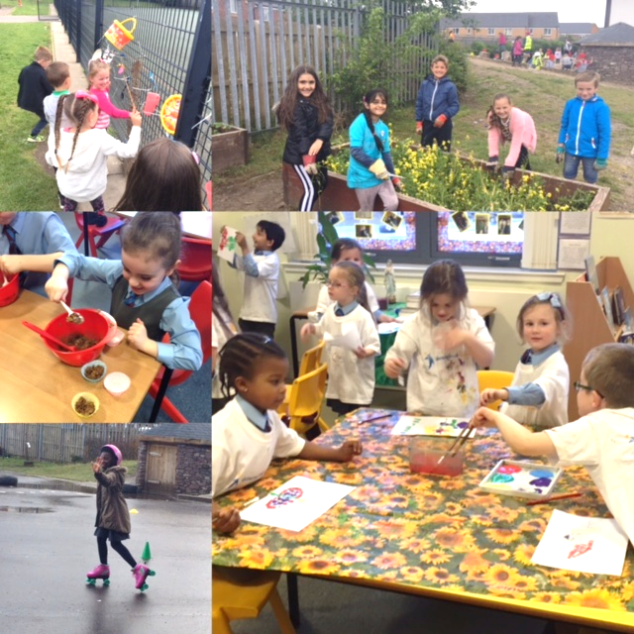

**What Master Classes can be expected?**

A wide range of Master Class opportunities will be available to your child including; painting, football, ICT, cricket, yoga, song writing, music, Spanish, science club and cycling, clay modelling, cooking, baking, hama beads, handball, story writing etc.

**\*Please note, if you have any interests/skills/talents and would like to lead a Master Class with support from a member of staff please contact the school as we are always keen to have support from our parents/carers and wider school community.\***

**Who can attend a Master Class?**

All children in the school attend Masterclass on a Friday afternoon. Previously, attendance at Masterclass was linked to our Promoting Positive Behaviour policy and based on a point system but this has changed.

Please see the Lunchtime Reflections Parent Information booklet for more details.

***.***

Saint Vincent’s Primary School aims to promote successful learning within a nurturing atmosphere where there is mutual respect and quality promotion of the school’s values: Friendship, Kindness, Respect, Resilience and Fairness. All members of the school community including pupils, staff, parents, carers and visitors are expected to contribute responsibly to appropriate behaviour practices.

This year, Master Classes will contribute to our aim to promote positive behaviour in school and give pupils the opportunity to develop their skills in a variety of ways with a range of different pupils and staff.

**Master Classes – The Format**

**What is a Master Class?**

A Master Class will be a 4 week session with a specific focus to allow children to develop their skills across the curriculum in a challenging, enjoyable, active and collaborative ways.

**When will Master Classes take place?**

Every Friday Afternoon, children will attend their master class between 2.00pm and 2.45pm.

**Who will take Master Classes?**

Each member of the Teaching Staff will be allocated to a different Master Class as well as support staff and parent helpers with specific interests/talents/skills who wish to lead a class.

**How will the classes be made up?**

We aim to have a minimum of 15 different Master Classes to ensure a maximum of 25 pupils in each class.

**How will pupils sign up to a Master Class?**

At the beginning of a 4 week session, pupils will be made aware of the Master Classes available and given the opportunity for a first and second choice. Pupils will be allocated a Master Class accordingly and will be notified prior to their 4 week block starting.

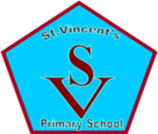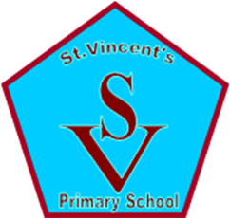

Saint Vincent’s

Master Classes

2019 – 2020

Parent Information Booklet

*Should you wish to discuss leading a Master Class in the school or any aspects of our new system, please contact the school and ask to speak to Mrs Tompkins or*

*Miss Timmons.*

*School Tel: 01355 241649*

*School email:* [gw14stvincentsoffice@glow.sch.uk](mailto:gw14stvincentsoffice@glow.sch.uk)