Saint Vincent’s
Primary School

Homework Policy
2021-2022

Saint Vincent’s Primary School
Homework Policy
In Saint Vincent’s Primary School, homework is at the heart of promoting independent learning in our children and supporting them in being successful learners. We view the practise of homework as part of their preparation for lifelong learning. Homework is only given when it is purposeful and useful in relation to class work. Teachers should ensure that tasks are varied and related to the abilities and needs of individual pupils. All homework tasks are to be explained clearly so that pupils know what is required and when it is expected to be completed. Through the use of homework diaries, pupils and parents should be clear about tasks. Homework diaries can also be used as an effective means of communication between home and school.

Rationale for homework:
Homework is any task undertaken outwith the school day which enhances children’s learning. Homework plays a positive role in raising a child’s attainment when it is purposeful and related to class work and activities. In Saint Vincent’s we acknowledge the important role of play, outdoor learning and family time in a child’s growth and development and therefore, while homework is important, it should not overshadow or overtake any of these activities. It should also not prevent children from participating in extra-curricular activities or clubs. We are aware that children spend more time at home than at school and we believe they develop their skills, interests and talents to the full only when parents encourage them to make maximum use of the experiences and opportunities that are available out of school. Homework should never become an experience where children feel upset or anxious and we would actively encourage that pupils spend appropriate lengths of time on homework dependent on their age and stage.

Expectations from homework:
Pupils will be given homework on 4 nights per week* – Monday through Thursday with the approximate time spent as follows:
- Infants: Primary 1-3 10 – 15 minutes
- Juniors: Primary 4-5 15 – 20 minutes
- Seniors: Primary 6-7 20 – 25 minutes

Staff will endeavour to issue all homework on a Monday, which is set for the full week. This allows families to complete homework activities around their own family plans throughout the week.

*There are times in which events will take place in the school in the evenings eg. School discos, Parents Evenings, Concerts or weeks which are much shorter than others and it will be at each teacher’s discretion if homework is given on these occasions as we understand that many of the pupils and families will be involved in late evenings at the school and we actively encourage our pupils and parents to be involved.

Staff should ensure that all tasks set are appropriate to the ability of the child. If a child has additional support needs, teachers will endeavour to adapt any tasks/instructions so that all children can contribute in a positive way. When setting homework to pupils with ASN, we should refer to pupils’ ASP targets to ensure the way in which we would offer support is being met.

Aims and Objectives:
Through planned, purposeful Homework activities we aim to:
- Promote self-reliance , self-discipline and self confidence
- Encourage independent learning
- Strengthen our liaison between home and school and involve parents in their child’s learning.
- Enable pupils to learn in different ways and in different settings.
- Develop and promote organisational skills
- Provide additional support for learning
More specifically we aim to:
- Reinforce class work and consolidate the learning process by providing further practice in developing skills
- Extend class work by doing preparatory work, follow up work or creative tasks related to activities in class.
- Widen the learning experience by encouraging pupils to work creatively and access resources and materials available at home or wider school community e.g. local library
- Help teachers monitor the effectiveness of learning and teaching.

Agreed Homework Activities:
In consultation with staff, it was agreed that a consistent approach to the homework activities set on a weekly basis should be followed throughout the school and more specifically throughout each stage of the school.

Primary 1:
- Range of reading and phonics activities throughout the week – with a suggested timetable for parents who wish to follow it exactly
- 2 Education City online maths activities

Primary 2-3:
- Reading Book – to be read each night with a family member
- Spelling/phonics activity (this may be on Education City or a written task)
- 1 or 2 maths activity each week related to classroom learning based online on Education City

Primary 4-7:
- An active spelling activity of choice from a grid provided to each pupil
- Personal Reading of a book of choice for 15-20 minutes (pupils are encouraged to have a ‘Book Blether’ with an adult where possible following their reading)
- 2-3 online based maths games on Education City or Rigour Maths

Primary 1 Homework Grid Example:

Day | Phoneme and Common Word | Reading
Monday | Sound 1 and 3 Common words:  1 or 2 activities from the “Ideas to help your Child with Phonemes and Common Words” sheet  (This sheet is on class website page) | Night 1  Discuss title and front cover  From looking at front cover:  What do you see?  What could happen in the story?  Adult reads the book to the child. Remind your child that you are reading from left to right. Point out the finger spaces between the words. Point out the capital letter and full stop. Point out any words they might find difficult  Discuss the characters.  At the end discuss what happened in the story.  Ask them, “What do you think would have happened if…”
Tuesday | Sounds and Common words:  Revise all sounds and common words learned so far. Write this week sound and common words 3 times on laminated sheet or jotter. | Night 2  Can you remember what happened in the book?  Try to find any sounds (phonemes) and common words they have learned so far.  Child reads the book
Wednesday | Sound 2 and 3 Common words:  1 or 2 activities from the “Ideas to help your Child” sheet  Make the words from the weekly homework sheet using the sound squares or magnetic board.  Helps your child read the sentences on the weekly homework sheet. | Night 3  Child reads the book.
Thursday | Adult reads a sentence from the weekly homework sheet, child writes the sentence on laminated sheet or in the jotter. Encourage finger spaces between the words and they are writing on the line. Make sure they are holding the pencil properly and sitting properly in a chair at a table if possible.  Try to do this for 2 or 3 of the sentences on the sheet.
Maths | Education City Activities  (these are online games which are optional)

Primary 2-3 Homework Grid Example:

Literacy
Spelling | Exclamation Marks  Phoneme - ea  (bread, head, deaf, ready, dead, instead, pleasant, pheasant, weather)  Common words – learn, children, because, earth  Commas  Phoneme - au  (sauce, because, applaud, pause, Paul, Laura)  Common words – learn, children, because, earth  Choose two/three strategies from the spelling menu for your groups phonemes and common words.
Reading/ Grammar | Read your book every night for at least 10/15 mins or until book is finished.  Complete Education City grammar activities. (Verbs)
Numeracy
Complete the Education City activity linked to number work in class.
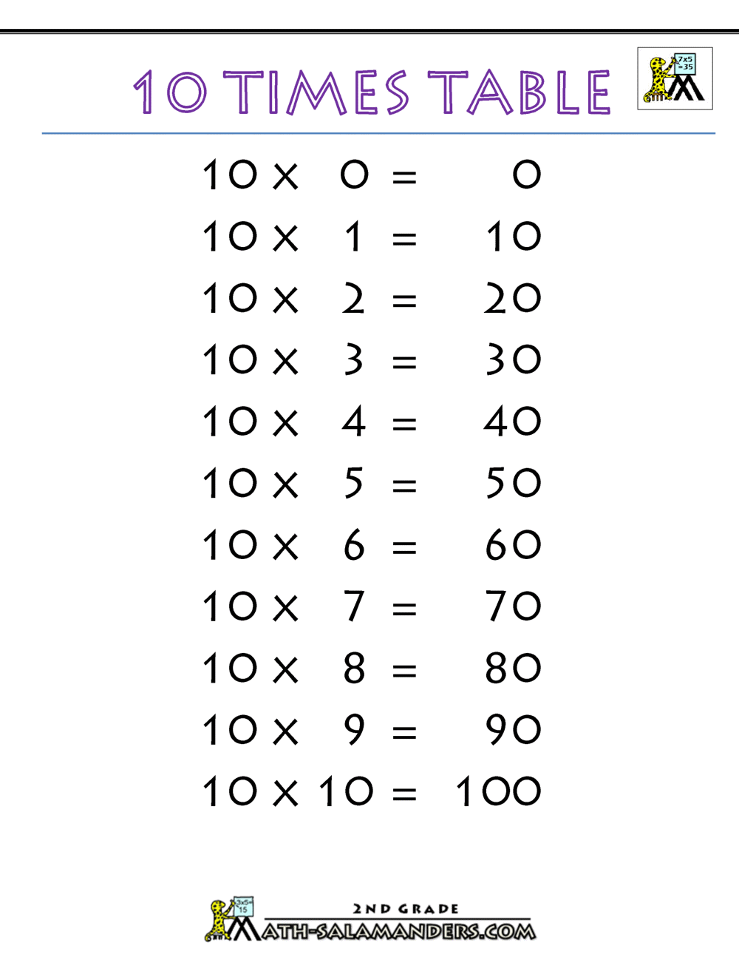
Practice the 10 times table.

(This could be reciting your chosen timestable at home, playing Hit the Buzzer on topmarks website or any other fun way you can think of to help the children.)

Primary 4-7 Homework Grid Example:

Issuing Homework:
In consultation with staff, in order to make the issuing of homework more consistent throughout the school we will endeavour to:
- Issue all homework for the full week on a Monday to be returned on Friday. Though we can suggest when different activities should be completed, pupils (particularly juniors and seniors) have the choice of when to complete different tasks depending on after school clubs and activities.
- All homework for the week will be published on the Google Classroom for your child’s class on a weekly basis. Where pupils/parents have trouble accessing Google Classroom, homework can be accessed via the School Website class pages or issued as a paper copy.
- It is optional whether pupils have to publish/submit their work to the Google Classroom each week.
- Maths homework throughout the school will be online maths activities from Education City and for senior classes at times they may use Rigour Maths. These are fun, interactive maths games, suitable for all stages. Each child has their own personal login for Education City.
- At times, Education City may also be used for literacy games, which are relevant to spelling/grammar learning in class.

Additional Considerations
In Saint Vincent’s Primary School we recognise that Homework is not compulsory although we will now ask parents to put it in writing when they are withdrawing their child from completing homework tasks.

Teachers are aware of problems that can arise and when setting tasks will give consideration to the following:
- Home circumstances vary as do parental expectations, abilities and understanding of tasks
- An anxious parent can put undue pressure on a child
- Some parents may give homework low priority and this is not the fault of the pupil in your class

