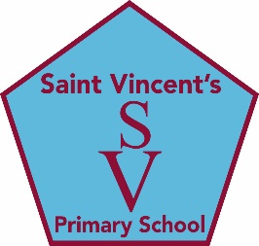

**education SERVICES**

**Executive Director: Tony McDaid**

**ST VINCENT'S PRIMARY SCHOOL -**

Head teacher Eileen Tompkins

7th October 2021

Dear Parent/Carer,

As October break approaches, please note that school will close tomorrow at 2.45pm and 3pm and re-open on Monday October 18th at 8,45am and 9am. Breakfast club for all will return at the usual time of 8.15am until 8.40am.   
  
On our return we will have a dress down day on **Friday 22nd October** (not tomorrow as originally planned) when we will ask the children to dress in clothes other than their school uniform and bring a donation in an envelope for Missio (Pope Francis' charity which supports the Missions)   
  
John Wilson Photography will visit the school on Thursday 21st October to take individual and family photos. Children are asked to dress in their **full school uniform**. You will receive full details in advance of how to order any photographs you wish to purchase via Parent Pay.   
  
On Friday 29th October children will have the opportunity to dress up in homemade, recycled or reused costumes for our ever popular**Eco'een**. This event attracts great interest and we never cease to be amazed by the creativity and skill of our families.  
  
With COP26 happening in Glasgow the following week ,the Eco’een will give us all a chance to focus on Care of the Earth  by reducing waste and recycling wherever possible. You will hear lots more from your children about this theme as all classes will be learning about what it means to be a Laudate Si school and care for our Common home.  
   
We urgently need parent volunteers for our Parent Council which is such an important support to our school community. We are so grateful to Mrs Clare Simpson, our current chair and to Mrs Olive Thomas her predecessor for doing a sterling job over the past years. They were helped by a small group of very dedicated, hardworking parents who staged events and provided funding for many extra opportunities for our children as well as valued support in other ways for the school community. We need more members to help us continue the work of the Parent Council. Please come to the re-scheduled AGM which will take place online after the October holiday (Details to follow). Sincere thanks to all our parents for their help and support and to Mrs Sarah Knox for once again co-ordinating the Personalised Christmas cards which will be available to purchase on time for Christmas.    
  
 As advised in a previous message, your child will have received their interim school report today with the opportunity for a follow up phone call later in October should you request it on the return slip.   
  
Wishing you and your families a very relaxing holiday whether at home or away.  
  
Kindest Regards   
Eileen Tompkins