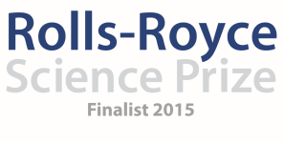
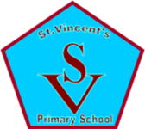

Saint Vincent’s Primary School
November Diary Entry
After School Clubs
This month, Primary 6 started their four week block of after school clubs for Space and Astronomy and visited the Windfarm for their stargazing event on 17th November. Following the Primary 7 block, it was essential to come together as a team and evaluate the most effective parts of our after school clubs for pupils and any aspects we needed to change or modify for Primary 6. Looking at both the pupil evaluations from our previous block and discussions within the team, the Training like an Astronaut session was most popular and was something we decided to do again with the Primary 6 pupils. One of the activities within this session proved a challenge for Primary 7 (the metre stick solar system) and therefore we decided to change this part to Moon Phases for the Primary 6 pupils which is relevant as part of their stargazing sessions. We also looked at our spectrometer session and while we still wanted to cover this, we realised that the making of the spectrometers took considerably longer than we had expected and the background to the importance of the spectrometer was lost a little. For this reason, we contacted Dr. Carol Trager-Cowen from Strathclyde University who was able to supply us with fold and stick style spectrometers which take minutes to assemble, giving the children much more time to actually make use of the spectrometers and gain a better understanding of why they are used and what they are used for. The primary 6 pupils also took part in the rocket launching challenge and through discussions with Steven Gray, owner of Cosmos Planetarium who runs the sessions, we discovered that he has a role as a STEM Ambassador and has offered to assist us with all our future stargazing Evenings. Steven joined us on the 17th November and proved invaluable in supporting the pupils, using the technology and providing pupils with a wealth of knowledge about the stars. Similarly with the Primary 7 block, all team members played an active role within the After School clubs. In Week 1, all team members were on hand to help the pupils in designing their rockets to launch. In week 2, each team member was responsible for a different station during Train like and Astronaut. In week 3, while Graham explained the science behind light, spectrometers and radio telescopes, one team member helped the pupils construct, one team member gave the children the opportunity to work with real spectrometers from Glasgow University and another two team members worked with pupils on using radio telescopes to find geostationary satellites. In week 4, Danielle led the session on the night sky with all team members supporting with their constellation activity and accompanying the pupils and parents to Whitelee Windfarm. We were very encouraged by the number parents and families that joined us at the Windfarm and the number of Primary 7 pupils who also decided to join us on Tuesday, having enjoyed the experience so much when they had their block back in October. Within the next week, the Space team will come back together to assess the four week block for Primary 6 and evaluate the success of the club in order to plan and prepare for the Primary 5 block.

Whole School Stargazing
This month we also held the first of our whole school stargazing events to make sure that our Space project remains at the forefront of the curriculum for all pupils and not just those attending their after school clubs. On Tuesday 27th October, every pupil in the school was invited to attend a whole school stargazing event from 5-6pm and then from 7-8pm in the school grounds. This was very well attended by pupils from primary 1 right through to primary 7 with attendance from a number of parents, brothers and sisters and grandparents. We had also planned to host another event on the Wednesday 28th October but unfortunately due to weather conditions we have had to postpone this until further notice.

Teacher CPD
In order to make the project sustainable, we are keen to encourage as much CPD with the teachers as possible through different science courses and events. Our Headteacher attended a course on Creativity during which she met Dr. Carol Trager-Cowen who was able to supply us with the Spectrometers. Two teachers will also attend a SSERC Residential course this coming week to enhance their teaching of the Science Curriculum. The teachers will then take part in a Gap Task to return to SSERC in March and will be able to use the Rolls-Royce Science Prize to assist them in taking space and astronomy forward in their own classes. As well as this, two teachers attended a lecture and Planetarium show in the Glasgow Science Centre on Tuesday 17th November to learn more about The Unseen Cosmos. In addition to this, several members of staff accompanied us on our trip to Whitelee Windfarm with the pupils to further develop their understanding of the night sky.

Video footage
This month, we have also been busy working on our team film footage and working together to determine the most effective way of putting across the work that is going on in our project. Together we created a short film all about the project and the role each member of staff plays within the project itself. We have been filming all of our after school clubs and watching the footage back played an important role as part of our evaluation on the most effective aspects of the after school clubs and informing our planning for Primary 5 and 6 pupils.

Visit to Rolls Royce and London Award Ceremony
Danielle was pleased to represent the school at the Rolls-Royce Science Prize Award Ceremony in London on Monday 9th November with Headteacher Eileen Tompkins. It was a very worthwhile opportunity in terms of meeting the other finalists for 2015-2016 and getting a chance to hear more about their different projects that Rolls-Royce is supporting this year. It was also a very worthwhile experience in terms of seeing the projects that were finalists for 2014-2015 and the level of outstanding Science Education taking place across the United Kingdom. It was very important to feedback to the team as soon as Danielle arrived back to really highlight the standard and level of competition but also to highlight just how much of an impact the project can have on both staff and pupils with the support of Rolls-Royce.

Going Forward
The Primary 5 block of after school clubs will begin on November 24th with a rocket launch workshop from Steven Gray the STEM Ambassador from Cosmos Planetarium and their final session will also include a visit to Whitelee Windfarm with their families for stargazing. As a team we have discussed various resources we would like to purchase with the prize money to enhance the experience for the pupils attending the after school sessions including Space themed Lego for the younger pupils encouraging them to build their own moon buggies, space stations and satellites, space food, a visit to Glasgow Science Centre Imax theatre to see a film about the ISS and a visit from Generation Science for the Infant department to see a show on The Sun, The Moon and the Stars.
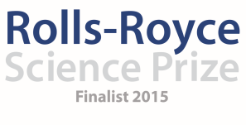

Saint Vincent’s Primary School
November Diary Entry

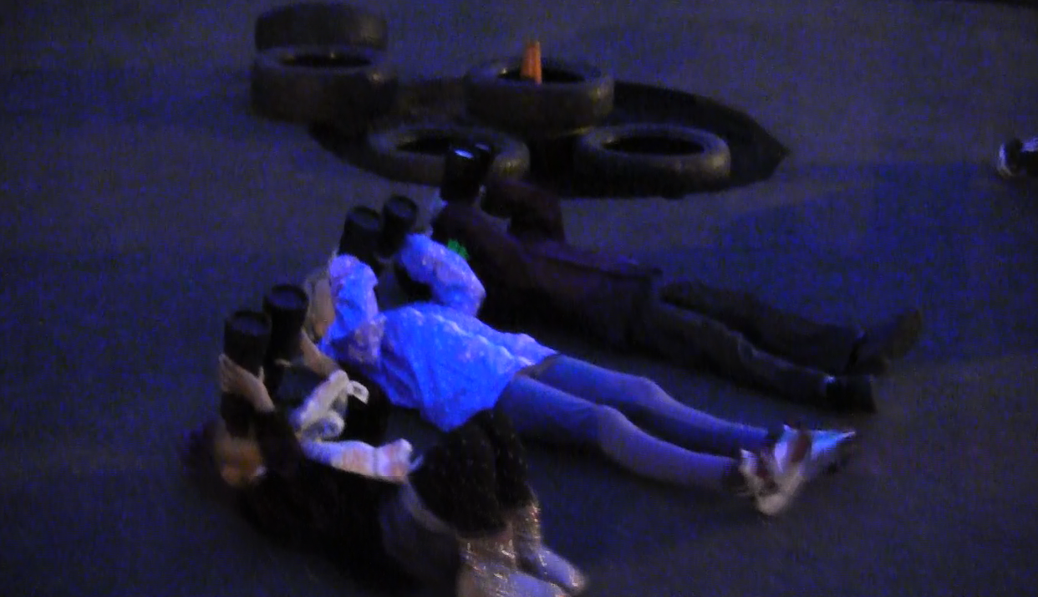
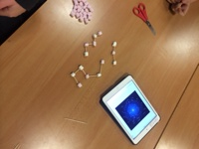
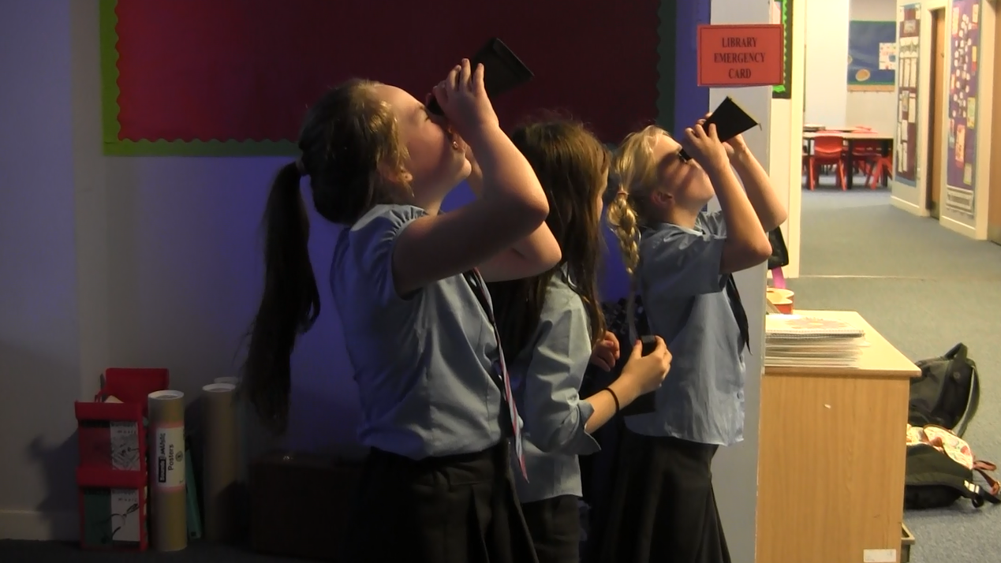
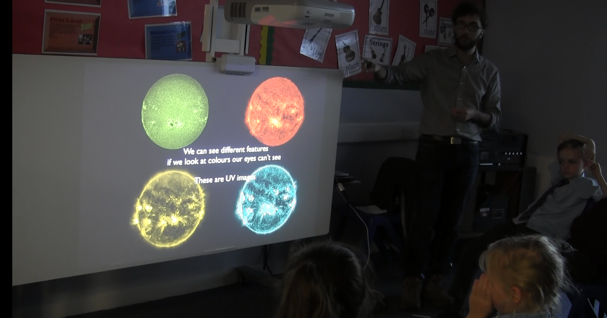
During our Whole School Stargazing Evening, children from primary 1 through to primary 7 came along to the school yard with their parents to take part using our new technology with support from all Rolls-Royce Science Prize team members.
Before the P.6. Stargazing event, pupils worked in teams using Night Sky App on their Ipads to identify different constellations and made these using cocktail sticks and marshmallows! When they came for stargazing later on, these were all on display before heading outside to see which constellations we could spot.
The pupils make their own fold and stick style spectrometers and use them against the light. Other pupils used spectrometers on loan from Glasgow University and worked outside with the Radio Telescopes.
Week 3 of Space and Astronomy Club for P.6. included a presentation from Rolls-Royce Science Prize Team Member Graham Kerr. He discussed the science behind light, spectrometers and radio telescopes before the children made their own spectrometers.

