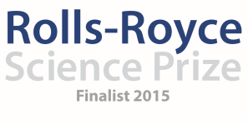
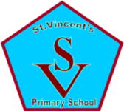

Saint Vincent’s Primary School
December Diary Entry
After School Clubs
This month we completed our after school Space and Astronomy Clubs for Primary 6 and have now completed our block for Primary 5 also. Following the evaluations from our Primary 6 pupils, we decided to make some changes to our after school clubs for the Primary 5 block to make it more relevant to the stage of learning of the pupils and this seems to have had really positive impact on the pupils in this block.
Week 1:
This session was again led by Steven Gray a STEM ambassador from Cosmos Planetarium. He delivered an altered version of his Rocket Launch workshop in order to better suit the audience of the primary 5 pupils. They engaged really well with the presentation and were able to demonstrate a great deal of knowledge in the way in which they both asked and answered questions. We were fortunate to have a full complement of team members for this session meaning we had one team member working with each of the different rocket building teams whilst another team member was able to film and photograph the work of the pupils.
Week 2:
With Tim Peake being a major focus in classrooms at the present time, the primary 6 pupils were insistent that we continued with the session on Training like an Astronaut for the Primary 5 pupils. Similar to previous sessions, each team member was responsible for a different station; using the wall bars to do physical exercises, leading the initial presentation to the pupils, supporting with the solar system and moon phase cards and helping the children to carry out tricky tasks wearing space gloves.
Week 3:
This week the children were researching the solar system in teams of 2 and then created their own models of the solar system which required them knowing about the size of the planets, the order of the planets and the category of the planets (rocky/gas giant). The children then took part in a ‘Who Wants to be a Millionaire’ style quiz based on their research of the solar system. This proved to be a really effective way of assessing what the children had learned and what they would perhaps need more support with.
Week 4:
This session fell on the same day that Tim Peake launched into space. The children watched the launch in the morning with the whole school and during this session worked with team members Graham Kerr, Liz Blake and Yvonne Boyle on looking at satellites and making their very own Cubesats in teams of 4. Normally the children would have visited the Windfarm following this after school club; however with weather problems and being such a busy time of year, the Rolls-Royce Science Prize (RRSP) Space and Astronomy Team made the decision to defer this until the 12th of January so that all children could be involved in this exciting opportunity.

Mentor Visit
This month we were also very happy to welcome our RRSP Mentor Neil Chattle to visit the school. His visit was not only very worthwhile for the team but also for our pupils. We had created an itinerary for Neil to allow time for him to work with and speak to each of the Space and Astronomy Team Members. This was very beneficial in terms of giving us the opportunity to ask any important questions, have his support in terms of technology and video and to update us on the Science Prize project with key dates and information. During his visit, Neil also worked with our three senior classes which had an enormous impact on those pupils as they have been very much the focus of our Space and Astronomy Club thus far and learned a great deal about the work of Rolls-Royce through his presentation and how their work in science could support them in their future careers which is part of our own School Improvement Planning – building skills for life and work. Neil joined us for one of our stargazing evenings at Whitelee Windfarm with an attendance of 36 children and 21 parents and families. It was a successful night with excellent feedback from parents in our evaluation sheets.

Astrophysicist Laura Thomas and the Tim Peake Launch
As part of the RRSP project, we are taking part in the Tim Peake Project for schools. Through this, we were assigned support from astrophysicist Laura Thomas who has been very supportive in giving different ideas, resources and activities to our team in terms of the best way to engage the pupils in learning about Space. Laura Thomas made a visit to the school on the 8th of December and worked for a full day with our Primary 6 pupils in relation to the Tim Peake launch. This really helped to build a momentum in the school for the launch whilst also developing the pupils’ knowledge and understanding of the work that an astronaut does when they work on the International Space Station (ISS). The pupils in the school were eagerly awaiting the Tim Peake Launch on the 15th December and so all pupils were timetabled to access the viewing from 10am onwards. Many of the classes carried out follow up activities after the launch had taken place, including ‘astronaut training’, research of the ISS and created astronaut based presentations. This was very much linked to the work we have been doing in the school this year for our RRSP and was very important that all children were given the opportunity to watch the launch live.

Creativity Planning
As part of an initiative from South Lanarkshire Council, our school has been selected to take part in a Creativity based project. As part of this, we met as a whole staff to discuss what we would like our Creativity based project to focus on and the unanimous decision was Space and Astronomy. The RRSP team members have since met with the leader of this project to discuss how we will now incorporate a Creativity Space project into each class as part of an Inter-Disciplinary Learning topic for the 6 weeks back after the Christmas break. As a team we discussed that one area that is perhaps missing from our Rolls-Royce Space and Astronomy project is looking at the environmental aspects associated with Space. For this reason, we have worked together with the Creativity Leader to design a whole school project looking at different types of planet and the survival of humans if we were to live on an ice planet, desert type planet or rainforest planet. The school staff are very excited about the project and it will have a major impact on our RRSP plans and ensuring that the work we are doing at after school clubs is filtering into the classrooms and having a more sustainable impact on the pupils and the staff.

Going Forward:
In the next term, we have a great deal planned both as part of the Creativity IDL Space Project and for our next block of after school activities. The Primary 4 pupils will be visiting the Science Centre to carry out astronaut training and see an Imax film about the ISS. AS well as this, in order to encourage participation in the RRSP from our local community, our local Brownies, Cubs and Scout clubs will be joining us at our Stargazing events in order to achieve their astronomy badge.
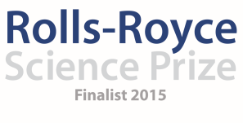

Saint Vincent’s Primary School
December Diary Entry

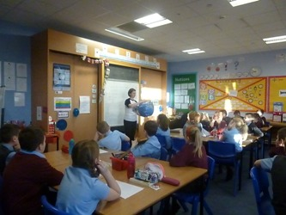
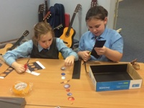
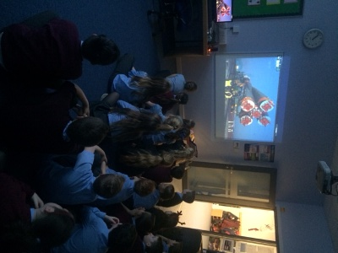
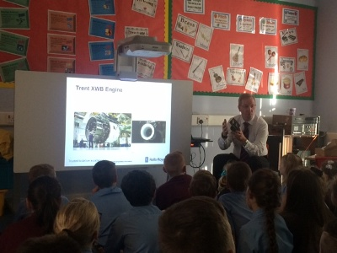
During week 3 of the Primary 5 block of after school activities, the pupils researched all about the solar system and then created their own solar system models from the research they had carried out.
This is just one of the eleven classes stopping for the morning to watch and enjoy the Tim Peake launch. The pupils engaged in a number of activities following the launch including designing their own rockets, training like astronauts, learning more about the ISS and designing a space suit for Tim.
When Neil visited the school, the senior pupils enjoyed learning more about where the Rolls-Royce Science Prize project comes from and what Neil’s role is for our own Science Prize team.
Astrophysicist Laura Thomas made a big impact on the Primary 6 pupils during her visit to the school to highlight the Tim Peake launch. The pupils created posters, solar system models, looked at satellites and really helped to build momentum in the school for the Tim Peake launch.

