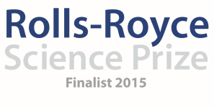
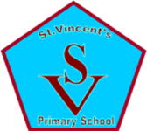

Saint Vincent’s Primary School
January Diary Entry
After School Clubs
This month we begin our Primary 4 set of after school clubs which also includes a full day visit to the Science Centre. Before planning our sessions for Primary 4, it was important to gather the views of the Primary 5 pupils to determine what they enjoyed, when they did their best learning, what they would keep the same for Primary 4 and what they would change (please see appendix 1). This helped us to decide what we arrange for the Primary 4 pupils to ensure their after school clubs will be engaging and suitable to the age and stage of learning for the pupils.
Team Member Summary:
Danielle Timmons:
I have been continuing to organise the Stargazing events for each after school club and our whole school stargazing events which take place in the school grounds. I have also been working on finding different CPD opportunities for Staff to further develop their confidence in delivering the Science Curriculum. Many of the staff continue to attend our after school clubs to see how we are using resources and engaging pupils in the science curriculum. I have also been organising different activities for the pupils of primary 1 to 3. With support from Yvonne Boyle, we have been looking at different resources and activities which would be suitable to the age and stage of the pupils in primary 1 to 3 when their after school activities start. I have arranged a visit from a company called Generation Science who will present a show called Night and Day to the Primary 1 and 2 pupils on the 2nd March. This will coincide with the beginning of their after school clubs and will act as a good introduction to the idea of the sun, the moon and the stars. I have also organised a trip to the Science Centre for all 75 Primary 3 pupils to visit the Planetarium the week before they have their stargazing night so that when we take the pupils stargazing at the Windfarm the visit will have more of a context and their learning in the planetarium will be fresh in their minds.

Liz Blake:
As I have been a teacher in Primary 4 for a number of years now, I am confident with the science curriculum at the stage and have a good understanding of what the children know and where they are in their learning in Science. For this reason, I have been very much involved in the planning for the Primary 4 after school clubs for this session as I am aware of what the pupils have already been learning and how we can take their learning forward through the after school club sessions. Last year, I visited the Science Centre with a Primary 4 class who were studying Mission X at the time and it was a very worthwhile experience in terms of developing their understanding of the work of Astronauts in the International Space Station. Therefore as part of the Primary 4 sessions of after school clubs I have organised for all Primary 4 pupils in the school to visit the Science Centre on Wednesday 20th January for a full day. During their visit, they will have the opportunity to do different Astronaut Training exercises and will see a 3D Imax film about the role of Astronauts on the ISS which will complement the work we are doing in class on Tim Peake and the work they will do at their after school Space and Astronomy Club.

Lorena Ziolo and Yvonne Boyle:
We have been responsible for organising our Inter-Disciplinary Learning (IDL) whole school creativity topic which has a focus on Space and Astronomy. From 6th of January until the 31st March, every class in the school will be engaging in an IDL Topic which will encourage all classes to look at the environmental aspects associated with Space and Space Travel. The topic is entitled ‘Our Fragile Earth’ and we have been consulting and working with a Creativity company Hidden Giants to help us create the topic and theme for learning in order to engage every class in the school. Our main role has been to consult with staff to ensure that they are all on board with the topic and have a firm understanding of what the topic is and have the confidence to deliver it. We will be supporting staff throughout this topic to ensure it has a big impact on the pupils and their understanding of Space in a wider context, particularly staff in the infant department as these pupils will require the greatest level of support.
The Topic:
The Topic itself is based around the idea that NASA is looking for the support of the future generations to help them with a new research project. We had a visit from Dr Gorman from NASA who explained to the pupils and parents that NASA has discovered that in just a couple of decade’s time, the earth will be uninhabitable. However, the discovery of 3 new planets, Planet X, Planet Y and Planet Z, means that we could potentially travel to and live on these. NASA has explained that they require the help of our pupils to carry out research into this to decide how possible this would be. The pupils have three months to carry out their research and answer any potential questions or problems that arise during this time as Dr Gorman will continue to visit the school and pose potential issues to consider. Each planet comes with its own challenge and the school has been split into three to research a different planet and the potential to live there. Primary 1-3 will be researching Planet X: The Desert Planet. Primary 4 and 5 will be responsible for Planet Y: The Rainforest Planet. Primary 6 and 7 will be responsible for researching Planet Z: The Ice covered planet. This will result in an International Conference with visitors from across the world (actors from Hidden Giants) and our very own Rolls-Royce Science Prize Mentor, Neil Chattle, coming to hear the results of the pupils’ work and research on the 31st of March. Each class will have to present their findings and demonstrate their understanding of the possibility of life on other planets with extreme conditions and their understanding of the harmful effects of global warming and space travel on earth.

Graham Kerr:
This month I have helped to plan out the space club sessions for P1-4, and some wider activities for the whole school. For the P4 class I have prepared a session on Pluto and space missions, where I will explain what we used to know about Pluto (not much at all!) and what we have learned in the past few months, since the arrival of the New Horizons spacecracft at Pluto. This will help the children understand the science behind such missions, that we have to carefully plan space missions years in advance (New Horizons spent several years en route to Pluto, in addition to a long time in development), and that obtaining unexpected results is an important way to further our understanding of the Universe. Following this discussion the children will be asked to put together a series of questions to be given to the New Horizons team that can be written up as an Interview with a Scientist in America via Skype to share with the rest of the school. I have been in contact with one of the senior New Horizons investigators, who has also agreed to work with the school to answer questions, and potentially have a Skype Q&A session with the older children. This is an exciting opportunity to talk with a senior scientist who has a careers worth of experience in designing space missions and interpreting the results of these missions.

Fiona Cleland:
This month I have been responsible for making links with our local Secondary School in terms of taking the Rolls-Royce Science Prize forward. In order to support the transition of Primary 7 pupils to Secondary school, we feel it is important that the Secondary are involved and have an understanding of the work that has been happening this year in terms of developing our pupils’ understanding of the Space outcomes in the Science Curriculum. We are currently organising an event for Primary 7 pupils to work with Fifth and Sixth Year students in February and ‘teach’ them how to stargaze and identify different features of the Night Sky. This will be a good opportunity to evaluate the impact of the after school clubs on the primary 7 pupils’ understanding and give them an opportunity to properly use what they have learned in teaching other pupils. We will meet with the Secondary School Science department on Thursday 21st January to confirm dates and organise different sessions to involve them with what has been happening in school.

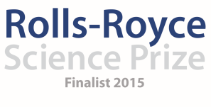

Saint Vincent’s Primary School
January Diary Entry
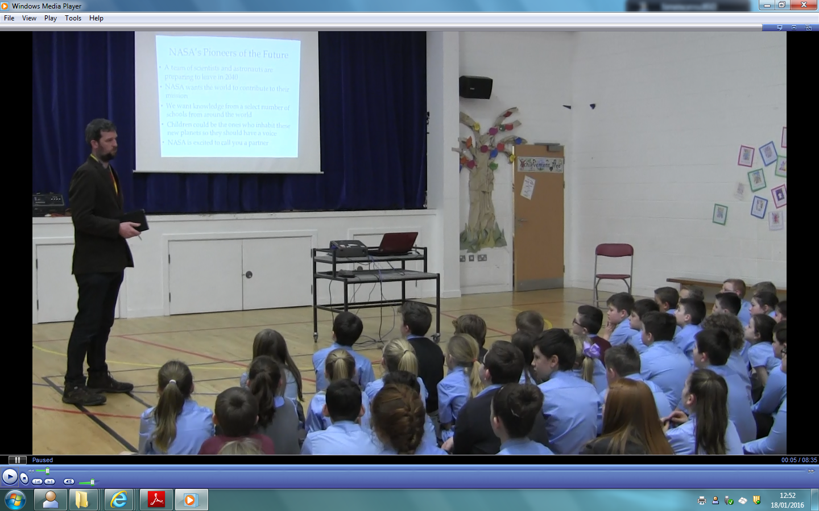
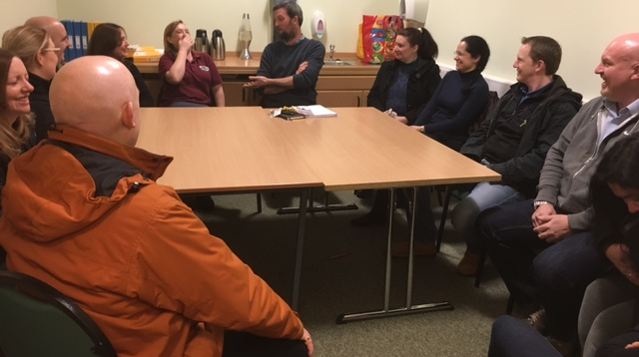
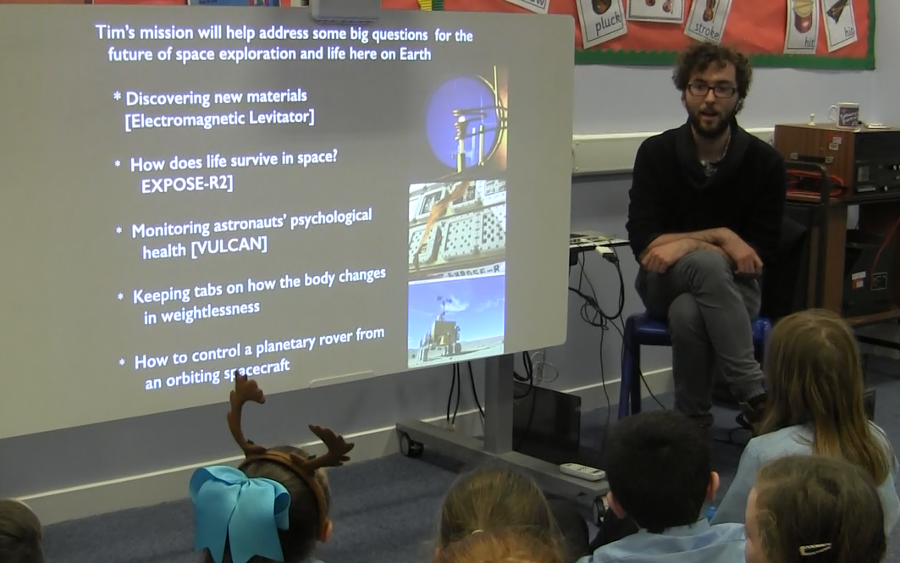
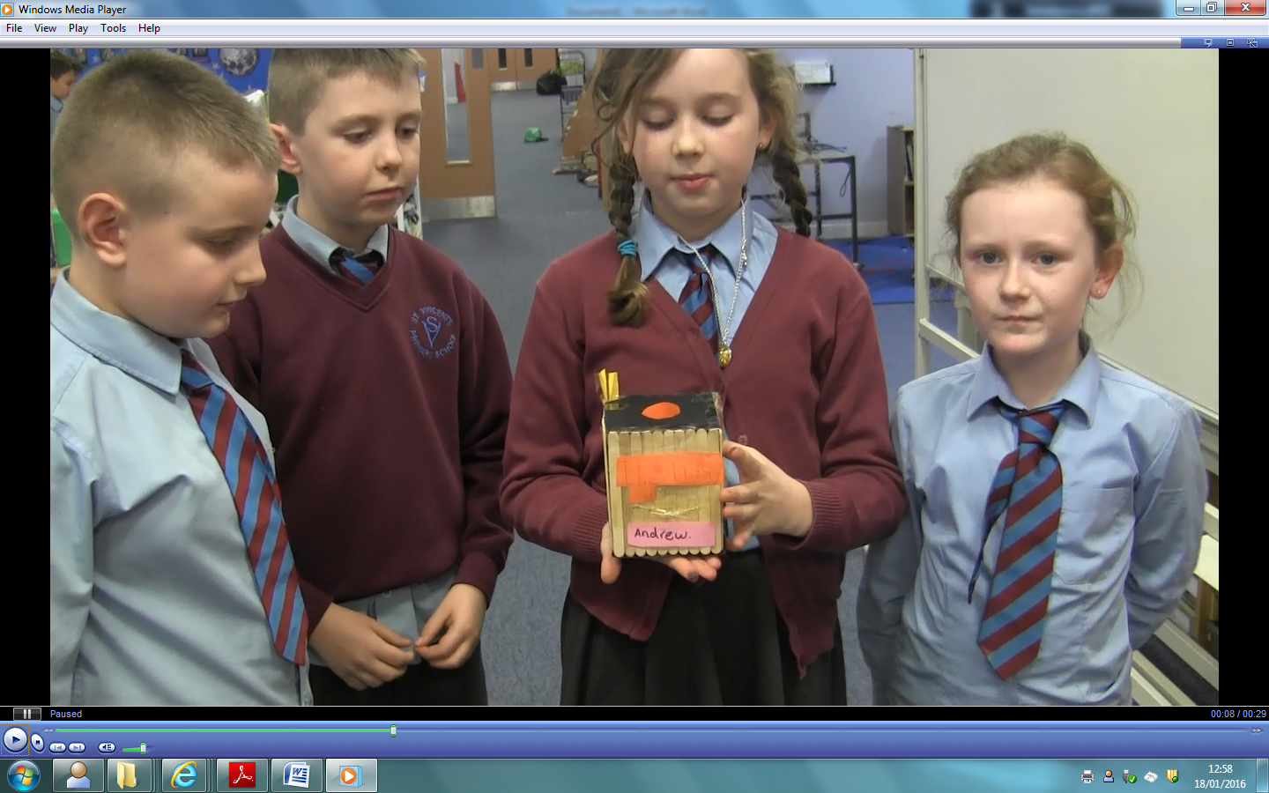
This is team member Graham Kerr explaining the science behind Cube Satellites and why they are used by scientists.
Parents from every class were invited in to the school to meet with Dr Gorman and discuss the work the children would be doing as part of the project, ‘Our Fragile Earth’ and how they could support the pupils in their learning at home.
This was the launch of Our Fragile Earth Creativity Topic. This is Dr Gorman from NASA explaining to the senior pupils the task that NASA has set them. The children asked some excellent questions at the end of the presentation and have now started working on finding answers for the NASA Conference on Thursday 31st March.
One of our Primary 5 sessions involved pupils making ‘Cube Sats’. They worked with Rolls-Royce Science Prize team member Graham Kerr who explained the science behind the Cube Satellites and assisted the pupils in creating their own. The groups were all able to talk about their creations at the end and explain exactly how their own designs worked.

