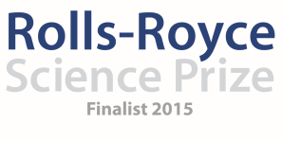
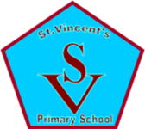

Saint Vincent’s Primary School
February Diary Entry
After School Clubs
This month we finished our block of after school activities with the primary 4 pupils. The activities that we had planned for Primary 4 were quite different to activities we had planned for Primary 5, 6, 7 in order that they were consistent with the Experiences and Outcomes of the Curriculum for Excellence at First Level but to also ensure we were building on the learning already happening in the classroom through the IDL topic. This term with the Primary 4 pupils, they visited the Science Centre in Glasgow, spending a full day learning about the training of astronauts, the night sky and seeing an informative 3D film in the Imax theatre about the International Space Station and the work of Tim Peake. All primary 4 children in the school attended and developed their understanding of the work of astronauts in the Space Station and seeing how their learning and the skills they are developing through the topic could be used in their future lives. The children also worked with Graham on learning and understanding more about Pluto based on the work of Professor Bagenal who will be speaking with the pupils in the school about her work and research in the New Horizons mission for Pluto. The children created a structure of the planets orbiting the sun to show how Pluto’s orbit is different and wrote questions to ask Professor Bagenal when we do our skype call with her. (Liz Blake)

Ongoing Monitoring and Evaluation:
Throughout our project we have been maintaining regular evaluations and feedback with the pupils and parents to ensure the work we are doing is having an impact on the pupils and their learning. Feedback from parents has been very positive and they have noted real engagement of their children in the topic. A number of the children asked for and received telescopes for Christmas and have been bringing them along to Stargazing Evenings and teaching their parents how to identify different stars and constellations in the night sky. Our Stargazing Evenings have been incredibly well attended and the feedback from parents has been very positive not only reflecting on their child’s enjoyment and enthusiasm but on the family experience of participating and learning from their own children. To ensure we are keeping our after school clubs interesting, challenging and suitable to the children we are working with, we have completed evaluations with all children at the end of each session and a final evaluation at the end of their four week blocks. This has been an effective way of establishing what has gone well in our sessions, when the children have done their best learning, identifying what the children have learned and helping us, as a team to decide what we plan to do with our next primary stage and how we can tailor it to suit the individuals at the clubs. (We have attached a selection of our feedback and monitoring as an appendix to this diary). It has been essential to gather the views of staff as well because ultimately our aim is to ensure that the learning that the pupils are doing at Space Club has an impact on the learning and teaching of science in the classroom. From the feedback we have had from the teachers whose classes have participated so far, they have each commented on a significant increase in confidence from many of the pupils in relation to science and a real enthusiasm for learning more and putting their new knowledge and skills in to a real life context by participating in Stargazing, visiting the Science Centre and working on research about Tim Peake. (Danielle Timmons)

Sustainability:
We are aware that we currently have a sizable amount left in our budget from the Rolls-Royce Science Prize, however this is with a view to making sure our project is sustainable and something we can continue to build on in the coming year. This month the team have been working together to establish a long term plan for the project and how we can ensure that we can keep up the momentum of learning about Science through Space and Astronomy. We are already planning a Science Week for September with a focus on Earth in Space, bringing all classes off timetable and inviting specialists in to work with the children throughout the week which our budget will contribute towards. We have also scheduled further visits from Cosmos Planetarium in to work with all pupils in October to work with new Planetarium resources and detailed information and video footage from the Tim Peake ISS Mission. In addition to that, we want to continue with Monthly visits to the Windfarm to carry out Stargazing from September onwards and for this we need £100 every time to cover the costs of the bus to ensure that we are able to provide spaces for all pupils, especially those who have no other method of travelling there and experiencing this with their peers. We will continue to work together on managing the budget in order that we can confirm plans for the coming year and ensure that the work we are doing will continue to have an impact on the pupils’ learning. (Yvonne Boyle)

IDL Topic:
Our IDL topic is having a major impact throughout the school. All classes are now fully submerged in their research to assist Dr Gorman (actor) in establishing the safest and most likely planet for pupils to live on when earth becomes uninhabitable. During our staff training day, we spent a great deal of time discussing each of the different elements of the project and sharing ideas for how to bring the topic alive and really engage the pupils. We have also been discussing how we plan to bring the topic together in March during our Nasa Space Conference. All classes will have their own ‘stall’ to discuss and reflect on the work that has been carried out and for a full day we will be welcoming in some important guests from Hidden Giants, Education Scotland, South Lanarkshire Council, Science Teachers from the local Secondary School, our Rolls-Royce Mentor Neil Chattle and of course our parents. At the minute, the Primary 6 and 7 pupils studying the ice planet are researching possible housing and building igloos. The Primary 4 and 5 pupils studying the Rainforest are currently considering climate and the impact on food and predators in survival. The Primary 1-3 pupils studying the Desert Planet are currently looking at clothing and the possibility of solar energy to survive. In relation to this, Graham has also been working with Professor Bagenal who has worked on the New Horizons project to give our senior pupils the opportunity to Skype call her from the Glasgow Observatory to question the research carried out into finding out more about Pluto and linking this back to our own work on researching life on other planets. (Lorena Ziolo, Graham Kerr)

Going Forward:
With the IDL topic on Our Fragile Earth having such a huge impact on the school community, we made the decision to postpone launching our whole school competition until after Spring Break. In doing this, we can ensure there is another focus for attention after the IDL project is complete to keep momentum going in the school for our Space and Astronomy topic. The 5th and 6th year pupils will also be visiting to work with our Primary 6 and 7 pupils on learning more about the night sky and will be joining us for a stargazing event where the Primary 6 and 7 will lead the learning. We have all primary 2 and 3 pupils visiting the Science Centre in March to take part in a planetarium show before doing their own stargazing and we also have visitors from Generation Science coming in to work with the Primary 1 and 2 pupils to better understand the concept of Night and Day in relation to the sun, moon and stars. (Fiona Cleland)

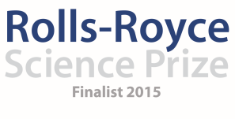

Saint Vincent’s Primary School
February Diary Entry

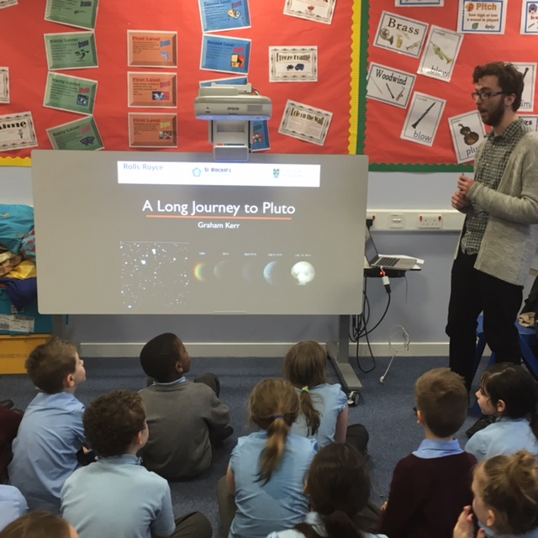
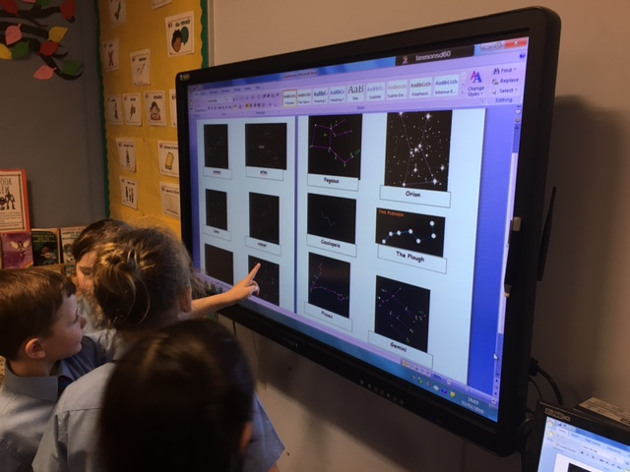
Graham Kerr was working with pupils in Primary 4 on Pluto research. The pupils then worked in teams to create a model which showed the way in which Pluto orbits the sun and how this is different to the way in which other planets orbit the sun. The children also created questions for Professor Bagenal that we will ask during our Skype call.

The children worked together to research and identify constellations in the night sky before creating their own marshmallow models. This was in preparation for their Stargazing evening so that the pupils of Primary 4 were confident with what they would be looking for.

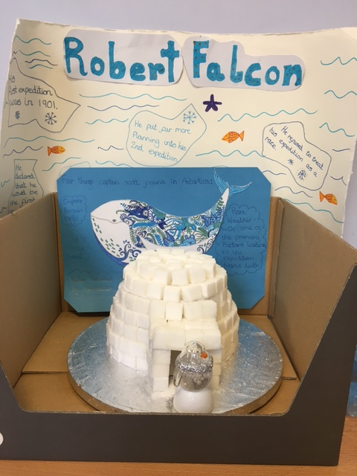
As the pupils continue with their IDL topic, they are working together to carry out research based on their contexts for learning. The primary 6 and 7 are currently researching housing in terms of survival on Planet Z. These pupils created a sugar cube model of an igloo and carried out research into different methods of living.

