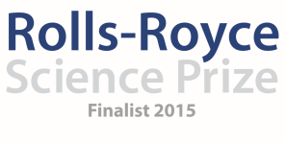
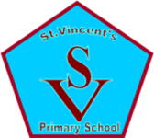

Saint Vincent’s Primary School
March Diary Entry
After School Clubs
This month our Primary 2 and 3 pupils started their after school club block. In all previous years in Saint Vincent’s, after school clubs are normally only ever offered to Primary 4 – 7 due to the activities we had on offer. Therefore, for us to be able to offer a Space and Astronomy club for all pupils from primary 1, 2 and 3 has been very popular and the uptake of pupils in Primary 2 and 3 for our after school club is the largest we have had to date. Session 1 for the primary 3 pupils was to work with our STEM Ambassador Steven Gray on Rocket Launching and the pupils were so enthusiastic about the activity and were able to fully explain their learning after the session. The primary 2 pupils really impressed us with their knowledge of the night sky following the work we have been doing with them all year to this point. They were able to identify a number of constellations, draw them on the computer and make them from Marshmallows. The primary 2 pupils also took part in the Generation Science Visit to explain, the sun, the moon and the stars and were able to recall a great deal of this knowledge during their first session in order to help them with their learning. (Yvonne Boyle and Lorena Ziolo)

Ongoing Monitoring and Evaluation:
We are continuing to monitor the progress of our project and the impact that the project is having on our pupils, parents and overall school community, especially as we determine how to take the project forward in the year ahead. Looking back at our original plans for our project, it is evident just how much the Rolls-Royce Science prize funding has allowed us to expand on our original ideas and really have a much bigger impact on the children than it would have done otherwise. Our original plan was to: ‘ensure all pupils would benefit from the experience and that the wider community would be involved also. The plan aims to provide a 4 week block after school clubs to every stage in the school. On the 4th week of each block, pupils will be invited to attend stargazing with their parents at our local Windfarm and ‘dark spot’. Our idea of having a 4 week after school block for all pupils in the school has happened, as have the stargazing nights at our local Windfarm. However, as well as that, we have been able to invite in specialists to work with our pupils from Generation Science, Cosmos Planetarium and ESRO and the children have had the opportunity to visit the Glasgow Science Centre on more than one occasion, visit Glasgow University Observatory and now have the specialist equipment to support their stargazing. Our feedback from parents continues to highlight how the project has surpassed their expectations and how their children are developing as a result. The teachers in the school are continuing to comment on the way in which the pupils in their class have a real knowledge of the Earth in Space Experiences and Outcomes from the Curriculum for excellence and even staff from the Science Centre commented that they had never had children as young as primary 2 and 3 with such a breadth of knowledge about the Night Sky. (Danielle Timmons)

Sustainability:
This month we secured a booking with our local bus company and Whitelee Windfarm to have another 7 months worth of visits to the Windfarm between September 2016 and March 2017. This will allow us to continue to take the children from all classes to the Windfarm in the coming school year so that the end of the Rolls-Royce project does not mean the end of our learning about Earth and Space. As previously mentioned, Cosmos Planetarium are now also booked in to kick off our Space and Astronomy Week in September to work with pupils from primary 1-7 on the Tim Peake Space Mission. Further to that, in planning and working with our local Secondary School we have put plans in place now for next year’s 6th Year Buddies to meet their Primary 7 pupils who will be transitioning to 1st year and accompany them on a stargazing visit where the Primary 7s will teach their 6th Year buddy from the Secondary School and this is now something we can continue annually. (Liz Blake)

IDL Topic:
Our topic on ‘Our Fragile Earth’ has also really taken shape and is beginning to really take over our school. All 3 areas of the school are transforming into the planet that they are studying and researching. Every week, Dr Gorman visits the school to introduce new complications or to ask new questions of the children to encourage their thinking and creativity. In addition to this, it has been very interesting to see how the topic as a whole for all three planets is now really focussing on the environmental aspects of living on these planets. The topic has encouraged children across the school from primary 1-7 to look at energy sources, creating, building and researching renewable energy sources for use on their planets. In addition to this, the Rainforest Team for Planet Y have been looking at the impact on nature if humans were to inhabit that planet and how we would conserve the environment. The teams for Planet X and Z have been looking at environmentally friendly housing; looking at having roof gardens, using solar panels, the materials we would use to build the dwellings on their new planet. This is not a route we ever expected the topic to go down and yet the impact it is having on the work we do in our school for Eco is huge and the children are growing more and more aware every day of the environmental impact of Earth in Space. (Yvonne Boyle and Danielle Timmons)

Going Forward:
On Thursday 31st March our school will host an ‘Our Fragile Earth Showcase’. Every class in the school will have an area in the hall to display their learning from the topic and children will talk about their learning throughout the project to our invited guests. As well as this, Neil Chattle will have his own stall for Rolls-Royce with staff from our very own Space and Astronomy Team to explain the project to our guests and our Young Engineers team will showcase their work in relation to the topic also. We have a number of invited guests for the morning including specialists from Education Scotland, SSERC, Headteachers from all schools within our Learning Community, the Head of our Learning Community, the Secondary School with 5th and 6th year pupils, our Parent Council, Steven Gray, David Aitken (our Young Engineers specialist), Staff from Whitelee Windfarm and many more. In the afternoon, parents are then invited to visit the school to listen to the children and see the work that has been happening throughout the project. At the moment, Primary 2 and 3 will continue with their after school clubs and the Primary 1 after school club will begin after the Easter break. Primary 2 and 3 will go stargazing on Wednesday 23rd of March which is why we planned the visit to the Planetarium one week before to ensure the learning was still fresh before doing stargazing at the Windfarm. We launch our whole school Space and Astronomy Competition on the 18th April with different categories for Parents, Seniors, Juniors and Infants with the finalists having the opportunity to have their creations made with a 3D printer. On the evening of Wednesday 30th March, our primary 6 and 7 pupils will visit the Glasgow University Observatory to speak to Professor Bagenal and learn more about the New Horizons project for Pluto. (Fiona Cleland and Graham Kerr)

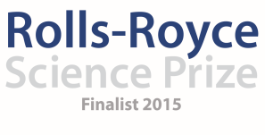

Saint Vincent’s Primary School
March Diary Entry

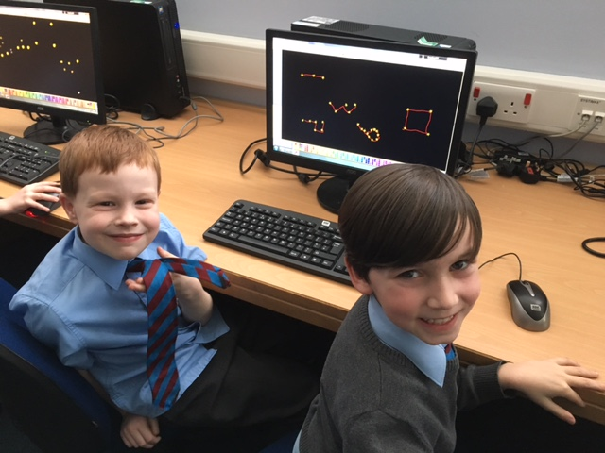
Our Primary 2 pupils were able to draw a range of constellations on the computer during their first night of Space and Astronomy club. They were able to name a range of constellations and then make them with marshmallows. That evening they were set the challenge of finding Orion’s belt in the night sky and many of the pupils reported the next day in their homework books of having stargazed with their parents in their gardens.

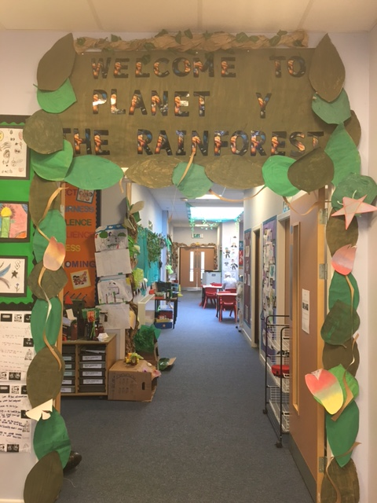

Each area of our school is turning into its own planet from the ‘Our Fragile Earth’ topic. This is Planet Y, the Rainforest Planet who have been researching how people could live on this planet. The Desert Planet classes have been researching Energy Sources and learning more about how they could power their planet and the Ice Planet are looking at wildlife and the impact human intervention would have on their living conditions.

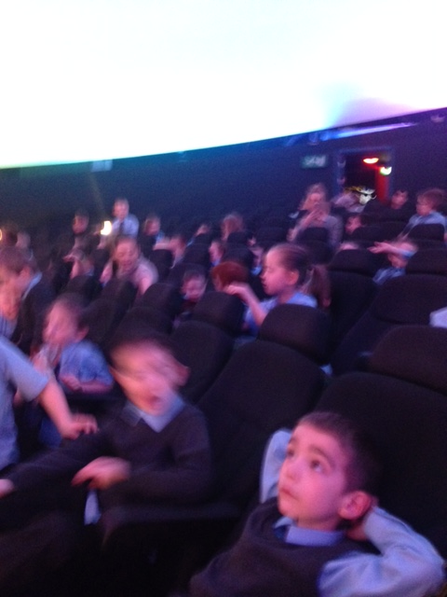
Our Primary 2 and 3 pupils visited the Science Centre in Glasgow to see a show in the new Planetarium. The feedback from the staff in the centre was that they had never come across children so young who were able to answer so much when it came to the night sky. The school staff were very impressed by the pupil knowledge and engagement. We have attached some pupil feedback in our appendix.

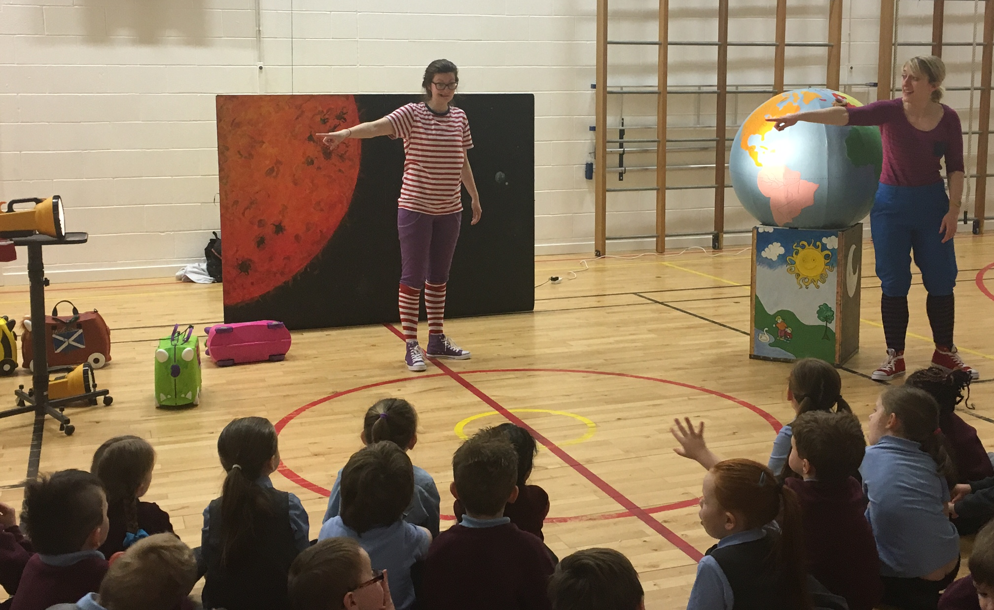
We organised a visit from Generation Science to work with Primary 1 and 2 pupils to help the children better understand the concept of night and day and the rotation of the planets and the cycle of the moon.

