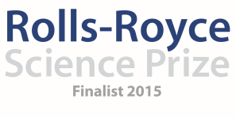
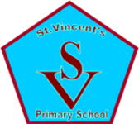

Saint Vincent’s Primary School
April Diary Entry
After School Clubs
This month, the Primary 2 and 3 pupils completed their after school clubs with a very successful trip to Whitelee Windfarm for Stargazing. This was attended by 46 pupils and 28 parents; one of our most well attended stargazing evenings to date considering this was only for primary 2 and 3 pupils. We were very fortunate to have support from the Whitelee Rangers who provided use of telescopes and also Steven Gray (STEM Ambassador from Cosmos Planetarium) who was able to set up our large telescopes which had been purchased using Rolls-Royce Science Prize Money. On this particular evening, Jupiter and the moons around Jupiter were very clearly visible through the telescope as was the full moon. This was such a special occasion for pupils, parents and staff within the school and feedback from all parents and pupils was incredibly positive. It was also excellent to see how many pupils and parents (and grandparents!) have purchased their own telescopes and binoculars to bring with them to the stargazing which really makes it a special family occasion and also highlights just how much of an impact our work in Space and Astronomy through the Rolls-Royce Science Prize is having on the entire community. (Lorena Ziolo)

Glasgow University Observatory:
For our Primary 6 and 7 pupils, we organised a visit to the Glasgow University Observatory where I work and was able to create a programme for the pupils which allowed them to visit the facilities, talk to other astronomers and carry out a live Skype call to Professor Fran Bagenal of the New Horizons team exploring Pluto. Thirty Primary 6 and 7 pupils as well as staff from the school visited the Observatory on the 30th March where we began with a Question and Answer session with Professor Bagenal where the children had written some excellent questions to develop their knowledge and understanding of Pluto and the research that has been carried out by the New Horizons Team. The pupils were really interested and although they knew some information about Pluto, the way in which Professor Bagenal was able to really explain the extreme temperatures helped to create a link with their topic about the Ice Planet and further develop their understanding of Pluto. Following this, I had arranged for the pupils to visit our Planetarium where I was able to talk in more depth about the Night Sky because of their now extensive knowledge of constellations and our galaxy. The children also had the opportunity to visit the observatory tower to see how we use the telescope to track planets and stars and to study different aspects of the night sky. This really caught the attention of our senior pupils and it was an excellent opportunity for them to see how they could continue to learn about sky and consider this as future careers. (Graham Kerr)

Creativity Showcase for IDL Topic:
This was a huge event within the school and overall, a massive success. Since January, the pupils throughout the school have been tasked with the challenge of researching the three new planets discovered by NASA; Planet X, Y and Z which was to culminate in a showcase of their learning where all pupils would present their findings to our ‘NASA Scientists’ on our ability to leave Planet Earth and survive on one of these other planets. The hall was transformed into a world showcasing all of the different planets and was a real reflection on just how much of an impact our Space and Astronomy Topic has been having not only on the pupils but on the staff within the school as well. Each stage of the school (primary1-3, Primary 4-5, Primary 6-7) was allocated an area in the hall which they could transform and display all of their work and learning since January. In the morning of the 31st March, we had a selection of specially invited guests from Education Scotland, SSERC, Whitelee Windfarm, Head Teachers and Teachers from within our Learning Community, STEM Ambassadors etc. who had the opportunity not only to visit the hall where children were able to confidently discuss their learning and the work they had on display but also had the opportunity to watch the children formally present their findings to our NASA Scientists. Every stage of the school made a presentation which explained what they had learned about their planets and provide arguments both for and against living on each of the different planets and being able to survive. The ‘Scientists’ and special guests (including our own mentor, Neil Chattle) were very impressed by the standard and quality of the presentations that even our youngest pupils were able to make and the way in which the pupils were able to articulate their answers when asked difficult questions at the end of their presentations. This again was a reflection not only on the hard work that all staff and pupils had been doing in class but the impact of our Space and Astronomy Project throughout the school. In the afternoon, our parents had been invited in to visit the hall and speak to the pupils about their learning and the work on display. The parent turnout was overwhelming, with it being one of our most popular attended curricular events to date. All feedback was incredibly positive from parents and we were able to capture a great deal of their enthusiasm both on camera and in writing. Again, the high numbers of parents attending that afternoon acts again as a reflection on just how much of an impact our project is having throughout the school community. (Danielle Timmons, Yvonne Boyle)

Ongoing Monitoring and Evaluating:
Our showcase event offered us a wonderful opportunity to gather views and feedback from a range of professionals and parents. The feedback has been overwhelmingly positive with many parents keen for our work to continue in the coming year. We have gathered evidence through our filming footage but also have a bank of written feedback from pupils, parents and professionals who have worked with the children or visited the school. Following our showcase event, we have been contacted by a number of other schools who have asked for the opportunity for their pupils and staff to visit Saint Vincent’s, to learn from our pupils and see the displays of work that have been created. This encourages involvement from our wider learning community and is an excellent opportunity for sharing learning, ideas and to have a wider impact with our Rolls-Royce Science Prize on the learning community. We continue to meet regularly as a team to discuss taking new ideas, projects and after school activities forward and have planned a number of different activities to take us through to summer including our competition, the Primary 1 after school clubs and into next year with our Space Week, ongoing visits to the Windfarm and from our STEM Ambassador Steven Gray.
(Liz Blake)

Going Forward:
This week we have launched our Rolls-Royce Space and Astronomy Competition which has different categories allowing Parents to submit entries, our local parish community to submit entries and each of the departments within the school for a selection of Space related prizes. This has been a very much long awaited competition and the pupils (and parents) were enthusiastic about its launch. All entries are to be submitted by Monday 30th May with the winners being announced at our whole school assembly on Wednesday 1st of June, during which parents will also be invited to attend. In addition to this, Primary 1 will now have an opportunity to attend our Space and Astronomy after school Club for their 4 week block. We have never really had an opportunity to offer an after school club to our primary one pupils before and so this is highly anticipated and we expect it to have a very high uptake. (Fiona Cleland)

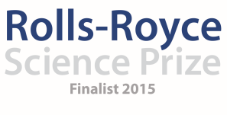

Saint Vincent’s Primary School
April Diary Entry
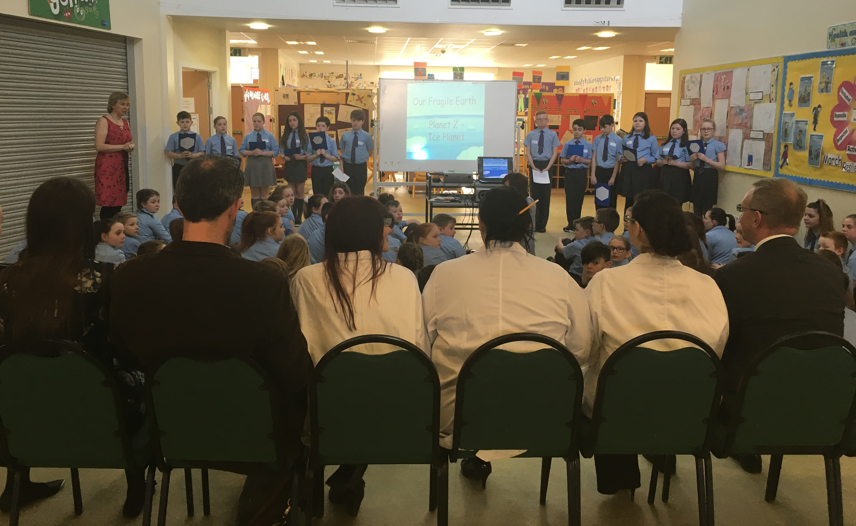
On the day of our Creativity Showcase, each class had the opportunity to present to our panel of Nasa Scientists, Dr Gorman, Neil Chattle and representatives from Education Scotland about their findings throughout the topic and what they had learned in relation to survival on Planet X, Y and Z.

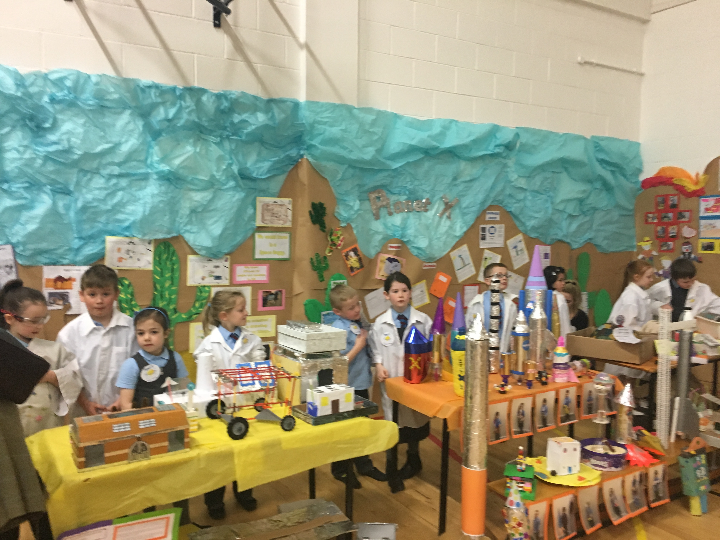

Planet X – The Desert Planet by Primary 1-3. This area took up the entire wall space at the back of the hall displaying all the hard work from the pupils in learning more about surviving on a desert planet. Throughout the showcase various pupils from primary1-3 were able to talk about all they had learned and talk about the work they had on display.

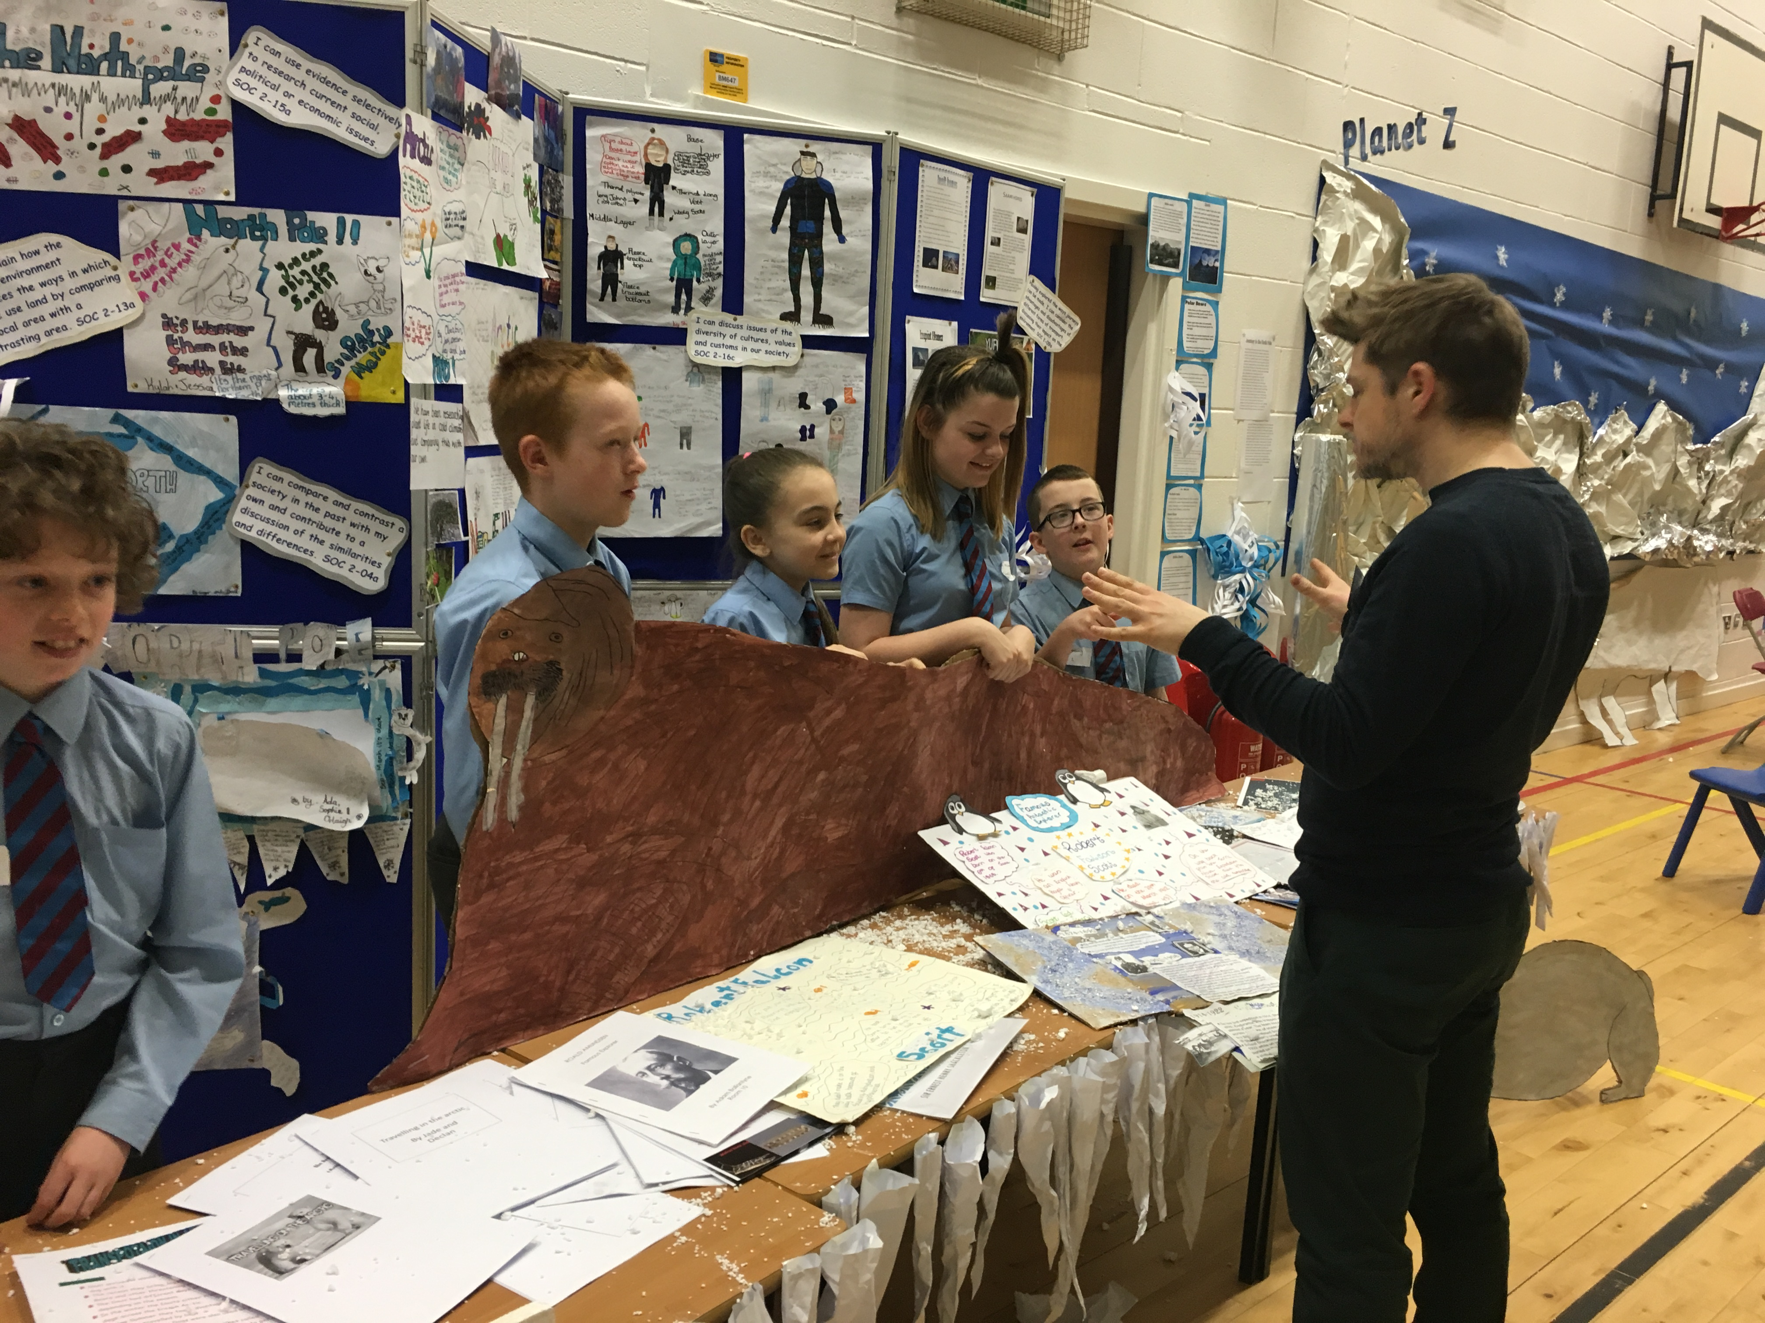

Planet Z – The Ice Planet by Primary 6 and 7. The pupils were able to talk confidently about how they would survive on Planet Z in terms of clothing, housing, food and how they would work together to avoid impacting on the environment around them. This is a group of pupils talking to a visitor from Education Scotland.

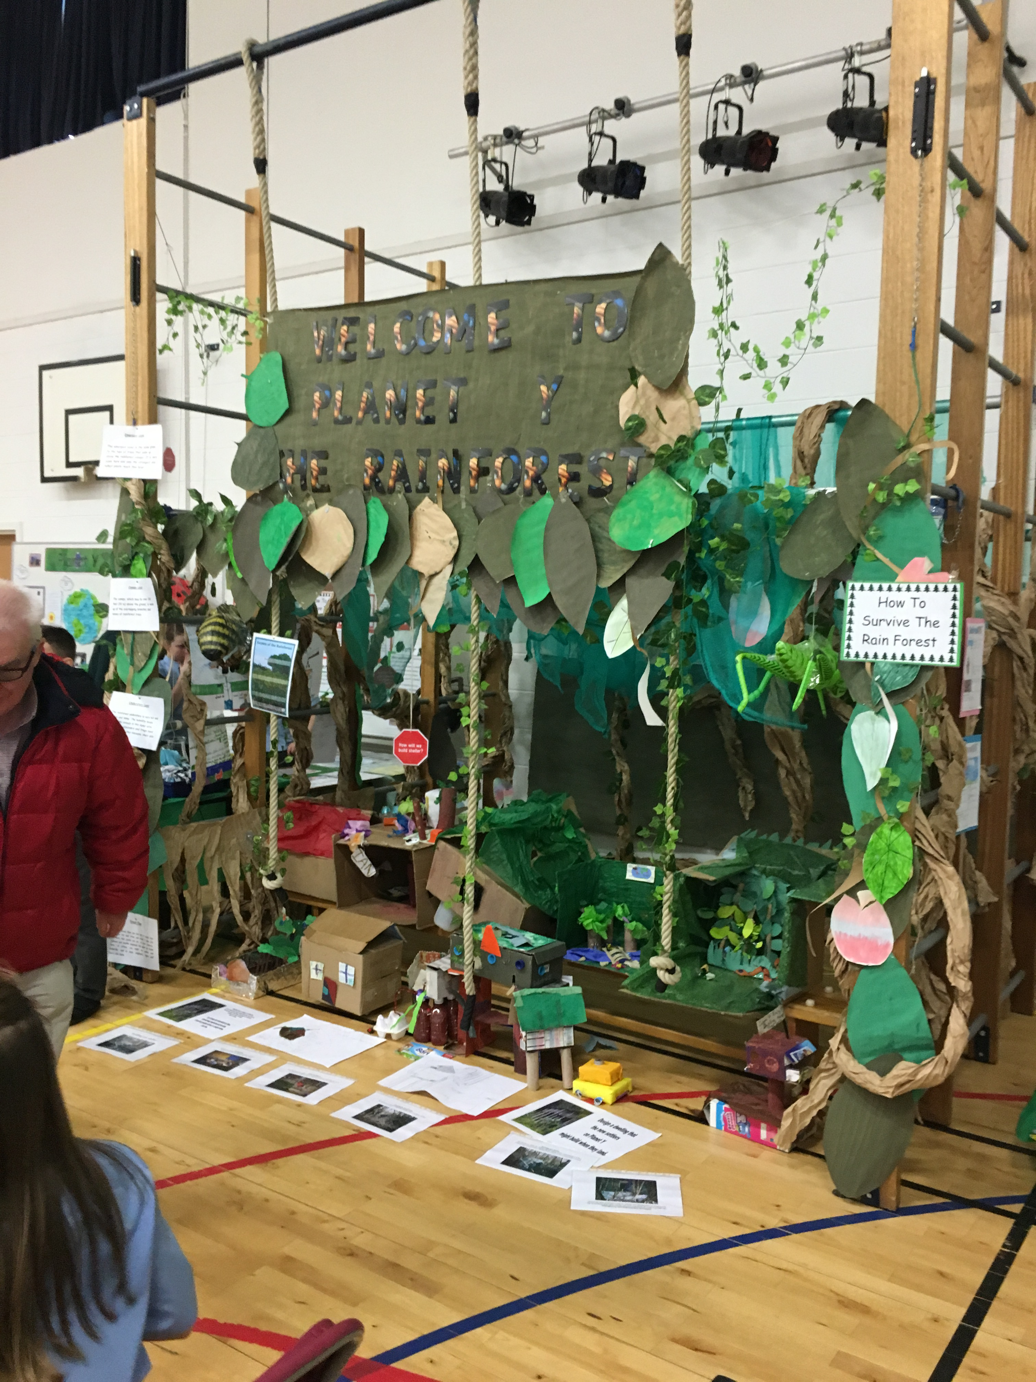

Planet Y – The Rainforest Planet by primary 4-5. These pupils created an entire rainforest inside the hall showcasing all of their work as well as having active experiments on show to explain how they would filter water to make it safe to drink on Planet Y. They were able to talk confidently to all visitors about their learning and why they believed living on Planet Y would be the best solution.

