Standards and Quality Report 2016-17
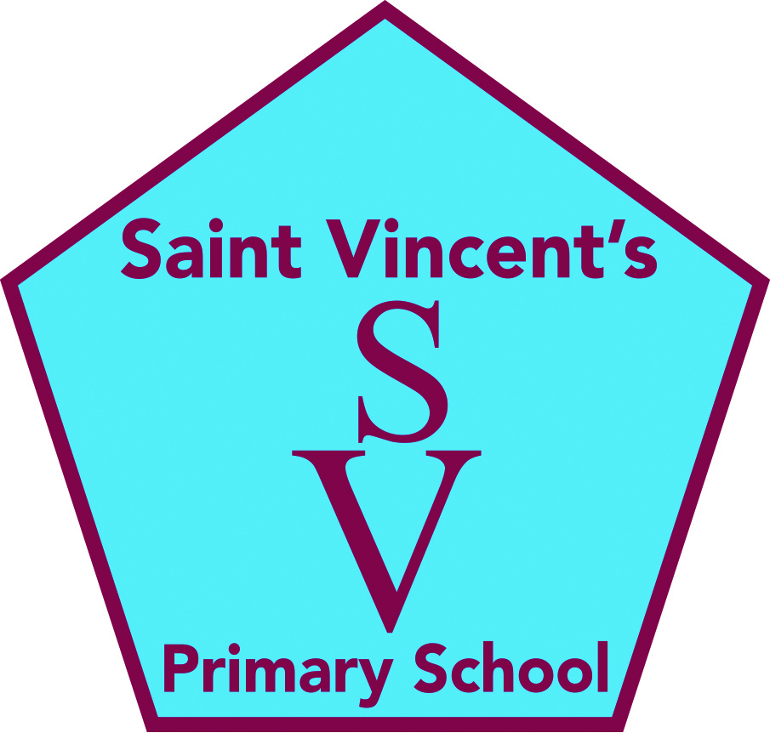
Saint Vincent’s Primary School
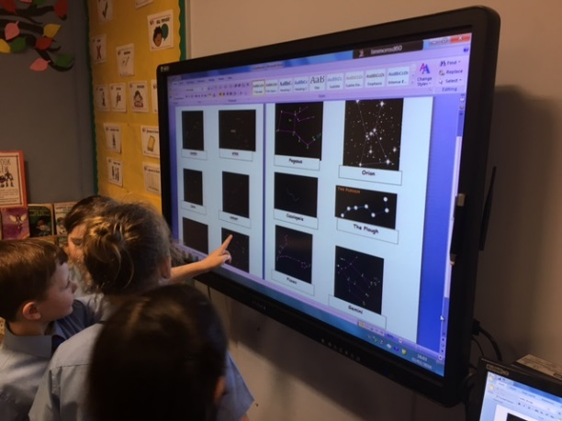
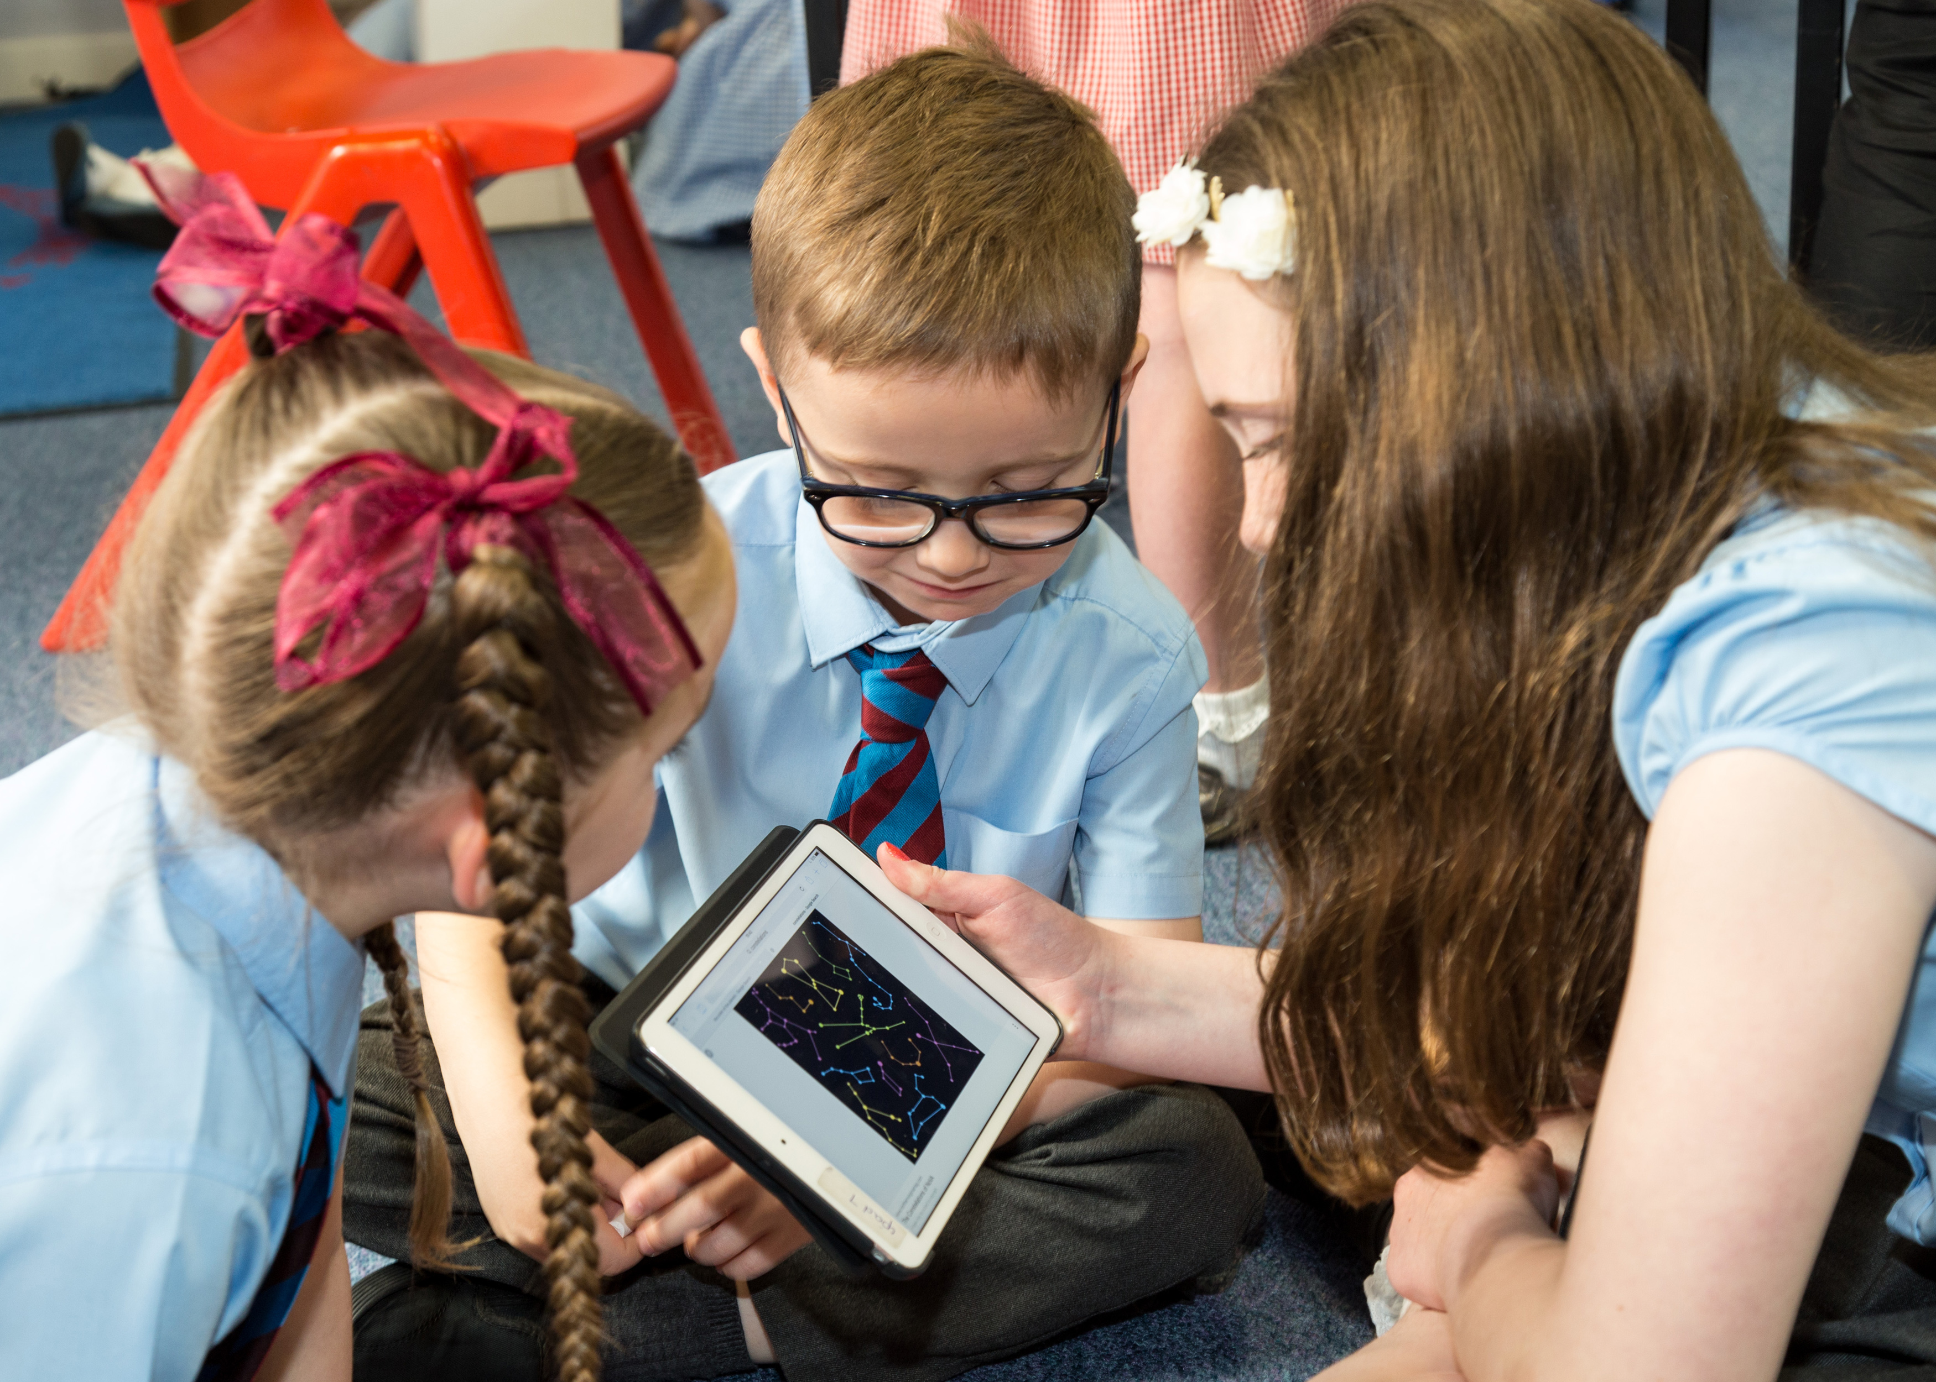

Context of the school:
Saint Vincent's Primary School serves the Greenhills/Lindsayfield area of East Kilbride and currently has a school roll of 318 reflecting the expansion in the local community from extensive building development in recent years .The school celebrated its tenth anniversary in its current modern school building which is shared with Ballerup Nursery in December 2016 and during last summer two open areas in the school were adjusted to create two new permanent classrooms. The school has made significant investment, with funding provided from fundraising by the parent council and other grants to furnish each of the twelve classrooms with up to date digital technology.
There is a strong tradition of education in Saint Vincent's for over 40 years .The school is highly regarded by the local community and works very effectively in partnership with Saint Vincent's parish, and with our Home school partnership worker Active schools coordinator as well as a number of organisations and businesses in the area and beyond.
Our school vision which is to provide quality education in a nurturing and creative environment where the achievement of excellence and the development of all is at the heart of our Catholic faith community has been formulated in consultation with the wider school community. Our deep core Gospel values of respect,resilience,kindness,friendship,fairness and excellence underpin everything we do in Saint Vincent's and mirror the charism of our patron Saint Vincent de Paul in this significant year the 400th anniversary of his mission .
Our school has an active Parent Council and the support of a number of volunteers whose contribution to the school in enriching the learning experience for our pupils is considerable.
As a member of Saint Andrew’s and Saint Bride’s learning community we have taken part in a variety of transition events and joint activities to provide for a seamless transition from primary to secondary .Similarly we work very well with Ballerup nursery and other nurseries to ensure that the transition from nursery to primary is well planned .
Our staffing has been generally stable but in the latter part of the year finding cover for longer term absences has proved very challenging. Our school has benefitted from the appointment of two of our experienced teachers to the principal teacher post on a job share basis which brings our staff complement to 14 consisting of HT, DHT, PT and 11.5 other teachers.
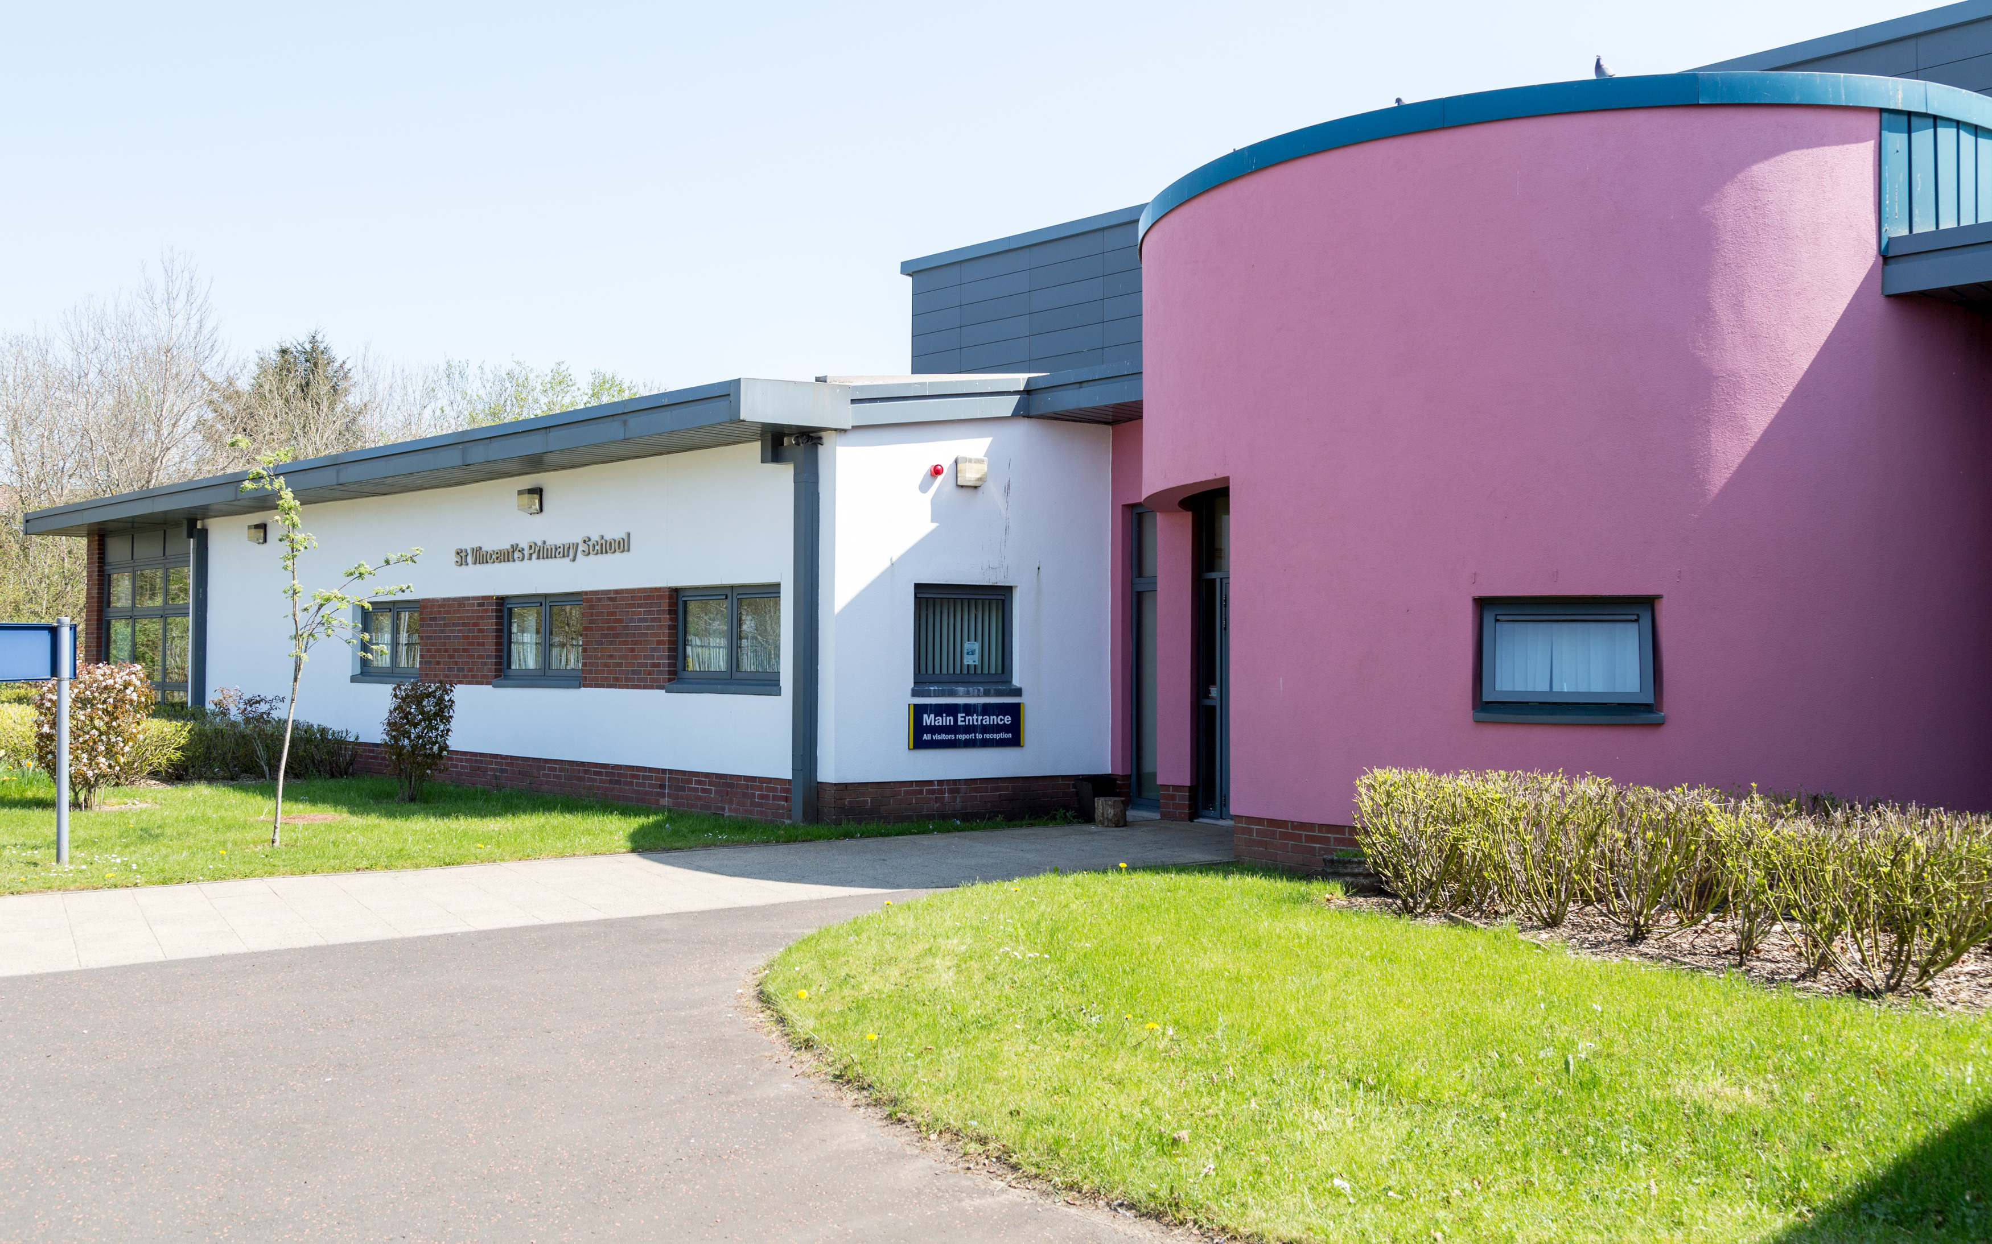

The National Context for Education
The National Improvement Framework (NIF) for Scottish Education sets out the Scottish Government’s vision to continually improve Scottish Education and to close the attainment gap, delivering both excellence and equity. Our school, working in partnership with South Lanarkshire Council is fully committed to delivering these ambitious aims.
The key priorities of the National Improvement Framework are:
- Improvement in attainment, particularly in literacy and numeracy
- Closing the attainment gap between the most and least disadvantaged children
- Improvement in children and young people’s health and wellbeing
- Improvement in employability skills and sustained, positive school leaver destinations for all young people

Key drivers of improvement have also been identified, these are:
- School leadership.
- Teacher professionalism.
- Parental engagement.
- Assessment of children’s progress.
- School improvement.
- Performance information.

Our school is committed to taking these priorities forward and developing each driver through our annual School Improvement Plan (SIP.)
Assessment of children’s progress throughout the Broad General Education (to end of S3)
As one of the drivers, our school, alongside all schools in Scotland, has been required to report on Curriculum for Excellence levels for literacy and numeracy achieved by all children at the end of stages P1, P4, P7 and S3. This data is submitted to South Lanarkshire Council in June each year and collected subsequently by the Scottish Government. This data is based on teacher judgement, informed by a wide range of assessment evidence including standardised testing where appropriate. As from session 2016/17 all schools in Scotland will be required to participate in the new Scotland National Standardised Assessment (SNSA) project. This will further help inform teacher judgement of levels.
The following table shows benchmarks for children achieving Curriculum for Excellence Levels.

Level | Stage covering 3 years approx.
Early | The pre-school years and P1, or later for some.
First | To the end of P4, but earlier or later for some.
Second | To the end of P7, but earlier or later for some.
Third and Fourth | S1 to S3, but earlier for some.  The fourth level broadly equates to Scottish Credit and Qualifications Framework level 4.  The fourth level experiences and outcomes are intended to provide possibilities for choice and young people’s programmes will not include all of the fourth level outcomes.
Senior phase | S4 to S6, and college or other means of study.

Some children and young people will start learning at these levels earlier and others later, depending upon individual needs and abilities. Many children not attaining National Levels will have an Additional Support Plan (ASP) and may be making good progress but against different milestones e.g. individual targets. Learning progress is not about how fast children move through the levels but about ‘how much’ and ‘how well’ children learn, having depth and breadth of experiences at each level.
Assessment of these levels is based on a wide variety of evidence and ways of measuring progress such as assessment of projects, general class work, observations and peer assessment. Where possible, children and young people are encouraged to be directly involved in the assessment process.
Schools and teachers work with others to set shared standards for assessing progress. These standards are based on National “benchmarks” for each area of the curriculum. This process is called moderation and it ensures that schools have similar expectations.
What follows is our school’s data about achievement of these levels for sessions 15/16 (when data was first collected) and 16/17.

1.1 Attainment data - Attainment of Curriculum for Excellence levels 2015/16 (teacher judgement)

 | Reading |  |  | Writing |  |  | Listening & Talking
School | P1 Achieved Early or better | P4 Achieved First or better | P7 Achieved Second or better | P1 Achieved Early or better | P4 Achieved First or better | P7 Achieved Second or better | P1 Achieved Early or better | P4 Achieved First or better | P7 Achieved Second or better
St Vincent's Primary | 84.9% | 88.9% | 81.0% | 88.7% | 82.2% | 64.3% | 88.7% | 88.9% | 83.3%
SLC | 80.0% | 75.2% | 72.3% | 78.2% | 67.9% | 62.7% | 83.8% | 82.6% | 79.7%
National | 80.8% | 75.2% | 72.3% | 78.2% | 69.3% | 65.1% | 85.0% | 80.9% | 77.4%

 | Numeracy
School | P1 Achieved Early or better | P4 Achieved First or better | P7 Achieved Second or better
St Vincent's Primary | 88.7% | 86.7% | 66.7%
SLC | 83.0% | 71.2% | 67.9%
National | 83.9% | 73.1% | 67.8%

1.2 Predicted Attainment

National Improvement Framework - Attainment of Curriculum for Excellence levels 2016/17

 | Reading |  |  | Writing |  |  | Listening & Talking
School | P1 Achieved Early or better | P4 Achieved First or better | P7 Achieved Second or better | P1 Achieved Early or better | P4 Achieved First or better | P7 Achieved Second or better | P1 Achieved Early or better | P4 Achieved First or better | P7 Achieved Second or better
St Vincent's Primary | 85.71% | 73.81% | 76.60% | 85.71% | 61.90% | 72.34% | 87.50% | 78.57% | 85.11%

 | Numeracy
School | P1 Achieved Early or better | P4 Achieved First or better | P7 Achieved Second or better
St Vincent's Primary | 85.71% | 66.67% | 72.34%

Achieving Excellence: Overall Progress towards National Improvement Framework Priorities
Session 2016-17
Use all available evidence (including data)

Literacy:
Progress | satisfactory | good | very good | excellent
 |  |  | x

Strengths
Our data and other evidence shows that in session 2015/16 that areas of strength were our performance in Reading and Talking and Listening in P1,P4 and P7 where our pupils performed better than both the SLC and national average. Similarly in writing at P1 and P4 our pupils outperformed SLC and national averages with particular strengths in primary 1 while results for writing in P7 showed a dip falling slightly below national averages but still above SLC averages. However this year’s predicted attainment for this cohort indicates 8 % improvement in writing for this cohort but a dip at primary 4.
Data from reading engagement surveys would indicate that attitudes and behaviours towards reading are shifting and this reflects the focus that has been on promoting reading for enjoyment particularly among boys at all stages of the school .
At all stages of the school pupils now engage with a wider variety of texts and there is consistency in the use of comprehension strategies and the focused development of reading skills.
Between February and June 2017, our Primary 7 teachers and selected staff of the English department of St. Andrew’s and St. Bride’s worked collaboratively in a pilot to meet an identified need for learners: targeting reading skills, in particular those associated with Reading for Understanding, Analysis and Evaluation (RUAE). The initiative comprised collaborative planning; fact finding through questionnaires; resource development and consultation; bi-sector reciprocal visits; parent/staff workshop delivery; a unit of lessons; a homework series; baseline and final assessment. The primary aim was to significantly improve performance in a discreet question type (translating into your own words), with the associated success criteria being a 15% average difference. The study produced an average improvement in pupil performance of 41% and an additional success was moderation experiences reduced disparity between primary and secondary judgements on pupil abilities from 5.8 marks to 0.1 marks

Areas for Development
We will continue to address the attainment gap in literacy by targeted interventions for particular pupils, staff training and the use of new resources to promote parental engagement and pupil motivation.
Further develop the use of digital technology to enhance curriculum especially for pupils who require individualised programmes and also to build on the work undertaken during 2016/17 in Moving Image.

Numeracy:
Progress | satisfactory | good | very good | excellent
 |  | x
Strengths
Our data and other evidence shows that in session 2015/16 performed better than SLC and national averages with almost 90%of our P1 pupils achieving early level or better. However results in P7 were slightly below national and SLC averages. Predictions for this session would indicate that we will continue to achieve in primary 1and an improved result for our primary 7 cohort but a dip in primary 4.with most of the children in primary 1 securing early level. Across all stages children are developing skills in numeracy and mathematics and most children are able to apply these skills very well.

Areas for Development
During the past session we moved to a new planning model and during the coming session our focus will be on ensuring that we address the attainment gap for children in receipt of Free school meals. We have already planned more focused help from support staff for individual pupils following Catch Up training.

Health and Wellbeing:

Progress | satisfactory | good | very good | excellent
 |  |  | x

Strengths There has been a continued focus on the development of health and wellbeing throughout the school with staff training provided in the nurturing school and other programmes .In the absence of a dedicated nurture class, the continued focus on providing nurturing support for our most vulnerable pupils is always a priority when any additional staffing is available.
All staff engage with partners and input during multi agency meetings to support individual children.
The launch of the school breakfast club as well as other courses and opportunities provided for targeted families in conjunction with our Home school partnership worker show evidence of increased participation and very positive engagement
This year we launched the learning of children's rights throughout the school with a week dedicated to visitors from the Commissioner’s office and lessons based around rights. We continued to have a monthly focus on wellbeing indicators school values and thinking circles with opportunities to recognise and celebrate wider achievements at weekly and monthly assemblies.
Areas for Development
We will have a renewed focus on mental and social wellbeing and specifically target PEF funding children through targeted sessions. We will continue with a rights focus month, continue with monthly wellbeing and values and look closer that improving social and emotional health as well as food technology
The provision of clubs and other opportunities will include a specific focus on addressing the needs of families with a free meal entitlement.

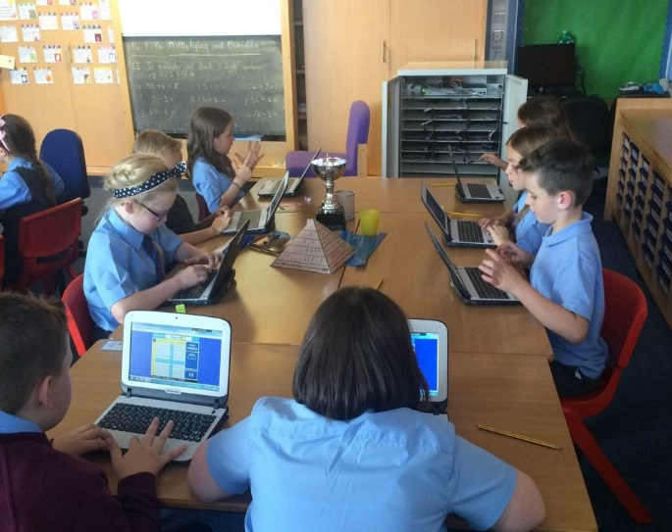

Employability Skills/Positive Destinations:

satisfactory | good | very good | excellent
 |  | x

Strengths
There has been a continuous focus over a number of years to develop skills for learning, life and work with high profile involvement from partners ranging from Sir Tom Hunter following the school’s success in the Micro Tyco pilot to BBC Scotland, Morgan Stanley, Spy Quest, Hidden Giants, Sense Scotland and Rolls Royce during the current session. Pupils are actively encouraged to develop their enterprise skills with opportunities for practical engagement. Our Masterclass programme incentivises our children to give of their best through the week and provides weekly opportunities for pupils across the school to develop skills for learning, life and work .Enterprise month develops our partnership working ,encourages teamwork ,communication and a raised awareness of personal skillset and evidence of this is captured in books produced by each class . Our Young Engineers, Raspberry pie and Spy Quest Clubs have all contributed to raising pupils’ awareness and aspiration in career choice.

Areas for Development
During the coming session we will work with Hidden Giants to develop creativity in conjunction with work already taking place. The Enterprise committee will organise a careers day and we aim to continue to develop our partnership working.
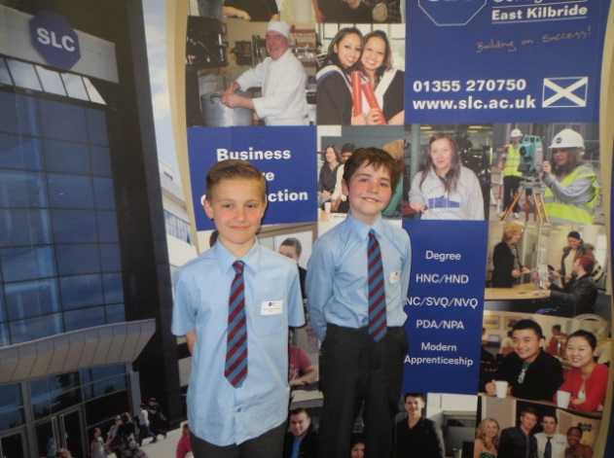
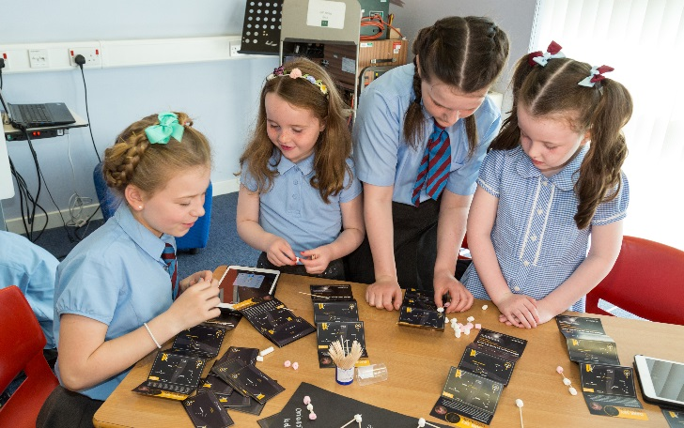
Overall quality of our learners’ achievements
Highlights of session 2016-17
The following were some of the highlights of session 2016-17:
- Saint Vincent's was awarded second place in the prestigious Rolls Royce UK wide Science competition.
- The usual programme of Christmas events including P1-3 Nativity, Cafe Noel and Christmas Carol performances gave each child the opportunity to perform and were exceptionally well attended.
- The Passion Cantata was staged by Primary 6 and Primary 7 over three performances to capacity crowds with a special afternoon performance for pupils from 6 other schools. And received huge praise from all who experienced it summed up in the following feedback:” Well I’ve never seen anything like it. can’t believe it was performed by primary school children absolutely beautiful and sheer professionals”
- Pop Up recording and showcase involved each child in Primaries 3 to 5 and culminated a very memorable performance in Westwoodhill parish church
- P7 pupils took part in their annual visit to Edinburgh to see a Musical and also enjoyed a very successful residential outdoor learning excursion in the Abernethy Centre Barnacle.
- Saint Vincent's pupils were winners and runners up in East Kilbride Fairtrade poster competition, Glasgow Music Festival and Lanarkshire chess tournaments.
- Saint Vincent’s pupils participated In the Rotary Quiz and also in the Euro quiz competition.
- Saint Vincent’s pupils took part in a variety of lunchtime and after school clubs and successfully represented the school at a number of sports events including athletics competitions, football tournaments and rugby festivals.
- Saint Vincent's pupil was a finalist in the Scottish School chess team selection event
- The whole school took part in a variety of workshops including Children’s Rights NSPCA, Air Quality Google expeditions and Coding workshops from Morgan Stanley volunteers.
- The school launched monthly wider achievement assemblies with guest speakers and at weekly class teachers promoted school values by rewarding selected children from each class with a certificate for their efforts.
- All children were incentivised to give of their best and rewarded for their efforts through the week with attendance at their preferred master class each Friday.
- Our school choir performed by invitation at Lanarkshire Schools Orchestral Concert, Harmers Hospital, and Lee Burn Restaurant and at the Schools Achievement Awards celebration and 3 children took part in the South Lanarkshire vocal day and subsequent performances.
- Pupil council representatives attended Parent Council meetings, EK South Pupil council meetings with other local schools and were also invited to join Andy Kerr CEO of Sense Scotland at Touch base for a business lunch.
- Pupils from P7 were invited to present to a South Lanarkshire Creativity conference where representatives from schools were “motivated and encouraged” by their “inspirational” report on Creativity in Saint Vincent’s.
- Pupil voice was encouraged at all stages with all pupils having the opportunity to take part in Thinking Circles and also to participate in events such as Ecoe’en, Talent shows and Learning Outside day.
- All classes took part in a whole school excursion to Blair Drummond Safari Park following the launch of The Sanctuary Saviours interdisciplinary topic and in turn they showcased their work over the term that followed at an open afternoon for all classes.
- All classes followed the development of the chicks with all children having the opportunity to look after the hatchery on their own corridor.
- Our Young Engineers presented at the nationwide SCDI celebration event in Glasgow and judges’ comments were that Saint Vincent’s exhibits were “Extremely engaging, interactive presentation with great demonstrations - especially apps. Good to see problem solving skills used and very practical solutions to everyday problems. Good to see STEM Ambassador involvement with the school.”

Comment on strategies that have been successful in engaging with children and young people, staff, parents and the wider community.
- Parents were invited to engage with and celebrate their child/ren’s learning at a wide variety of events in the school throughout the year. These included performances, class showcases, workshops, school sports day. Feedback was always very positive as reflected in this comment :

“It was an absolute joy to be invited along and join in with the school celebrations. The children and teachers put such a lot of work into their productions “
- Families of children involved in sacramental preparation attended school meetings and church celebrations for the sacraments in large numbers.
- Parents meetings with individual appointments for all children took place in October and March had 100% attendance in almost all classes.
- Transition events for our P7 leavers and Pre-Entrants were consistently well attended and gave parents and pupils the opportunity to be well informed and equipped for transition.
- Review meetings and enhanced transition meetings were organised for particular pupils
- The Open afternoon in August received very positive feedback from the 84 parents who visited their child’s class but was less well attended in the senior classes.
- All classes devised their own products for sale and organised their own stall at the Christmas fayre organised by the Parent Council. This event was very well attended, fostered community links and helped children develop their enterprise skills.
- The Mother’s day celebration where our primary 1 linked their enterprise skills with a showcase to honour their Mums was a hugely popular, well attended and much appreciated event.
- All classes took part in fundraising for the school charity Mothers care India during Lent when each corridor was given an opportunity to organise and promote an event.
- We placed a considerable emphasis on promoting family learning through our revised homework policy which encouraged the use of a placemat of activities
- Following parental consultation, our Home school partnership worker organised a number of events including family quizzes and a book club which were open to all. Parents and the wider community were also given volunteering opportunities that enhanced learning experiences for some targeted pupils through Scotland Reads, Grandbuddies, Cookery classes, Story sacks and an excursion to Glasgow with 12 parents and children to promote family learning.
- Parent Consultation mornings and parent council meetings gave parents the opportunity to contribute to school improvement and also to shape changes in school policy regarding homework and the use of mobile phones. Parents’ views were sought, acted upon and contributed to changing of practice e.g. Parents lining up in the school yard
- Parents and grandparents were involved in supporting the delivery of curriculum including a lunchtime Spanish club, Maths Challenge day ,ongoing mentoring of our Pope Francis award pupils.
- Parents and grandparents ran the school library, credit union and also gave ongoing literacy and numeracy support to groups of children through the year as directed by class teachers.
- All staff engaged in a variety of CLPL opportunities egg. Visits to and from other schools, professional enquiry , peer and trio observed visits and participated in the establishment of a very successful sharing good practice forum to develop good practice and share their skills .
- Some teachers were invited to present at authority and national events all of which received very positive feedback.
- All classes took part in a very worthwhile authority teaching and learning school visit and some classes had visitors from British Council, Glasgow University to observe good practice in Creativity and Christian Meditation.
- Primary 7 staff took part in a language pilot with staff from the secondary to devise new materials and approaches
- Parents and the wider community were regularly informed of what was happening in our school, invited to participate and to celebrate the schools achievements through regular updates in the school website, school newsletters and reports in authority wide publications, local and national newspapers.

- The following message from a parent via email captures a flavour of many of the highlights of the year and the positive feedback received : “between last night’s confirmation, the first holy communion ,the P4’s concert down at the Westwood ,the recent show in the church by the P7’s ,all the recent trips, the club’s during and after school , The Rolls Royce science prize, and not least the first class learning experience our children have the opportunity to be exposed to , you are entitled to look back (with delight ) on what has been achieved”.

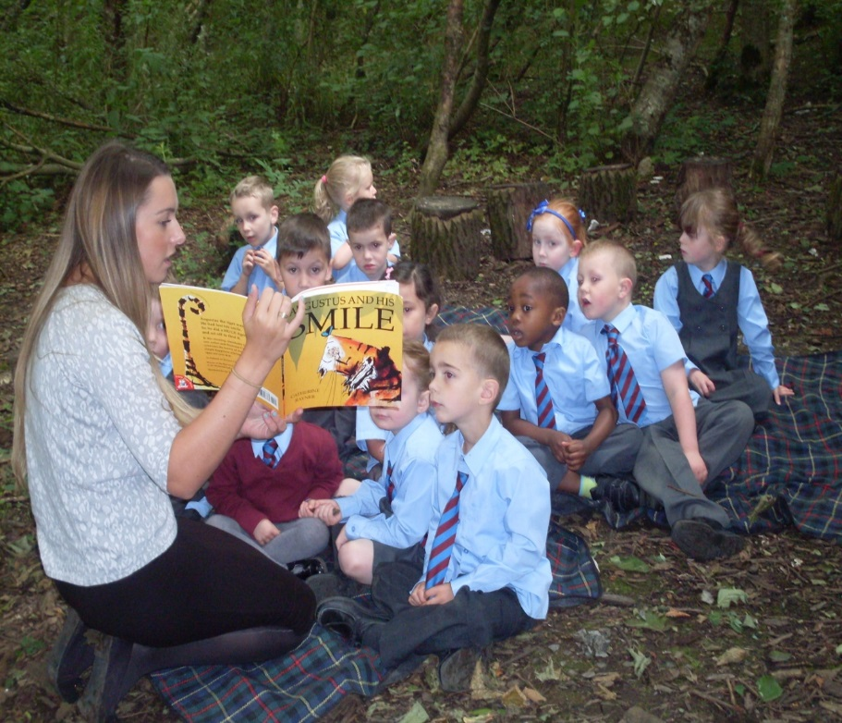

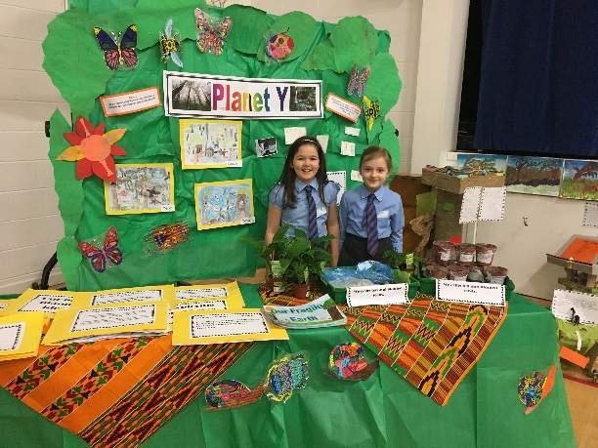
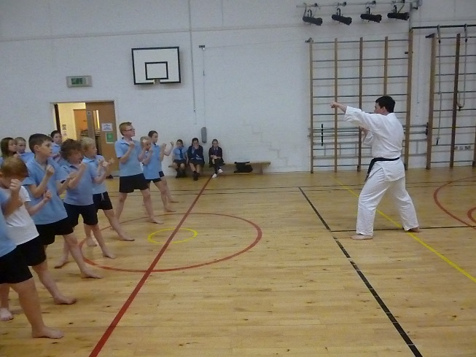
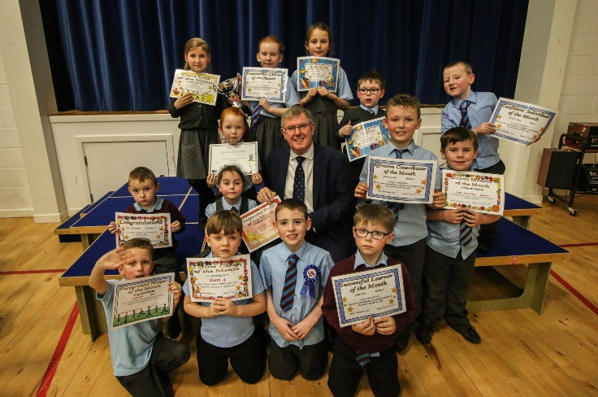
Review of SIP progress session (2016/17)

Priority 1: Development of assessment and moderation of literacy and numeracy

National Improvement Framework Key Priorities  - Improvement in attainment, particularly in literacy and numeracy;  - Closing the attainment gap between the most and least disadvantaged children;  Improvement in children and young people’s health and wellbeing; and  - Improvement in employability skills and sustained positive school leaver destinations for all young people. | National Improvement Framework Key Drivers  - School leadership  - Teacher professionalism  - Parental engagement  - Assessment of children’s progress  - School improvement  - Performance information
HGIOS 4 QI: 2.2 curriculum 3.2 raising attainment and achievement
2.6 Transitions 2.7 Partnerships
Progress and Impact:
- Evidence from class visits, pupil dialogue and regular feedback from ongoing professional dialogue with colleagues would show that staff show an increased confidence and there is consistency in teaching and learning, assessment and moderation of literacy and numeracy. This has been achieved by staff having access to appropriate professional learning new resources, opportunities for shared planning and moderation and regular dialogue with colleagues including shared moderation activity with learning community colleagues.. The culture of our school reflects an inward, outward, forward looking approach to learning where staff actively seek out and share good practice through visits to other schools and through engagement in practitioner enquiry by student teachers and some upper school staff with secondary colleagues.
Next Steps:
- Continue to refine and develop a robust tracking system in line with the direction from SLC and continue to interrogate the data from standardised testing to monitor progress and use diagnostic elements to address individual needs. Engage in moderation activities and relevant professional learning within and out with school to confirm and inform professional judgements.

Priority 2: To empower the school community to develop as a community of faith through increased parental involvement ,support and guidance and through developing partnerships to provide a wide range of opportunities for achievement ,pupil participation and the promotion of global citizenship.
National Improvement Framework Key Priorities  - Improvement in attainment, particularly in literacy and numeracy;  - Closing the attainment gap between the most and least disadvantaged children;  Improvement in children and young people’s health and wellbeing; and  - Improvement in employability skills and sustained positive school leaver destinations for all young people. |  | National Improvement Framework Key Drivers  - School leadership  - Teacher professionalism  - Parental engagement  - Assessment of children’s progress  - School improvement  - Performance information
HGIOS 4 QI: 1.1 Self-evaluation for self-Improvement. 1.2 Leadership of learning, 1.3 Leadership of change 1.5 Management of resources to promote equity. 2.5 Family Learning .2.6 Transitions 2.7 Partnership 3.1 Ensuring wellbeing, equality and inclusion 3.2 raising attainment and achievement.
Progress and Impact:
We have worked to enhance the existing good practice at all stages of the school by providing additional opportunities for parental involvement via consultative groups ,family leaning activities, showcases of learning and events for parents to come together to celebrate faith and their children’s achievements.
An evidence-based analysis of the needs of children and their families underpins our approach to build the capacity of each child to enable them to experience success in learning and attain their potential. Parents are helped to develop their skills and increase their engagement with the school so they can effectively support their child’s learning through workshops and planned activities customised to meet the needs of specific families delivered by teachers and also in collaboration with our home school partnership worker .
The preparation for and celebration of the sacraments as well as Primary 1 Blessing ,Mothers’ day assembly ,monthly and leavers’ Masses are all established events in our school calendar and show very high attendance and involvement of parents and carers with so many examples of hugely positive feedback received.
The introduction of the Wider achievement assemblies this past session along with the weekly masterclasses has increased pupil motivation and promoted wellbeing.
Partnership working with Fr Ivan and our local Saint Vincent’s Parish ,Jim Thomson as well as organisations such as Hidden Giants, Sense Scotland, Westwoodhill church Pop UK have provided enhanced opportunities for pupil participation and parental involvement and built on the strong community that exists in Saint Vincent’s .

Next Steps:
During 2017/18 our focus will be on Serving the common good (Theme from “Developing in faith”) where we will build on existing good practice and organise our school calendar to ensure that all pupils are involved in a committee that develops this theme. We will build on our links with our school charity Mothers Care India and other charities to address global citizenship within this theme,
Priority 3 Review Curriculum design with a focus on using Significant Aspects of learning to inform planning and assessment and further develop creativity.

National Improvement Framework Key Priorities  - Improvement in attainment, particularly in literacy and numeracy;  - Closing the attainment gap between the most and least disadvantaged children;  Improvement in children and young people’s health and wellbeing; and  - Improvement in employability skills and sustained positive school leaver destinations for all young people. | National Improvement Framework Key Drivers  - School leadership  - Teacher professionalism  - Parental engagement  - Assessment of children’s progress  - School improvement  - Performance information
HGIOS 4 1.1 Self Evaluation for self-improvement 1.2 Leadership for learning 2.2 Curriculum
3.2 Raising attainment and achievement 3.3 Increasing creativity and employability /Developing creativity and skills for learning ,life and work

Progress and impact
Staff have worked together to produce a Curriculum rationale which will incorporate learning and teaching based on shared values and a coherent planning and assessment framework .Staff have begun to look at Benchmarks in place of SAOL .. We continue to focus on developing quality literacy, numeracy and health and wellbeing and also demonstrate a strong understanding of the application and transfer of skills across learning. This was particularly evidenced in the quality of interdisciplinary learning produced for the whole school topic “Sanctuary Saviours where meaningful and well-planned experiences enhanced learning across curriculum areas We continue to develop Outdoor learning as a regular experience for all children and as a context for learning across the curriculum.
Next steps :

Continue to use the benchmarks as a focus for assessment and further develop creativity within all aspects of curriculum in collaboration with Hidden giants with a special focus on family learning and meetings the needs of our most vulnerable pupils. Through this partnership we will continue to be ambitious and further challenge our children in their learning through a wide range of innovative approaches. We will continue to ensure that there is very good pace and that children experience levels of challenge in their learning

Priority 4: Introduce Film Education to support and enhance Literacy across Learning .

National Improvement Framework Key Priorities  - Improvement in attainment, particularly in literacy and numeracy;  - Closing the attainment gap between the most and least disadvantaged children;  Improvement in children and young people’s health and wellbeing; and  - Improvement in employability skills and sustained positive school leaver destinations for all young people. | National Improvement Framework Key Drivers  - School leadership  - Teacher professionalism  - Parental engagement  - Assessment of children’s progress  - School improvement  - Performance information
HGIOS 4 QI: 2.2 curriculum 3.2 raising attainment and achievement
2.6 Transitions 2.7 Partnerships
Progress and Impact:
- Evidence from class visits, pupil dialogue and regular feedback from ongoing professional dialogue with colleagues would show that staff show an increased awareness of the potential of moving image education.
- Staff skills in the use of moving image education have been developed and enhanced
- There is evidence of increased confidence in pupils to question, analyse, explore and understand the meaning of what they are watching and hearing.
- Films are being used in all classes as stimuli for imaginative, functional and personal pieces of writing with children showing increased engagement in the writing process.
- There is now improved use of digital technology in recording and supporting learning including the senior pupils participation in the Elizabeth B Mitchell project as part of a shared transition
Next Steps:
Continue to embed skills learnt in engaging with Moving Image education in Literacy curriculum and also to further develop digital learning to incorporate the development of moving image

Quality Indicator | Key Strengths |  | Areas for Development | School Self-Evaluation
1.1  Self-Evaluation for Self-Improvement | A robust system of self- evaluation contributes to curriculum developments and a clear rationale for future aspirations .We continue to develop our use of data to inform decision making and our tracking and monitoring processes to demonstrate learner’s success and achievements. |  | Continue to develop effective practice using HGIOS4 as the basis for self- evaluation ,adopt new tracking system and further involve parents and partners in our self –evaluation processes.
1.3  Leadership of Change | All staff demonstrate a commitment to implementing change and there is an ethos of participation and involvement at all levels of the school community .Almost all staff take on leadership roles and all engage in CLPL . |  | Continue to engage in curricular development and develop strategies for improvement through partnership working, meaningful CLPL and maximising the opportunity of working with Strathclyde university
2.3  Learning, teaching and assessment | Our pupils benefit from a stimulating learning environment with up to date ICT and learning and teaching approaches which respond to individual needs, promote creativity and are active and engaging for learners with an emphasis on pace and challenge. |  | Continue to develop assessment procedures to ensure
3.1  Ensuring wellbeing, equity and inclusion | All staff contribute to the nurturing ethos of our school and are very confident in identifying barriers to learning and implementing strategies and approaches that promote wellbeing and improve overall attainment for all pupils  Robust plans are in place to support children with additional support needs and families, children and partners are fully involved in this process. |  | Maintain and update GIRFEC practices and procedures as required to ensure best outcomes for all learners Further develop consistent and effective outdoor learning experiences and outdoor learning spaces Seek out quality professional development in promoting wellbeing with a particular focus on mental wellbeing for the school community
3.2 Raising attainment and achievement | Overall children are making very good progress in achieving expected Curriculum for Excellence levels. The school’s attainment data identifies that by the end of P7 the majority of pupils will achieve second level. By the end of P4 the majority of children will achieve first level. By the end of P1 almost all children will achieve early level. Across all stages children are developing skills in literacy numeracy and mathematics and most children are able to apply these skills very well. |  | Develop data analysis to improve understanding of attainment over time. And ensure progress for all learners
Overall impact of establishment’s actions to improve excellence and equity (PEF)
Amount allocated . £47.000
How are we doing? | How do we know?  (Evidence measures of success) | What are we going to do now?
In our SIP we have identified the work we propose to undertake with Strathclyde University and Hidden Giants to build on what has already been taking place in our school. We have also outlined our intention to provide further staff training , new resources and engage with partners to provide more opportunities for achievement for targeted pupils. .A programme of work already in place with our Home school partnership worker will be further developed to target our most vulnerable families. Although we cannot comment on the impact of our first PEF spend, we are confident that the plans we have in place will lead to significant improvement for all pupils and in particular for our targeted families.

Overall evaluation of establishment’s capacity for continuous improvement
Saint Vincent’s Primary is strongly committed to continuous improvement and the evidence of our self-evaluation would show that we have made significant improvements to provide rich learning experiences with quality teaching and learning for our learners. Staff are eager to meet the needs of all learners and to develop their skills. They have engaged in professional learning collectively and individually and are now delivering programmes and approaches in confident and consistent ways. Children who may have barriers to learning and attainment gaps are effectively identified and supported with an openness to try new ways of working with our pupils and also with parents and carers
We will continue to use HGIOS4 as a self-evaluation tool and introduce a rigorous tracking system to monitor attainment of all children while monitoring closely children on FME .We will build on and sustain improvements in attainment and further develop data analysis to improve understanding of trends in learning over time
We are confident that we have encouraged leadership at all levels and that we have a leadership team and staff who are both committed and solution- focused.
We expect that our school will be inspected during this session and we look forward to the engagement and opportunity for rich dialogue and professional learning that this visit will afford us to take forward teaching and learning in our school..

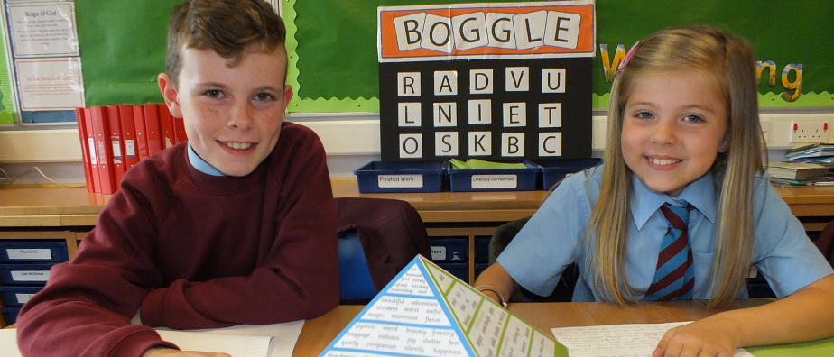
Signed ________Eileen Tompkins____________ (HT) Date____________________________

