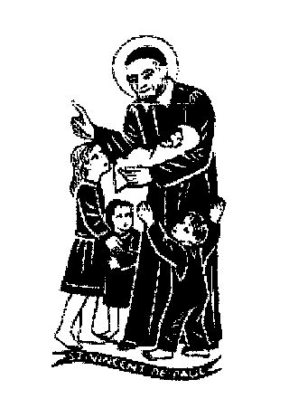  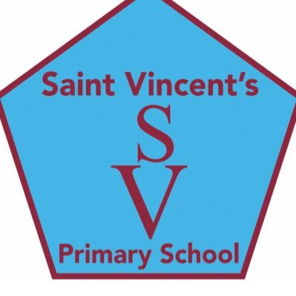

**education SERVICES**

**Executive Director: Tony McDaid**

**ST VINCENT'S PRIMARY SCHOOL -**

Head teacher Eileen Tompkins

2nd October 2020

Dear Parent/Carer,

As we begin the month of October, I want to give you some important information about upcoming events .We are all acutely aware that COVID 19 requires us all to make changes in how we work and how we meet and this is very much reflected in the routines we have in place at school . As always and especially at this time, the safety of our children and of the staff is paramount in all the decisions we make, as we work together following government and NHS guidelines.

We are very grateful for your support and co-operation in following the one way system and maintaining social distance when you come to deliver and collect your child from school. We are also grateful that you keep us informed of any COVID related absences. We want you as much as possible to stay informed and involved in the life of the school and particularly in supporting your child’s learning. In the absence of the opportunity for face to face meetings with class teachers to discuss your child’s progress at this time, we have put the following in place:

* A short interim report on your child’s progress this term will be issued next Friday October 9th You will be able to request an **optional** follow up phone call from your child’s class teacher after October week (at a time to be advised) by ticking the appropriate box on the interim report.
* You will also receive details today of our school’s contingency plan for home learning should this be required in the current climate at short notice for school, class or individual circumstance. Your child’s class teacher will also give you specific details of home learning information for your child’s class to be used if required in a COVID related absence.
* Google Classroom is the online platform being used for homework and for online learning. Parents are asked to visit their child’s class Google classroom where the school’s acceptable user agreement is uploaded this is important to ensure we all work together to ensure cyber safety for all our children.
* You will have the opportunity to hear more about the workings of the school if you join the Parent Council online AGM which takes place on this Wednesday Oct 7th at 7pm. All parents /carers are most welcome to take part and a link will be forwarded from the Parent Council via the school app.
* Please also ensure that we have your most up to date contact details and if you need to contact the school for any reason, please phone the school office on 01355 241649 or alternatively email [gw14stvincentsoffice@glow.sch.uk](mailto:gw14stvincentsoffice@glow.sch.uk).

**Playground zones**

Over the next weeks there are plans for noticeable and important improvements to our school playground including the clearing of the forest area. Our school grounds have been zoned into specific areas for each class to reduce contact between pupils and so far this is operating well. We will continue to monitor this and hope that the improvements to the playground will make a more interesting and enjoyable space for all.

**Maths Week Scotland**

It is always so rewarding to see children happily engaged in their learning and the interest, resilience and enthusiasm with which the children have re-adjusted to school routines has impressed us all. Since our return in August the main focus of the curriculum has been on Health and wellbeing, Literacy and Numeracy. During these weeks all classes have enjoyed some great learning experiences as part of Maths week Scotland. You can get a flavour of the learning that is taking place on class and school Twitter pages.

**Month of October**

In Saint Vincent’s Primary we work very closely with our parish and at present we are unable to have our usual celebration of Holy Mass together in Saint Vincent’s church We hope to be able to celebrate Holy Mass to mark the feast of our school patron Saint Vincent de Paul as a whole school on a live stream with Fr Ivan over the next weeks .We will share the link with you via our school app, website and Twitter accounts as we are always delighted to have you join us.

As is a tradition in our school over many years, we honour Mary the Mother of God by praying a decade of the rosary in the playground before school each morning during October (weather permitting) A decade consists of one Our Father, ten Hail Mary’s and finish with Glory be to the Father. We are encouraging the children to pray a decade with their families at home also and we would be very grateful if you would support us in doing this

The children continue to practice Christian Meditation in all classes and it is always great to hear that they share this with their families also.

**Sacraments**

The following are the dates for the celebration of the sacraments during the coming year:

* First reconciliation for children in Primary 3 is due to take place on Thursday 11th March 2021
* The dates for the Primary 4 and Primary 5 celebrations of First Holy Communion next year will be on Saturday 15th and Saturday 22nd May 2021. Fr Ivan will issue further details shortly of a booking system so you can select the date that suits you best.
* We are awaiting final confirmation but we expect P7 Confirmation to be on

24th March 2021 at 7pm

**Congratulations**

Our warmest congratulations to our thirteen children and their families: Gracie, Sophie, Erin, Finn, Rhys, Aidan, Bella, Kayla, Finn, Tommy, Connor, Lewis and Owen who received their first Holy Communion on September 12th. In spite of the COVID restrictions they had a beautiful and very memorable celebration

We also extend our sincere good wishes for a long and happy married life to the new Mrs Sinead Wight and her husband Michael. Their recent wedding under COVID restrictions was an occasion of great joy for all. Many congratulations to you both Sinead

**Glasgow Music festival**

Many children have expressed an interest in taking part in the Reading competitions at this festival which take place on the 14th and 15th March. Further details will follow should you wish your child to participate.

**Looking ahead**

School will close for October week break on Friday 9th October at 3pm and re-open on Monday 19th October at 9am

Hallowe’en class parties will take place on Friday 30thOctober. To minimise expense, this will be eco themed so the children can make their own costume using recycled materials.

The School Immunisation team will visit the school for flu vaccination on December 2nd .It is more important than ever to get the flu vaccine as it will reduce the risk of children getting or spreading the flu.

We hope you and your families keep safe and enjoy a relaxing October holiday when it comes.

Kindest Regards

Eileen Tompkins