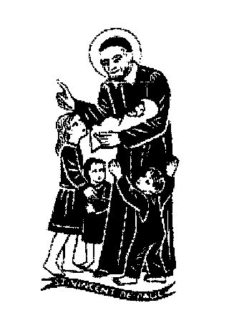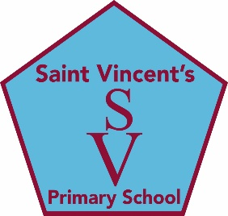

**education SERVICES**

**Executive Director: Tony McDaid**

**ST VINCENT'S PRIMARY SCHOOL -**

Head teacher Eileen Tompkins

27th November 2020

Dear Parent /Carer

Four weeks today, we celebrate Christmas day. This year our celebration may be different but here in Saint Vincent’s we will be reminding the children that the message of Christmas remains the same. Jesus is born for us and we will do everything we can to spread the love, joy, peace and happiness that this means for our world. This weekend we begin the four weeks of Advent preparation. Today Fr Ivan blessed the Advent wreaths which the teachers have made for their classes. We will be praying that Jesus will come into our hearts and homes this Christmas with new hope for all.

**Mr Arthur McAneny RIP**

The death of our much loved former school janitor is deeply felt by all who knew him and worked with him here in Saint Vincent’s over the many years he served our school community. Seven years ago at his retirement, we were able to honour the influence of his life on us all and the legend he will always be whenever we remember him. Arthur’s was a life well lived in service to the school and also as a very devoted father to his family and as a much loved husband to his wife, Alice our colleague and friend. We offer our heartfelt and sincere sympathy to Alice and all the family at this very difficult and painful time for them.

Arthur will be laid to rest in Philipshill cemetery on Monday 7th December after Requiem Mass at 12 noon which will take place under COVID restrictions in Saint Vincent’s Church and will be live streamed for all to join. As a school community we will have the opportunity to pay our respects when the funeral cortege will move through the school grounds after Mass on the way to the cemetery. May Arthur’s gentle soul rest in peace.

**Saint Andrew’s Day**

On Monday 30th November we celebrate our national patron Saint Andrew. We will join Saint Vincent’s parish via live stream at 9.30am for Holy Mass. Children are asked to wear something tartan on Monday and to bring a donation of treats and/or sweets for hampers at the EK foodbank. We hope you will be able to support this opportunity for our children to help other children. As with any gifts or cards that come into school, they will be quarantined before being distributed. All classes have prepared a Scottish poem which they will perform and share via Google classroom.

**Preparations for Christmas**

While we are not able to have our usual Nativity, Café Noel or performances from the choir this year we will do our very best to prepare for Christmas in as meaningful a way as possible while observing COVID restrictions at all times.

* Christmas lunch will be served on Wednesday 17th December. Please see the menu which is available online and we ask that your child let their teacher know their order before Tuesday 1st December. Children are welcome to dress in festive clothes e.g. Christmas jumpers on this day.
* All classes are developing their Enterprise skills and making gifts which would usually be sold at the Christmas fayre but this year you will be able to make an online purchase of what your child has made.
* Christmas parties will take place in the classrooms under COVID restrictions on Friday 18th December. We will have a whole school Christmas themed Fun day that day and children will be able to wear their party clothes to school.
* As part of our Walk a Mile, all classes are keeping track of their steps and taking part in the virtual Walk to Bethlehem outside. Please make sure your child comes well wrapped up as PE can only take place outside under Tier 4 and classes have to be well ventilated at all times.
* Children have asked about bringing in Christmas cards etc. to school and as mentioned above any items that come in from home will be quarantined before being distributed.
* We will ensure that all classes have the opportunity for an online pantomime or entertainment.

**Absence Procedures**

Thank you for keeping us informed of any COVID related updates that affect your child or your family. This is of utmost importance and much appreciated as we all work together to keep everyone safe. If your child is displaying any of these symptoms: persistent cough, temperature or loss of taste and smell, they cannot attend school and a test should be arranged. If a test comes back negative, children can return to school.

If you or anyone in your household is awaiting a COVID test please do not send your child to school until you have received a negative result.

Head cold symptoms, such as a sore throat, runny nose, or headache are not considered common Covid-19 symptoms and therefore if a child has a head cold, with no other symptoms, and they feel well enough, they can attend school. Please ensure that we have your up to date contact details.

**Adverse weather**

You will be aware there are occasions when severely inclement weather can result in the early closure of schools. Every effort would be made, in the event of early closure, to advise parents of the situation via the school App. Please make sure that the School Office is kept up-to-date with changes to contact numbers. No child, however, would be sent home without the school ensuring that an adult was available. Parents are advised to listen to local radio and telephone the school if they have any doubts whether or not the school is likely to be closed. Further information will be available online at Twitter: @EkVincents and on our school website ([www.st-vincent’s](http://www.st-vincent's)-pri.s-lanark.sch.uk) and on the South Lanarkshire Website ([www.southlanarkshire.gov.uk](http://www.southlanarkshire.gov.uk))

With warmest good wishes to you and your families and every blessing for Christmas 2020

Eileen Tompkins

Kindest Regards

Eileen Tompkins