Dear Parent/ Carer,
I have attached the answers to this week’s weekly activity below. Some of the answers will be down to your own judgement however I have listed my own answers to give you an idea. Answers included are for:
- Maths: Revision of Area (This has been split in coordinates/symmetry and angles groups).
- Literacy: Grammar and Comprehension.
Feel free to email me any questions or to show me any work produced. I hope you are all doing well.

Many Thanks,

Mr Garvey

Maths
Coordinates and symmetry 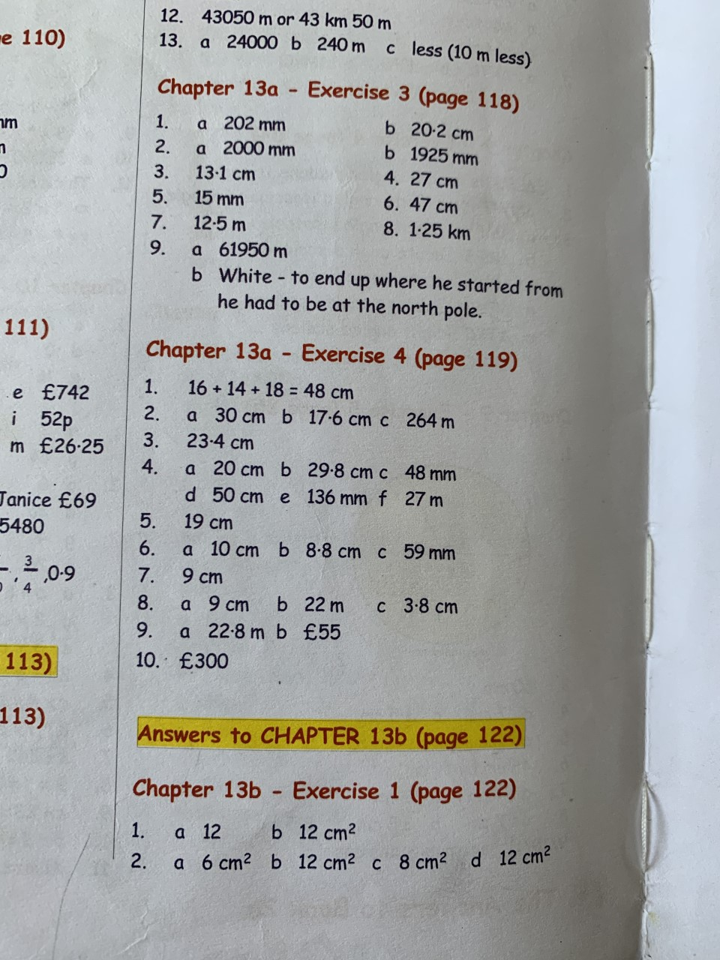 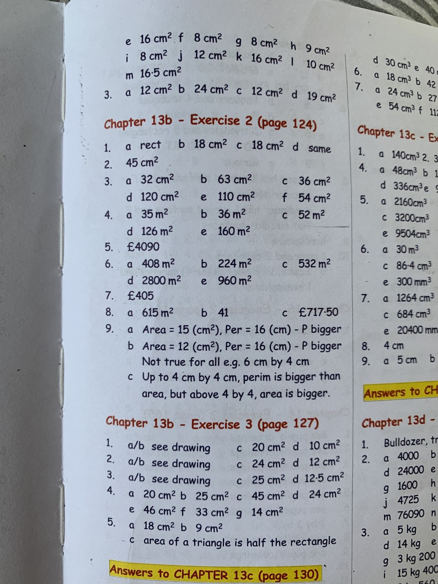
Angles
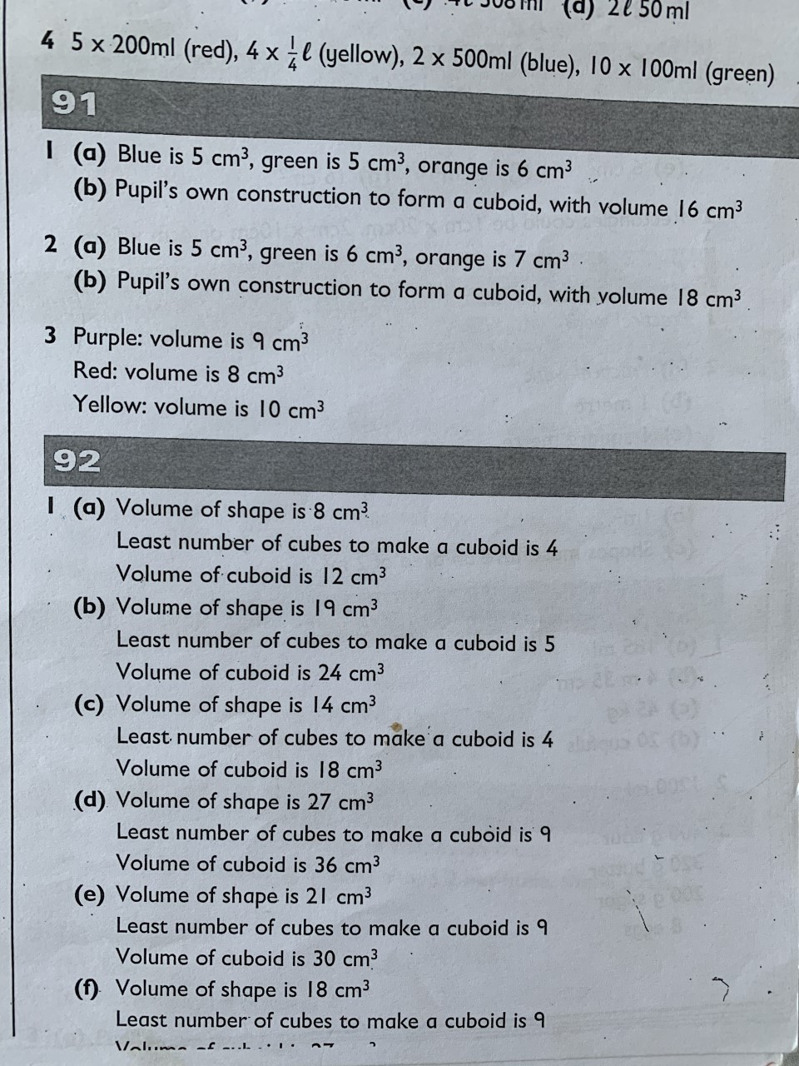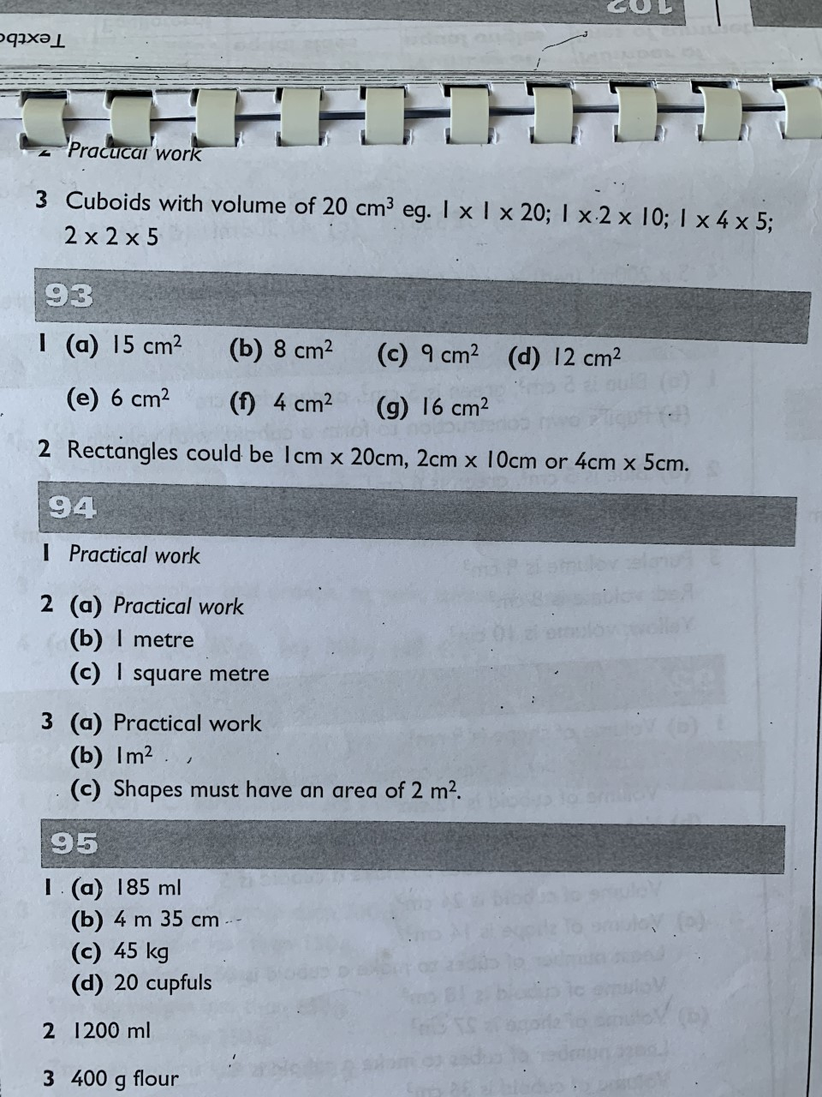

Literacy
Grammar
Unit 4: Pronouns

A pronoun can be used instead of a noun.

The dog has a kennel.

It has a kennel. (It = Pronoun)

Some pronouns show ownership or possession.

They are called possessive pronouns.

This coat is mine.
That coat is yours. (Both Possessive Pronouns)

Here are some more possessive pronouns.
his : The book on the floor is his.
hers : This torn letter is hers.
mine : The red bicycle is mine.
ours : All the sheep in that field are ours.
theirs : Our garden is bigger than theirs.
yours : Is this yours?

Grammar Focus

Copy the following sentences into your book.

Use possessive pronouns in place of the green
words.

1 Your writing is neater than mine.

2 My pen is broken. Will you lend me yours?

3 She has lost her pencil. Is this hers?

4 That‟s a blue pencil. It must be his.

5 The teachers left some books here. I‟m not sure which are theirs.

Grammar Practice

Copy the following sentences.

Write a possessive pronoun in each gap.

1 “This chair is ___mine___, and that chair is __yours____,” Ian said to his sister.

2 “These games are __ours____,” shouted the boys.

3 Carl made a model castle. Lynn helped him so it is ___hers___ as well.

4 The children had to take some baby photographs to school. The twins were not sure if they could find __theirs____.

5 The teacher asked for the homework. Katy and I hadn‟t brought __ours____.

Grammar Extension

Write a sentence using each pair of possessive
pronouns.

1 This packet of crisps is mine and that packet is yours.

2 That skipping rope is theirs and this skipping rope is ours.

3 The pencil is his, it cannot be hers.

4 He took all of ours because he thought they were better than his.

5 I stole hers because I thought it was better than mine.

Comprehension
Unit 15 – The Magic Box

Think ahead
Inside Pandora's Box (Unit 14) were all sorts of nasty things. Inside this box are all sorts of nice things. Before you read the poem, guess what things the poet might have chosen to go in his `magic' box.

I will put into that box
the swish of a silk sari on a summer night
fire from the nostrils of a Chinese dragon, the tip of a tongue touching a tooth.
I will put into the box
a snowman with a rumbling belly,
a sip of the bluest water from lake Lucerne,
a leaping spark from an electric fish.
I will put into the box
three violet wishes spoken in Gujarati,
the last joke of an ancient uncle,
and the first smile of a baby.
I will put into the box
a fifth season and a black sun, a cowboy on a broomstick and a witch on a white horse.
My box is fashioned from ice and gold and steel,
with stars on the lid and secrets in the corner. Its hinges are the toe joints
of dinosaurs.
I shall surf in my box
on the great high-rolling breakers of the wild Atlantic,
then wash ashore on a yellow beach
the colour of the sun.

From Cat Among the Pigeons by Kit Wright

Thinking back

1 If SSSSN = the swish of a silk sari on a
summer night, what would these mean?
a) FNCD = fire from the nostrils of a Chinese dragon.
b) SRB = a snowman with a rumbling belly.
c) LSEF = a leaping spark from an electric fish.
d) LJAU = the last joke of an ancient uncle.
e) FSB = a fifth season and a black sun.
f) WWH = a witch on a white horse.

2 What will be spoken in Gujarati? – Three violet wishes will be spoken in Gujarati.

3 Describe how the box is made. – The box is made from ice and gold and steal. It has stars on the lid and secrets in its corners. It’s hinges are made from the toe joints of dinosaurs.

4 Describe the beach the poet will land on. – The beach the poet will land on is yellow like the colour of the sun.

Thinking about it

1 What is Gujarati? - I think Gujarati is a foreign language because three wishes are spoken in it.

2 How could you `capture' the first smile of a baby? – I would use a camera to capture the first smile of a baby.

3a) What name would you give to a fifth
season? – I would name my fifth season Wummer.
b) What would the weather be like in your
fifth season? – The weather during Wummer would be sunny and warm like summer but cold and snowy at times like Winter.

4 Which of the things in the box do you think are real and which are imaginary? I think that everything in purple is real and everything in green is imaginary. I think this because all of the things in green seem like they link to something real, e.g. the last joke of an ancient uncle. This could be written down and placed inside the box. This is in comparison to a fifth season in green as there are only four seasons.

Thinking it through

1 In what way is the poem about magic? - I think the poem is about magic because some of the things the writer has chosen to put into their box cannot be placed into a box. To put something like a cowboy on a broomstick inside a box you might require magic.

2 What is your favourite thing in the box?
Why? – My favourite thing inside the box is the fifth season. This is my favourite because I would really want to see what this would look and feel like in the real world.

3 What is the most strange thing the poet
will put in the box? Why? – I think the most strange thing the poet put in the box was a snowman with a rumbling belly. I think this is strange because snowmen do not have stomachs because they are made of snow.

4 What do you think is special about this
poem? – I think this poem is special because it is written so imaginatively and so decrepitly that the poem itself does not even rhyme.

5 Is wishing the same as wanting?
Explain what you think. – I think they are the same however are different. I think that if you wish for something you want it, however you desperately want it or need it.

