Dear Parent/ Carer,
I have created this resource to provide weekly work that children can complete at home. This could be used in conjunction with your home learning packs. I have included:
- Maths: Revision of Time (This has been split in coordinates/symmetry and angles groups).
- Literacy: Grammar, Comprehension, Handwriting and Writing exercises.
- Additional Activities: Small activities linking to topic, R.E., Art and Science.
Answers to math and literacy exercises will be posted on Thursday. Feel free to email me any questions or to show me any work produced. I hope you are all doing well.

Many Thanks,

Mr Garvey

Maths
Coordinates and symmetry 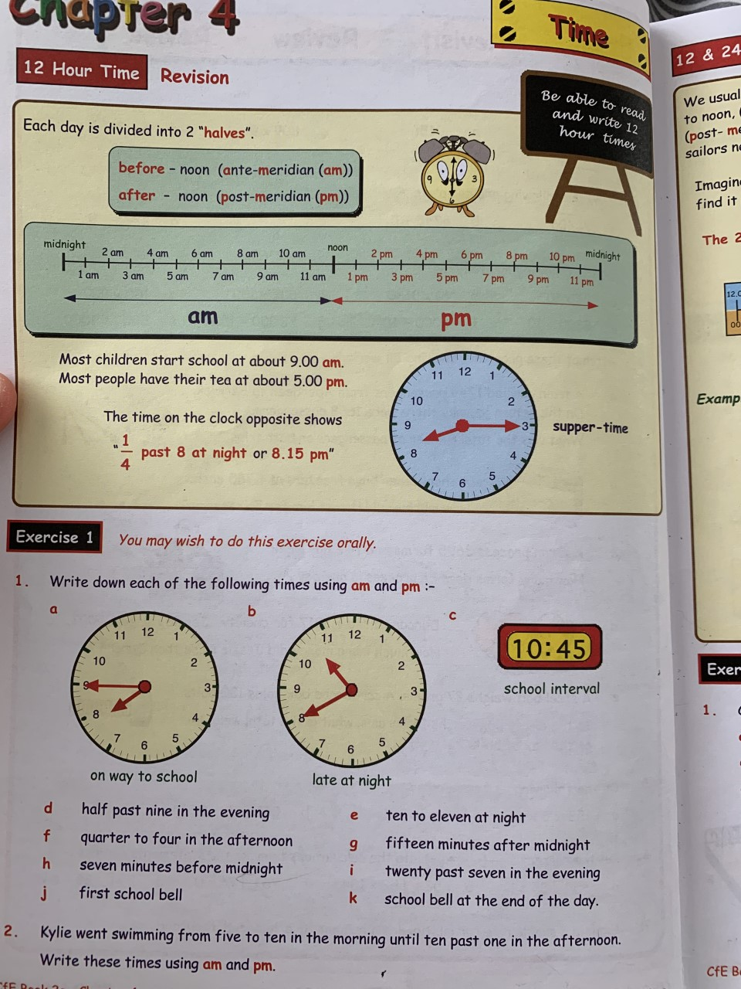 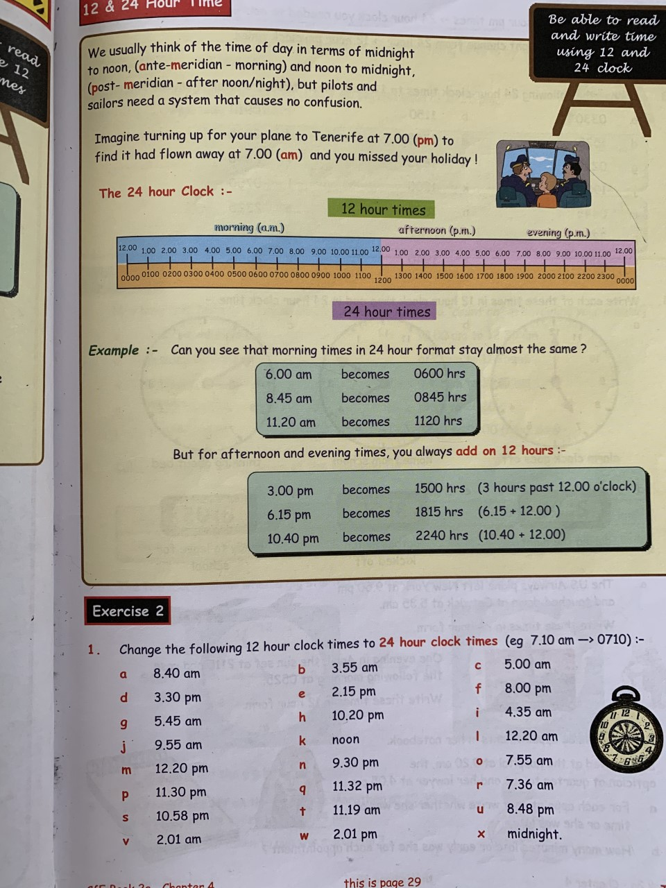 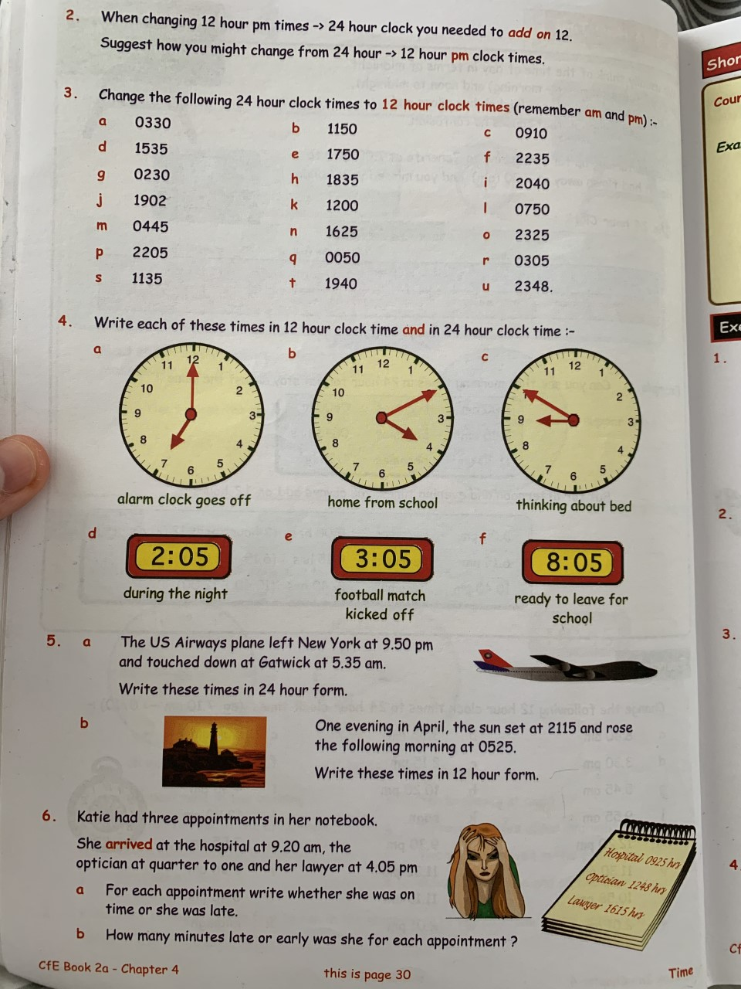 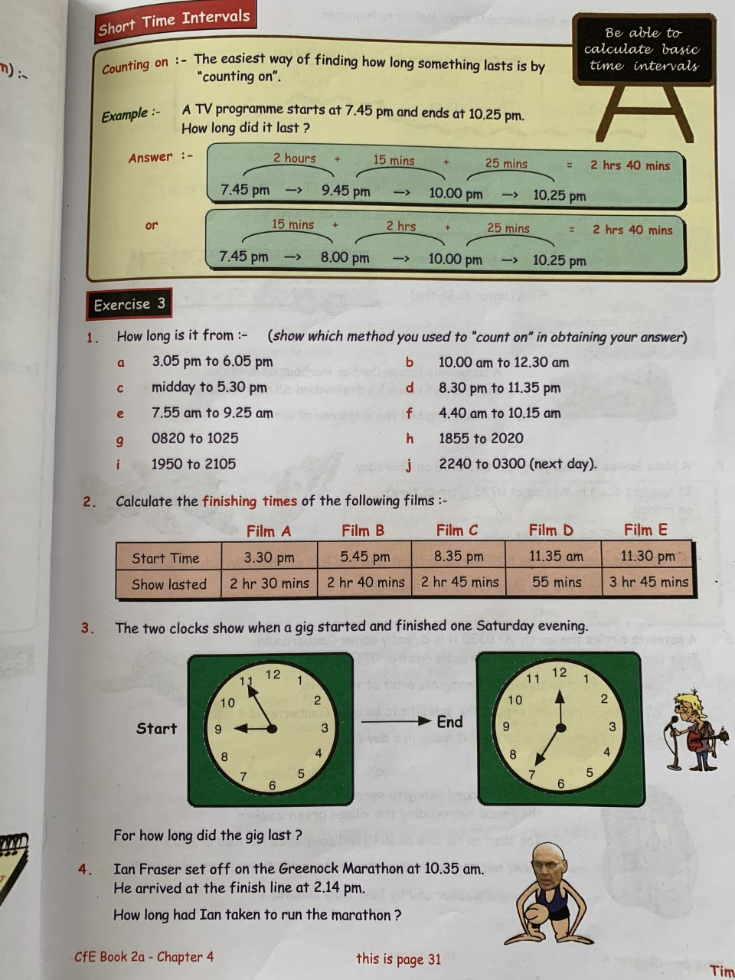 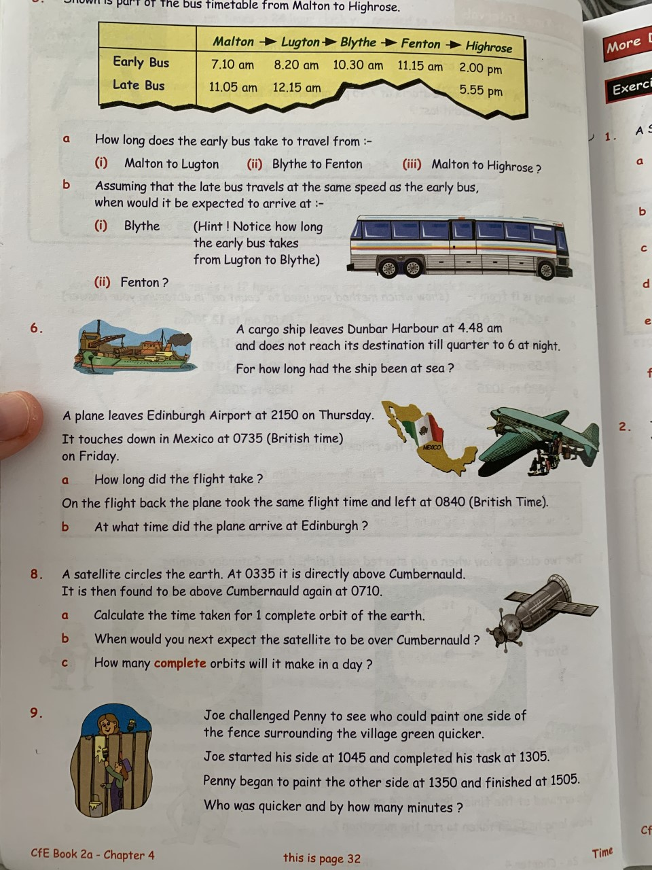 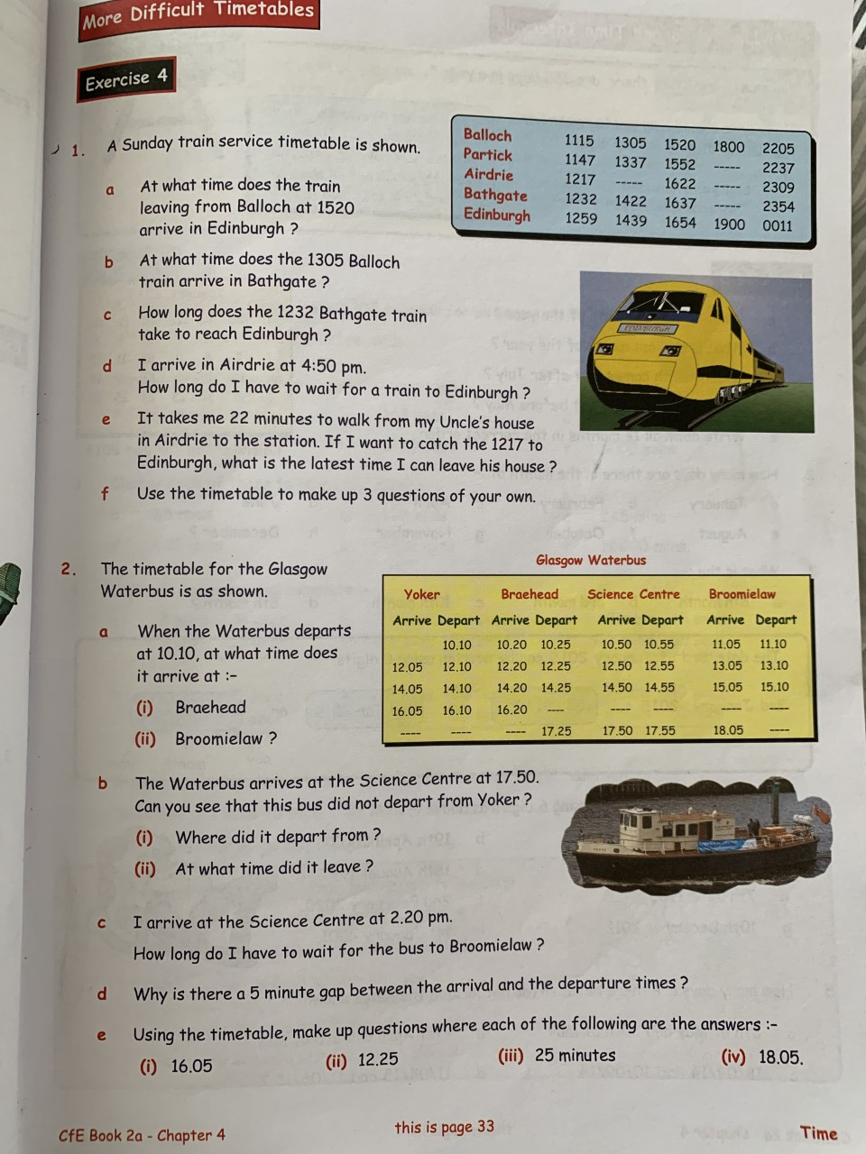
Angles
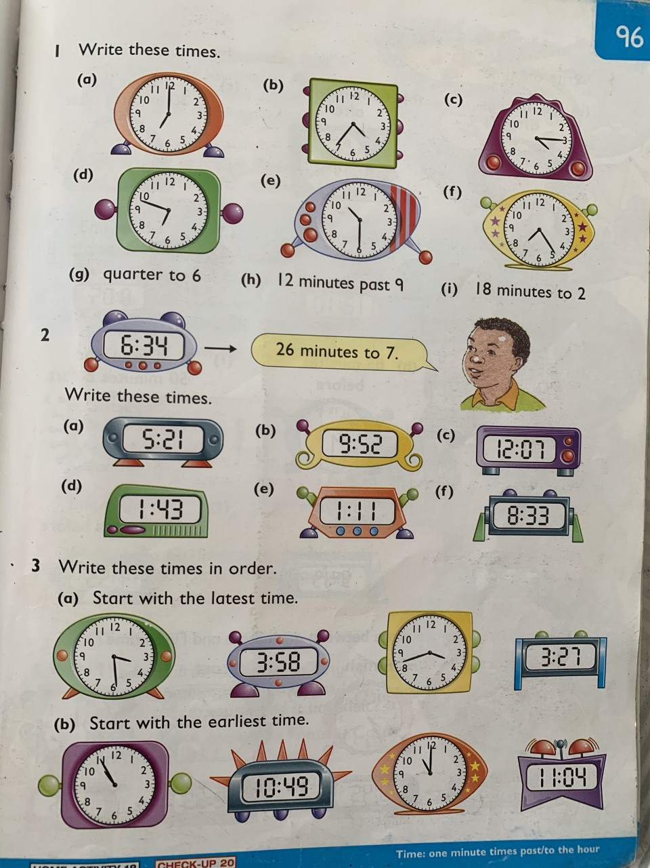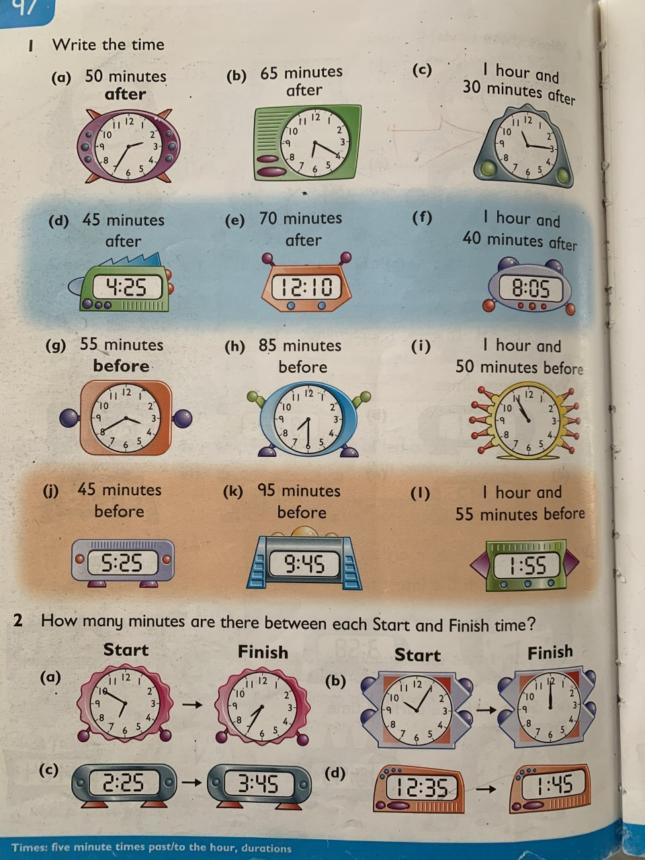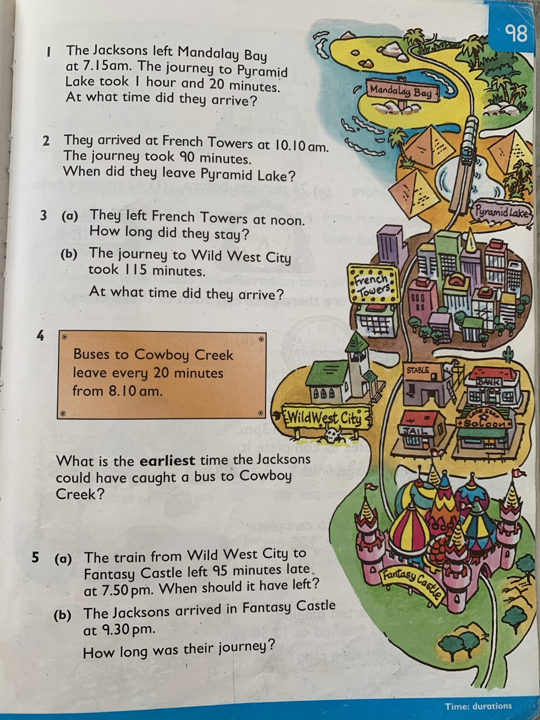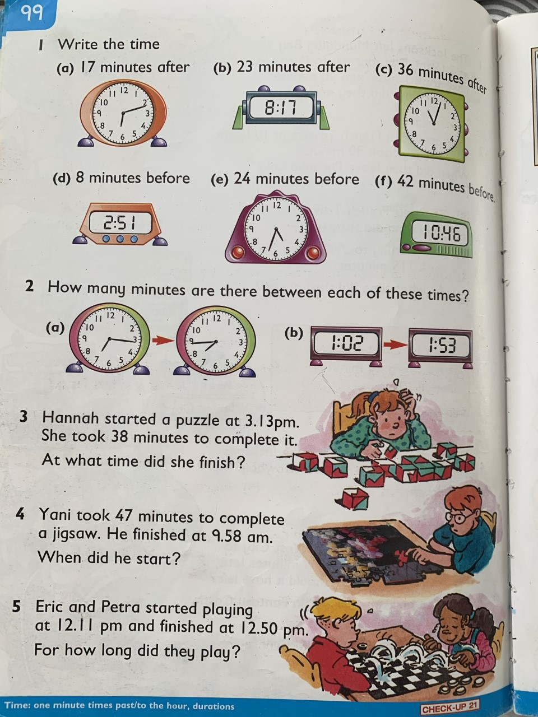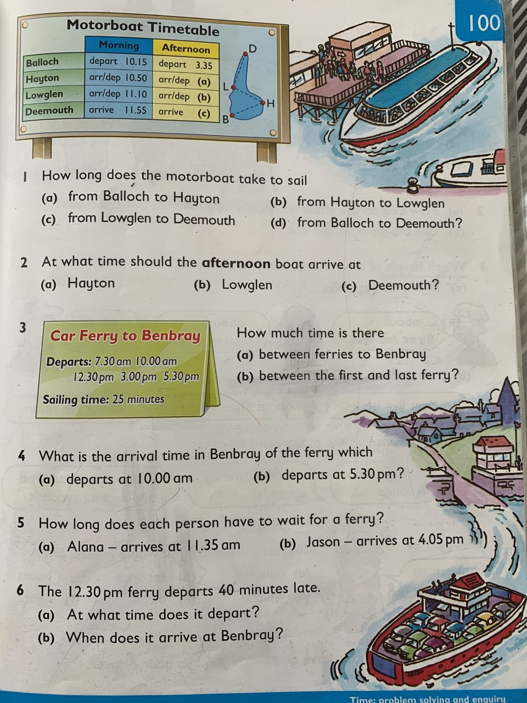

Literacy
Grammar
Unit 4: Nouns

A suffix is an ending

Nouns can be made from verbs, usually by adding a suffix like ing, er or ment.

verb : to paint
noun: the painting
the painter

verb : to manage
noun : the manager
the management

But be careful!
Sometimes the word changes slightly when a noun is made from a verb.

verb : to thieve
noun : the thief
the theft

Grammar Focus

Copy the following list of verbs into your book.
Next to each verb, write the matching noun.

Verb:

to hate
to explain
to laugh
to explore
to lose
to run
to drive

Noun :

exploration
loser
runner
hatred
driver
laughter
explanation

Grammar Practice

Check your answers in the dictionary. Some of
the spellings are tricky.

Copy the following sentences.
Make a noun from the verb in brackets to fill the
gap in each sentence.

1 Aziz made a good __________. ( to suggest)
2 We made an __________ about what to watch
on television. (to agree)
3 The __________ to the cave was blocked by
fallen rocks. (to enter)
4 The Big Book of __________ was very helpful for
my project. (to know)
5 The old house needed many __________. (to
improve)
6 David had a slight __________ after the race. (to
injure)
7 The __________ was sea-sick when the weather
was rough. (to sail)
8 Stella was a very good __________. (to swim)

Grammar Extension

Look at each of the following nouns in your
dictionary.

Write the meaning, and the verb from which it is
made.

1 conversation
2 embarrassment
3 fertiliser
4 germination
5 hypnotism
6 imagination
7 judgement
8 lubrication
9 magnification
10 organisation

Comprehension
Unit 15 – The Magic Box

Think ahead
Read the poem. What would it be like to be caught outdoors in a hurricane?

Shut the windows
Bolt the doors
Big rain coming
Climbing up the mountain

Neighbours whisper
Dark clouds gather
Big rain coming
Climbing up the mountain

Gather in the clothes lines
Pull down the blinds
Big wind rising
Coming up the mountain

Branches falling
Raindrops flying
Treetops swaying
People running
Big wind blowing
Hurricane! on the mountain

From A Caribbean Dozen by Dionne Brand

Gustus Bass, a young Jamaican boy, is sheltering from a hurricane in the schoolhouse with his family. He is worried about his banana tree at home, so he sets out to check if it is all right.

`Where's Gustus! Imogene ... where's Gustus?'
`He was `ere Pappy,' she replied, drying her eyes. I dohn know when he get up.'
Briskly, Mr Bass began combing the schoolroom to find his boy. He asked: no-one had seen Gustus. He called. There was no answer ...
By this time Gustus was halfway on the mile journey to their house. The lone figure in the raging wind and shin-deep road-flood was tugging, snapping and pitching branches out of his path. His shirt was fluttering from his back like a boat-sail ... As he grimaced and covered his ears he was forcefully slapped against a coconut tree trunk that laid across the road.
When his eyes opened, his round face was turned up to a festered sky. Above the tormented trees zinc sheets writhed, twisted and somersaulted in the tempestuous flurry ... As Gustus turned to get up, a bullet-drop of rain struck his temple. He shook his head, held grimly to the tree trunk and struggled to his feet ...
When Gustus approached the river he had to cross, it was flooded and blocked beyond recognition ... The wrecked footbridge had become the harbouring fort for all the debris, branches and monstrous tree trunks which the river swept along its course. The river was still swelling. More accumulation arrived each moment, ramming and pressing the bridge. Under pressure it was cracking and shifting minutely towards a turbulent forty-foot fall.
Gustus had seen it! A feeling of dismay paralysed him, reminding him of his foolish venture ... But how can he go back? He has no strength to go back. His house is nearer than the school. An' Pappy will only strap him for nothin' ... for nothin' ... no shoes, nothin' when the hurricane is gone...
He made a bold step and the wind half-lifted him, ducking him in the muddy flood. He sank to his neck. Floating leaves, coconut husks, dead ratbats and all manner of feathered creatures and refuse surrounded him ... But he struggled on desperately until he clung to the laden bridge, and climbed up among the leafless branches ...
The urgency of getting across became more frightening, and he gritted his teeth and dug his toes into the debris, climbing with maddened determination ...
There was a powerful jolt. Gustus flung himself into the air and fell in the expanding water on the other side. When he surfaced, the river had dumped the entire wreckage into the gurgling gully. For once the wind helped. It blew him to land.
Gustus was in a daze when he reached his house. Mud and rotten leaves covered his head and face, and blood caked in a gash on his chin.
He could hardly recognise his yard. The terrorised trees that stood there were writhing in turmoil. Their thatched house had collapsed like an open umbrella that was given a heavy blow. He looked the other way and whispered, `Is still dere! Dat's a miracle! Dat's a miracle!'
Dodging the wind, he staggered from tree to tree until he got to his own tormented banana tree. Gustus hugged the tree.

From A Thief in the Village by James Berry

Thinking back

Write these sentences in the correct order.

As he walked the wind was raging and blowing stuff everywhere.

The bridge gave way and Gustus was thrown into the water.

Gustus was sheltering in the schoolhouse because of the hurricane.

To his surprise he found his banana tree was still standing.

The bridge was nearly cracking under the strain.

Gustus was in a daze when he reached his house.

He was worried about his banana tree so he set off home to check it.

The river was flooded.

Thinking about it

1 Who do you think Imogene is?

2 What do you think Mr Bass thought when he could not find Gustus? How do you think he felt?

3 Why do you think Gustus was worried
about his banana tree? What could have been so special about it?

4 Why was it dangerous to be outside in
the hurricane?

5 What sort of things would Gustus have
seen and heard and felt on his journey?

6 Why did Gustus think he would get into
trouble with his father?

7 What surrounded Gustus when he was
blown into the muddy flood?

8 Why do you think Gustus was in a daze
when he reached home?

9 What had happened to his house?

10 Why did Gustus hug the banana tree?

Thinking it through

1 Do you think Gustus was foolish or brave? Give your reasons.

2 Gustus was determined to reach his home. How can you tell this from the story?

3 How do you think Gustus felt when he
reached home?

4 What do you think might happen to Gustus next?

5 The author paints a vivid picture of the
hurricane. Write some of the words or
phrases that he uses to show the power of
the wind.

6 How can you tell the story was set in
Jamaica? (There are several clues in the
story.)

Writing

Notice that your comprehension from this week was a poem. This poem did not however rhyme! Instead the first line of each stanza (paragraph) always mentioned the subject og the poem (the box). The stanza also used 3 sentences to describe things about the box. See below as an example:

My box is fashioned from ice and gold and steel,
with stars on the lid and secrets in the corner. Its hinges are the toe joints
of dinosaurs.

Try to create your own non rhyming poem about a magic object. Remember the first line should always include your object and a description, e.g.

My car is multicoloured, like all the colours of the rainbow.

Your poem should be 3 paragraphs minimum and 5 maximum. Try to make yours as interesting as possible, using alliteration, similes and metaphors!

Once completed draw your object using the descriptions you have provided.

Handwriting

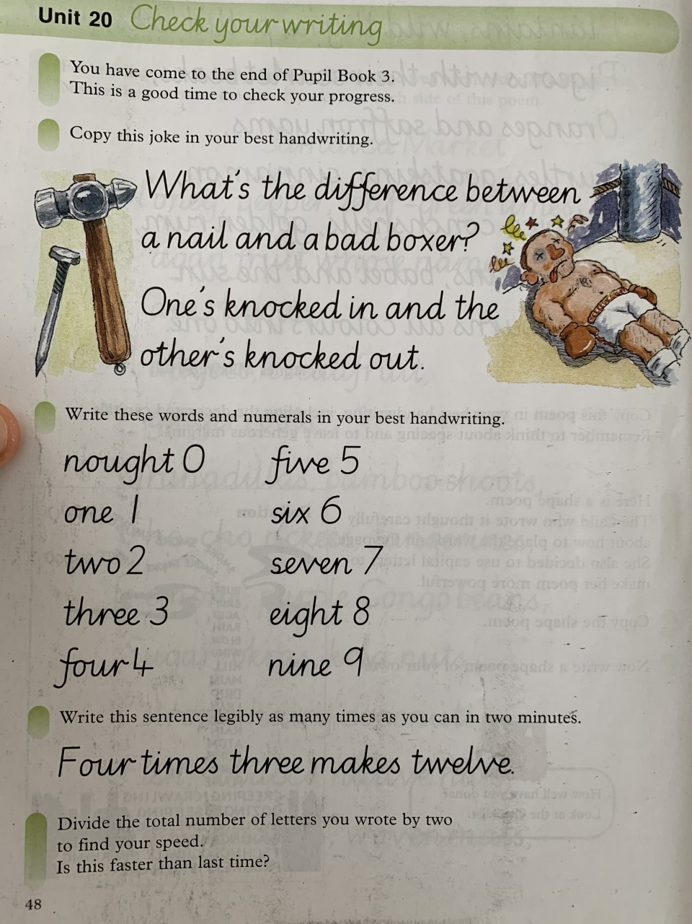

Additional Exercises

Science

Create your own Moving liquid art

Instructions:

- Mix dish soap and mil together in a container or bowl.
- This will cause the surface tension of the mil to break down.
- Add some food colouring to witness a pretty cool chemical reaction!

Complete this experiment with an adult!

Topic

Complete this short quiz about the differnet terms relating to the Scottish Parliament.

Rule and Laws

Below is a map of a town called UPTOWN. The town is on the planet ZOG. There are no rules and laws. Two people die every minute in this town as their are no traffic laws, people also drive on the pavements and at very fast speeds. The graveyard and the hospitals are getting full. There is lots of crime. Laws are needed urgently.
On the map you need to include;
- A PRISON (in an appropriate location)
- POLICE STATION (in an appropriate location)
- SPEED RESTRICTIONS (using examples from the highway code)
- TRAFFIC LIGHTS
- ROUNDABOUTS
- ZEBRA CROSSINGS
- BRIDGES OVER THE MOTORWAY (Yellow lines)
On a separate piece of paper you need to include;
- SOCIETY LAWS AND JUSTIFICATION FOR THE PENALTY (for example if you are going to send someone to jail for stealing you need to say what length the sentence might be and perhaps why the sentence is longer/shorter than others).
- SHORT PIECE OF WRITING TO JUSTIFY THEIR MAP

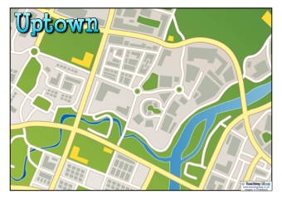

Art

On one of your daily walks either take a picture of a landscape that you think looks interesting (or you could do this from memory). For example Morrisons at Lyndsayfield. Draw your landscape. Once done put a small dot in one of the corners of your page. this will represent the sun. Think about where the sun would hit the things in your drawing (Remember light travels in straight lines!) Shade the areas that the sun would not hit using the crosshatch method.

If you cannot find a good landscape to draw, try using google maps! Put yourself into streetview anywhere in the world that you find interesting and draw what you see.

R.E.

Read John 10: 1-10. You can find this online by searching the Bible passage. Complete the worksheet on your own piece of paper.
Create a poster which shows the main points of the parable. Try to include 1 quote (sentence) from the passage which you think really goes with your poster and make that the heading.
