Dear Parent/ Carer,
I have created this resource to provide weekly work that children can complete at home. This could be used in conjunction with your home learning packs. I have included:
- Maths: A brief look at weight (This has been split in coordinates/symmetry and angles groups).
- Literacy: Grammar, Comprehension, Handwriting and Writing exercises.
- Additional Activities: Small activities linking to topic, R.E., Art and Science.
Answers to math and literacy exercises will be posted on Thursday. Feel free to email me any questions or to show me any work produced. I hope you are all doing well.

Many Thanks,

Mr Garvey

Maths
Coordinates and symmetry 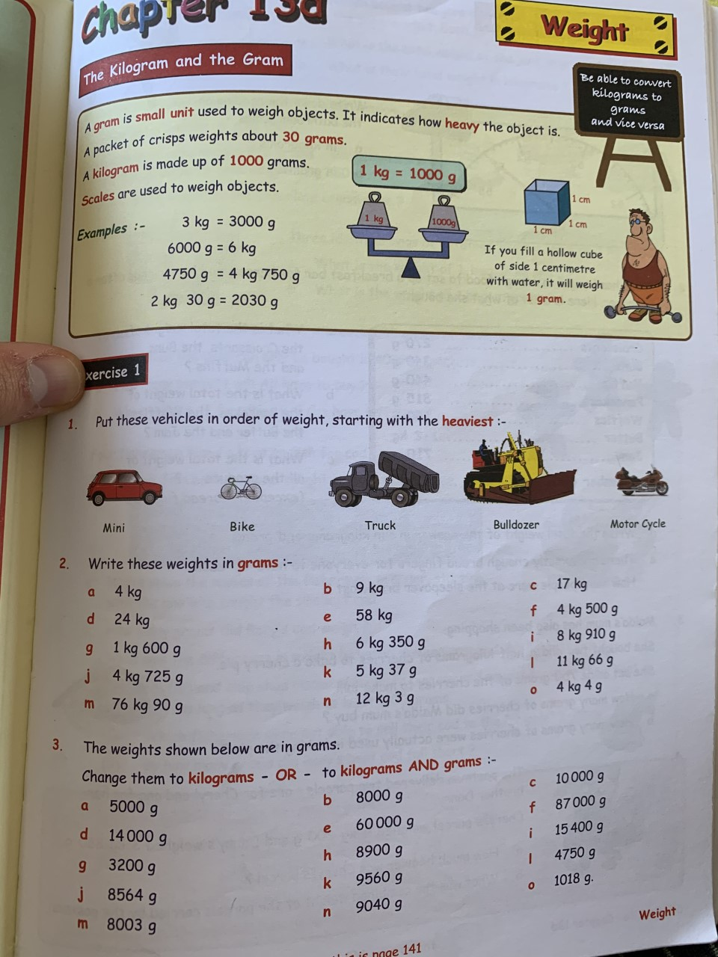 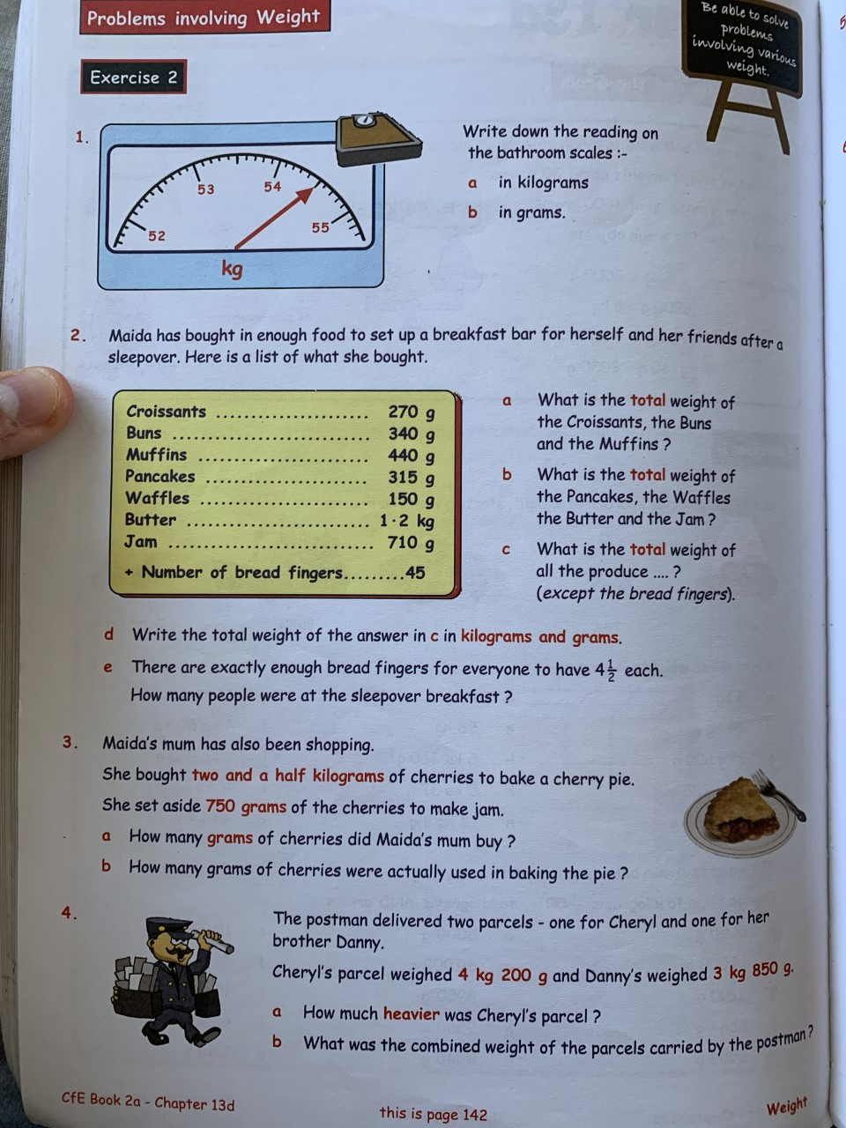 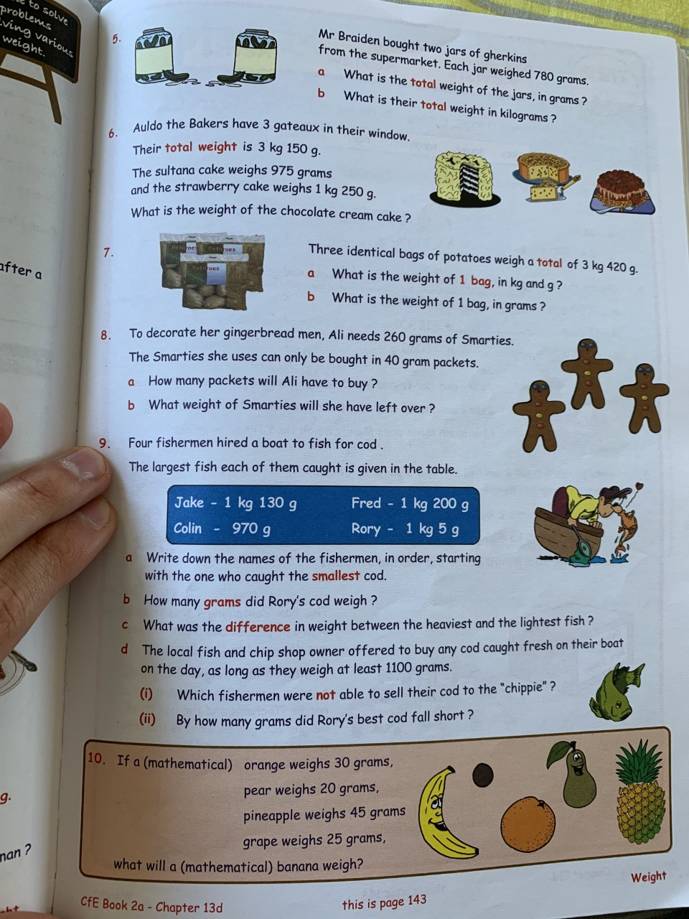
Angles
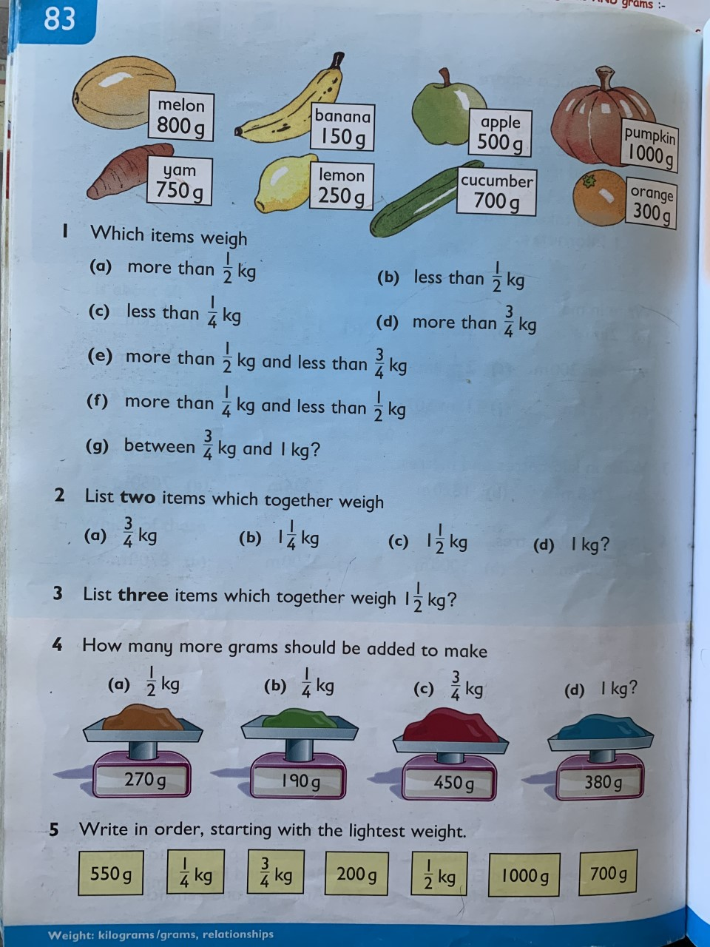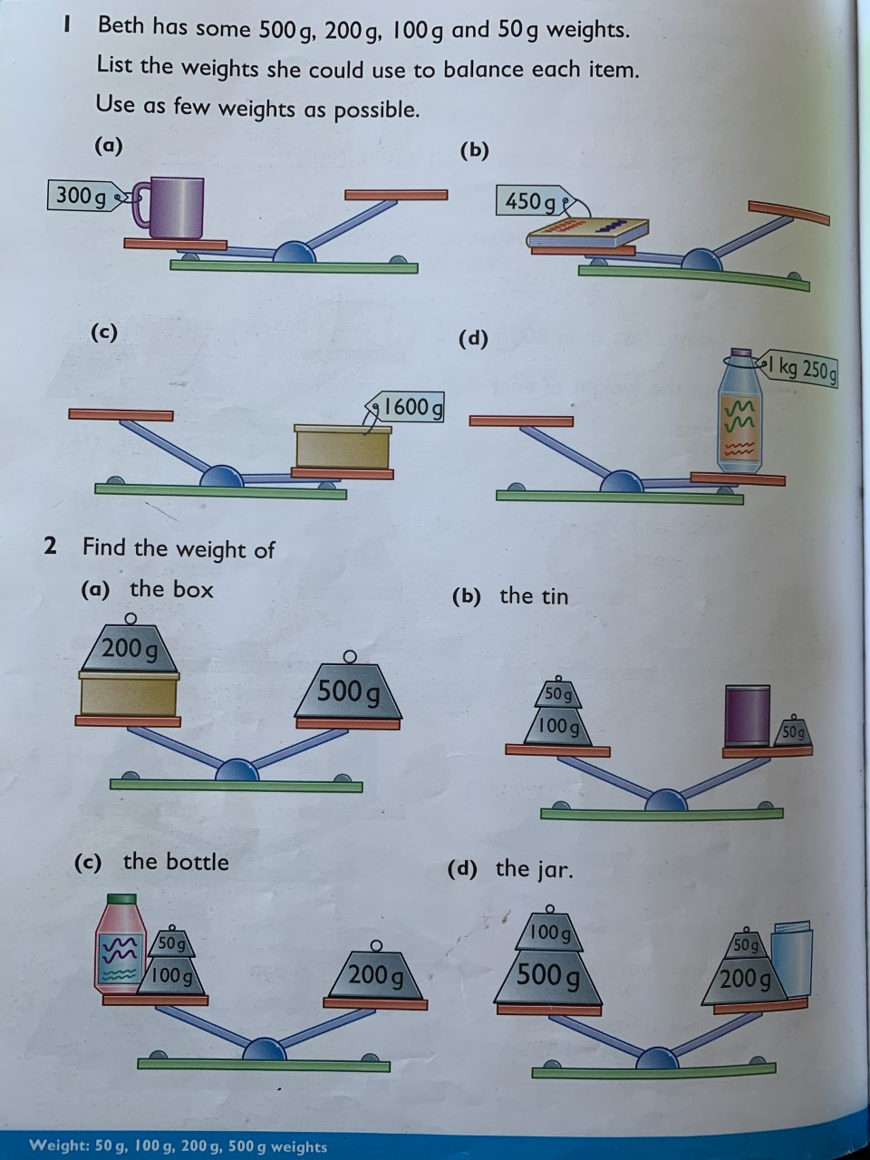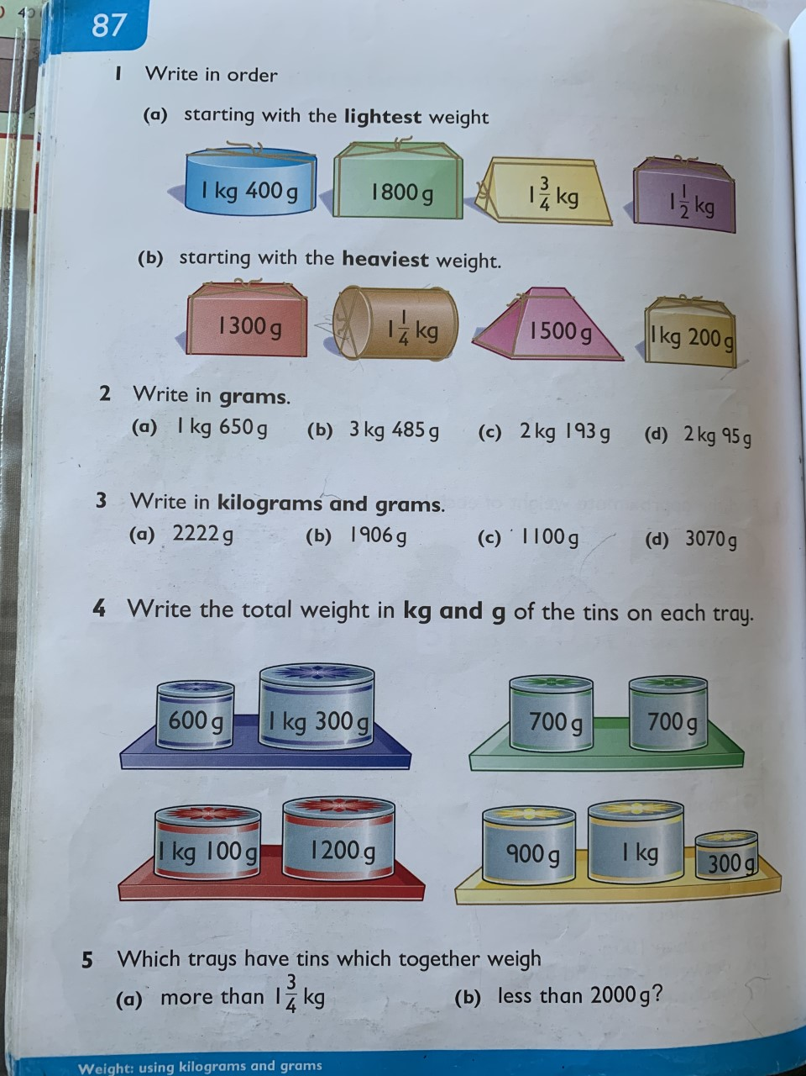

Literacy
Grammar
Unit 4: Nouns

Nouns and verbs can be singular or plural.

When we use a singular noun we must use a
singular verb.

The tunnel (singular noun) goes (singular verb) under the sea

When we use a plural noun we must use a plural
verb.

The cockrels (plural noun) crow (plural verb) every morning

The words “each‟ and “every‟ always come before singular nouns.

Each flower has coloured petals.
Every petal is very delicate.

Collective nouns are always followed by singular
verbs.

The herd lives on the hill.
The flock of birds circles overhead.
Sums of money and popular food are singular.
£2.50 is the price of that magazine.
Fish and chips is not a healthy meal.

Grammar Focus

Copy the following into your book.

Write whether each would followed by a singular or a plural verb.

1 the sandals
2 the spoonful
3 each boy
4 eggs and bacon
5 this bunch
6 the pedals
7 every horse
8 80p

Grammar Practice
Copy the following sentences.
Choose the singular or the plural verb to complete each one.

1 Vandals wreck / wrecks other people‟s
property.
2 We is / are careful about locking the door.
3 The group play / plays on Saturdays.
4 Sausage and mash is / are my favourite meal.
5 Each ticket has / have a number on it.

Grammar Extension
A Add a predicate to each of these subjects to
make a sentence.

Remember, the predicate is all of the sentence
except the subject.

1 One million pounds __________.
2 The orchestra __________.
3 Every tree __________.
4 Each new pupil __________.
5 Baked beans __________.

B Add a subject to each of these predicates to make a sentence.

The subject of a sentence is the person or
thing written about.

1 __________ sparkles with jewels.
2 __________ gallop around the race course.
3 __________ was very long.
4 __________ were under the bed.
5 __________ are very late.
Comprehension
Unit 19 – The Tide Rises, The Tide falls

Think ahead
What does the title of the poem make you think of?

The following poem was written by Henry Wadsworth Longfellow

The tide rises, the tide falls,
The twilight darkens, the curlew calls; Along
the sea-sands damp and brown
The traveller hastens to the town,
And the tide rises, the tide falls.

Darkness settles on roofs and walls;
But the sea, the sea in darkness calls;
The little waves, with their soft white hands,
Efface the footprints on the sands,
And the tide rises, the tide falls.

The morning breaks; the steeds in their stalls
Stamp and neigh, as the hostler calls;
The day returns, but nevermore
Returns the traveller to the shore,
And the tide rises, the tide falls.

Thinking back

Choose the best ending to complete each sentence.

1 The curlew calls
a) at twilight
b) at dawn
c) in the afternoon

2 The sea-sands were
a) golden brown
b) muddy and brown
c) damp and brown

3 The traveller was travelling to
a) the city
b) the town
c) the village

4 Darkness settles
a) on the church tower
b) on the village green
c) on roofs and walls

5 The poet says the waves have
a) soft white hands
b) watery faces
c) whispering voices

Thinking about it

1 Explain what time of day twilight is.
2 What do you think a curlew is?
3 How can you tell the traveller is in a hurry to get to town?
4 Why do you think the traveller is going to town?
5 What do you think `the waves efface the
footprints on the sand' means?
6 What other name is used for horses in the poem?
7 What do you think a 'hostler' is?

Thinking it through

1 What time of day is each verse about?
What do you notice?
2 How can you tell the poem was written
some time ago?
3 Why do you think the poet keeps repeating the line `The tide rises, the tide falls'?
4 What does the poet mean when he says
that the waves have `soft white hands'?

Writing

This week’s comprehension task was again a poem. This poem, compared to our previous one, does rhyme!
It includes the line ‘and the tide rises, the tide falls’ which ends each stanza (paragraph).

Every other line in the poem ends with a word that will rhyme with the next lines end word.

This poem is all about travelling somewhere, describing the weather, the time of day, the things the rider sees and as a whole tells a story!

I would like you to try and recreate this poem using your own experiences travelling. This could be a car ride, going on a boat or even on a plane. Try and describe the things you see and feel while trying to continue on the story!

Your poem should be 3 paragraphs minimum and 5 maximum. Try to make yours as interesting as possible, using alliteration, similes and metaphors!

Handwriting

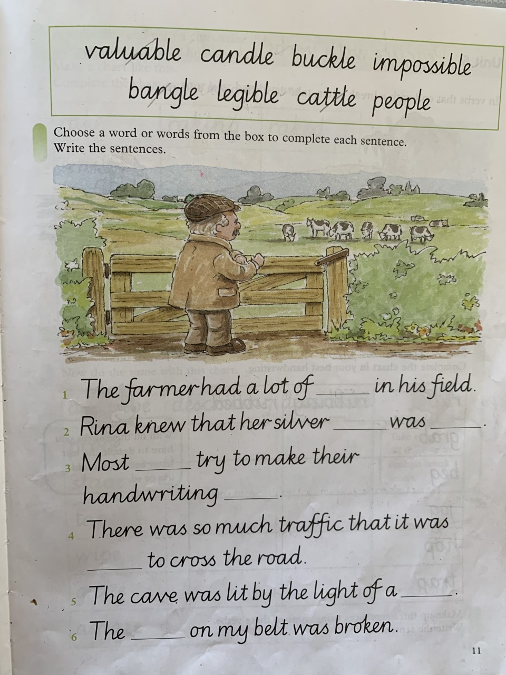

Additional Exercises

Science

Create your own homemade parachutes

Materials:

- Empty yoghurt pot or plastic cup or similar item
- String or thread
- Plastic carrier bag or bin bag
- Sellotape
- An egg (optional)
- J-cloth or other scrap piece of cloth (optional)

Before beginning this activity think:

- what is the purpose of a parachute?
- Why do you think a parachute slows down a falling object?
- Do you think the size of a parachute makes a difference to how quickly it falls? Why?
- What else could we change?
- Do you think it matters how you release the parachute?
- If we’re comparing two different parachutes, how can we make it a fair test? Answer: Drop them from the same height at the same time.
- Do you think the shape of a parachute makes a difference to how quickly it falls? Why?
- Do you think the number of strings you use to tie the parachute to the yoghurt pot will make a difference? Why?
- What do you think will happen if we use a different type of material for the parachute? Why?

Now watch this video:

https://www.youtube.com/watch?v=UpWU2Hg1sBs

Instructions:

- Make a parachute based on the instructions Jackie gives in the video. You can vary the design by adding more strings and making other alterations that you think might be useful.
- Decide what cargo your parachute will carry. You can put anything you like inside your container, but we found using an egg makes it more eggciting.
- Decide where you will drop your parachute from and how you will judge what makes a ‘good’ parachute. Is it how long it takes to hit the ground or whether or not it protects the cargo?
- Investigate what happens if you have a bigger or smaller parachute.
- Investigate what happens if you change the design of your parachute in other ways, for example by changing the length or number of strings you use and changing the material you use or even cutting holes in the material.

Complete this experiment with an adult!

Topic

You are going to take on the role of an MP (Member of Parliament)

You are going to try to survive a week in politics and keep your party, your voters and the media happy.
This game gives you a virtual taste of life as an MP. Highlighting the range and value of MPs' work, the game will build your understanding of the role of a Member of Parliament.
Click the link below to play:

https://www.parliament.uk/mpforaweek

Art

This week we will try to continue our work on 2 point perspective.

I have listed a YouTube video to remind you about how to start this activity

https://www.youtube.com/watch?v=M6MOIP_mLsc

draw a horizontal line on the paper and plot two dots on each side of it. EVERY LINE YOU DRAW WILL GO BACK TO THESE DOTS.

If you are not comfortable using this method try to draw some easy 3D shapes like cuboids.

If you are feeling more confident you could try to create your own city landscape, including roads and buildings (Remember the windows!)

R.E.

Read John 14: 1-12. You can find this online by searching the Bible passage. Complete the worksheet on your own piece of paper.
Research the Trinity. What is it? Who is involved in the Trinity? Try and draw a diagram of what this looks like.

