Dear Parent/ Carer,
I have attached the answers to this week’s weekly activity below. Some of the answers will be down to your own judgement however I have listed my own answers to give you an idea. Answers included are for:
- Maths: Revision of Symmetry (This has been split in coordinates/symmetry and angles groups).
- Literacy: Grammar and Comprehension.
Feel free to email me any questions or to show me any work produced. I hope you are all doing well.

Many Thanks,

Mr Garvey

Maths
Coordinates and symmetry
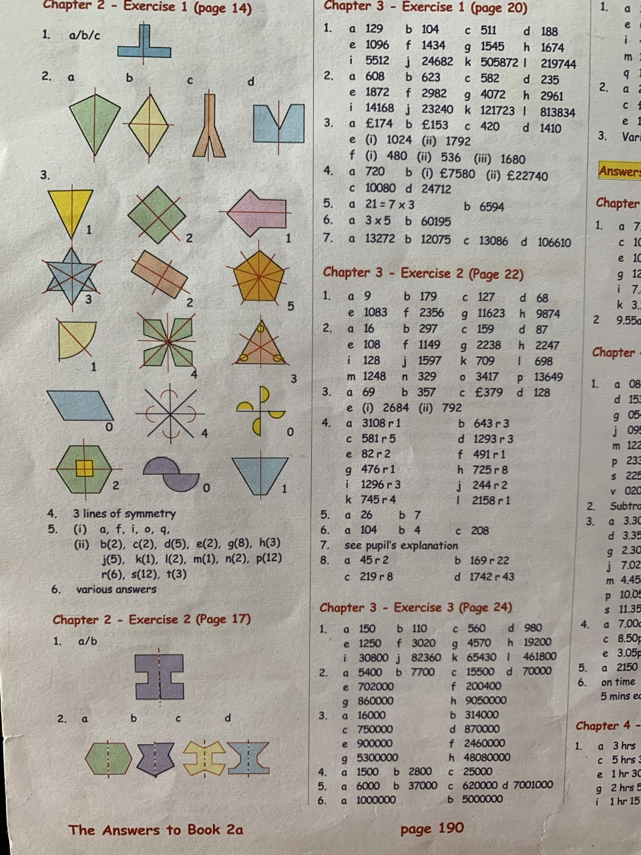
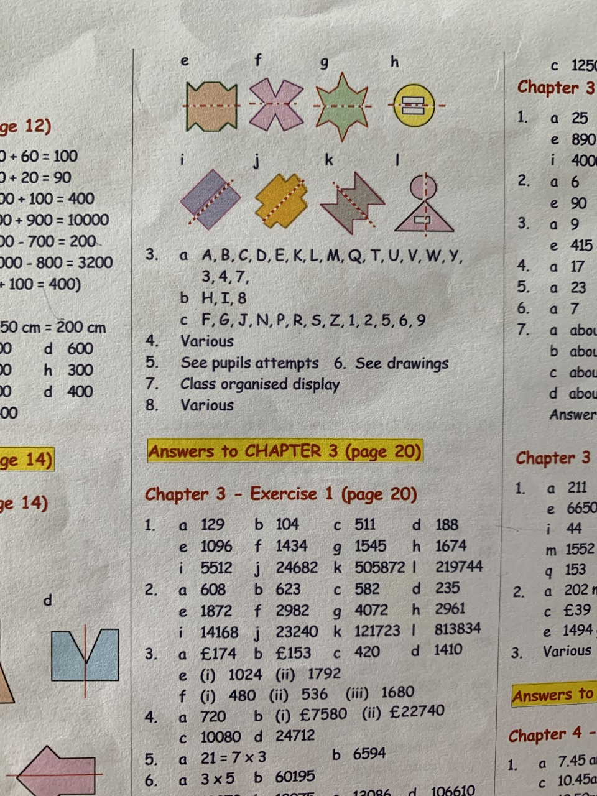
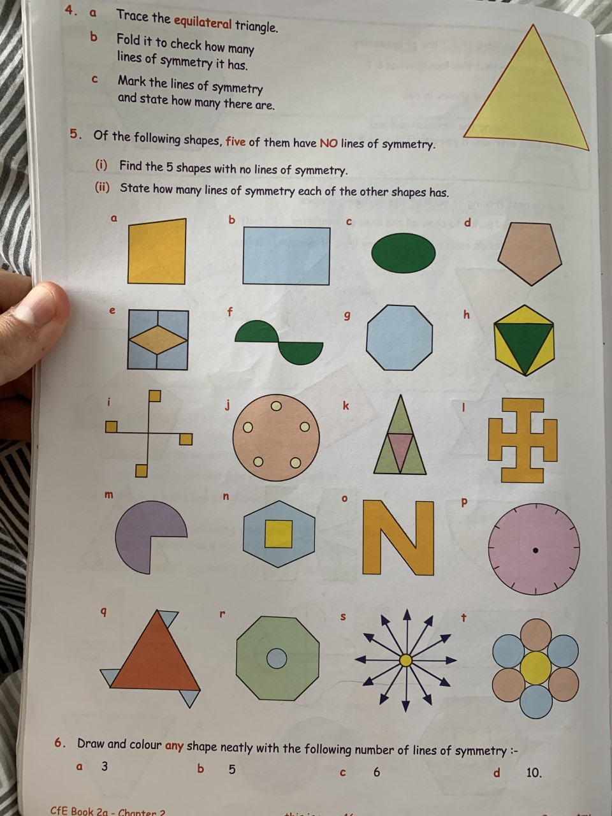

Angles

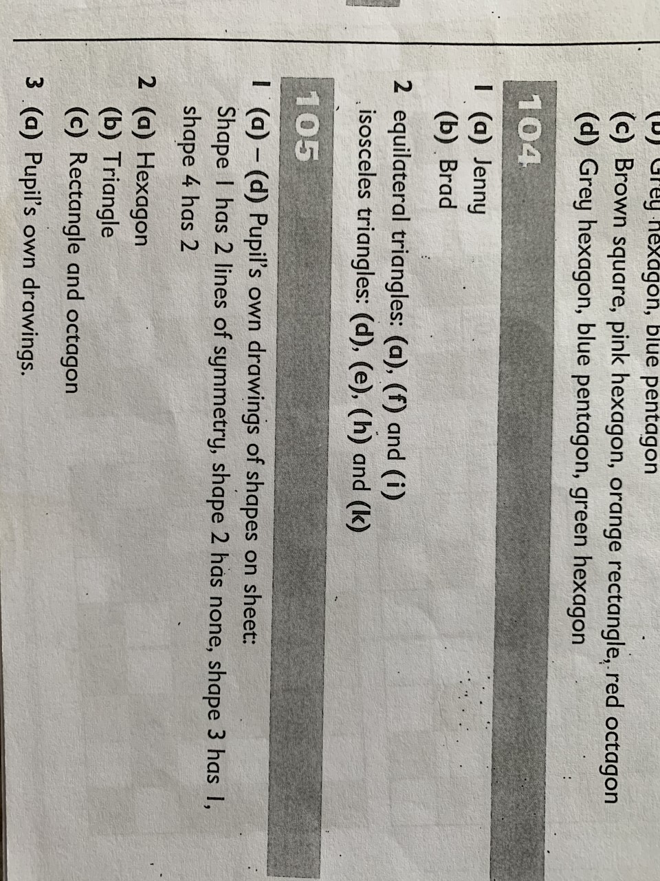

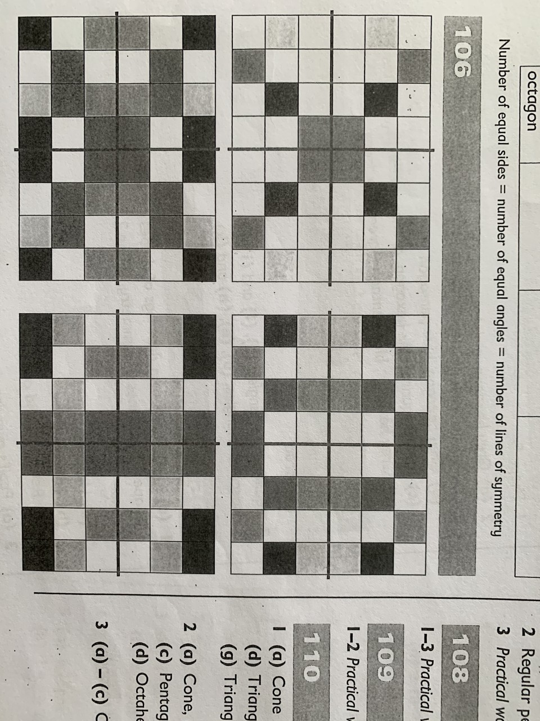

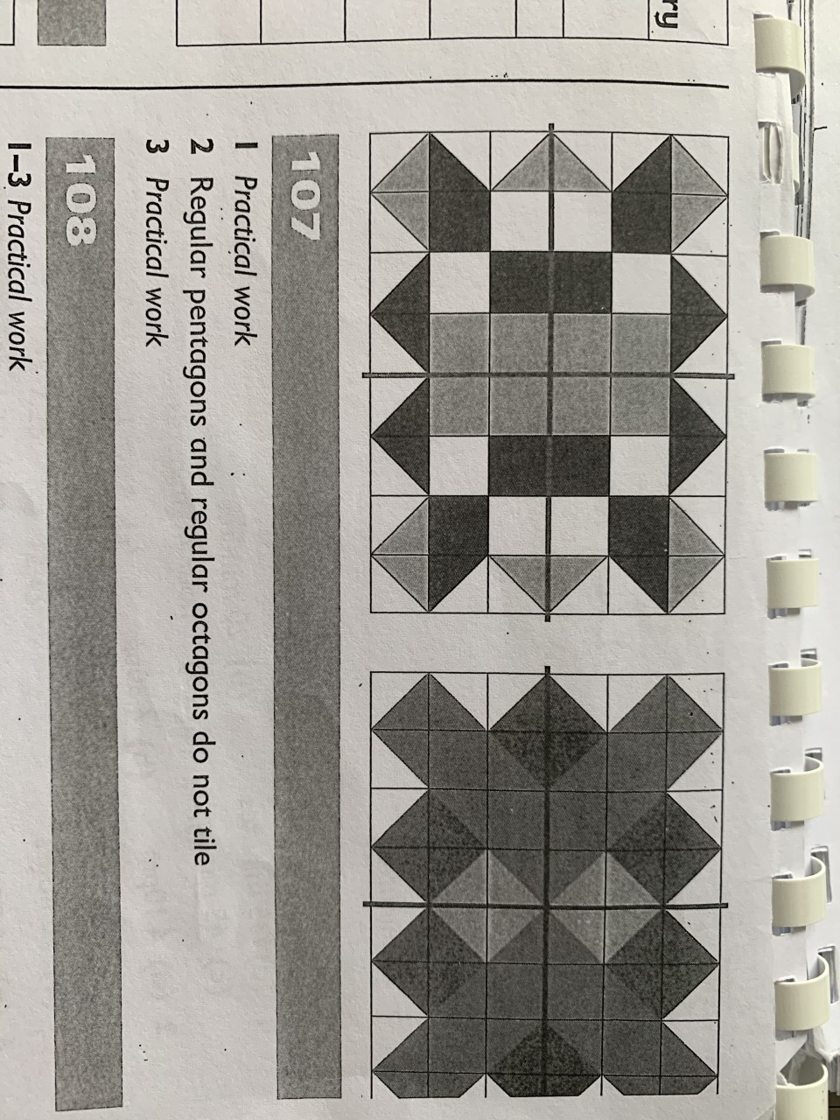

Literacy
Grammar
Unit 7: Adverbs

Sometimes, a single adverb is not enough to tell us how, when or where something happens. We need to use two or three words to describe how, when or where something happens so that the reader has a clear picture of what we are writing about.
We could write about a rocket by saying:
The rocket took off quickly.
A reader would have a much clearer picture of what happened if we wrote:
The rocket took off in a huge burst of flame.
“In a huge burst of flame‟ is an adverb phrase, telling us how the rocket took off.
We could write: The rocket took off on Thursday night.
“On Thursday night‟ is an adverb phrase, telling us when the rocket took off.
We could write: The rocket took off into the dark night sky.
“Into the dark night sky‟ is an adverb phrase, telling us where the rocket took off.
A phrase is a group of words that does not contain a verb.

Grammar Focus
Look for the words which tell you how, when or where the action takes place.
Copy the following sentences into your book. Underline the adverb phrase in each one.
1 The giant approached the village with loud, thudding footsteps.
2 Yesterday morning, I planted some seeds.
3 The painter climbed to the top of the ladder to paint the window frame.
4 We ran as quickly as we could.
5 The eagle built its nest on the mountain top.

Grammar Practice
A
Use these adverb phrases in sentences of your own
1 I think about going on holiday from time to time.
2 I had to get up this morning before sunrise.
3 They had to make a decision at the crossroads.
4 The scarecrow stood in the middle of the field.
5 Carefully and slowly, I approached the figure.
6 I completed my test with great confidence.

B
Write a sentence with an adverb phrase to describe how, when or where each of these verbs happened.
1 I had to mix the bowl in the kitchen.
2 The man was going to measure the wall before it rained outside.
3 We had to depart tomorrow morning.
4 my family had to discuss what we would do next.
5 I found it hard to laugh at the unfunny joke.
6 I woke up to cough in the middle of the night.
You can use any part of the verb. You do not have to use the verb family name.

Grammar Extension
A
Three of the following are adverb phrases and three are sentences. Copy the adverb phrases and add a verb and any other words you need to make them into sentences.
1 I was so excited before the first lesson.
3 I waited patiently in front of the cinema.
4 I swam up gasping for breath

B
Find the three sentences from part A. Write them with their correct punctuation.
2 “We’ll meet at the corner” I said.
4 Simon rand the bell repeatedly.
6 “You must find that letter” he said.

Comprehension
Unit 20 – Excalibur
Think ahead
`Out of the lake came a shining sword, a hand holding it, and an arm in a white silk sleeve.' What do you think Excalibur could be? What special properties could it have?

`What is this place?' I asked.
`This lake separates life from death, Arthur. Beyond the mists is the Island of Avalon. Those who live there are not living, neither are they dead. They live in a half-life. They are people not of this world, yet they can come into this world. They have earthly powers and unearthly powers, powers for good and evil. Yet the lake is just a lake like any other.’
`Where is this Excalibur?' I asked yet again. `And what is it anyway? Can't you tell me?'
`Oh, be still with your questions, Arthur,' said Merlin. Suddenly he leaned forward and pointed. `Look.'
I looked, but could see nothing at first. But then as I looked I saw the surface of the lake shiver and break. And, to my amazement, up out of the lake came a shining sword, a hand holding it, and an arm in a white silk sleeve.
`There,' Merlin whispered. `You have your answer. That is Excalibur. It comes from that half-world of Avalon, the blade forged by elf-kind, the scabbard woven by the Lady Nemue herself, the Lady of the Lake, and my lady too.' And as he spoke his voice faltered. `See, here she comes.'
And out of the mists came a figure in flowing green, walking across the water. Yet the water seemed undisturbed beneath her feet as is she was walking on air. She came towards us, holding a scabbard in both her hands, and a sword belt dangling from it. From the way she looked at Merlin and from the way he was looking at her, I could see there was an old love between them, a love still strong. There was a secret smile in her eyes and it was all for him. But when she spoke, she spoke to me.
`My Lord Arthur, I have made this for you. It is woven from the gold of Avalon. Keep it always with you. Always, you hear me?'
`But the sword,' I said, `How do I get the sword? Do I have to swim for it?'
`You will not need to,' she said, and she smiled gently. As she spoke, I saw a boat lying in amongst the reeds. Where it had come from, and how it came to be there I do not know.
`Get in,' she said.
I did not hesitate. The moment I stepped down into the boat, it moved, gliding with scarcely a sound through the dark waters out towards the arm in the middle of the lake. As we came nearer, the boat slowed and paused, only just long enough for me to reach out and take the sword by the blade. The arm withdrew into the lake. I watched until the last finger vanished.
I sat down in the bottom of the boat and examined the sword on my lap. The hilt was encrusted with jewels and gold, and fitted my grasp like no other I had ever held. The blade was broader than any I had seen before, yet it felt as light as a feather, as if it were part of my arm and not a sword at all.
The boat reached the shore and I looked up. Merlin was waiting for me, the scabbard in his hand. The Lady of the Lake was nowhere to be seen. I slid the sword into the scabbard and Merlin buckled the sword belt around my waist. He stood back to look at me. `So, now you have Excalibur. Which do you prefer, Arthur, the sword or the scabbard?'
`The sword, of course,' I said, drawing it out for the first time. `A scabbard without a sword is useless.'
`Not this one,' said Merlin. `I tell you Arthur, if you do as Lady Nemue said, if you have the scabbard round your waist, then you will never loose a single drop of blood. Excalibur may bring you victory and glory and honour, it may scythe down your enemies like so much ripe corn; but the scabbard will always keep you safe. Never be parted from it, Arthur, never. She made it specially for you as a favour to me. The woman is the love of my life. One day,' he went on, musing, `one day, I shall go to her, but not yet.' When he turned to me, his eyes were filled with tears. `I must be with her. She is always in my head. I think you understand what I mean, don't you, Arthur?'
I understood, only too well. `How much longer will you stay with me, Merlin?' I asked.
`A little while yet,' he said. `A little while. And besides, I will never leave you quite alone, you know that. You will always have Bercelet.' And Bercelet came up beside me and shook himself again, showering me from head to toe. `
Oh, a comfort,' I laughed. `A great comfort!
And so we came home with Excalibur to Camelot.

From Arthur, High King of Britain by Michael Morpurgo

Thinking back
Choose the best ending for each sentence.
1 Arthur and Merlin were standing by
a) a river

2 Out of the lake came a hand holding
a) a sword

3 Out of the mists came
c) Lady Nemue

4 Merlin and Lady Nemue were
c) old lovers

5 Lying amongst the reeds was
b) a boat

6 The sword's hilt was encrusted with
c) jewels and gold

7 When Arthur reached the shore again Lady Nemue
a) had vanished

8 Merlin told Arthur that the scabbard would always
b) keep him safe

Thinking about it
1 What sort of people live on Avalon? - The people who lived on Avalon were neither living or unliving. They live in a half-life. They are people not of this world, yet they can come into this world. They have earthly powers and unearthly powers, powers for good and evil.
2 In what sense was the lake `magical'? - The lake was magical because it separated the living from the dead.
3 Was Merlin young, middle-aged or old? How can you tell? - I think Merlin was older. I can tell this because he shared an old love with Lady Nemue. He also holds a lot of knowledge about the lake.
4 How did Arthur react when he first saw Excalibur? - Arthur was surprised when he first saw Excalibur. I can tell this because the hilt was encrusted with jewels and gold, and fitted his grasp like no other I had ever held. The blade was broader than any he had seen before, yet it felt as light as a feather, as if it were part of his arm and not a sword at all.
5 Why do you think Merlin's voice faltered when he talked about the Lady of the Lake? - I think Merlin’s voice faltered when he talked about The Lady of the Lake because he did not want to interrupt her approaching Arthur.
6 Why was there a `secret smile' in Lady Nemue's eyes? - I think there was a secret smile in Lady Nemue’s eyes because she loved Merlin and wanted to show him that, however had an important task to complete.
7 What do you think a scabbard is? - I think a scabbard is a sheath for a sword. I think this because Arthur wears it around his waist.
8 What special qualities and powers did the sword have? - The special qualities and powers that the sword had were that it would bring victory and glory and honour in battle.
9 Arthur asked Merlin how long he would stay with him. Where do you think Merlin intended to go when he left Arthur? - I think Merlin intended to go to Lady Nemue. I think this because Merlin’s states that he will return to her.
10 Who, or what, do you think Bercelet is? Why? - I think Bercelet is a dog. I think this because it shook itself all over Arthur getting him wet.

Thinking it through
1a) Who is telling the story? - I think Arthur is telling the story. I know this because it is written in the first person, from Arthur’s perspective.
b) What is he? (The book title is a clue!) - Arthur is the High King of Britain.
2 When do you think the story takes place – in the past, in the present, in the future? Give your reasons. - I think the story takes place in the past because people were still using swords. Merlin also comments on Excalibur being able to scythe down your enemies like so much ripe corn. This would not be needed in the present day as tractors are used.
3 There are many legends about King Arthur. What is a legend? - A legend is something that may or may not be true. They are stories passed down from generation to generation.
4 What do you think Camelot was? Describe how you think it might have looked. - I think Camelot was Arthurs home. It is a large castle made of stone, with tall towers and a moat.

