Dear Parent/ Carer,
I have attached the answers to this week’s weekly activity below. Some of the answers will be down to your own judgement however I have listed my own answers to give you an idea. Answers included are for:
- Maths: Revision of Measurement (This has been split in coordinates/symmetry and angles groups).
- Literacy: Grammar and Comprehension.
Feel free to email me any questions or to show me any work produced. I hope you are all doing well.

Many Thanks,

Mr Garvey

Maths
Coordinates and symmetry
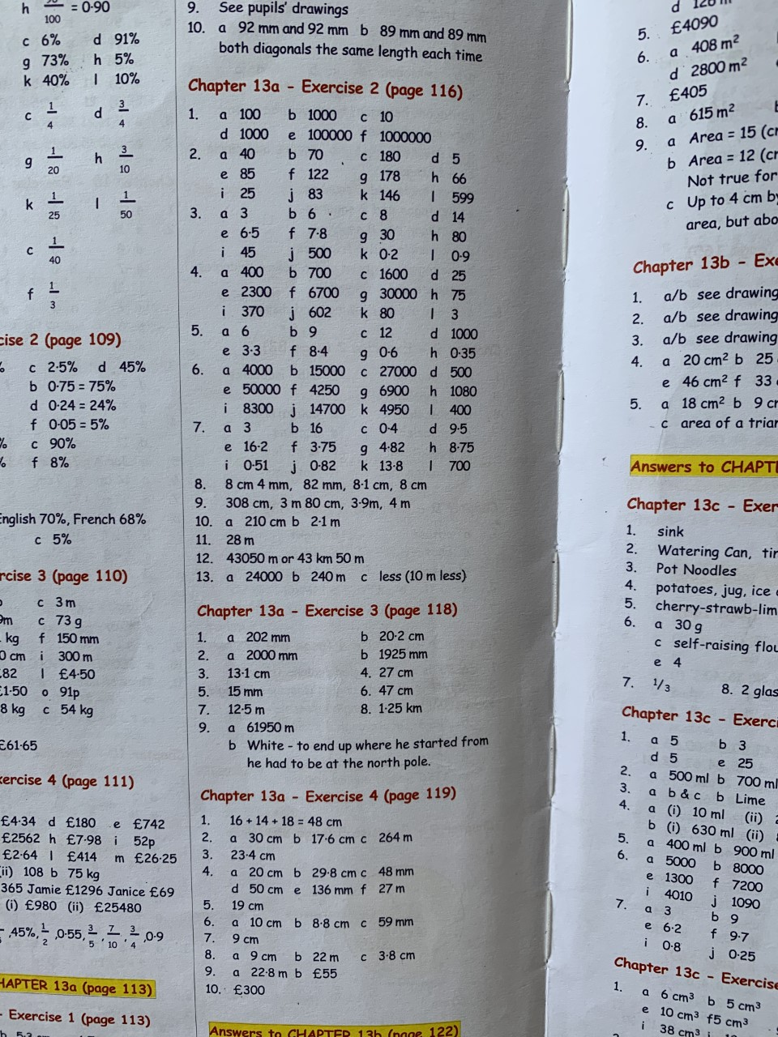

Angles

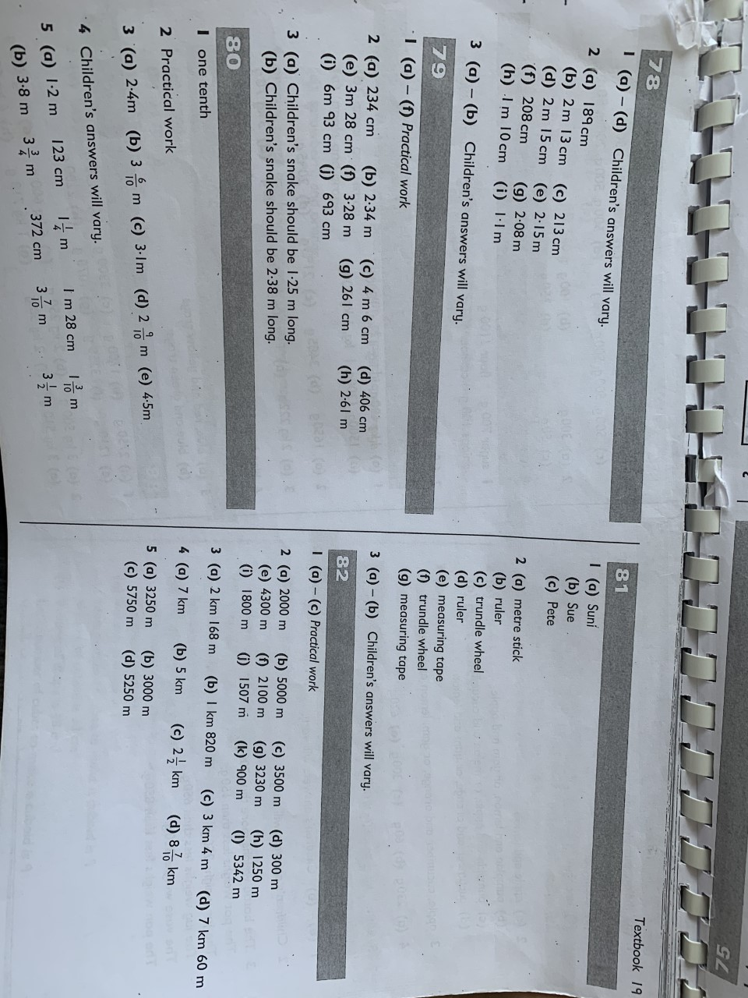

Literacy
Grammar
Unit 8: Sentences
Indirect speech is sometimes called reported speech because we report what somebody has said.
Direct speech is when we write the actual words that someone has spoken.
Inverted commas go around the spoken words. Punctuation at the end of the spoken words goes before the inverted commas. When a different person speaks we begin a new line.

"The driver got the bus stuck on the bridge
today said Meg.
"What happened?" asked Mum.
"The police came and sent for a tow
truck. It took them ages to get it free. We
were late for school!" replied Meg.
Indirect speech is when we write about what a person has said. We don't use the actual spoken words so we don't need inverted commas.

Meg told her Mum that the bus had got stuck on the bridge. Mum wanted to know what happened and Meg said that the police and a tow truck came to free the bus but it took so long they were late for school.

Grammar Focus

In your book, write which of these sentences use direct speech and which use indirect speech.

1 "Look at my swimming certificate," said Len. – direct speech

2 Sonia said that she couldn't find the newspaper. – indirect speech

3 "Stop, thief!" shouted the policewoman as the burglar ran away. – direct speech

4 Rob told his Dad that the computer was broken. – indirect speech

5 The doctor asked how long I had been feeling unwell. – indirect speech

Grammar Practice

A

Write each of these sentences using indirect speech.

1 “Would all passengers go to platform 8,” boomed the voice over the loudspeaker. – The loudspeaker asked if all passengers would go to platform 8.

2 “I like porridge for breakfast,” said Dad. – Dad told me that he liked porridge for breakfast.

3 “How long do I have to wait to be served?” snapped the customer – the customer asked how long he would have to wait to be served.

4 “I‟ve forgotten my lines!” groaned the actor. – The actor groaned that he had forgotten his lines.

B

Write each of these sentences using direct speech.

1 Chris said that his book was very dull. – “This book is very dull”, said Chris.

2 Owen wanted to know how far they still had to go. – “How far do you still have to go?”, asked Owen.

3 The singer asked if many people had come to the show. – “Has many people come to the show?”, asked the singer.

4 Martha encouraged Sandy to tell her what had happened. – “What happened Sandy?”, encouraged Martha.

Grammar Extension

A

Write a conversation in direct speech between Malcolm and Emma about what they watched on television last night. Remember to use inverted commas, punctuation and to begin a new line when a different person
speaks.

Malcolm and Emma sat on the couch. Suddenly Malcolm asked, “What did we watch on television last night?”.
“I cant remember”, said Emma.
“Did we not watch a movie?”, replied Malcolm.
“Yes!”, exclaimed Emma, “We watched Harry Potter”.
B

Write the same conversation between Malcolm and Emma in indirect speech. Remember that you do not need inverted commas because you are not writing the words that were actually spoken.

While sitting on the couch Malcolm asked Emma about what they were watching on the television last night. Emma could not remember what they had watched. Malcolm thought that they had both watched a movie. Emma then remembered that they did watch Harry Potter.

Comprehension
Unit 21 – Swallows and Amazons
Think ahead

Swallows are birds. Do you think this story is going to be about birds? How can you tell without reading the whole passage?
In the holidays, John, Susan, Timmy and Roger use their boat Swallow to go camping on an uninhabited island. Soon they see a strange pirate boat called Amazon and they meet the mysterious owner of the houseboat with a green parrot. Are they friends or enemies?

At that moment something hit the saucepan with a loud ping, and ashes flew up out of the fire. A long arrow with a green feather struck, quivering, among the embers. The four explorers started to their feet.
`It's begun,' said Timmy.
Roger grabbed at the arrow and pulled it out of the fire.
Timmy took it from him at once. It may be poisoned,' she said. `Don't touch the point of it .'
`Listen,' said Captain John.
They listened. There was not a sound
to be heard but the quiet lapping of the water against the western shore of the island.
`It's him,' said Timmy. `He's winged his arrow with a feather from his green parrot.'
`Listen,' said John again.
`Shut up, just for a minute,' said mate Susan.
There was a sharp crack of a dead stick breaking somewhere in the middle of the island.
`We must scout,' said Captain John. `I'll take one end of the line, the mate the other. Timmy and Roger go in the middle. Spread out. As soon as one of us sees him, the others close in to help.'
They spread out across the island, and began to move forward. But they had not gone ten yards when John gave a shout.
`Swallow has gone,' he shouted. He was on the left of the line, and as soon as he came out of the camping ground he saw the landing-place where he had left Swallow when he came back with the milk. No Swallow was there. The others ran to the landing-place. There was not a sign of Swallow. She had simply disappeared.
`Spread out again. Spread out again,' said John. `We'll comb the whole island. Keep a look-out, Mister Mate, from your shore. She can't have drifted far away. He's taken her, but he's still on the island. We heard him.'
`Roger and I pulled her right up,' said Timmy. `She couldn't have drifted off.'
`Spread out again,' said Captain John. `Then listen. Advance
as soon as the mate blows her whistle. A hoot like an owl means all right. Three hoots means something's up. Blow as soon as you're ready, Mister Mate.'
The mate crossed the island nearly to the western shore. She looked out through the trees. Not a sail was to be seen on the lake. Far away there was the smoke of the morning steamer, but that did not count. Roger and Timmy, half a dozen yards apart, were in the middle of the island. Captain John moved a little way inland, but not so far that anyone could be between him and the shore without being seen. They listened. There was not a sound.
Then, over on the western side of the island, the mate blew her whistle.
The four began moving again through the trees and undergrowth.
`Roger,' called Timmy. `Have you got a weapon?' `No,' said Roger. `Have you?'
`I've got two sticks, pikes, I mean. You'd better have one.' She threw one of her sticks to Roger. An owl hooted away to the left.
`That must be the captain,' she said. She hooted back. Susan on her right hooted in reply. And again they listened. Then they moved forward again.
`Hullo,' said Roger. `Someone's been here.'
Timmy ran to him. There was a round place where the grass and ferns were pressed flat as if someone had been lying there. `He's left his knife,' said Roger, holding up a big clasp knife that he had found in the grass.
Timmy hooted like an owl three times.
The captain and the mate came running. `He must be quite close to,' said Timmy.
`We've got his knife, anyway,' said Roger.
Captain John bent down and felt the flattened grass with his hand.
`It's not warm,' he said.
`Well, it wouldn't stay warm very long,' said the mate. At that moment there was a wild yell ...

From Swallows and Amazons by Arthur Ransome

Thinking back

1 Who did the boat called `Swallow' belong to? – The boat called swallow belonged to John, Susan, Timmy and Roger.

2 What struck the saucepan? – A long arrow with a green feather struck the saucepan.

3 Why did Timmy not want Roger to touch the arrow? – Timmy did not want Roger to touch the arrow in case it was poisoned.

4 Where did they think the green feather on the arrow had come from? – They thought that the green feather had come from the strange man’s parrot.

5 What noise did they hear coming from the middle of the island? – They heard the sharp crack of a dead stick coming from the middle of the island.

6 Who discovered `Swallow' had gone? – John had discovered that Swallow had gone.

7 What was the signal to advance? The signal to advance was when the mate blows their whistle.

8 What weapons did Roger and Timmy carry? The weapons Roger and Timmy carried were pikes.

9 How did Roger know he had found a place where someone had been? – Roger knew he had found a place where someone had been because the grass and ferns here had been pressed flat like someone had been lying on them.

10 What else did Roger find in the grass? – In the grass, Roger found a knife.

Thinking about it

1 What did Timmy mean when she said, `It's begun'? – Timmy meant that a fight was going to start when she said ‘It’s Begun’ because they were unsure if the man was their friend or enemy. This confirms he is their enemy.

2 Who do you think fired the arrow? Why? – I think the man fired the arrow because a green feather was attached to it. The man had a green parrot so it seem like it could only be him that fired it.

3 Who is the leader of the group? How do you know? - The leader of the group appears to be John. I know this because he is the captain and everyone listens to him.

4 Do you think the `mysterious' owner of the `Amazon' is an enemy or not? Why? – I think the mysterious owner of the ‘Amazon’ could be an enemy. I think it is possible as the arrow had a feather from his bird attached to it.

5 Do you think the Swallow drifted off on her own? What do you think happened? Explain your answer. – I do not think the Swallow drifted off on its own because the children seemed so sure that they had pulled it up onto the beach. Instead I think someone has pushed it out to sea or has taken it from them.

6 When they were searching the island how did they keep in touch with each other? – When searching the island they kept in touch with each other through owl hoots.

7 Why did John feel the flattened grass with his hand? – John felt the flattened grass with his hand to see if it was still warm. This could tell them if whoever had been here had only just left or had been gone a while.

8 Who do you think gave the yell at the end? Why? – I think the mysterious owner gave a yell at the end. I think this because the four children where together and the only other person on the island was him.

Thinking it through
1 What sort of story do you think this is – animal, ghost, adventure, mystery?
Why? - I think this story is an adventure story. I think this because it is all about being on a deserted island with pirates.
2 How does the author try to keep you interested? – The author tries to keep the reader interested by using short paragraphs and lots of dialogue. This keeps the passage flowing quickly.

3 Do you think this could really have happened or is it unlikely? Say why. – I think this could really have happened at some point in history, however not in present times. I think it could have happened when pirates roamed the seas. However I do not think it could have happened because four children would not be allowed by their parents to go exploring like they are in the story.

4 What do you think the dangers could be in a group of children going off camping on an island on their own? – I think there are many dangers in allowing a group of children to go camping on an island on their own. They may fall in the sea when sailing, they may not know how to sail, they may loose the boat, they may get cold on the island and not know how to start a fire or create a shelter, and they may not know how to get food.

5 What do you think happens at the end? Continue the story. – I think that the mysterious stranger has found himself in trouble, e.g. he has broken his leg. He remembered that the children were on the island and fired an arrow with his birds feather on it towards them to try and get their attention. The children then find him and he explains all of this. The children manage to save him.

