Dear Parent/ Carer,
I have created this resource to provide weekly work that children can complete at home. This could be used in conjunction with your home learning packs. I have included:
- Maths: Problem Solving and Time (This has been split in coordinates/symmetry and angles groups).
- Literacy: Grammar, Comprehension, Handwriting and Writing exercises.
- Additional Activities: Small activities linking to topic, Outdoor Learning, R.E., Art and Science.
Answers to math and literacy exercises will be posted on Friday. Feel free to email me any questions or to show me any work produced. I hope you are all doing well.

Many Thanks,

Mr Garvey

Maths
Coordinates and symmetry

Angles

Literacy
Grammar
Unit 9: Verbs
Remember! The subject is what the sentence is about.

When the subject of a sentence does the action, the verb is called an active verb.

The man bought a ticket.

“man‟ = subject of the sentence

“bought‟ = what the subject is doing

In this sentence, “bought‟ is an active verb.

When the subject of the sentence has the action done to it, the verb is called a passive verb.

The ticket was bought by the man.

“ticket‟ = subject of the sentence

“was bought‟ = what was done to the subject

In this sentence, “was bought‟ is a passive verb.

Grammar Focus

Find the subject. Is the subject doing the action, or is the
action being done to the subject?

Find the verb in each of these sentences.
In your book, write whether the verb is active or
passive.

1 The judge banged on the table.

2 A sailor was hit by the rigging.

3 A few regular customers went into the shop
every day.

4 The monster attacked the town.

5 One of the escalators was stopped by the shop
manager.

6 The bridge fell into the river.

7 The library was broken into last night.

8 I have lost my dictionary.

Grammar Practice

Find the subject. Change the sentence so that the
action is being done to the subject.

A

Rewrite each of the following sentences, changing the verb from active to passive. The first one has been done for you.

1 Our teacher read the class a story.

A story was read to the class by the teacher.

2 The captain won a famous victory.

3 We heard thunder in the afternoon.

4 I tidied my room yesterday.

Find the subject. Change the sentence so that the
subject is doing the action.

B

Rewrite these sentences, changing the verb from
passive to active. The first one has been done for you.

1 The new vase was cracked by the boy.

The boy cracked the new vase.

2 The windows were cleaned this morning by my
Dad.

3 The play was disliked by the audience.

4 The house was shaded by the trees.

5 Rabbits are shot by some farmers.

Grammar Extension

A

Write sentences where each of these verbs are
active.

1 to carry

2 to lift

3 to see

4 to write

5 to cover

6 to bury

B

Rewrite the sentences from part A, making the
verbs passive.

Comprehension
Unit 22 – A Visitor in the Night
Think ahead

Read the introduction to the story. Look for clues.
What do you think the passage is going to be about?

Mary's parents die in India and she is sent to live at her uncle's house in Yorkshire. Mary thinks she is the only child in the house, but one night ...

Mary had been lying awake, turning from
side to side for about an hour, when
suddenly something made her sit up in
bed and turn her head towards the door listening. She listened and listened.
`It isn't the wind now,' she said in a loud whisper. `That isn't the wind. It is different. It is that crying I heard before.'
The door of her room was ajar and the sound came from down the corridor, a far-off sound of fretful crying. She listened for a few minutes and each minute she became more and more sure. She felt as if she must find out what it was. Perhaps the fact that she was in a rebellious mood made her bold. She put her foot out of the bed and stood on the floor.
`I am going to find out what it is,'
she said. `Everybody is in bed and I don't care about Mrs Medlock - I don't care!'
There was a candle by her bedside and
she took it up and went softly out of the room. The corridor looked very long and dark, but she was too excited to mind that. She thought she remembered the corners she must turn to find the short corridor with the door covered with tapestry - the one Mrs Medlock had come through the day she lost herself. The sound had come up that passage. So she went on with her dim light, almost feeling her way, her heart beating so loud that she fancied she could hear it. The far-off, faint crying went on and led her. Sometimes it stopped for a moment or so and then it began again. Was this the right corner to turn? She stopped and thought. Yes, it was. Down this passage and then to the left, and then turn up two broad steps, and then to the right again. Yes. There was the tapestry door.
She pushed it open very gently and closed it behind her, and she stood in the corridor and could hear the crying quite plainly, though it was not loud. It was on the other side of the wall at her left and a few yards farther on there was a door. She could see a glimmer of light coming from beneath it. The Someone was crying in that room, and it was quite a young Someone.
So she walked to the door and pushed it open, and there she was, standing in the room!
It was a big room, with ancient, handsome furniture in it. There was a low fire glowing faintly on the hearth and a nightlight burning by the side of a carved four-poster bed hung with brocade, and on the bed was lying a boy, crying pitifully.
Mary wondered if she was in a real place or if she had fallen asleep again and was dreaming without knowing it.
The boy had a sharp delicate face, the colour of ivory, and he seemed to have eyes too big for it. He also had a lot of hair which tumbled over his forehead in heavy locks and made his thin face seem even smaller. He looked like a boy who had been ill, but was crying more as if he were tired and cross than as if he were in real pain.
Mary stood near the door with her candle in her hand, holding her breath. Then she crept across the room, and as she drew nearer, the light attracted the boy's attention and he turned his head on his pillow and stared at her, his grey eyes opening so wide that they seemed immense.
`Who are you?' he said at last in a half-frightened whisper. `Are you a ghost?'

From The Secret Garden by Frances Hodgson Burnett

Thinking back

Say if these sentences are true (T) or false (F) .

1 Mary had heard the sound of crying before.

2 The sound came from the attic.

3 Mary took a lantern to light the way.

4 Mary was in a big house with lots of
rooms.

5 The door of the boy's bedroom had a
mirror on it.

6 In the bedroom, the boy was sitting in an
armchair, crying.

7 The boy looked ill.

Thinking about it

1 Why do you think Mary could not sleep?

2 Who do you think Mrs Medlock was?

3 Why did Mary `almost have to feel' her
way down the corridor?

4 What two clues told Mary there was
someone in the room before she even
opened the door?

5 Describe how the boy's bedroom was
furnished.

6 Describe the boy.

7 Was the boy surprised to see Mary?
How can you tell?

Thinking it through

1 Why might Mary have felt very strange
in this house?

2 The author manages to create a rather
`creepy' atmosphere. Give some
examples of how she does this.

3 How can you tell Mary is excited?
Find a sentence or some words from the
passage that tell you.

4 How does the author make you feel sorry
for the boy?

5 Think of five things you would say to
persuade someone who hasn't read the
passage to do so.

Writing
This week for your writing exercise I would like you to continue the story. Below you will see a small introduction for a story. Use the picture below as a reference for your story.
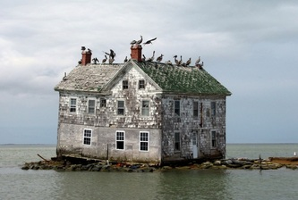
The boy looked on to the beach, observing the tranquillity of the scene he saw before him. The sun was setting, changing the colour of the sky to a crimson pink, and the heat that had once warmed his skin was replaced by a chill. It was only then that he noticed the silhouette of the house on the horizon. Although he had been at the beach the majority of the day, he had not noticed the imposing building lingering on the rocks. The mirage had peaked the boys interest and he decided, against his common sense, to go and investigate…

Handwriting

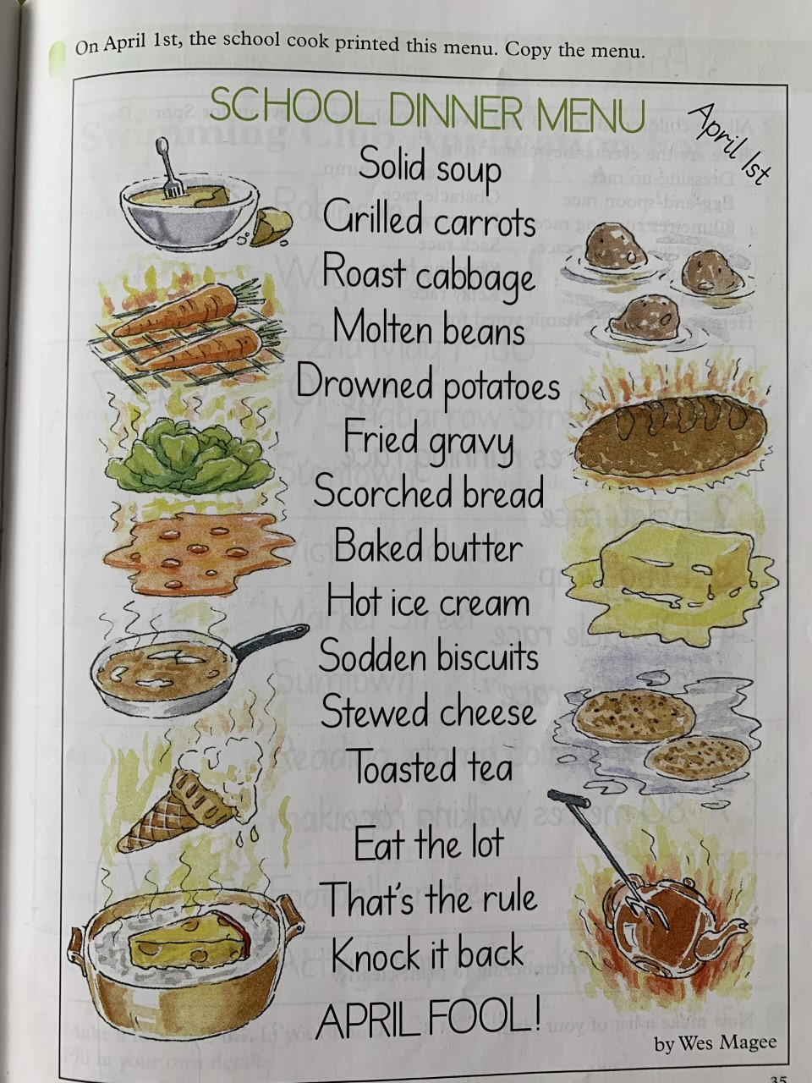

Additional Exercises
Science
Fizzy Bottle Rockets
Materials:
• Small (500ml or less) drinks bottle with a sports cap lid which pops open (see left. The 200ml and 300ml Fruit Shoot bottles worked particularly well).
• Fizzy headache or vitamin tablets (Alka Seltzer or Berocca type tablets).
• Mug or glass or jar that allows upside-down bottle to fit inside, with lid touching bottom.
• Warm water from the hot tap
Take great care if using tablets with paracetamol or other medicines in them. They should not be consumed by children. The activity can also be done with fizzy vitamin tablets

Before beginning this activity think:
When tablet is put in glass of water:
What do you think is in the bubbles?
Where do you think the bubbles are coming from?
What do you think would happen if we used more than one tablet? Why?
What do you think would happen if we used warm water? Why?
Before making rocket:
What do you think will happen if we put some tablets and water in this bottle and close the lid? Why?
What things could we change to make the rocket go higher?
Now watch this video:
https://www.youtube.com/watch?v=z4645B03AC4
Things to do:
Show children what happens when you drop a tablet into a glass of cold water. Explain that the bubbles are made because the tablet and the water react to make carbon dioxide gas. If using headache tablets, explain that the liquid is not for drinking.
Repeat this with a glass of much warmer water – you should see a difference in the way the tablet reacts with the water.
Unscrew the lid of your bottle and make sure pop up lid is firmly pressed down.
Half-fill the bottle with warm water.
Break two fizzy tablets in half and drop them into the bottle.
Quickly screw lid back on firmly, give bottle a quick shake and place upside down in mug or glass or jar.
Stand back and wait.
Allow at least three minutes to pass before checking rocket. If it has not launched, try again with slightly warmer water.
You can experiment with the temperature of the water to get your perfect fuel mixture.
Complete this experiment with an adult!

Outdoor learning
Measuring Microclimates

This is a nice way of enabling children to use fieldwork to observe, measure, record and present the physical features in the local area using a range of methods, including: sketch maps; tables; graphs and digital technologies; thus, supporting geography, science and technology studies.
The results can be a great way of promoting discussion around the design and layout of the grounds from selecting gathering spaces to growing areas. It can also spark discussions about harnessing renewable energy sources around the grounds.
Equipment
• Thermometer to measure air temperature
• Instruments to measure wind speed and direction such as a portable anemometer and weather vane (see over leaf for DIY versions).
• Pencils, graph paper and clipboards
Preparation
Discuss which areas of the grounds might be especially prone to the influence of temperature and wind – choose several locations that are likely to provide the best contrast
Create measuring devices as per the designs or research and make alternatives.
Activity
1. At regular intervals during the day, children go out to measure and record temperature and wind in each location. Record the data in a table.
2. Analyse the results. How wide are the variations from place to place? Do they change during the day? Why? Do the variations affect where children prefer to sit or socialise? Do they affect play or plant growth?
Extension:
Does the surface material have an impact – for example, is the temperature 30cm above tarmac the same as 30cm above grass? Why might there be a difference?

Topic
You are going to learn How ideas become law in the Scottish Parliament!
Try to get your idea turned into a law through a bill making game Click the link below to play:
https://www.parliament.scot/visitandlearn/15108.aspx

Art
Drawing Small

The aim of this exercise is to help you tune in to drawing as an activity.

Relax into this drawing exercise and don’t put pressure on yourself to make an amazing drawing. Sometimes making a drawing can feel like a big ask, especially if you think that drawing is not your thing (we’ll prove that wrong!).

Repeat this exercise over a few days, each time choosing a different “small” object, and you’ll soon see how the marks you make change and improve.

So let’s start small and take it one tiny drawing at a time!

You Will Need:
- Paper
- Pen or pencil
- Collection of small objects

To Begin

Your challenge is to draw a collection of tiny objects – by tiny we mean things which are roughly the size of a five pence piece – things like small shells, pebbles, leaves, beads, screws. Popcorn also makes a good subject matter and even dead flies if you can find a few

Start by scattering the objects over a large, clean sheet of paper. Take a pen or sharp pencil, and make sure you are near to the objects so that you can really see all their detail.

Begin by making sketches on the page, amongst the objects themselves. You should be making tiny movements with your fingers and hands – drawing from the wrist, but other than that draw however you feel most comfortable. This exercise is just to help you focus, relax, and begin to coordinate hand and eye, so don’t worry too much about results or technique.

Make as many sketches as you like, on as many sheets as you like.

As you draw, become aware of the relationship between looking and drawing. Let your eyes flit between looking at the object and looking at your sketch – it’s easy to concentrate more on your sketch and to forget to keep looking at the object. Ideally you should look at the object for a few seconds, then your drawing for a few seconds, then the object, then the drawing…

Also begin to become aware of how you can change the the marks you make in response to what you see. For example experiment with how much pressure you use, in different parts of the drawing.

There will be no mistakes and you can’t really go wrong. You are just making quick sketches. Each sketch should only take a couple of minutes…. Enjoy drawing small!

Watch the video below to see how!
https://vimeo.com/413069049

R.E.
Read John 3: 16-18. You can find this online by searching the Bible passage.
Or you can alternatively watch this video:
Complete the worksheet on your own piece of paper.
Think about the Holy Spirit and the gifts that you receive from it. Try list ass many as you can!

