Dear Parent/ Carer,
I have attached the answers to this weeks weekly activity below. Some of the answers will be down to your own judgement however I have listed my own answers to give you an idea. Answers included are for:
- Maths: Revision of place value and addition/subtraction (This has been split in coordinates/symmetry and angles groups).
- Literacy: Grammar and Comprehension
free to email me any questions or to show me any work produced. I hope you are all doing well.

Many Thanks,

Mr Garvey

Maths
Coordinates and symmetry
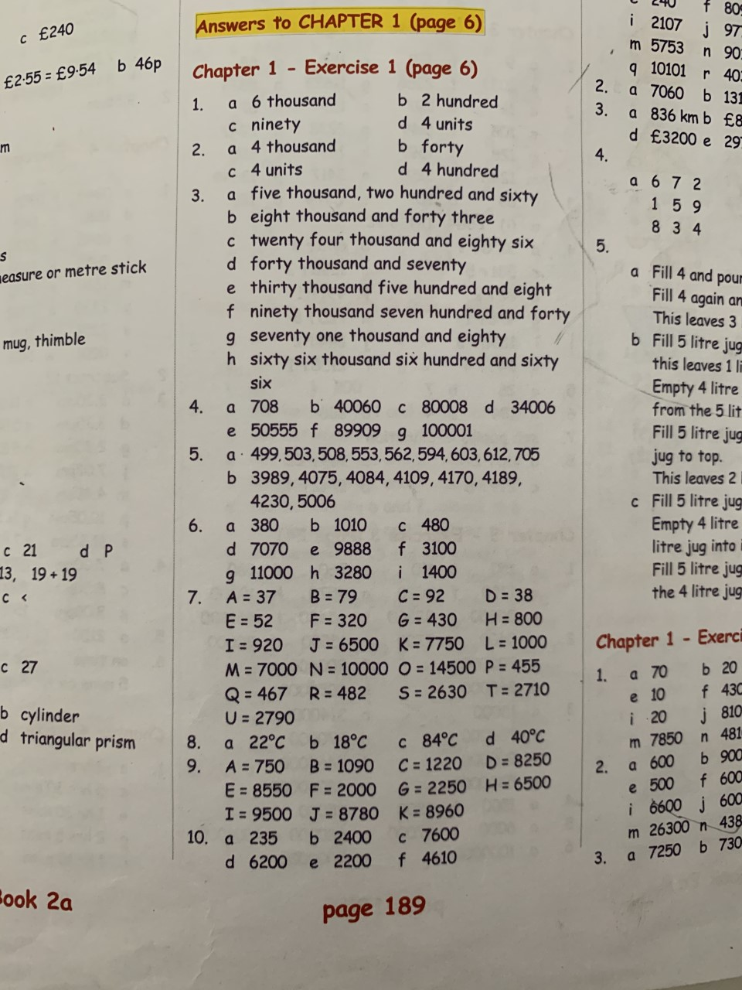
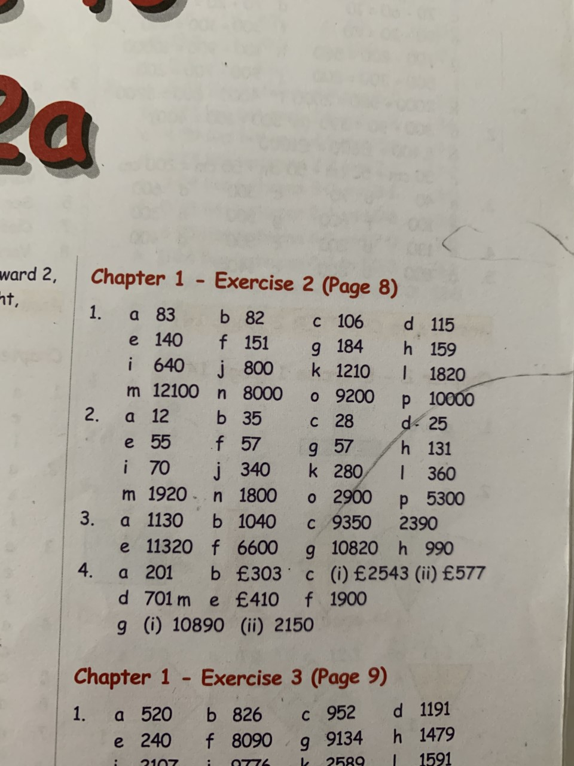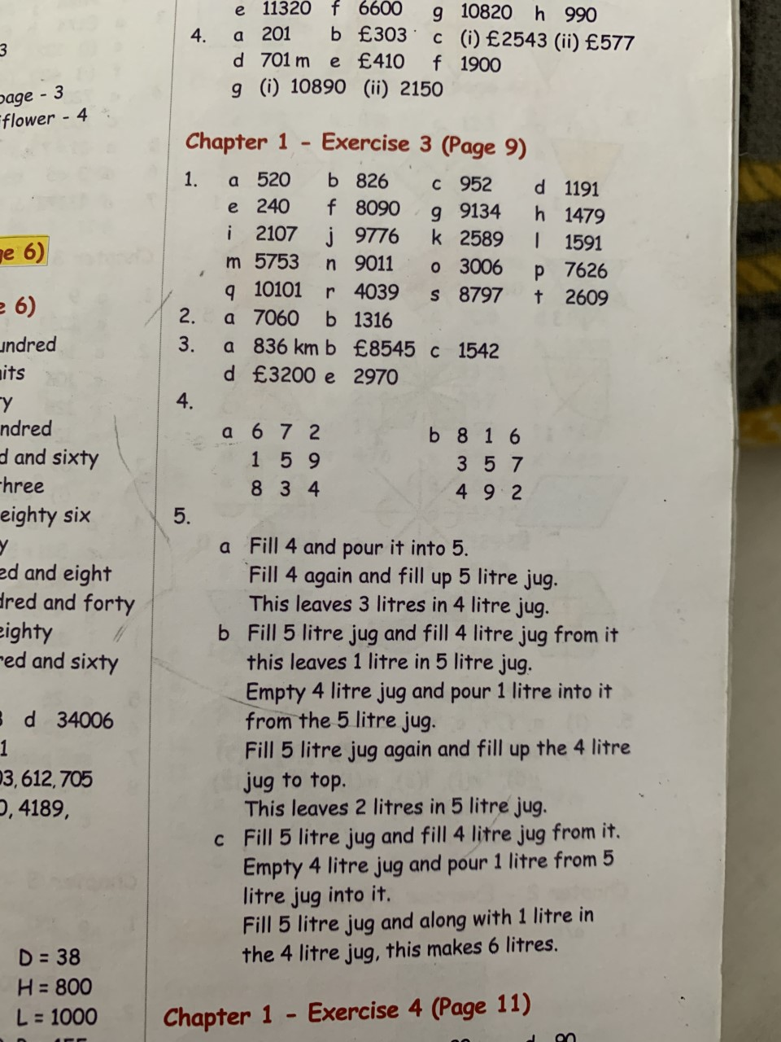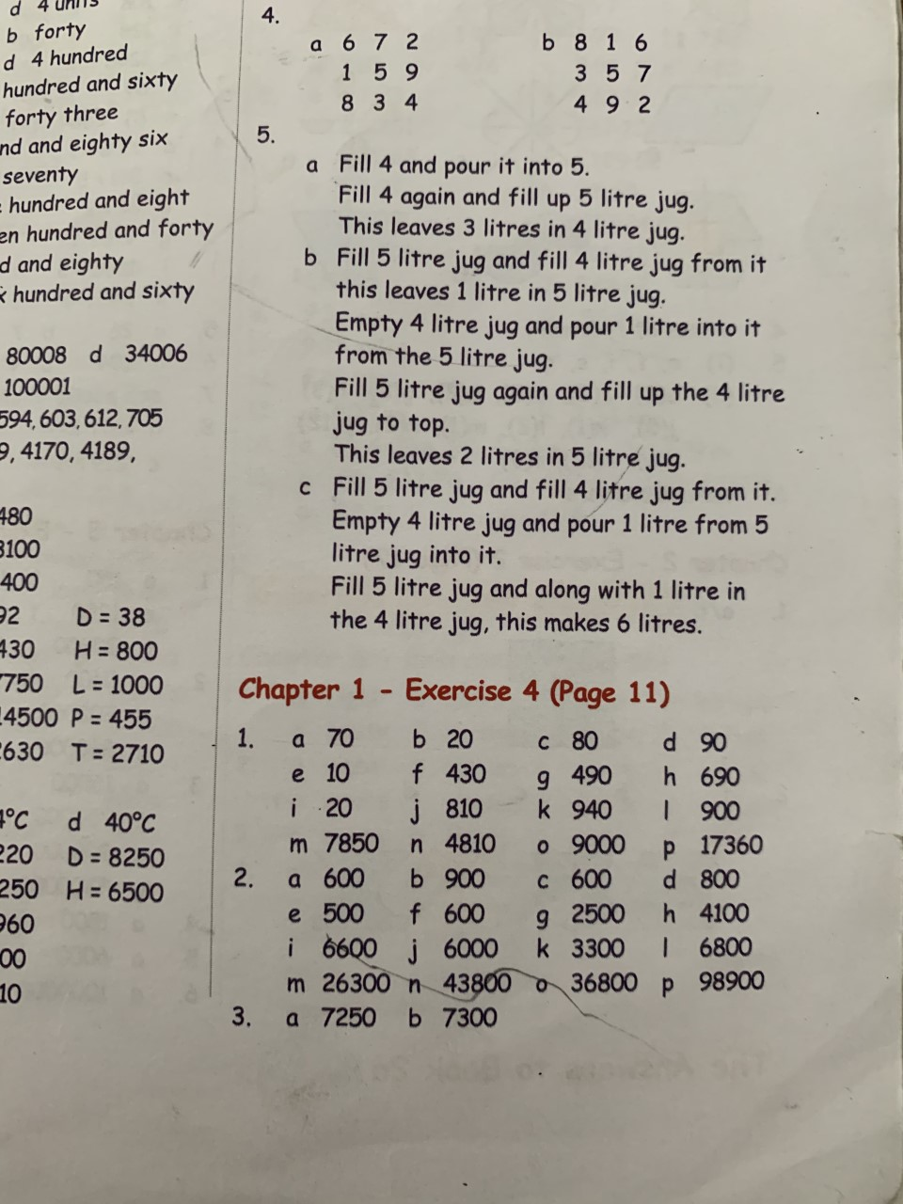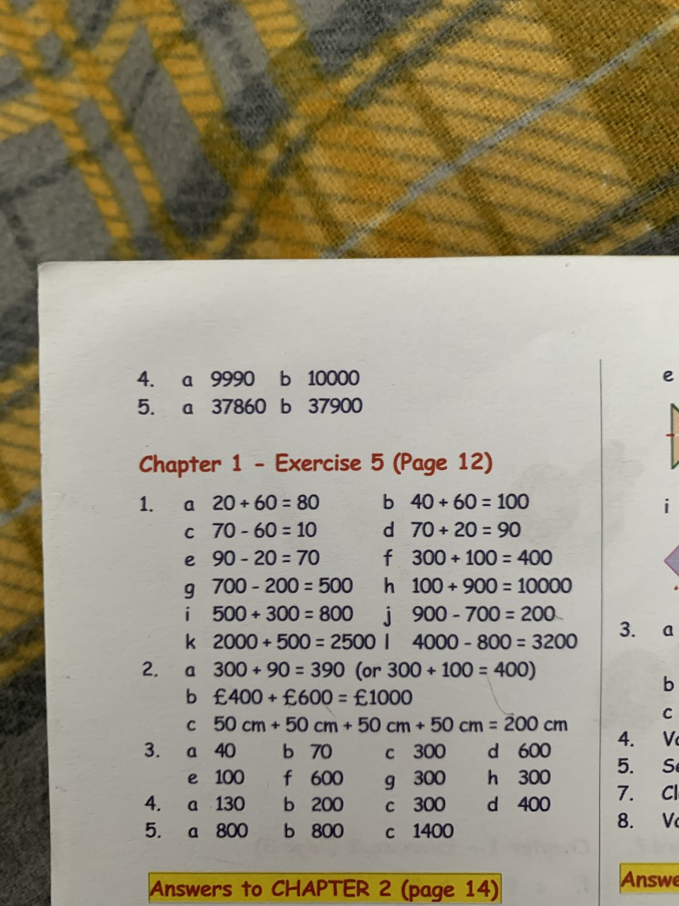

Angles
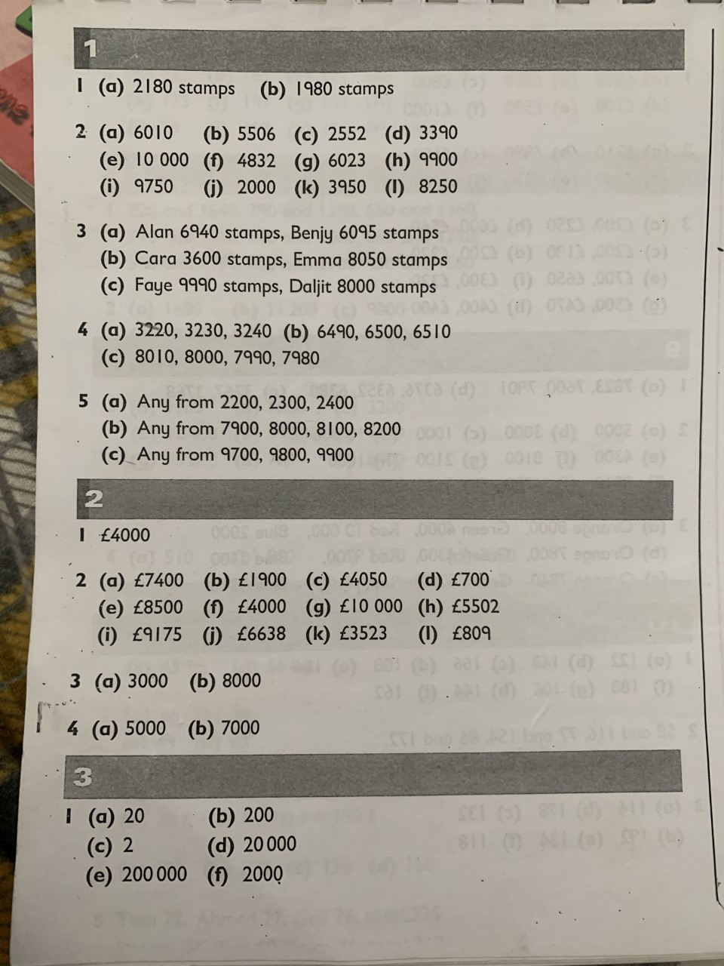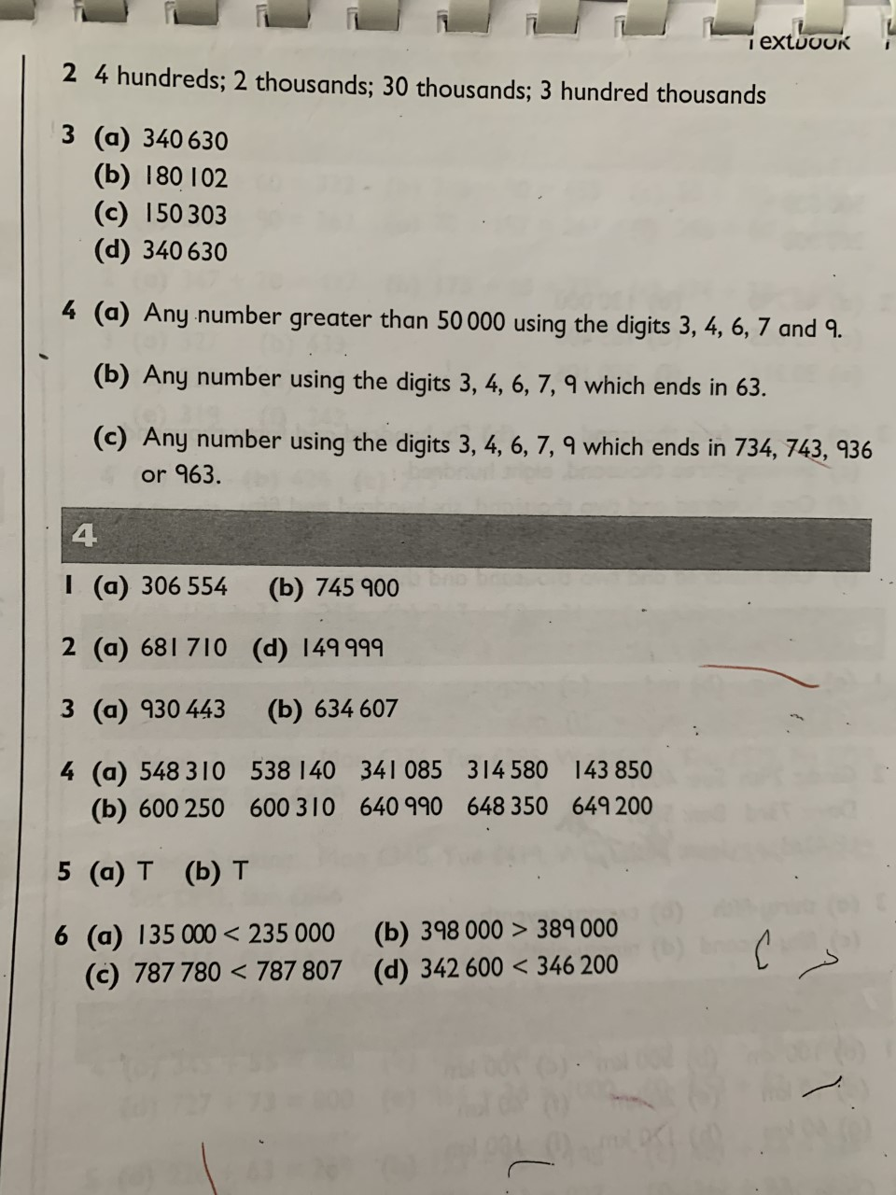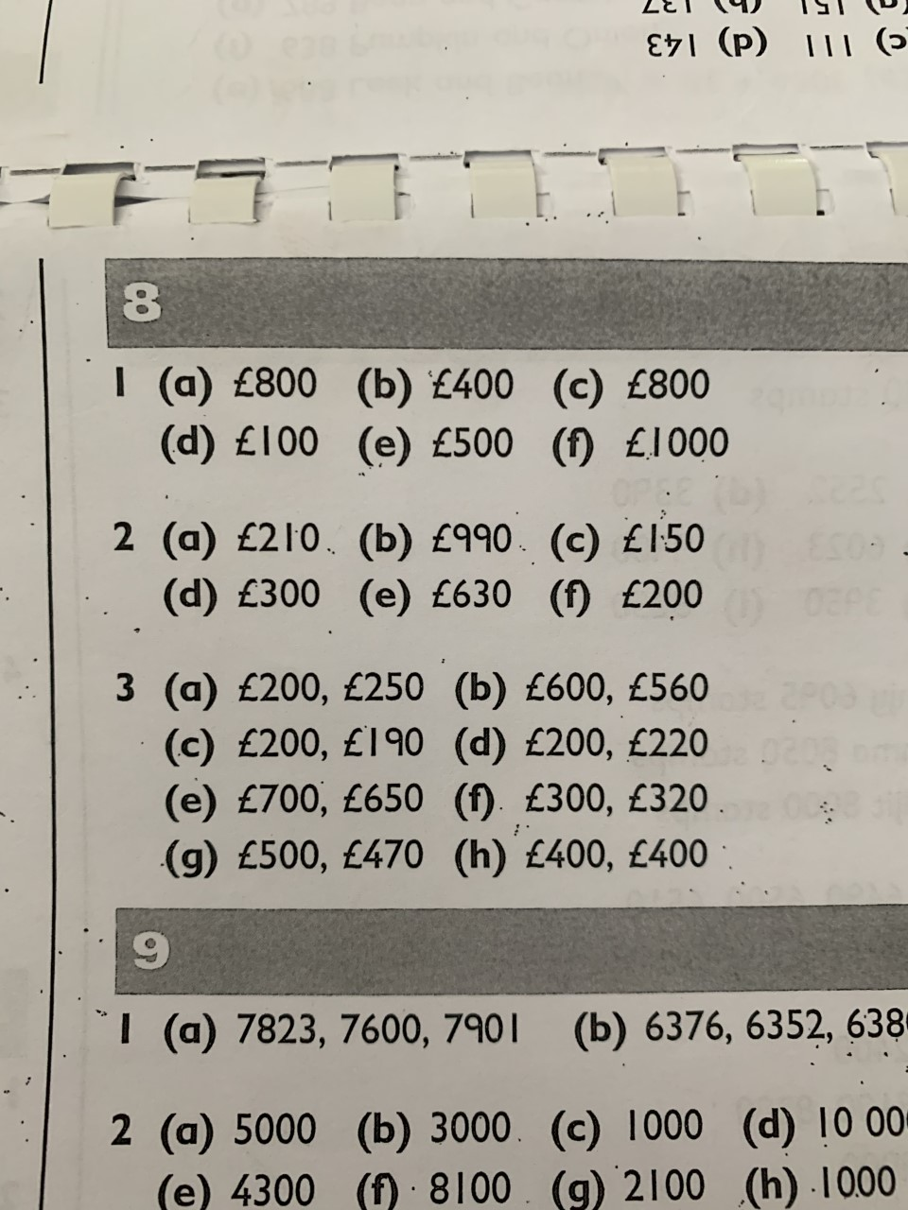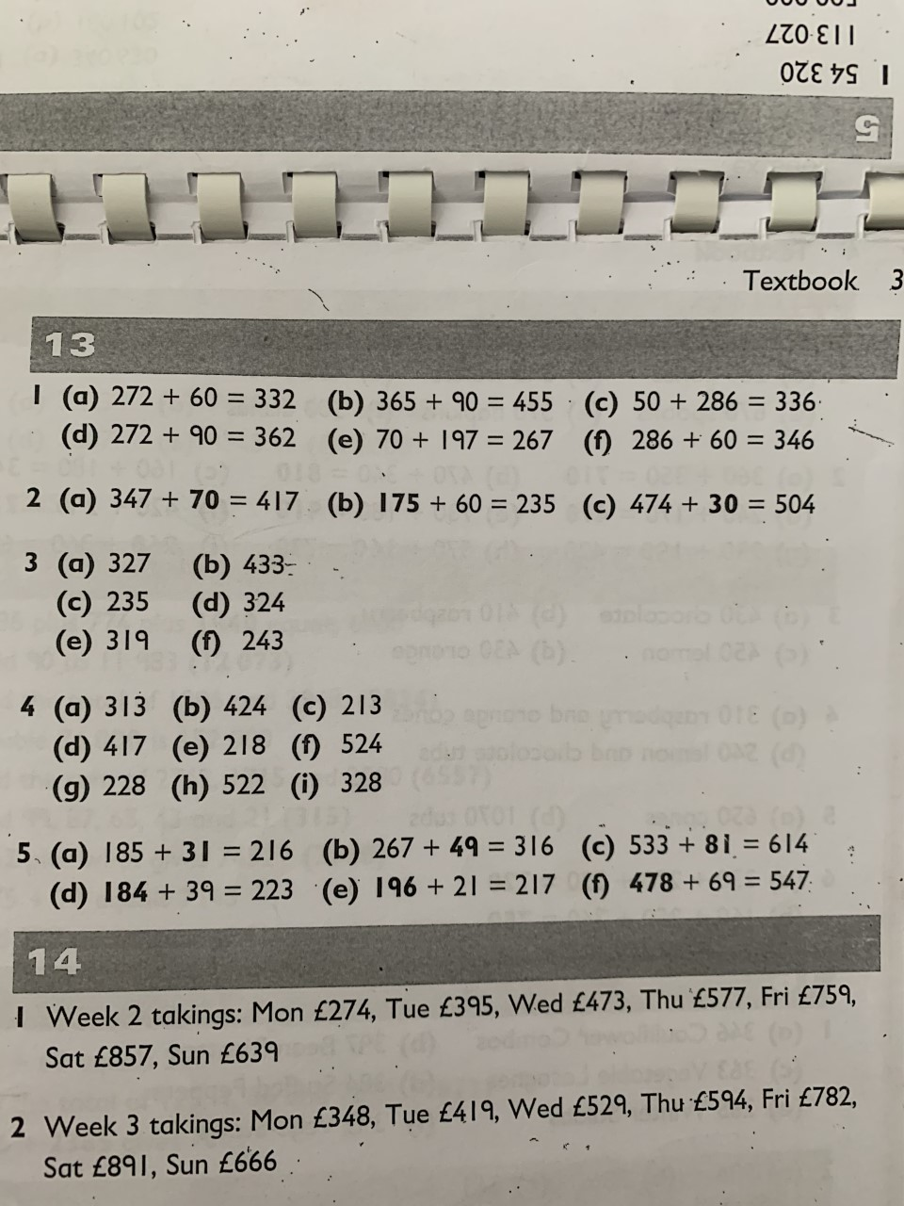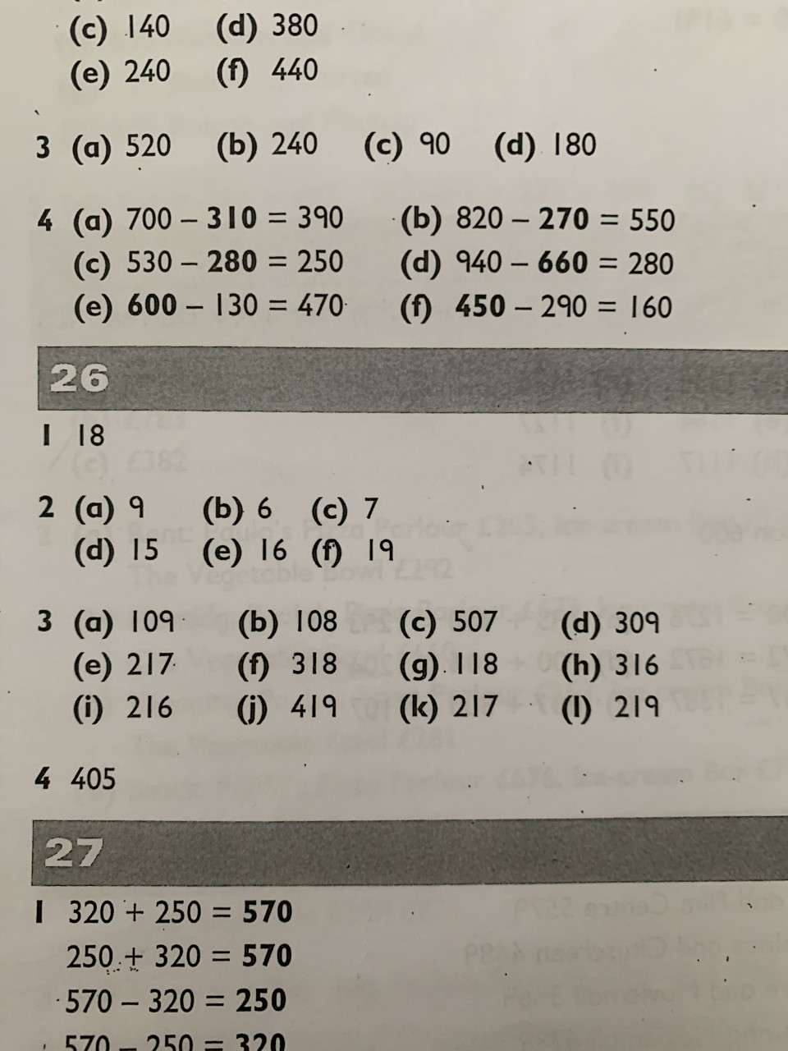

Literacy
Grammar
Unit 1 : Adjectives
Sometimes, a single adjective is not enough to describe a noun or pronoun.
We need to use a phrase (a group of words) to describe a thing so that the reader has a clear picture of what we are writing about.
We could say:
An old lady is crossing the road.
A reader would have a much clearer picture of the old lady if we wrote:
An old lady with a big floppy hat is crossing the road.
'Old' is a single adjective. 'With a big floppy hat' is an adjective phrase.
Joining two adjectives makes an adjective phrase.
The garden, silent and deserted, was covered with snow.
The adjective phrase 'silent and deserted' describes the garden.
REMEMBER: A phrase is a group of words that does not contain a verb.

Grammar Focus
Copy the following sentences into your book. Underline the adjective phrase in each sentence. REMEMBER: Look for more than one adjective.
The answers have been highlighted in red.
1 The weather, cold and wet, kept us in all day.
2 The handsome but sulky prince was in a bad mood.
3 The wood was dark and frightening in the moonlight.
4 Five small blue flowers had grown on the rubbish heap.

Grammar Practice
This area will be down to your own judgement to correct. I will give some examples of what correct answers could look like.
A
Use these adjective phrases in sentences of your own.
1 sleek and graceful – The sleek and graceful swan glided across the water.
2 with no shoes – The girl ran outside quickly with no shoes on.
3 frozen and slippery – The boy fell on the frozen and slippery ground.
4 with loud cries – The lion found a thorn in its paw and with loud cries tugged it out.
5 without an umbrella – The family went outside on a rainy day without an umbrella.
B
Write a sentence with an adjective phrase to describe each of these nouns:
1 meadow – The beautiful and flowery meadow stretched on for miles.
2 feathers – The bird ruffled its soft and fluffy feathers.
3 cough – The man let out a loud and uncomfortable cough.
4 photograph – The photograph was so vivid and colourful.
5 shepherd – The tired and hungry shepherd woke up for work at 4 am.
6 dolphin – The sleek and elegant dolphin cut through the ocean.

Grammar Extension
Three of the following examples are adjective phrases and three are sentences. Find the three adjective phrases. Add a verb and any other words you need to make each one into a sentence. Find the three sentences and write them with their correct punctuation.
REMEMBER: A phrase is a group of words that does not contain a verb.
I have entered the correct answer as well as an example of the punctuation and sentence you could use.
1 thank you said Jim – sentence – “Thank you” said Jim.
2 Janet ran home – sentence – does not need changed.
3 the poor injured duck – adjective phrase – The poor injured duck searched for help.
4 a shivering and frightened – adjective phrase – A shivering and frightened dog ran home to its owner.
5 give me that – sentence - “Give me that!” shouted the man.
6 with a heavy bag – adjective phrase - She got on the plane with a heavy bag.

Comprehension
Unit 2 – The moon of Gomrath
Colin woke suddenly and discovered his sister's bed was empty.
Colin tiptoed downstairs and groped his way to the door. It was still bolted. Had Susan dropped nine feet to the cobbles? He eased the bolts, and stepped outside, and as he looked he saw a thin silhouette pass over the skyline of the Riddings.
Colin ran: and by the time he stood up at the top of Clinton Hill he had halved the lead that Susan had gained. For it was undoubtedly Susan. She was wearing her pyjamas. Straight ahead of her were the dark tops of the trees in the quarry.
`Sue!' No, wait. That's dangerous. She's sleep-walking. But she's heading for the quarry. Colin ran as hard as he had ever run. He came to the fence that stood on the edge of the highest cliff and looked around while he recovered his breath.
The moon showed all the hill-side and much of the quarry: the pump tower gleamed, and the vanes turned. But Susan was nowhere to be seen. Colin searched the sides of the quarry with his eyes, and looked at the smooth black mirror of the water. He was frightened. Where was she?
Then he cried out in fear as something slithered over his shoe and plucked at his ankle. He started back, and looked down. It was a hand. A ledge of earth, inches wide, ran along the other side of the fence and crumbled away to the rock face a few feet below: then the drop was sheer to the tarn-like water. The hand now clutched at the ledge.

Thinking back
Rearrange these sentences to retell the main points of the passage:
Answers have been listed in numeric order.
Something grabbed Colin's ankle. - 4
Colin woke up and discovered Susan's bed was empty. - 1
Colin ran to the edge of the cliff but could not see Susan. - 3
Colin looked down and saw a hand clutching a ledge. - 5
Susan was sleep-walking towards the quarry. - 2

Thinking about it
These answers will be down to your interpretation. I have provided some possible answers. Remember to write these in sentences!
1 What do you think woke Colin? – I think Colin woke because Sue got out of bed, making noising, and therefore waking him.
2 Why couldn't Colin understand how Susan had got out? – Colin couldn’t understand how Susan had got out because the door was still bolted.
3 How did Colin realise it was Susan? – Colin realised that it was Susan because she was wearing her pyjamas.
4 What was the countryside like near their house? – The countryside near their house was very hilly. It also had what could have been a lake of water.
5 How can you tell Colin could see clearly, even though it was at night? – Colin could see clearly because the moon was helping to light up his surroundings.
6 Why didn't Colin shout to warn Susan? Maybe Colin did not shout out to warn his sister because he was frightened.
7 Whose hand do you think it was? Why? I think the hand could belong to Susan because she was sleepwalking and fell over the cliff edge.

Thinking it through
1 How can you tell Colin was really worried? – You can tell Colin was really worried because he chased after Susan.
2 What words and phrases does the writer use to tell you Colin was in a hurry? - The word ran and the phrase ‘ran as hard as he had ever run’ tell me that Colin was in a hurry.
3 What thoughts would have gone through Colin's mind when he found Susan's bed empty? I think Colin would have been very worried. He would probably wonder where she was.
4 What do these words mean? (Use a dictionary if you are unsure.) a) silhouette – the dark shape and outline of someone or something visible in restricted light against a brighter background b) quarry – an excavation pit, usually open to the air, from which building stone, slate, or the like, is obtained by cutting, blasting, etc c) tarn – a small mountain lake
5 Did you find the passage exciting? Why? – I found the passage exciting because it built to a climax on the cliff.
6 What did you like about the way the author wrote? – I like the way the author writes from Colin’s perspective. They use questions like it is one of Colin’s thoughts.
7 When a story ends at an exciting point, it is often called a `cliff-hanger'. This passage is a `cliff-hanger' in two different ways. Why? – It is a cliff-hanger in two ways because the passage ends on a very exciting point, where something mysterious has happened, and the end of the passage is set on a cliff where someone is hanging.

