Dear Parent/ Carer,
I have created this resource to provide weekly work that children can complete at home. This could be used in conjunction with your home learning packs. I have included:
- Maths: Revision of area (This has been split in coordinates/symmetry and angles groups).
- Literacy: Grammar, Comprehension, Handwriting and Writing exercises.
- Additional Activities: Small activities linking to topic, R.E., Art and Science.
Answers to math and literacy exercises will be posted on Friday. Feel free to email me any questions or to show me any work produced. I hope you are all doing well.

Many Thanks,

Mr Garvey

Maths
Coordinates and symmetry 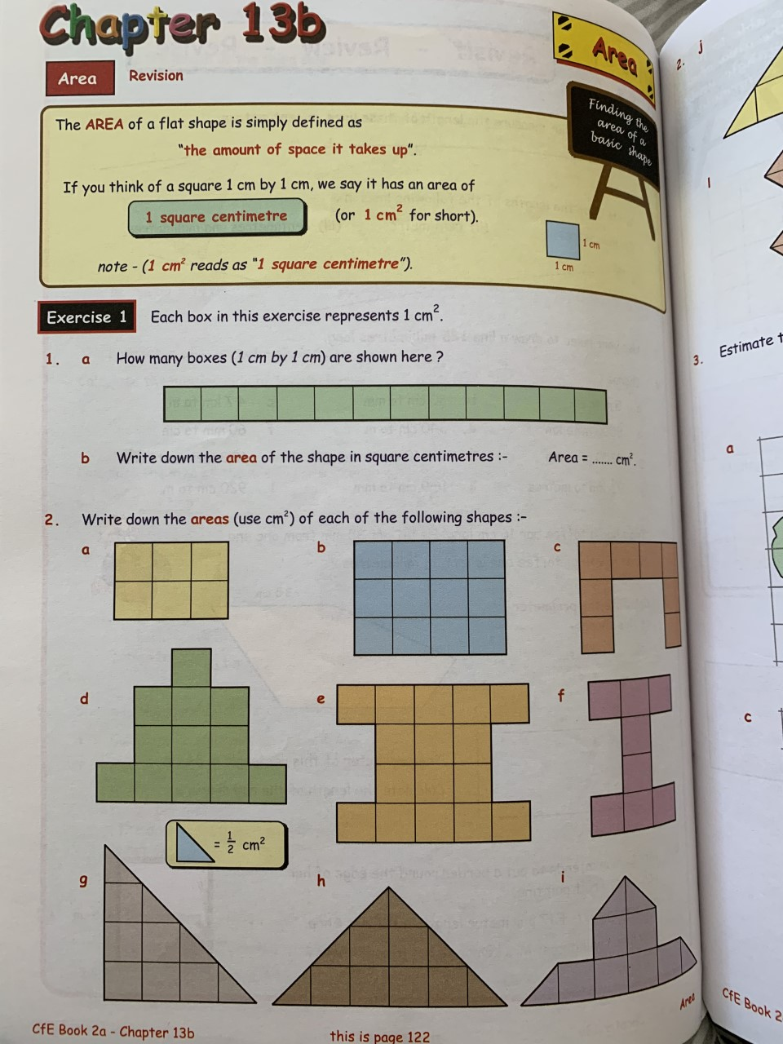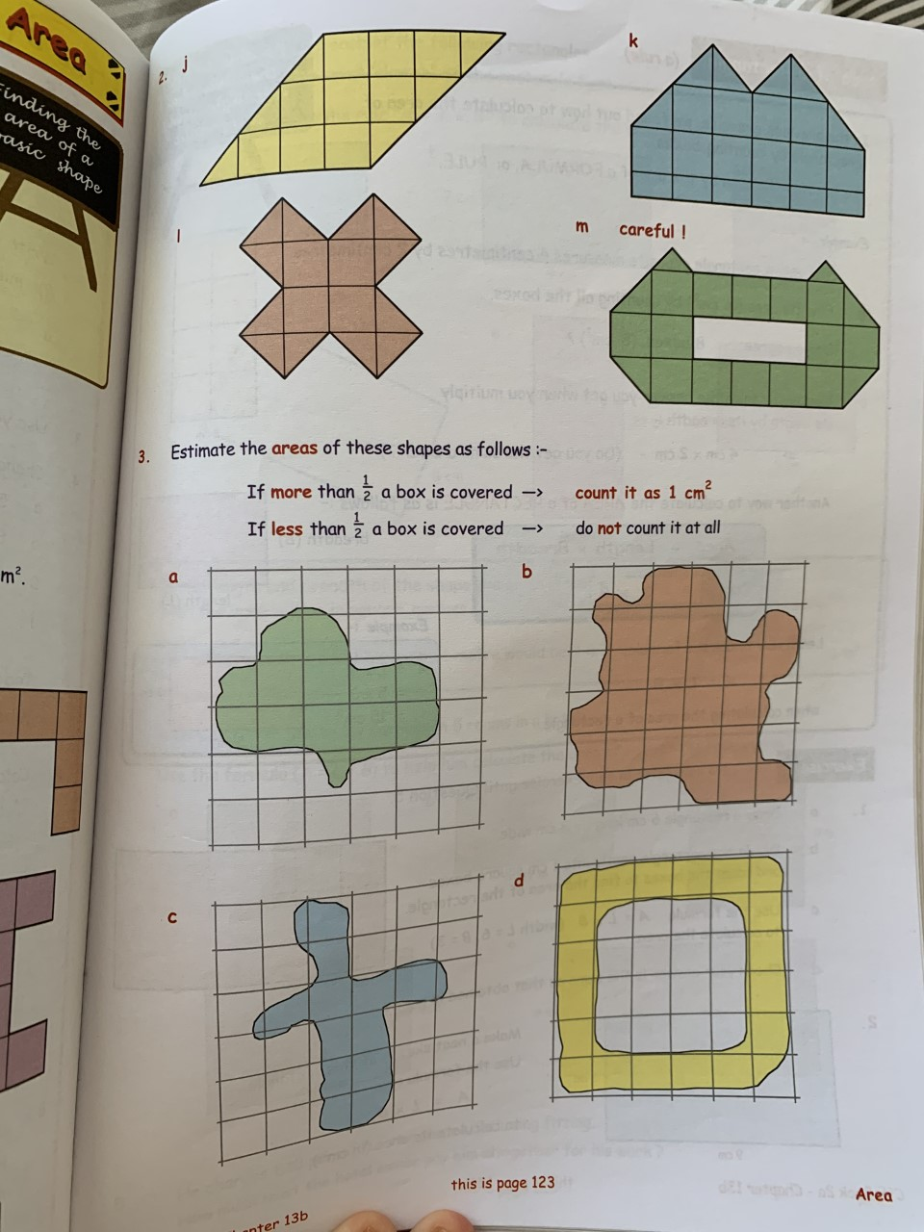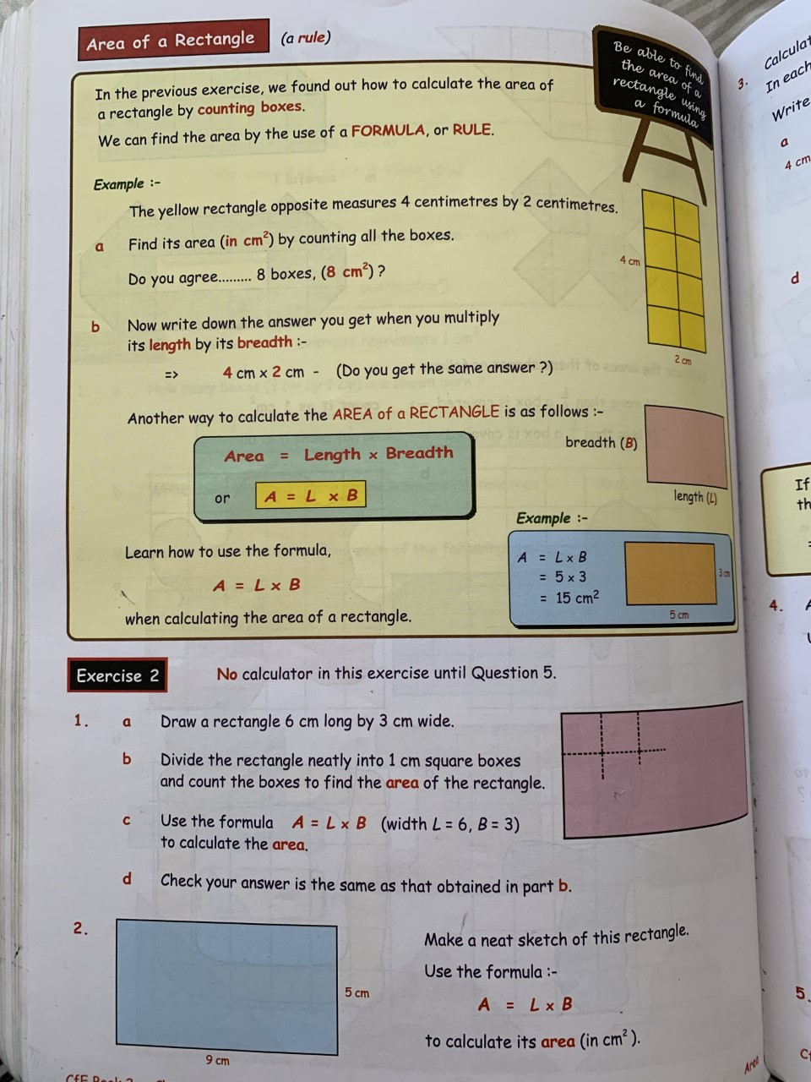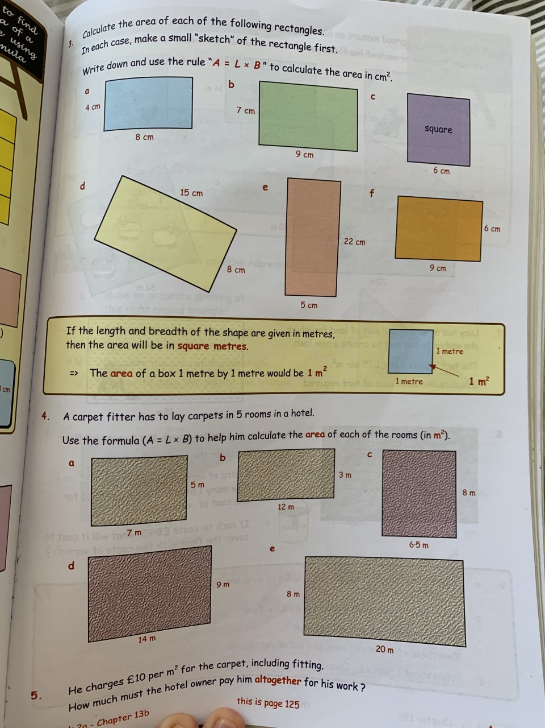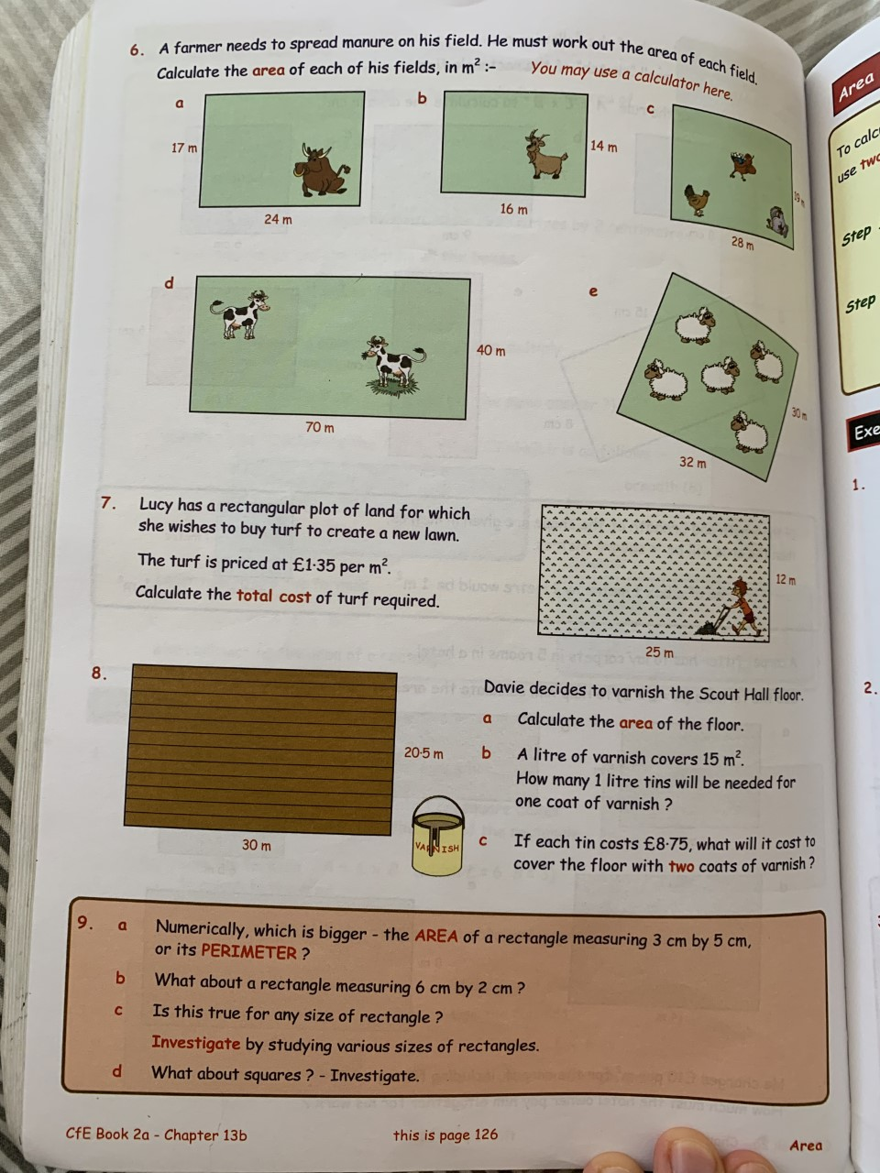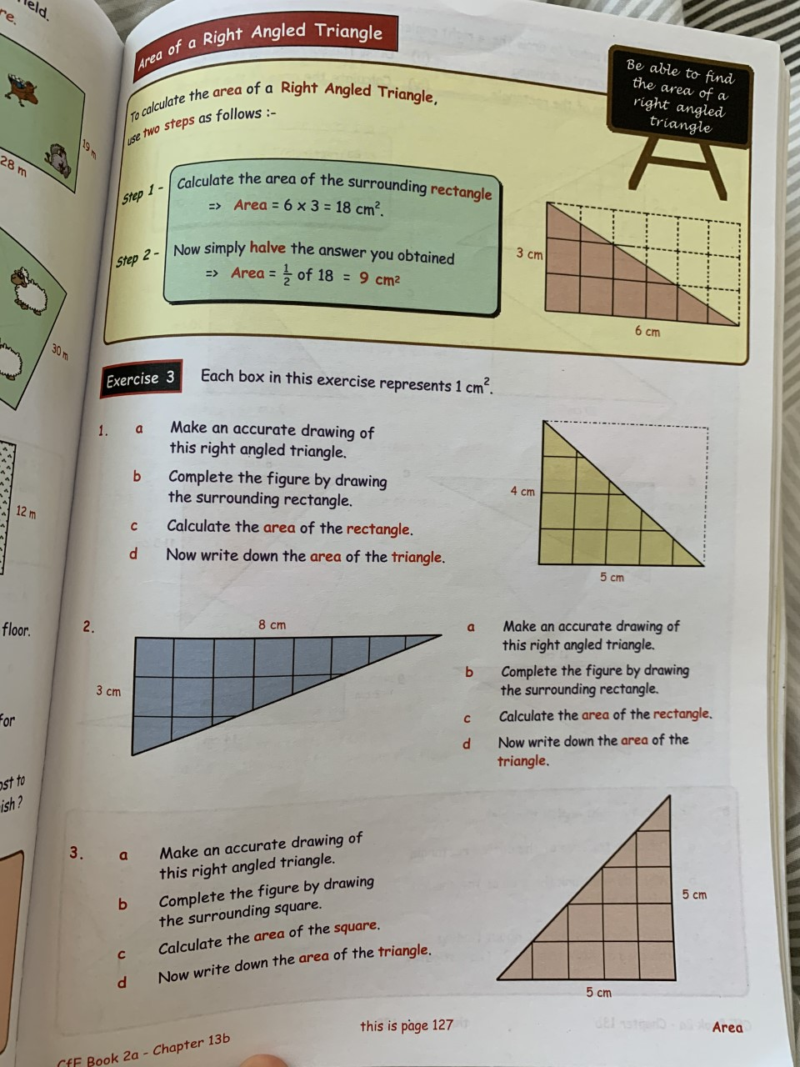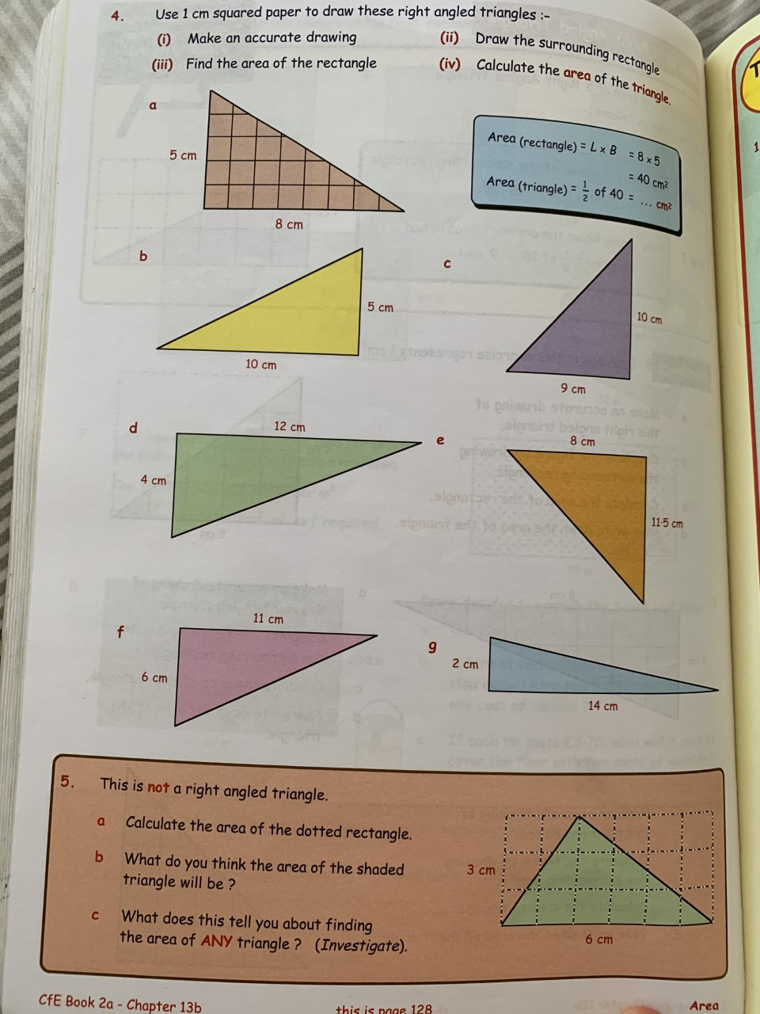
Angles
On Page 93, all squares should be measured as 1cm2
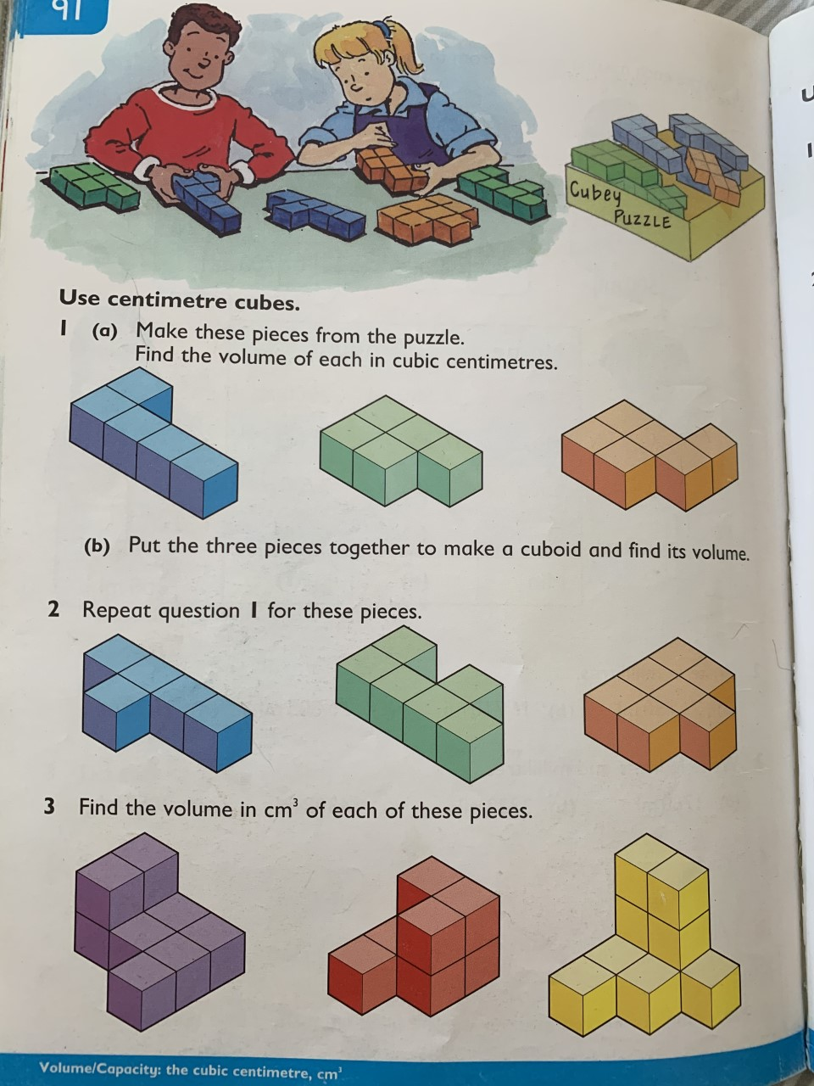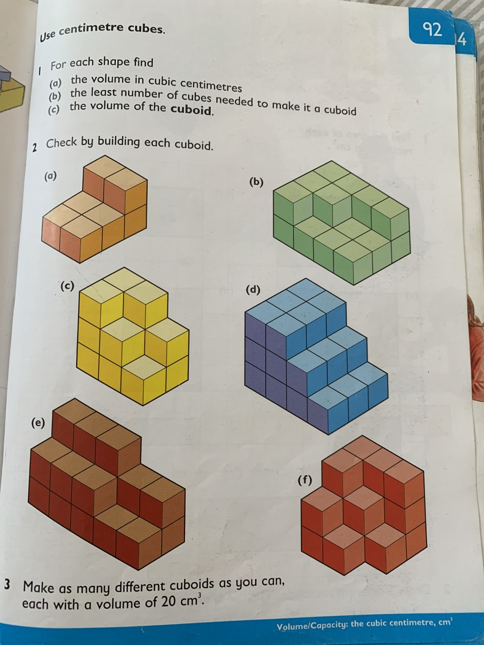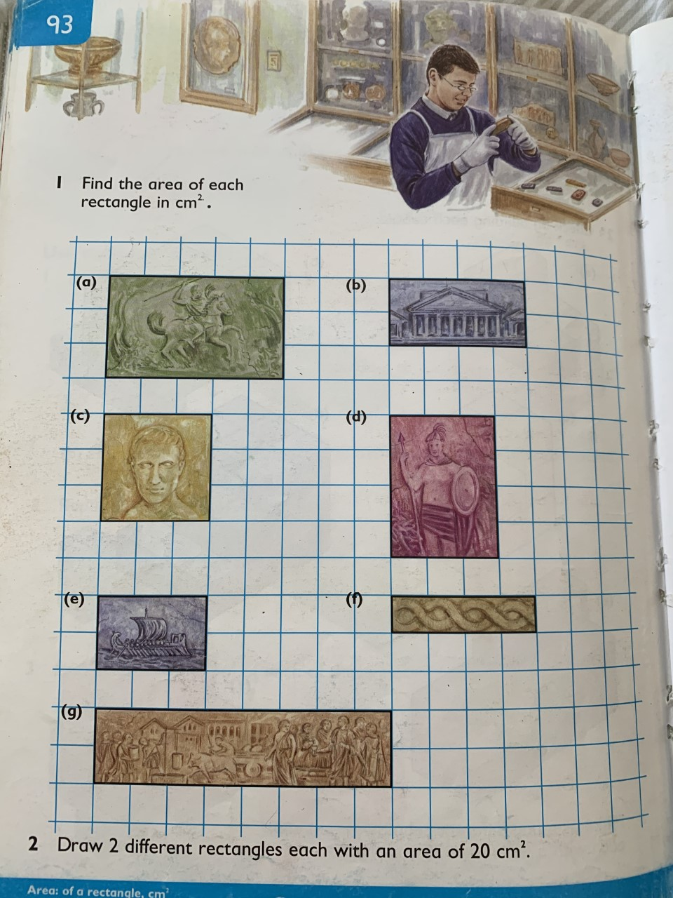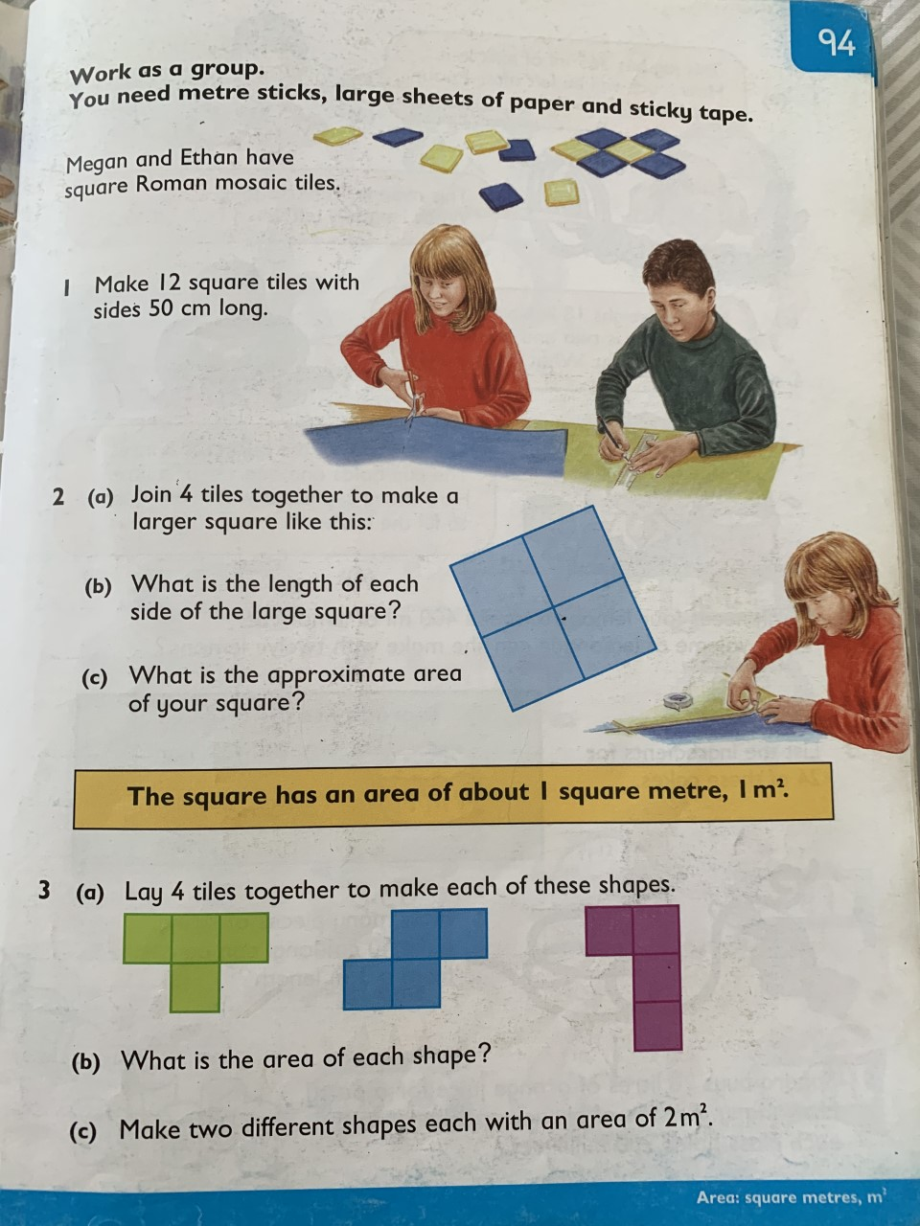

Literacy
Grammar
Unit 4: Pronouns

A pronoun can be used instead of a noun.

The dog has a kennel.

It has a kennel. (It = Pronoun)

Some pronouns show ownership or possession.

They are called possessive pronouns.

This coat is mine.
That coat is yours. (Both Possessive Pronouns)

Here are some more possessive pronouns.
his : The book on the floor is his.
hers : This torn letter is hers.
mine : The red bicycle is mine.
ours : All the sheep in that field are ours.
theirs : Our garden is bigger than theirs.
yours : Is this yours?

Grammar Focus

Copy the following sentences into your book.

Use possessive pronouns in place of the green
words.

1 Your writing is neater than my writing.

2 My pen is broken. Will you lend me your pen?

3 She has lost her pencil. Is this her pencil?

4 That‟s a blue pencil. It must be his pencil.

5 The teachers left some books here. I‟m not sure which are their books.

Grammar Practice

Copy the following sentences.

Write a possessive pronoun in each gap.

1 “This chair is ______, and that chair is ______,” Ian said to his sister.

2 “These games are ______,” shouted the boys.

3 Carl made a model castle. Lynn helped him so it is ______ as well.

4 The children had to take some baby photographs to school. The twins were not sure if they could find ______.

5 The teacher asked for the homework. Katy and I hadn‟t brought ______.

Grammar Extension

Write a sentence using each pair of possessive
pronouns.

1 mine yours

2 theirs ours

3 his hers

4 ours his

5 hers mine

Comprehension
Unit 15 – The Magic Box

Think ahead
Inside Pandora's Box (Unit 14) were all sorts of nasty things. Inside this box are all sorts of nice things. Before you read the poem, guess what things the poet might have chosen to go in his `magic' box.

I will put into that box
the swish of a silk sari on a summer night
fire from the nostrils of a Chinese dragon, the tip of a tongue touching a tooth.
I will put into the box
a snowman with a rumbling belly,
a sip of the bluest water from lake Lucerne,
a leaping spark from an electric fish.
I will put into the box
three violet wishes spoken in Gujarati,
the last joke of an ancient uncle,
and the first smile of a baby.
I will put into the box
a fifth season and a black sun, a cowboy on a broomstick and a witch on a white horse.
My box is fashioned from ice and gold and steel,
with stars on the lid and secrets in the corner. Its hinges are the toe joints
of dinosaurs.
I shall surf in my box
on the great high-rolling breakers of the wild Atlantic,
then wash ashore on a yellow beach
the colour of the sun.

From Cat Among the Pigeons by Kit Wright

Thinking back

1 If SSSSN = the swish of a silk sari on a
summer night, what would these mean?
a) FNCD b) SRB c) LSEF
d) LJAU e) FSB f) WWH

2 What will be spoken in Gujarati?
3 Describe how the box is made.

4 Describe the beach the poet will land on.

Thinking about it

1 What is Gujarati?

2 How could you `capture' the first smile of a baby?

3a) What name would you give to a fifth
season?
b) What would the weather be like in your
fifth season?

4 Which of the things in the box do you think are real and which are imaginary?

Thinking it through

1 In what way is the poem about magic?

2 What is your favourite thing in the box?
Why?

3 What is the most strange thing the poet
will put in the box? Why?

4 What do you think is special about this
poem?

5 Is wishing the same as wanting?
Explain what you think.

Writing

Notice that your comprehension from this week was a poem. This poem did not however rhyme! Instead the first line of each stanza (paragraph) always mentioned the subject og the poem (the box). The stanza also used 3 sentences to describe things about the box. See below as an example:

My box is fashioned from ice and gold and steel,
with stars on the lid and secrets in the corner. Its hinges are the toe joints
of dinosaurs.

Try to create your own non rhyming poem about a magic object. Remember the first line should always include your object and a description, e.g.

My car is multicoloured, like all the colours of the rainbow.

Your poem should be 3 paragraphs minimum and 5 maximum. Try to make yours as interesting as possible, using alliteration, similes and metaphors!

Once completed draw your object using the descriptions you have provided.

Handwriting

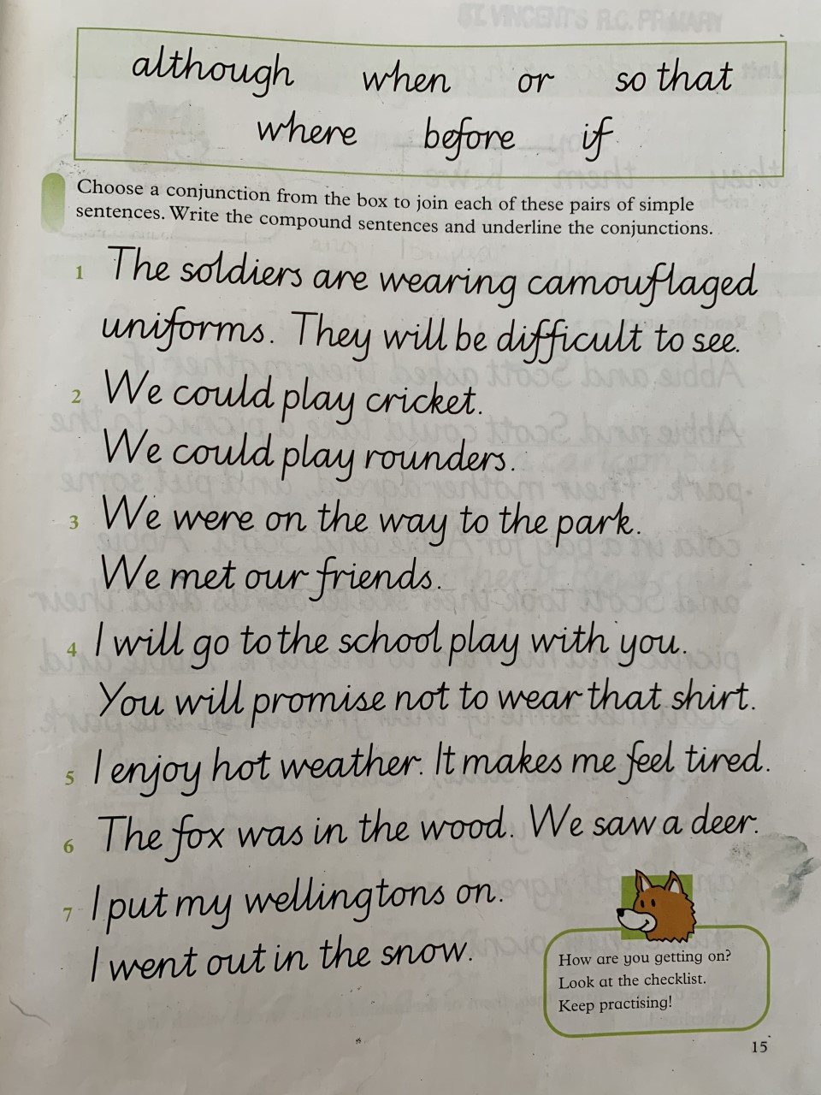

Additional Exercises

Science

Create your own Magic Mud using only potatoes and warm water.

Instructions:

- Wash and cut up potatoes into small pieces.
- Put the pieces into a bowl and pour in hot water (enough to cover the pieces) and stir.
- The water will begin to turn red.
- Strain the water from the chunks and leave to stand for 10 minutes.
- A small white layer will be produced.
- Pour out the water and the white layer should remain.
- Clean this by adding some fresh water.
- Move all the liquid to a jar and shake. Leave again for 10 minutes.
- It should separate into layers again.
- Pour out top layer, leaving milky white layer in jar
- This layer should act as a solid material when you handle it, but as soon as you stop moving it liquifies.

Complete this experiment with an adult!

The video below should help you.
https://www.youtube.com/watch?v=_0J4dRqg7CE

Topic

Complete this short quiz about the differnet terms relating to the Scottish Parliament.

Using the words below, try to complete this passage about the Scottish Parliament.

Art

Recreate famous pieces of art using your toys, action figures, Lego and dolls. If you do not have these be imaginative and use house hold objects!
(you could even draw the background yourself, placing the object in front to make it look like it is actually in the painting!)

Use a camera to capture your recreations.

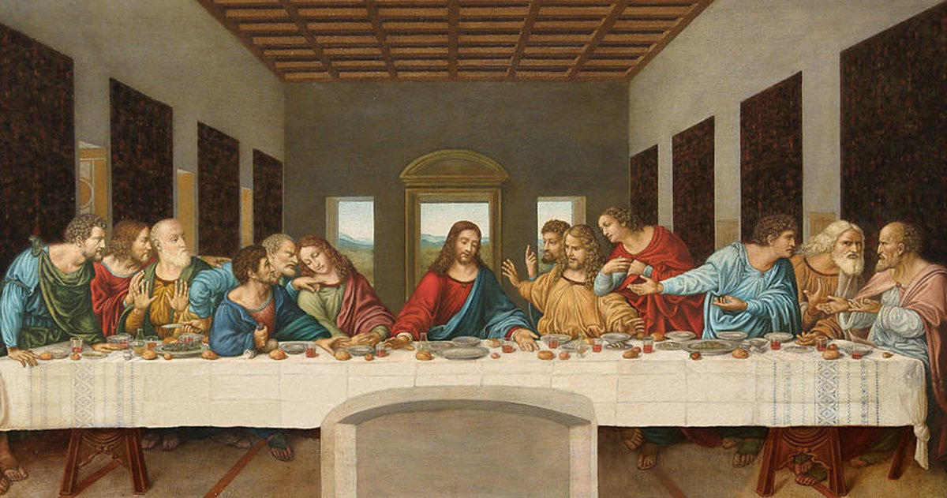

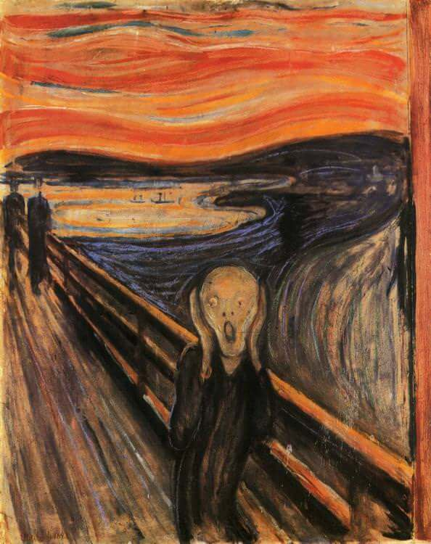
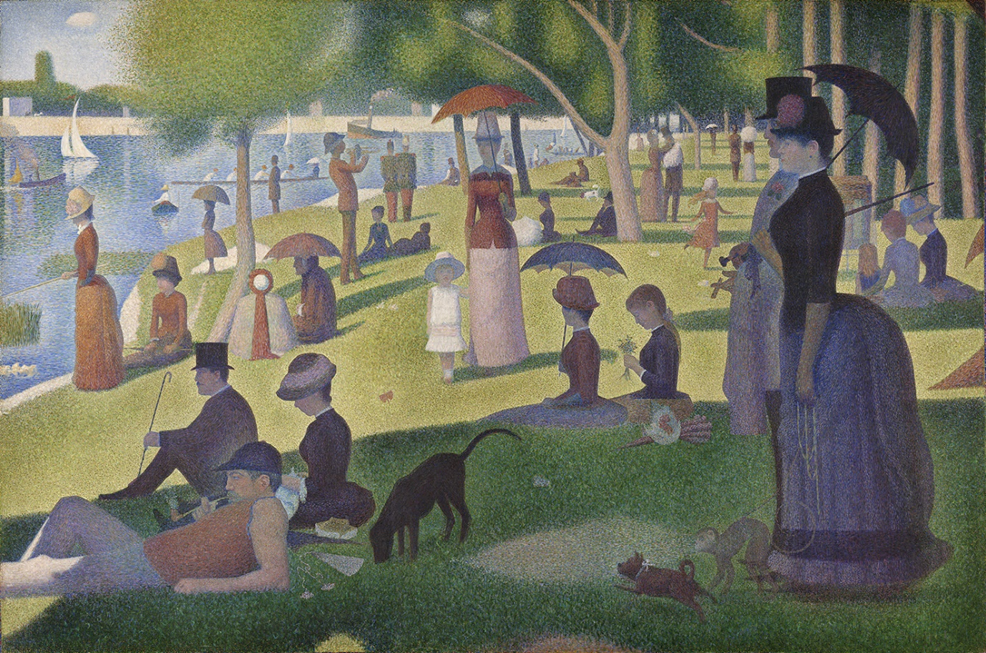

R.E.

Read Luke 24:13-35. You can find this online by searching the Bible passage. Complete the worksheet on your own piece of paper.
Write a story from the perspective of one of the Travelers. You meet a man on the road home, telling him all about the death of Jesus. You invite home home for supper, only to realise that HE is Jesus.

