[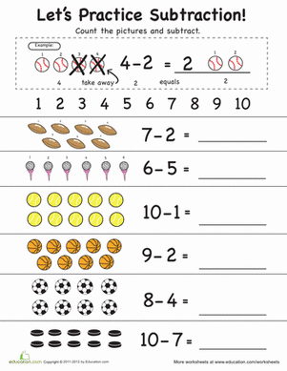](https://www.google.co.uk/url?sa=i&url=https%3A%2F%2Fwww.education.com%2Fworksheet%2Farticle%2Fpractice-subtraction-1-10%2F&psig=AOvVaw16HGcXopA4PlTF9n468OTJ&ust=1585041994263000&source=images&cd=vfe&ved=0CAIQjRxqFwoTCKini9qjsOgCFQAAAAAdAAAAABAI)

[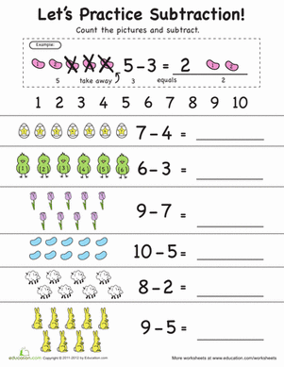](https://www.google.co.uk/url?sa=i&url=https%3A%2F%2Fwww.education.com%2Fworksheet%2Farticle%2Fsubtract-1-10%2F&psig=AOvVaw16HGcXopA4PlTF9n468OTJ&ust=1585041994263000&source=images&cd=vfe&ved=0CAIQjRxqFwoTCKini9qjsOgCFQAAAAAdAAAAABAY)

[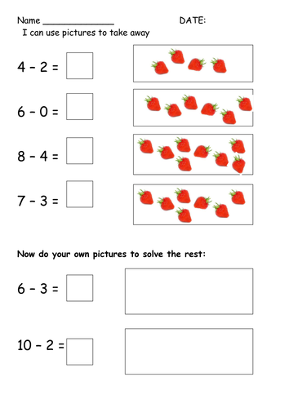](https://www.google.co.uk/url?sa=i&url=https%3A%2F%2Fwww.tes.com%2Fteaching-resource%2Fy1-subtraction-using-pictures-6120497&psig=AOvVaw16HGcXopA4PlTF9n468OTJ&ust=1585041994263000&source=images&cd=vfe&ved=0CAIQjRxqFwoTCKini9qjsOgCFQAAAAAdAAAAABAd)

[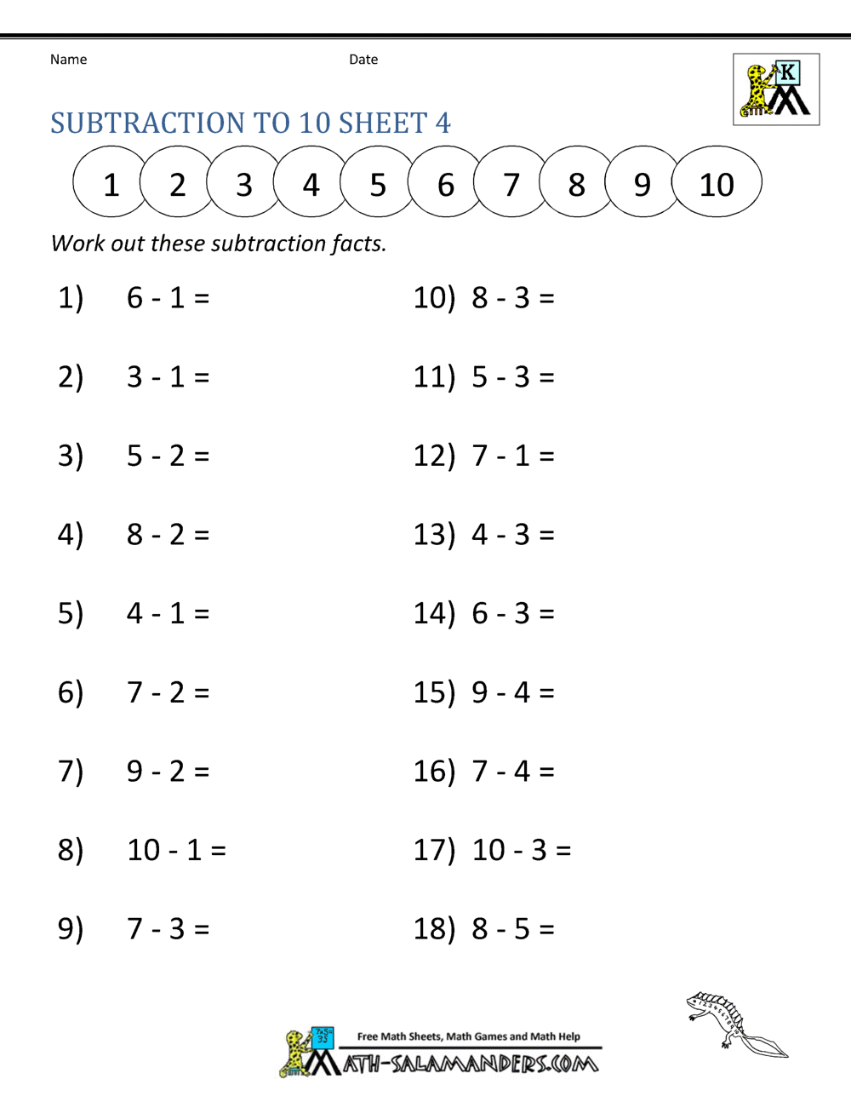](https://www.google.co.uk/url?sa=i&url=https%3A%2F%2Fwww.math-salamanders.com%2Fsubtraction-to-10.html&psig=AOvVaw16HGcXopA4PlTF9n468OTJ&ust=1585041994263000&source=images&cd=vfe&ved=0CAIQjRxqFwoTCKini9qjsOgCFQAAAAAdAAAAABAE)

[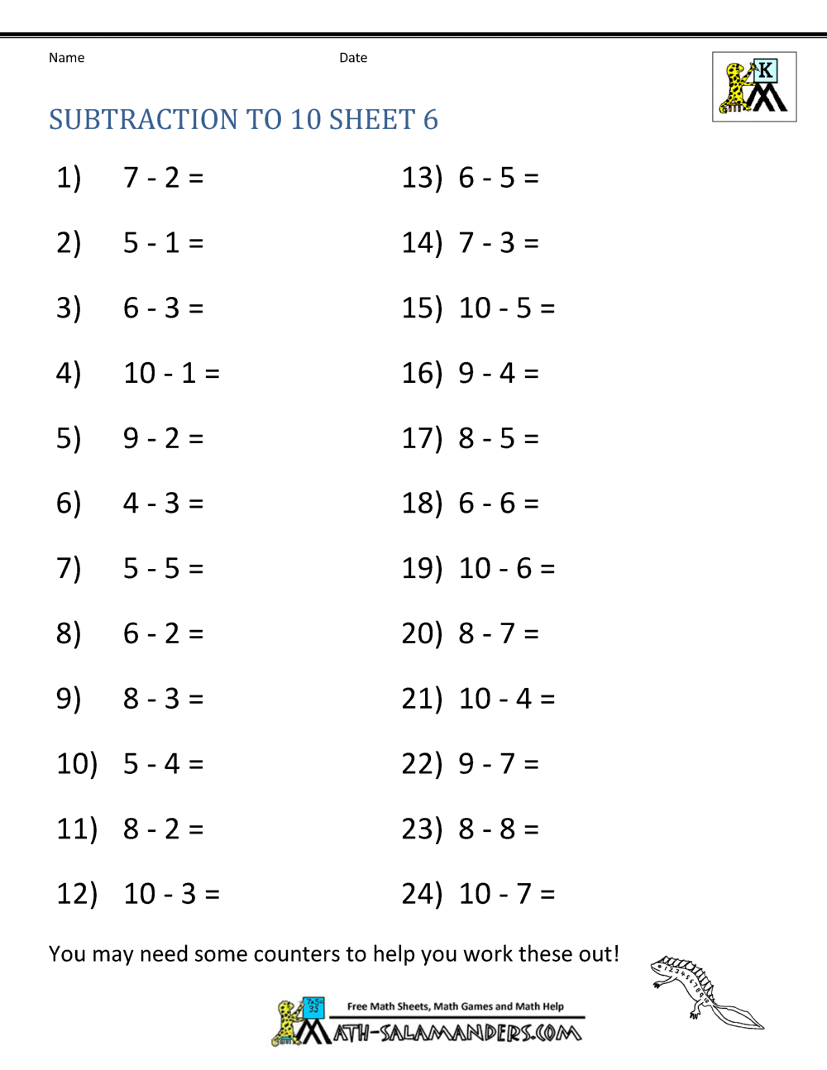](https://www.google.co.uk/url?sa=i&url=https%3A%2F%2Fwww.math-salamanders.com%2Fsubtraction-to-10.html&psig=AOvVaw16HGcXopA4PlTF9n468OTJ&ust=1585041994263000&source=images&cd=vfe&ved=0CAIQjRxqFwoTCKini9qjsOgCFQAAAAAdAAAAABAT)