https://thestemlaboratory.com/?s=walking+water+rainbow  Walking Water Rainbow Stem Activity  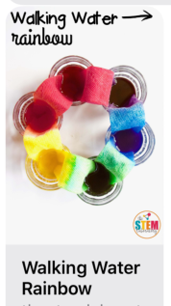 | https://www.adabofgluewilldo.com/?s=apple+boats  Apple Boats Stem Activity  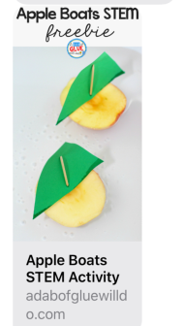 | https://thestemlaboratory.com/?s=cloud+in+a+jar  Cloud In A Jar Stem Activity
Sun Safety Word Search  See class page of website  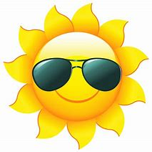 | https://www.childrensgardeningweek.co.uk/things-to-do/rock-painting-bugs/  Rock Painting Bugs  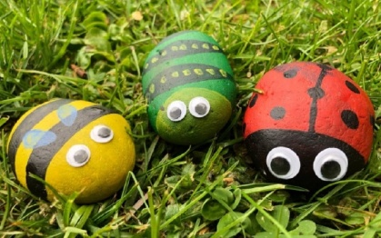 | Design Your Own Flip flops  See class page of website  