How to access EasiMaths and Doorway Online through your glow tile.
- Firstly, google glow login and click the first link.
- Log in with the first part of your glow. e.g. gw17maguireclaire1 and password. If anyone cannot remember their glow or having problems logging on- please email me on gw17maguireclaire1@glow.sch.uk

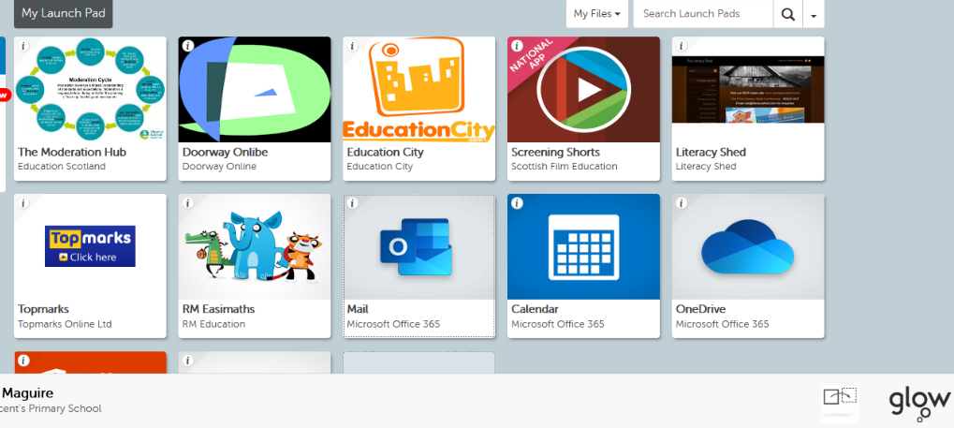

- Then click on Easi Maths (picture with an elephant, crocodile, and tiger) and log in with glow login and password. This is a great site as it naturally progresses your child through different levels. For example, if there is an area in maths your child needs to strengthen, it will keep giving them questions surrounding that area. Or if your child is getting all questions correct, it will move them up to the next level.
- This is Doorway Online- with the blue and green icon. It is a great resource for both numeracy and literacy.

Once logged on, the top tabs can take you into different areas.
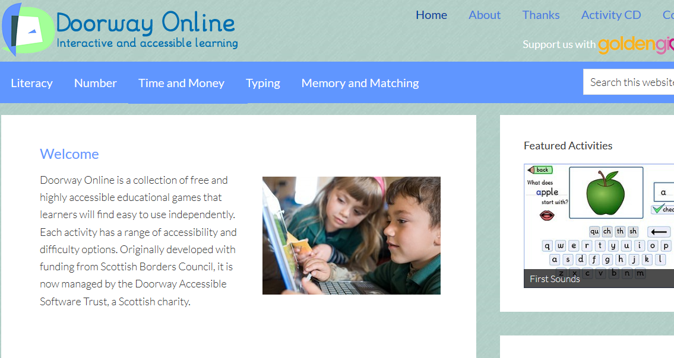

For phonics we are going to click on literacy and in the drop-down box ‘speller 2’, Enter then next.

Most of our sounds can be found by clicking into the yellow crayon box. Click on the focus sound your child is learning and it will bring up a list of words up they can practise.

Other sounds can be found here: -

The common words and lists are great and split into different groups. Your child can make their way through these for reinforcement and revision.
Sum dog
I emailed via glow everyone their Sumdog login and password. Google Sumdog and click on the first link. Then enter your login, password, and the school code stvek. Games and challenges will be posted, and I can see how you are getting on.
