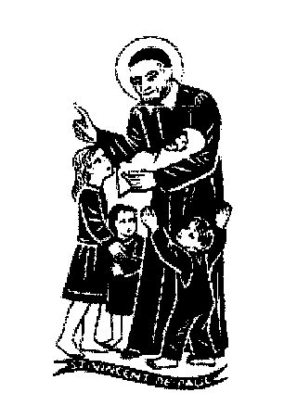  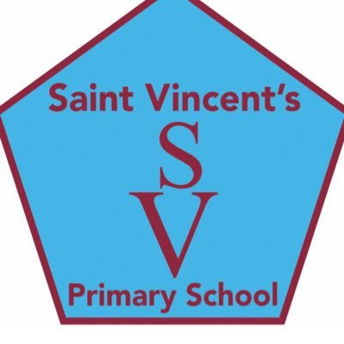

**education SERVICES**

**Executive Director: Tony McDaid**

**ST VINCENT'S PRIMARY SCHOOL -**

Head teacher Eileen Tompkins

6th August 2020

Dear Parent/Carer,

I hope you and your families are well and keeping safe. We are looking forward very much to seeing all our boys and girls who are returning to school and to welcoming our new primary 1 children and other children who are joining Saint Vincent’s. I want to update you on the additional arrangements we are putting in place to ensure the safe return of all our children Please refer to the June newsletter for general information and we will continue to keep you informed via the school app ,Twitter and the school website.

Starting on **Wednesday 12th August** we welcome **P1** only **from 9 – 3pm**.

As you will have read in the June newsletter, parents are not permitted in the school building but on Wednesday 12t,h ,primary 1 parents can accompany their child to the school playground from 8.45 onwards where you will have time for all important first day photograph before your child goes into school through the designated P1 entrance at 9am .

**Thursday 13th August** is for P**1-3/4 only (Rooms1-6)**

To allow P1 parents to also accompany their child/ren on their second day of school, we are giving P1 **only** a soft start from 9 to 9.15am and a soft finish from 2pm. From Monday 17th August, P1 will attend from **9am – 3pm** and we ask that parents do not enter the playground in the morning. Staff will be at the gate to encourage and support any child who may be still a little reluctant to come in.

P2-3 (Rooms 3-6) begin school **at 8.45am** and finish **at 2.45pm**. The children will be collected by their teachers from the school playground and enter the school building via classroom doors. We will adopt a one- way system within the school as far as possible and will encourage a ‘Keep to the Left’ policy for travelling around the building.

On **Friday 14th August, all P4-7 only (Rooms 7-13)** start **at 9.15am** and finish at **3.15pm**. Please note that P4 children in the P3/4(Room6) class are also invited to attend on Friday 14th August. This will allow them to reconnect with the other P4 children.

Children are not expected to adhere to the government’s 2m physical distancing advice with each other. Physical distancing between adults and between adults and children should continue as far as possible. Please note that on the first day your child returns to school any prescribed medication that they require must be provided and the appropriate administration of medicine form completed. A member of staff will be available at the main school entrance to complete this with you. Do not give the medication to your child. Please note that only medication that has a prescription label on it will be accepted by the school. There can be no unplanned access to the school for parents or visitors.

On **Monday 17th August – P1-7 all children return to school.**

Rooms 1-5 **- 8.45am to 2.45pm** Rooms 6-9 - **9am – 3pm** Rooms10-13- **9.15am – 3.15p****m**

These staggered times will remain in place allowing us to monitor and ensure safe entry and exit of children. We will ensure that the main gate to the playground is open for arrival and departure times and ask that parents observe social distancing when dropping and collecting their children.

**Other information**

There will be no whole school gatherings such as assemblies, extra-curricular activities, or breakfast club until further notice. PE will resume for pupils the week commencing 17th August and details of your child’s gym days will follow. Prior to the end of term, we advised that PE was not permitted but this has now changed. Children are required to wear their gym kit to school on gym days as changing rooms remain closed and we are asked to limit cross contamination.

School bags can be taken to school but are unlikely to be necessary. Each child will be given their own tray containing all the resources they will need. These resources will be for the child’s sole use. Packed lunches and filled water bottles can be brought to school. Hot lunches will now be served in the dining area.

Children or staff are not required to wear PPE in line with the medical advice from Health Protection Scotland however a child or adult may wear a mask should they wish. Children may also bring their own hand gels, soap and wipes for individual use but this is not necessary as sanitiser and soap is provided and sanitiser is available around the school and at all entry points.

Our school uniform remains unchanged and ties can be purchased from the school office by putting £3.75 in an envelope. Children will require a pair of indoor shoes to wear around the school building· All items of clothing including shoes will need to have your child’s name on them.

The church car park should be used by parents, although if possible, we ask that you walk/cycle to school to ease congestion. At no time should the school car park be used by parents unless you are a blue badge holder.

Any child suffering from a new continuous cough or high temperature is required to isolate at home for 10 days as per government advice. Should a child become unwell with a temperature or cough their parent will be contacted immediately and they will be isolated from other pupils. Please ensure that we have your most up to date contact details .Hope you and your families enjoy what remains of the holidays .

Kindest regards. Eileen Tompkins (Headteacher)