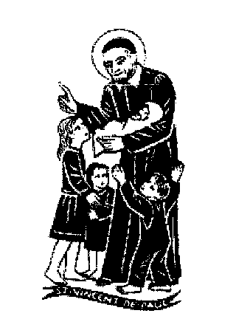
education SERVICES
Executive Director: Tony McDaid
ST VINCENT'S PRIMARY SCHOOL - Headteacher Eileen Tompkins
Dear Parent/Carer,
With just a month to go to the end of term and the beginning of Christmas holidays, we are fast approaching the busiest four weeks of the school year. It has been a great pleasure to welcome parents of our P1-3 children for Stay and Play sessions on Friday mornings. Our hope is that over the next weeks we will have many opportunities for parents, carers and families to join us in the many events that are taking place here at school . We hope we can make very special memories for all and help our children and our families prepare to celebrate the real meaning of Christmas
What’s on between now and Christmas?
School and class Masses
On Sunday we begin the Season of Advent. This is a special time of preparation to get our hearts ready. So often in our world, the pace of life is such that Jesus gets crowded out. During these days we will try to find time each day to pray and think about what and who we celebrate at Christmas. Each class will have an Advent wreath and on Monday November 28th the Pupil Council will bring their class Advent wreath to be blessed during Mass by Fr Romanus.
Each class will also have the opportunity to attend Mass with their class during Advent and we will also have two whole school Masses beginning on Wednesday 30th to celebrate the feast of Saint Andrew and ending with Mass on Friday December 23rd at 9.30am. As always you are welcome to join us. We are asking that children would bring some item to support the Loaves and Fishes foodbank appeal. (More details on the school Twitter page)
School performances and Theatre visits
The P1-3 performance of the Nativity is always a highlight and we are so looking forward to this year’s production of “The Donkey Seller” on Tuesday 6th 1.45pm and Wednesday 7th 1.45pm and 6.30pm.
This year P4-7 invite you to join us in Saint Vincent’s church for an unmissable production of “Glad Tidings” on Monday December 19th at 1.30pm which will feature many well-loved Christmas carols for you to enjoy.
We look forward with great anticipation and joy to the school choir’s performance on Thursday December 15th at 6.30pm which is sure to be an occasion to remember.
Primary 6 and 7 will travel to Glasgow on Wednesday December 7th and visit Kelvingrove Museum before going to see Beauty and the Beast at the Kings Theatre. Please note the late return at 4.30pm
Hopscotch theatre will make a return visit to Saint Vincent’s on 22nd December for their production of Jack and the Beanstalk which all classes will enjoy.
We look forward to welcoming back one of our parents Mr Fibbers to perform for p1-3 on Tuesday December 20th. Mr Fibbers entertained us all so wonderfully well during our Queen’s Jubilee celebration.
Café Noel will be on Wednesday December 21st at 9.15am.This is an opportunity for all our families to enjoy seeing all classes perform in a very informal fun setting that is always a hugely popular event in the lead up to Christmas. All are welcome.
Our Whole school achievement assembly on Thursday 8th December will have a special focus on Christmas Books and each day during the next four weeks there is an opportunity to enjoy a book being read by a member of staff which will be uploaded to Twitter and Google classroom. We also hope to have some additional Outdoor learning opportunities.
Wednesday 14th December is School Christmas Lunch. All are welcome to come in festive dress.
We will have a special visitor to the Primary 1 Christmas party on Tuesday 20th December when P1-3 class parties will also take place. P4-7 Parties will be on Wednesday 21st December.
We have the School Fair organised by our hardworking and committed parent Council and we hope to see a great turnout on this Wednesday 30th November from 5pm to 7pm.
Special thanks to all who organised and supported the wonderful Ladies Night last Friday. It was indeed a night to remember.
Our parents/carers /grandparents are invited to come in for a cuppa and mince pies with some time to reflect as Christmas comes closer and enjoy each other’s company on Tuesday December 13th at 1.30pm
Adverse weather arrangements
What a busy time there is ahead! We hope the weather obliges but in the event of any adverse weather particularly snow we ask you to keep an eye on the school app or on SLC Twitter for any updates which may involve delayed school opening or school closure.
We look forward to seeing you over the next weeks and hope we share many happy moments in the run up to Christmas 2022. School will close at 2.30pm on Friday December 23rd on time to get the turkey ready for what we hope for all will be the happiest of Christmases.
Kindest Regards
Eileen Tompkins

